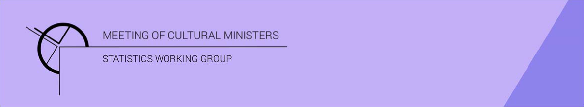

Cultural Funding by Government — 2017–18

Australian Government
In 2017–18 the estimate of expenditure on cultural activities, funded by the Australian Government, was $2,674.9m representing a rise of 12% or $291.1m from 2016–17.
Table 1—Australian Government cultural expenditure, 2015–16 to 2017–18
2015–16 | 2016–17 | 2017–18
$2,306.1m | $2,383.8m ↑ 3% | $2,674.9m ↑ 12%

- The estimate of per person cultural funding was $107.96.

Heritage
Funds on Heritage activities rose 29% (or $137.7m) to $611.3m.
This increase was driven by expenditure on the categories of Other museums and cultural heritage (↑$84.5m), Libraries (↑$32.9m) and Art museums (↑$22.4m).
The largest categories of Heritage expenditure were Other museums and cultural heritage with $290.3m followed by Archives with $122.1m.
Figure 1. Australian Government heritage expenditure
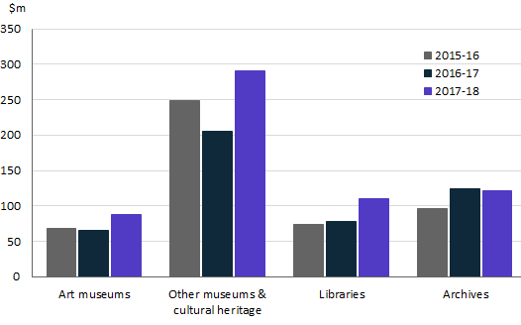

Arts
The majority (77%) of funding by the Australian Government for cultural activities was allocated to Arts activities.
Funds for Arts activities rose 8% (or $153.4m) to $2,063.6m.
The main contributors to this movement were Community arts and cultural development ↑$60.6m, Theatre ↑$41.4m and Performing art venues ↑$27.4m. Conversely, funding for Film and video production and distribution dropped $15.8m.
Figure 2. Australian Government arts expenditure, by selected categories
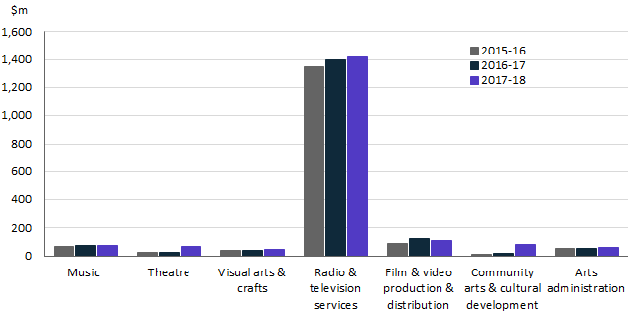
Funding for Radio and television services ($1,418.5m), accounted for over two-thirds (or 69%) of all expenditure by the Australian Government on Arts activities.
Other main categories of Arts activities funding were:
- Film and video production and distribution—$110.9m
- Community arts and cultural development—$80.0m
- Music—$74.8m
- Theatre—$70.3m
- Visual arts and crafts—$50.3m.

Recurrent expenditure
Recurrent expenditure rose 6% (or $122.5m) to $2,307.6m and accounted for 86% of funded cultural expenditure.
The largest recurrent expenditure was for Radio and television services, $1,356.7m, followed by Other museums and cultural heritage ($228.4m).
Other main categories of recurrent expenditure were:
- Archives—$114.6m
- Film and video production and distribution—$110.9m
- Music—$74.3m
- Libraries—$68.6m.
Figure 3. Australian Government recurrent cultural expenditure, by selected categories
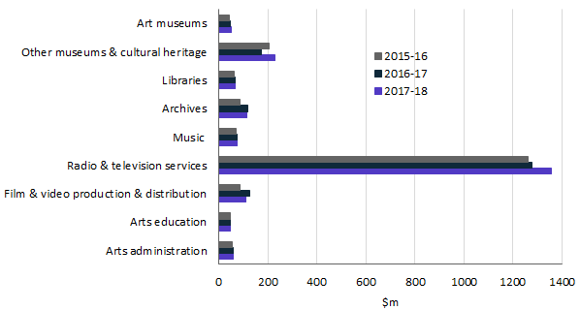

Capital expenditure
Capital expenditure rose 85% (or $168.6m) to $367.2m in 2017-18 and accounted for 14% of Australian Government cultural spending.
The largest capital expenditure was for Community arts and cultural development ($63.9m), followed by Other museums and cultural heritage ($61.9m) and Radio and television services ($61.8m).
Other main categories of capital expenditure were:
- Theatre—$45.6m
- Libraries—$42.2m
- Art museums—$37.2m.
Figure 4. Australian Government capital cultural expenditure, by selected categories
