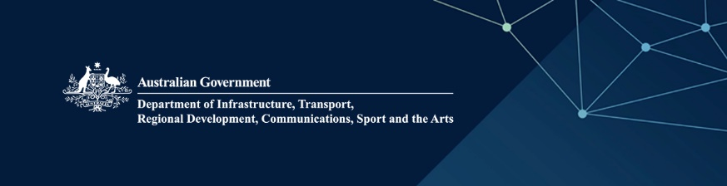

Australian Lending Rights schemes

Australia’s Lending Rights schemes provide compensation for the free multiple use of books in Australian public and educational lending libraries.

For information about the Lending Rights schemes, including how to register for Lending Rights Online and how to make title claims, visit www.arts.gov.au/lendingrights

Check your eligibility
You may be eligible to claim as a creator if you are:
- an author
- an illustrator
- an editor
- a translator
- an individual who has contributed a significant proportion of original content to the whole or part of a book.
You must be an Australian citizen or permanent resident and be entitled to receive ongoing royalties from the sale of your book.
You may be eligible to claim Lending Rights as a publisher if you are a:
- company whose business consists wholly or substantially of publishing books and that regularly publishes in Australia (i.e. at least once in the preceding 3 years)
- not-for-profit organisation that publishes books to further its aims or objectives
- creator who publishes their own books (self-publisher).

Is my book eligible?
Eligible books include printed books, ebooks and audiobooks that:
- have an International Standard Book Number (ISBN)
- been published and offered for sale
- are claimed within 5 years from the year of publication
- have a catalogue record in the Australian National Bibliographic Database (ANBD) or Schools Catalogue Information Service (SCIS)
- have individual creators, not companies or organisations
- are original works protected by copyright and not wholly or substantially created using artificial intelligence.

Title claims
The closing date for new title claims is 31 March each year.
New claimant:
- go to https://lendingrights.arts.gov.au
- register as a new claimant
- receive your claimant number
- lodge your title claims.
Existing claimant:
- go to https://lendingrights.arts.gov.au/SignIn
- sign in using your claimant number and password
- lodge your title claims.
For step-by-step guidance, go to www.arts.gov.au/lendingrights

Title claims processing
Assessment of eligibility:
- title claims are assessed; new books are assigned a Book Reference Number (BRN)
- new and previously existing eligible books are surveyed.

Annual survey process
Public Lending Right (PLR):
- Book scores are estimated based on a survey of public library data.
Educational Lending Right (ELR):
- Book scores are estimated based on a survey of school, university and TAFE library data.
You’ll need a minimum of 50 copies of your book in either survey to qualify for payment.

Annual payments

Annual payment calculation
PLR payment calculations:
- payments are calculated based on estimated book scores from the public library survey.
ELR payment calculations:
- payments are calculated based on estimated book scores from the educational library survey.

Annual notification and payment
- Claimants are notified by post or email in May each year to advise of book scores and if a payment is due
- Payments are deposited into the nominated bank account by 30 June each year.
Remember: you don't need to claim the same titles every year. Only claim new titles or if your book has a new ISBN from a new format or new edition.

Contact us
Lending Rights
Phone: 1800 672 842 during office hours (AEST/AEDT)
Email: lendingrights@arts.gov.au
Web: arts.gov.au/lendingrights
Mail: GPO Box 3241 Canberra ACT 2601
Department of Infrastructure, Transport, Regional Development, Communications, Sport and the Arts

