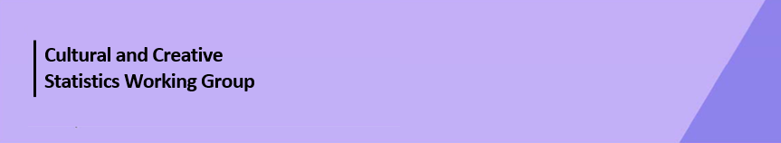

Cultural Funding by Government—2023–24

Australian Capital Territory Government
The estimate of expenditure funded by the Australian Capital Territory (ACT) Government in 2023–24 for cultural activities was $98.5m, representing an increase of 20% or $16.4m from 2021–22.
Table 1. ACT Government cultural expenditure, 2020–21 to 2023–24
2020–21 | 2021–22 | 2023–24
$74.4m | $82.1m ↑10% | $98.5m ↑20%
- Recurrent expenses accounted for 87% ($85.6m) of funded cultural expenditure.
- Capital expenditure was $12.9m, and the largest two categories were Other museums and cultural heritage ($5.2m) and Libraries ($2.4m).
- The estimate of per person funding was $209.62.
Funds for Total Heritage activities (recurrent and capital) rose by 11% (or $4.8m) to $47.4m.
The largest categories of Heritage expenditure were Other museums and cultural heritage with $20.2m and Libraries with $17.6m.
Funds for Archives increased by $4.1m. This is due to the establishment of the Territory Records Office, which has enabled a valuation for archival storage in 2023–24. This was not previously able to be separated from commercial operations.
Figure 1. ACT Government heritage expenditure (recurrent and capital)

Funds for Total Arts activities (recurrent and capital) increased by 29% (or $11.6m) to $51.1m.
This increase was largely attributable to increases in expenditure on Community arts and cultural development (↑$4.4m) and Performing arts venues (↑$3.0m).
Figure 2. ACT Government arts expenditure (recurrent and capital), by selected categories

Performing arts venues ($20.4m) accounted for the largest proportion (40%) of total expenditure on Arts activities.
Other main categories of Arts activities funding were:
- Community arts and cultural development—$6.5m
- Visual arts and crafts—$3.2m
- Arts administration—$3.2m
- Multi-arts festivals—$3.0m
- Design—$2.5m
Total heritage and arts recurrent expenditure increased by 15% (or $11.3m) to $85.6m.
The largest recurrent expenditure was for Performing arts venues ($19.3m) followed by Libraries ($15.2m) and Other museums and cultural heritage ($15.0m).
Figure 3. ACT Government recurrent cultural expenditure, by selected categories

No survey was conducted for 2022–23 due to the move to a biennial collection cycle.
Includes $7.5m targeted cultural and creative sector COVID support funding, reported across categories and totals.
Includes $3.5m targeted cultural and creative sector COVID support funding, reported across categories and totals.
Australian Capital Territory does not have a tier of local government with libraries funded by the ACT Government.

