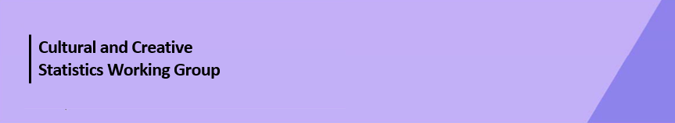

Cultural Funding by Government—2023–24

Northern Territory Government
The estimate of expenditure funded by the Northern Territory Government in 2023–24 for cultural activities was $80.4m, representing an increase of less than 1% or $0.5m from 2021–22.
Table. 1 Northern Territory Government cultural expenditure, 2020–21 to 2023–24
2020–21 | 2021–22 | 2023–24
$77.2m | $79.9m ↑3% | $80.4m ↑<1%
- Recurrent expenses accounted for 91% ($73.0m) of funded cultural expenditure.
- Capital expenditure was $7.3m, and the largest categories were Other museums and cultural heritage ($2.1m) and Art museums ($2.0m).
- The estimate of per person funding was $316.47.
Funds for Total Heritage activities (recurrent and capital) increased 13% (or $5.6m) to $48.0m.
This increase was driven mostly by expenditure on Art museums (↑$9.5m).
The largest categories of Heritage expenditure were Art museums with $31.3m, followed by Other museums and cultural heritage with $9.7m. Expenditure on Art museums was nearly two thirds (65%) of Heritage expenditure by the Northern Territory Government.
Figure 1. Northern Territory Government heritage expenditure (recurrent and capital)

Funds for Total Arts activities (recurrent and capital) dropped 14% (or $5.2m) to $32.3m.
The main contributor to this decrease was Multi-arts festivals ↓$6.9m and Arts administration ↓$4.7m, offset by increases in funding for Other arts ↑$4.2m and Performing arts venues ↑$1.6m.
Figure 2. Northern Territory Government arts expenditure (recurrent and capital), by selected categories

The main categories of Arts activities funding were:
- Multi-arts festivals—$5.6m
- Arts education—$4.7m
- Other arts—$4.3m
- Visual arts and crafts—$3.6m
- Film and video production and distribution—$3.1m
- Arts administration—$2.7m
- Performing arts venues—$2.4m
Total heritage and arts recurrent expenditure increased by less than 1% (or $0.1m) to $73.0m.
The largest recurrent expenditure was for Art museums, $29.3m, followed by Other museums and cultural heritage ($7.6m), Multi-arts festivals ($5.6m) and Libraries ($5.4m).
Figure 3. Northern Territory Government recurrent cultural expenditure, by selected categories⁴

No survey was conducted for 2022–23 due to the move to a biennial collection cycle.
Includes $0.7m targeted cultural and creative sector COVID support funding, reported across categories and totals.
Includes $0.2m targeted cultural and creative sector COVID support funding, reported across categories and totals.
Other arts is defined as Expenditure on the administration, maintenance, operation and construction of arts and cultural activities/services that cannot be assigned to a preceding category.
Value for Performing arts is an aggregate of the following categories: Music, Theatre, Dance, Music theatre and opera, Circus and physical theatre, Comedy, Other performing arts, and Performing arts venues.
Value for Visual arts, crafts & design is an aggregate of the following categories: Visual arts and crafts and Design.

