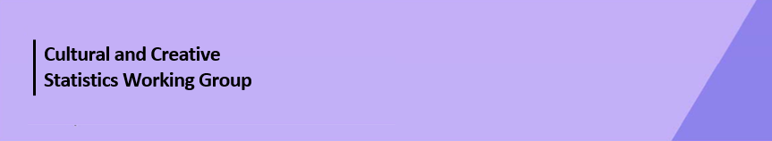

Cultural Funding by Government—2023–24

South Australian Government
The estimate of expenditure funded by the South Australian Government in 2023–24 for cultural activities was $373.7m, representing an increase of 26% or $77.7m from 2021–22.
Table 1. South Australian Government cultural expenditure, 2020–21 to 2023–24
2020–21 | 2021–22 | 2023–24
$233.3m | $296.0 ↑27% | $373.7 ↑26%
- Recurrent expenses accounted for 53% ($199.7m) of funded cultural expenditure.
- Capital expenditure was $174.0m, an increase of 232% ($121.5m) from 2021–22. This variation is due to an increase in Performing arts venues capital expenditure of $132.8m (874%).
- The estimate of per person funding was $200.25.
Funds for Total Heritage activities (recurrent and capital) decreased by 13% (or $15.4m) to $100.5m.
Expenditure decreased in the categories of Other museums and cultural heritage (↓$15.4m) due to a reduction in capital expenditure from 2021–22, Libraries (↓$0.1m) and Archives (↓$0.1m), with a rise in Art museums of $0.3m.
The largest categories of Heritage expenditure were Other museums and cultural heritage with $44.5m, followed by Libraries with $35.0m.
Figure 1. South Australian Government heritage expenditure (recurrent and capital)

Funds for Total Arts activities (recurrent and capital) increased by $93.2m (↑52%) to $273.3m.

The largest increases were in Performing arts venues (↑$102.9m) and Cross-art form (↑$3.6m).

Figure 2. South Australian Government arts expenditure (recurrent and capital), by selected categories

Performing arts venues ($164.3m), accounted for 60% of all funded expenditure by the South Australian Government on Arts activities. However, as noted above, this figure included capital expenditure totalling $148.0m in 2023–24.
Other main categories of Arts activities funding were:
- Multi-arts festivals—$20.0m
- Arts education—$13.2m
- Music—$12.8m
- Cross-art form—$11.2m
- Arts administration—$10.9m.
Total heritage and arts recurrent expenditure decreased 18% or $43.8m from 2021–22.
Recurrent expenditure was largest for Libraries ($34.3m), Other museums and cultural heritage ($33.3m) and Multi-arts festivals ($20.0m).
The largest recurrent dollar increase was for the categories of Cross-art form ↑$3.6m and Other museums and cultural heritage ↑$2.4m, between 2021–22 and 2023–24. The largest decrease in recurrent expenditure was for Performing arts venues (↓$29.9m) and Film and video production and distribution (↓$11.5m).
Figure 3. South Australian Government recurrent cultural expenditure, by selected categories

No survey was conducted for 2022–23 due to the move to a biennial collection cycle.
Includes $14.2m targeted cultural and creative sector COVID support funding, reported across categories and totals.
Includes $11.3m targeted cultural and creative sector COVID support funding, reported across categories and totals.

