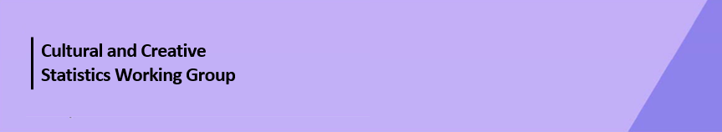

Cultural Funding by Government—2023–24

Western Australian Government
The estimate of expenditure funded by the Western Australian Government in 2023–24 for cultural activities was $376.0m, representing an increase of 7% or $25.9m from 2021–22.
Table 1. Western Australian Government cultural expenditure, 2020–21 to 2023–24
2020–21 | 2021–22 | 2023–24
$294.9m | $350.1m ↑19% | $376.0m ↑7%
- Recurrent expenses accounted for 81% ($306.0m) of funded cultural expenditure.
- Capital expenses accounted for 19% ($70.1m) of funded cultural expenditure. The largest categories were Other museums and cultural heritage ($25.1m) and Film and video production and distribution ($23.3m).
- The estimate of per person funding was $128.39.
Funds for Total Heritage activities (recurrent and capital) decreased by 7% (or $11.9m) to $165.7m.

The largest proportion (65%) of Heritage funds were spent on Other museums and cultural heritage ($108.5m) followed by Libraries (19%, $30.9m), Art museums (15%, $24.9m) and Archives (1%, $1.4m).
Figure 1. Western Australian Government heritage expenditure (recurrent and capital)

Funds for Total Arts activities (recurrent and capital) increased 35% (or $54.2m) to $210.4m.
The main contributors to this increase were Music ↑$8.3m, Visual arts and crafts ↑$10.9m, and Film and video production and distribution ↑$13.0m.
Figure 2. Western Australian Government arts expenditure (recurrent and capital), by selected categories

The main categories of Arts activities funding were:
- Film and video production and distribution—$44.3m
- Performing arts venues—$28.6m
- Multi-arts festivals—$23.4m
- Arts administration—$19.9m
- Visual arts and crafts—$19.8m
- Music—$15.4m
- Community arts and cultural development—$14.3m
- Arts education—$10.1m
- Theatre—$7.7m
Total heritage and arts recurrent expenditure increased 11% (or $31.2m) to $306.0m.
The largest recurrent expenditure was for Other museums and cultural heritage ($83.4m) followed by Libraries ($30.5m), Art museums ($23.9m), Multi-arts festivals ($21.8m) and Performing arts venues ($21.7m).
Figure 3. Western Australian Government recurrent cultural expenditure, by selected categories⁴

No survey was conducted for 2022–23 due to the move to a biennial collection cycle.
Includes $12.1m targeted cultural and creative sector COVID support funding, reported across categories and totals.
Includes $16.8m targeted cultural and creative sector COVID support funding, reported across categories and totals. $16.2m of this expenditure is included in the totals only.
Recurrent and total expenditure in the categories of Performing arts venues and Theatre for 2021–22 has been revised.

