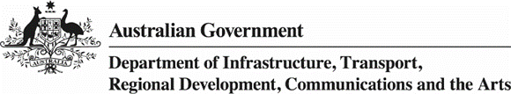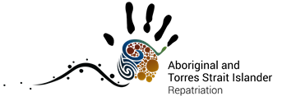

Fact sheet: International repatriation of Aboriginal and Torres Strait Islander ancestors
The Australian Government has supported international repatriation for over 30 years. The repatriation of Aboriginal and Torres Strait Islander ancestral remains (ancestors) is administered by the Department of Infrastructure, Transport, Regional Development, Communications and the Arts (the department).

About international repatriation
The Australian Government is committed to the ongoing work to facilitate the repatriation of ancestors to Australia. The department seeks the voluntary and unconditional return of ancestors held in overseas institutions and with private holders. This requires the collaborative efforts of the department; First Nations people; international collecting institutions and private holders; other Australian Government departments; foreign governments; and Australian and international experts.
“This is some of the most important, respectful work a Government can do.”
Hon. Tony Burke MP, Minister for the Arts

Significance of repatriation
The repatriation of ancestors is a priority for First Nations people. The Australian Government Policy on Indigenous Repatriation acknowledges First Nations people as the rightful custodians of their ancestors. Returning ancestors back to Country helps to promote healing and justice and it acknowledges the injustices of the past providing an opportunity for reconciliation.
“Bringing our ancestor home, touches on our shared pain and our untold histories. For us, it is important that the past is set right for our ancestors.”
Lama Lama People of Yintjingga, Queensland
Where the Traditional Custodians are known, they are closely involved in the repatriation process. When ancestors cannot be identified to community, it is the view of First Nations people that the ancestors are returned to Australia to be cared for closer to home.
“I am happy because I am taking them home, and this feeling I have is coming from their spirit. As we travel home with them I will have the home song going in my mind, I will be singing them home.”
Major Sumner AM, Ngarrindjeri and Kaurna Elder, South Australia

Number of ancestors repatriated
The return of ancestors to their Traditional Custodians is a priority for the Australian Government. To date, the Australian Government has facilitated the repatriation of more than 1,650 ancestors from across nine countries to Australia.
“We all feel quite sad about our ancestor being taken, but want to ensure her repatriation encourages others to return ancestors to Traditional Custodians here in Australia, in the future.”
Tahn Donovan, Wardandi, Western Australia

Further information
To find out more about the repatriation of ancestors from overseas please call 1800 006 992, email repatriation@arts.gov.au or visit www.arts.gov.au/repatriation.

