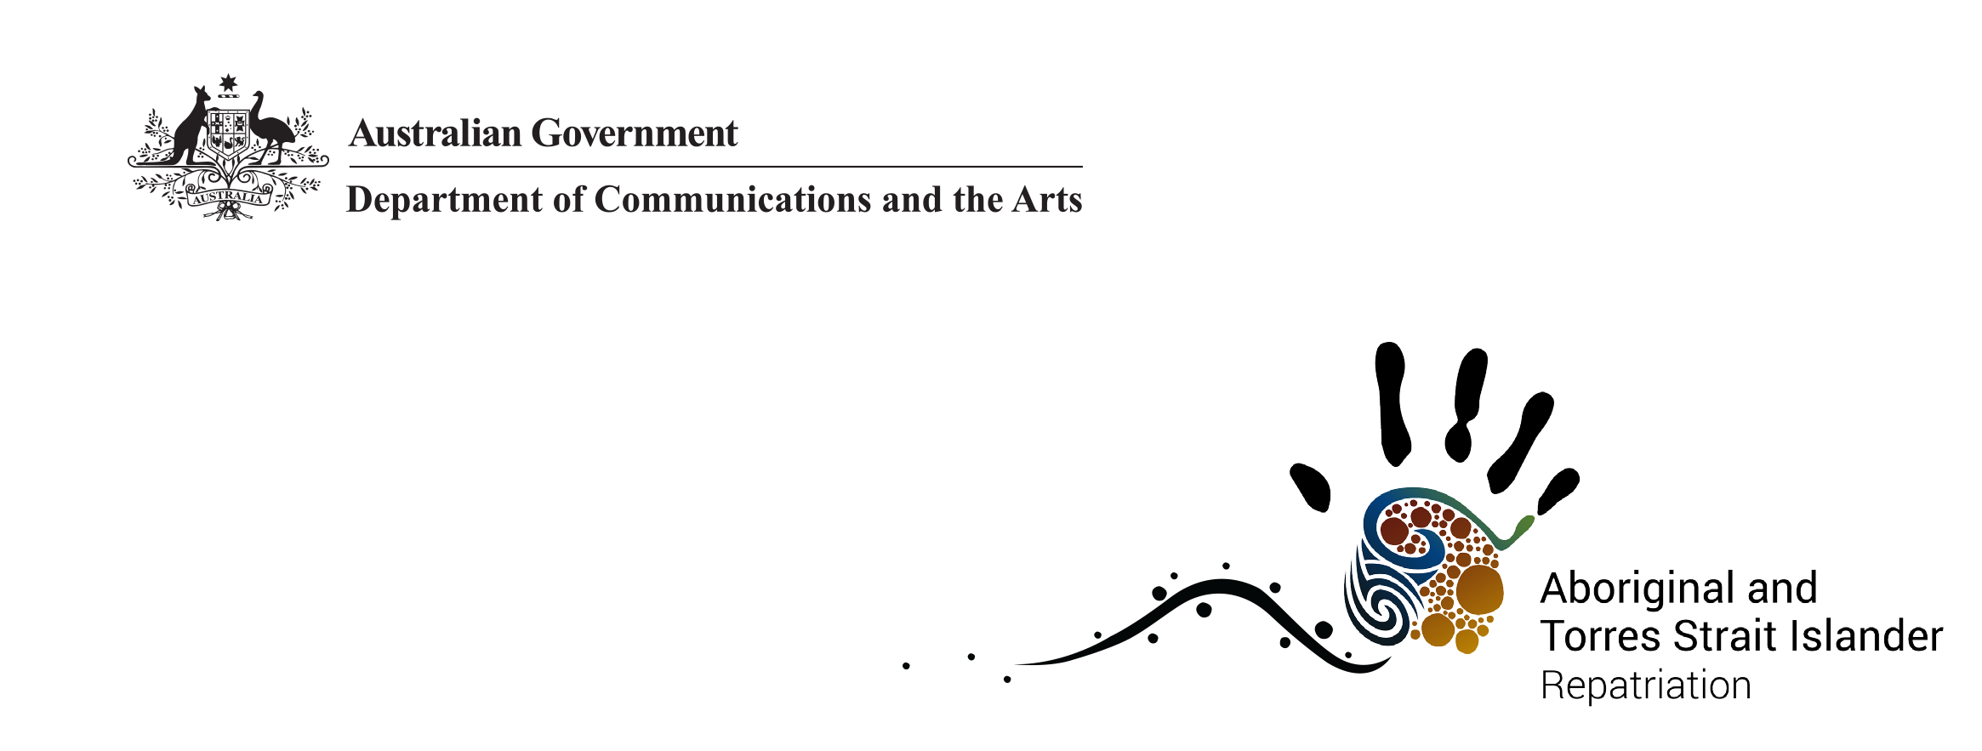

Indigenous Repatriation Program – Prohibition on the Export of Aboriginal and Torres Strait Islander Ancestral Remains and Secret Sacred Objects
For more than 150 years, Aboriginal and Torres Strait Islander ancestral remains were removed by anthropologists, medical officers, anatomists, ethnologists and pastoralists and were taken to museums, universities and private collections in Australia and overseas for ‘scientific’ research linked to explaining human biological differences.
The Australian Government supports the unconditional return of Australian Aboriginal and Torres Strait Islander ancestral remains through the Indigenous Repatriation Program.

Export ban
The Protection of Movable Cultural Heritage Act 1986 regulates the export of a wide range of Australian cultural material or objects. The categories and classes of objects subject to export control are listed in the National Cultural Heritage Control List in Schedule 1 to the Protection of Movable Cultural Heritage Regulations 1987. The Control List establishes two classes of objects: Class A and Class B.
Class A objects cannot be exported under any circumstances and include Aboriginal and Torres Strait Islander ancestral remains, bark and log coffins used as traditional burial objects, and secret sacred objects. This prevents, for example, Aboriginal and Torres Strait Islander ancestral remains being temporarily exported overseas for scientific testing, or any other reason.

Enforcement
It is an offence to either export or attempt to export Class A objects. Punishment may include a fine of up to $210,000 for each offence or imprisonment for up to five years for an individual, and a fine of up to $420,000 for each offence for a corporation. Class A objects that are exported, or seized at Australia’s border to prevent their export, will forfeit to the Commonwealth.

Find out more
More information about the National Cultural Heritage Control List and export of movable cultural heritage is available at arts.gov.au/movable or contact movable.heritage@arts.gov.au or 1800 819 461. More information on the Indigenous Repatriation Program is available at arts.gov.au/repatriation or contact repatriation@arts.gov.au or 1800 006 992.

