# 

# **Indigenous Languages and Arts Program** Fact Sheet

**June 2023**

The Australian Government’s vision is for an Australia where respect for our rich diversity begins with respect for the world’s oldest continuing culture, that of Australia’s First Peoples.

Indigenous languages and arts are integral to the identity, connection with culture and emotional health of Aboriginal and Torres Strait Islander people, and are essential to maintaining the vitality and strength of Indigenous communities.

The *National Agreement on Closing the Gap* now includes a dedicated outcome and a target for Indigenous languages in Australia over the next ten years:

* Aboriginal and Torres Strait Islander cultures and languages are strong, supported and flourishing (Outcome 16)
* By 2031, there is a sustained increase in number and strength of Aboriginal and Torres Strait Islander languages being spoken (Target 16)

Together with the UNESCO *International Decade of Indigenous Languages 2022–2032*, the forthcoming decade will see a greater focus on the conservation, revitalisation and promotion of Indigenous languages and arts in Australia and globally.

To support these major initiatives the Indigenous Languages and Arts program invests over $27 million per annum to assist Aboriginal and Torres Strait Islander peoples to express, conserve and maintain their cultures through languages and arts activities around Australia.

The program includes annual operational funding support to a network of 24 Indigenous Language Centres throughout the country working on conserving, revitalising and sustaining Indigenous languages. The program also supports Aboriginal and Torres Strait Islander peoples to create, promote and celebrate Indigenous cultural expression.

Bundiyarra-Irra Wangga Language Centre Language Expo at Gunnadoo Farm
Talking about language on the airwaves with Radio MAMA.
Bangarra’s Wudjang: Not the Past
Roslyn Packer Theatre photographer Daniel Boud
Augmented Reality Guugu Yimithirr Personal Pronouns Poster
Guugu Yimithirr teacher and student using augmented reality personal pronouns poster


|  |  |  |
| --- | --- | --- |
| Talking about language on the airwaves with Radio MAMA | Bangarra’s Wudjang: Not the Past | Guugu Yimithirr teacher and student using augmented reality poster |

## How is the Indigenous Languages and Arts program helping Indigenous communities?

The ILA program provides grant funding to support the following objectives:

* **Conserve, revitalise and sustain Indigenous languages** by:
  + Supporting the use of spoken language in everyday life by facilitating language practise in a range of contexts through culturally appropriate learning and teaching activities.
  + Supporting community members to improve their language knowledge and skills and build capacity in the sector by providing language learning and teaching pathways that include opportunities to gain formal qualifications in learning and teaching an Indigenous language.
  + Recording, preserving and making available Indigenous languages using digital technology in an innovative and culturally appropriate way.
  + Facilitating the use of Indigenous languages in everyday life by producing and providing access to language materials that enable community to enjoy, learn, use and teach their languages.
* **Create, promote and celebrate Indigenous cultural expression** by:
  + Developing, producing, presenting, exhibiting or performing a diverse range of traditional and contemporary Indigenous art forms which could include dance, theatre, film, literature, music and traditional Indigenous arts and crafts.
  + Promoting and celebrating Indigenous art forms and providing access to arts activities that enable community to enjoy, connect and take pride in their cultures.

## Grant funding opportunities

There is an annual grant opportunity where organisations can submit an application for project funding to deliver community-led Indigenous languages and arts activities. The Indigenous Languages and Arts program guidelines are available on the Australian Government’s GrantConnect website at [www.grants.gov.au](http://www.grants.gov.au).

## Indigenous languages and arts activities

In 2022-23, the ILA program funded around 117 projects that supported a wide variety of community-based Indigenous languages and arts activities, including a network of 24 Indigenous Language Centres throughout the country:

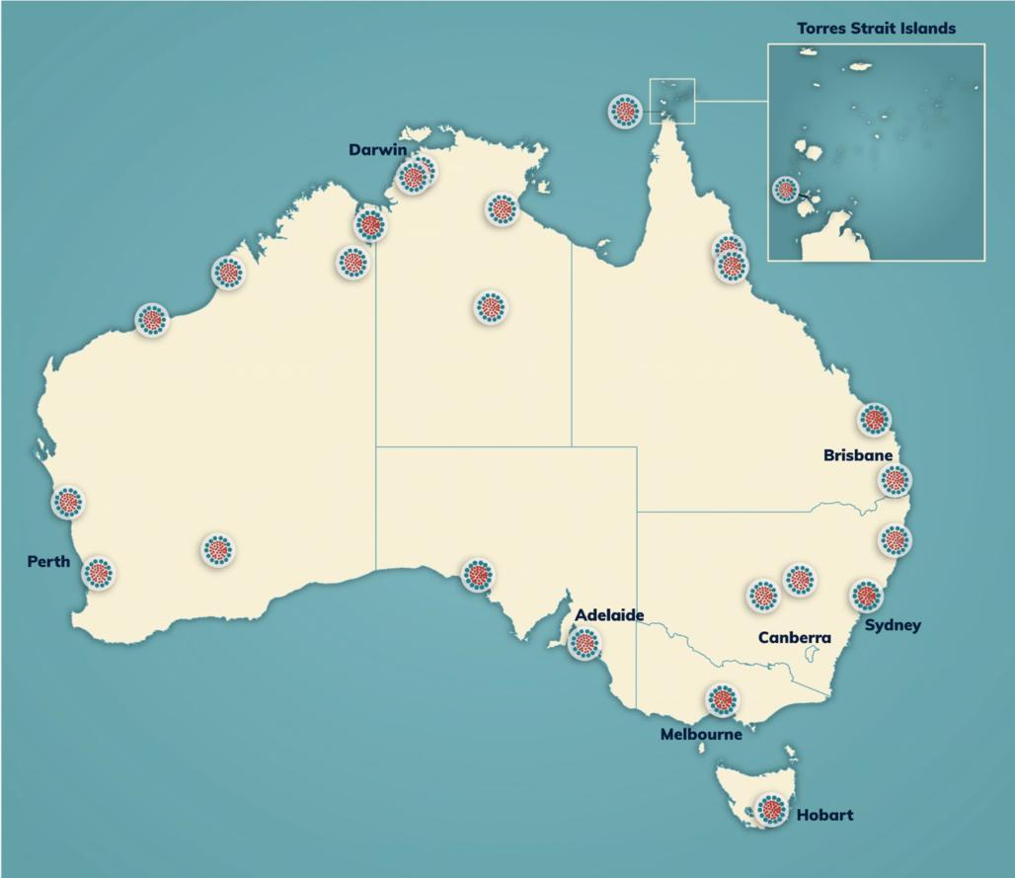

For more information on the ILA program, including location and contact details of the Indigenous Language Centres, you can:

* visit our website at [www.arts.gov.au/ila](http://www.arts.gov.au/ila)
* phone 1800 006 992
* or email [ILA@arts.gov.au](mailto:ILA@arts.gov.au).