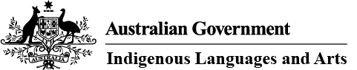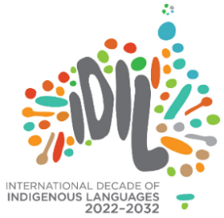

Indigenous Languages and Arts (ILA) Program—fact sheet
December 2025

First Nations languages and arts are integral to the identity, connection with culture and emotional health of Aboriginal and Torres Strait Islander people, and are essential to maintaining the vitality and strength of First Nations communities.
The ILA program will invest over $47 million in 2025–26 to support Aboriginal and Torres Strait Islander Australians to express, conserve and sustain their cultures through First Nations languages and arts activities and strongly aligns with the following Australian Government policies and initiatives:
- National Agreement on Closing the Gap—To learn more about the National Agreement on Closing the Gap and Target 16 specific to increasing and strengthening the number of Aboriginal and Torres Strait Islander languages being spoken, visit National Agreement on Closing the Gap and Target 16.
- Revive: a place for every story, a story for every place (National Cultural Policy)—The Australian Government’s National Cultural Policy: Revive, aims to advance Aboriginal and Torres Strait Islander agency, financial and creative control and provide opportunities for Aboriginal and Torres Strait Islander cultural support for languages and arts – both traditional and contemporary. To learn more, visit Revive: a place for every story, a story for every place.
- Voices of Country – Australia’s Action Plan for the International Decade of Indigenous Languages 2022-2032—Under the action plan, the important role of languages is recognised for its ability to tell stories, maintain and share culture, care for lands and waters, enhance physical and mental wellbeing and to improving social and economic outcomes for Aboriginal and Torres Strait Islander people. To learn more, visit Voices of Country.
- UNESCO’s International Decade of Indigenous Languages (2022-2032)—the Decade highlights a ten-year action plan to draw the world’s attention to the critical loss of Indigenous languages and the urgent need to preserve, revitalise and celebrate them. To learn more, visit International Decade of Indigenous Languages 2022-2032.

How is the ILA program helping First Nations communities?
Grant funding is available for First Nations-led community-based organisations working on conserving, revitalising and sustaining their languages for their community; and to create, promote and celebrate First Nations cultural expression through traditional and modern art forms. The ILA program also provides annual operational funding to First Languages Australia, the peak organisation representing for First Nations languages in Australia; and a network of 25 Indigenous Language Centres throughout Australia.

Annual Grant Opportunity
The ILA program has an annual Open Competitive Grant Opportunity where eligible organisations can apply for project funding to deliver one-off community-led First Nations languages and/or arts activities. The 2026–27 Grant Opportunity is scheduled for February 2026.
The program supports activities that will contribute outcomes to the following objectives:
- Conserve, revitalise and sustain First Nations languages by:
- Supporting the use of spoken language in everyday life by facilitating language transmission and practise in a range of contexts through culturally appropriate learning and teaching activities.
- Supporting community members to improve their language knowledge and skills and build capacity in the sector by providing language learning and teaching pathways that include opportunities to gain formal qualifications in learning and teaching First Nations languages.
- Recording, conserving and making First Nations languages using digital technology in an innovative and culturally appropriate way.
- Facilitating the use of First Nations languages in everyday life by producing and providing access to language materials used in activities that facilitate the transmission of language, enabling community to enjoy, learn, use and teach their languages.
- Create, promote and celebrate Indigenous cultural expression by:
- Developing, producing, presenting, exhibiting or performing a diverse range of traditional and contemporary First Nations art forms which could include dance, theatre, film, literature, music and traditional First Nations arts and crafts.
- Promoting and celebrating First Nations art forms and providing access to arts activities that enable community to enjoy, connect and take pride in their cultures.

ILA program in 2025–26
In 2025–26, the ILA program funded 124 projects supporting a range of community-based First Nations languages and/or arts activities, including the network of 25 Indigenous Language Centres.
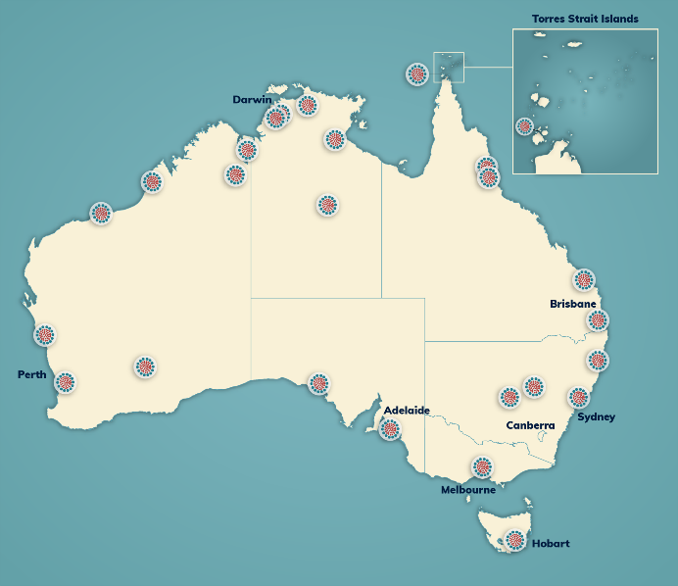
For more information on the ILA program, including location and contact details of the Indigenous Language Centres, you can:
- visit our website at www.arts.gov.au/ila
- visit the Department’s Regional Data Hub at Explore | Regional Data Hub
- phone 1800 006 992
- or email ILA@arts.gov.au.

