

**[Indigenous Languages and Arts program](https://www.arts.gov.au/funding-and-support/indigenous-languages-and-arts-program) language centres list**

**July 2022**

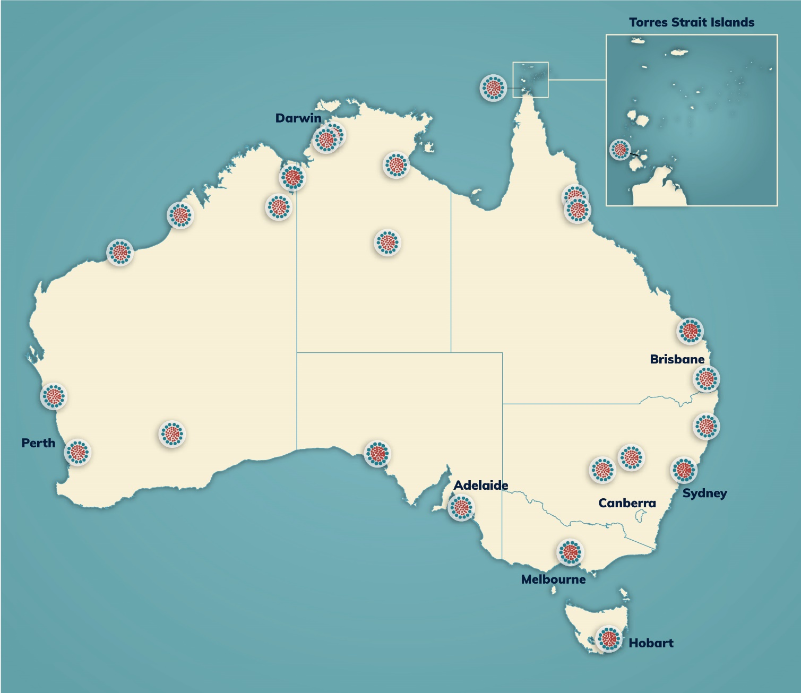

Indigenous Languages and Arts Program – map of Indigenous Language Centre locations

The [Indigenous Languages and Arts (ILA) program](https://www.arts.gov.au/funding-and-support/indigenous-languages-and-arts-program) currently supports a number of organisations, including a network of 24 Indigenous Language Centres.

While these centres are listed here by State, language areas do not align with State borders. As such, some centres physically located in one State could service areas in another State. To see a map depicting Indigenous language areas see the [AIATSIS map of Indigenous Australia.](https://aiatsis.gov.au/explore/articles/aiatsis-map-indigenous-australia)

Note that each of the languages shown here correspond to the relevant language code in the [Australian Indigenous Languages Database (Austlang).](https://collection.aiatsis.gov.au/austlang/search) Through Austlang, you can view more information about the language including its alternate spelling. Access to Austlang is free.

**Language centre list by state**

|  |  |  |
| --- | --- | --- |
| **Language Centre** | **Location** | **Languages** |
| **New South Wales** |  |  |
| [Miromaa Aboriginal Language](http://www.miromaa.org.au/) [and Technology Centre](http://www.miromaa.org.au/)  Also known as Awabakal Cultural Resource Association  Inc. | 840 Hunter St, Newcastle West NSW 2302 | [Awabakal S66](http://austlang.aiatsis.gov.au/main.php?code=S66) |
| [Regional Enterprise](http://redie.org.au/) [Development Institute Ltd](http://redie.org.au/) | Blueridge Business Park, 1 Asset Way, Dubbo NSW 2830 | [Gamilaraay D23,](http://austlang.aiatsis.gov.au/main.php?code=D23) [Yuwaalaraay D27,](http://austlang.aiatsis.gov.au/main.php?code=D27) [Parkantyi/Barkindjl D12,](http://austlang.aiatsis.gov.au/main.php?code=D12) [Ngiyampaa](http://austlang.aiatsis.gov.au/main.php?code=D22)  [Wangaaypuwan D18/D22,](http://austlang.aiatsis.gov.au/main.php?code=D22) [Wayilwan](https://collection.aiatsis.gov.au/austlang/language/d20) [(D20),](https://collection.aiatsis.gov.au/austlang/language/d20) [Muruwari (D32)](https://collection.aiatsis.gov.au/austlang/language/d32) |
| [Muurrbay Aboriginal Language](http://www.muurrbay.org.au/) [& Culture Co-operative Ltd](http://www.muurrbay.org.au/) | 14 Bellwood Rd, Nambucca Heads NSW  2448 | [Gumbaynggirr E7,](http://austlang.aiatsis.gov.au/main.php?code=E7) [Gathang E67*,](http://austlang.aiatsis.gov.au/main.php?code=E67%2A) [Bundjalung E12,](http://austlang.aiatsis.gov.au/main.php?code=E12) [Darkinyung S65,](http://austlang.aiatsis.gov.au/main.php?code=S65)  [Dhanggati E6,](http://austlang.aiatsis.gov.au/main.php?code=E6) [Yaygirr E10](http://austlang.aiatsis.gov.au/main.php?code=E10) |
| [Wiradjuri Condobolin](https://wiradjuricc.com/) [Corporation](https://wiradjuricc.com/) | McDonnell St &  Cunningham St, Condobolin NSW 2877 | [Wiradjuri D10,](http://austlang.aiatsis.gov.au/main.php?code=D10) [Wemba Wemba D1,](http://austlang.aiatsis.gov.au/main.php?code=D1) [Yorta Yorta D2,](http://austlang.aiatsis.gov.au/main.php?code=D2) [Nari Nari D9](http://austlang.aiatsis.gov.au/main.php?code=D9) |
| **Northern Territory** |  |  |
| [Aboriginal Resource and](https://ards.com.au/)  [Development Services (ARDS](https://ards.com.au/) [Aboriginal Corporation)](https://ards.com.au/) | 64 Winnellie Rd,  Winnellie NT 0820 | [Dhuwal N198,](https://collection.aiatsis.gov.au/austlang/language/n198) [Dhangu N192,](https://collection.aiatsis.gov.au/austlang/language/n192) [Dhuwala](https://collection.aiatsis.gov.au/austlang/language/n199)  [N199,](https://collection.aiatsis.gov.au/austlang/language/n199) [Marrangu N116.Q,](https://collection.aiatsis.gov.au/austlang/language/n116_q) [Dhay'yi N118,](https://collection.aiatsis.gov.au/austlang/language/n118) [Djangu N202](https://collection.aiatsis.gov.au/austlang/language/n202) |
| [Batchelor Institute of Indigenous](http://www.batchelor.edu.au/) [Tertiary Education (Batchelor](http://www.batchelor.edu.au/) [NT)](http://www.batchelor.edu.au/) | Cnr Awilla Rd and Nurndina Crescent, Batchelor NT 0845 | [Murrinh-Patha N3,](http://austlang.aiatsis.gov.au/main.php?code=N3) [Marri Ngarr N102,](http://austlang.aiatsis.gov.au/main.php?code=N102) [Marri Amu N162*,](http://austlang.aiatsis.gov.au/main.php?code=N162%2A) [Marri Tjevin N161*,](http://austlang.aiatsis.gov.au/main.php?code=N161%2A) [Magati Ke N163*,](http://austlang.aiatsis.gov.au/main.php?code=N163%2A) [Malak Malak N22,](http://austlang.aiatsis.gov.au/main.php?code=N22) [Ngan’giwumirri N17,](http://austlang.aiatsis.gov.au/main.php?code=N17) [Ngan'gikurunggurr](http://austlang.aiatsis.gov.au/main.php?code=N8) [N8,](http://austlang.aiatsis.gov.au/main.php?code=N8) [Jaminjung N18,](http://austlang.aiatsis.gov.au/main.php?code=N18) [Marrithiel N7,](http://austlang.aiatsis.gov.au/main.php?code=N7) [Matngele N12,](http://austlang.aiatsis.gov.au/main.php?code=N12) [Burarra/Gun-nartpa N82,](http://austlang.aiatsis.gov.au/main.php?code=N82) [Djinang N94.1,](http://austlang.aiatsis.gov.au/main.php?code=N94.1) [Ndjebbana N74,](http://austlang.aiatsis.gov.au/main.php?code=N74) [Nakkara](http://austlang.aiatsis.gov.au/main.php?code=N80) [N80,](http://austlang.aiatsis.gov.au/main.php?code=N80) [Kune N70](http://austlang.aiatsis.gov.au/main.php?code=N70) [Worrorra K17,](http://austlang.aiatsis.gov.au/main.php?code=K17) [Wunumbal K22,](http://austlang.aiatsis.gov.au/main.php?code=K22) [Ngarinyin—Ungarinyin](http://austlang.aiatsis.gov.au/main.php?code=K18) [K18](http://austlang.aiatsis.gov.au/main.php?code=K18) Arrernte C8, Pertame C8, Anmatyerr C8.1, Warlpiri C15, Luritja – Martutjara,  Martuntara C7.1 |
| [Ngukurr Language Centre](https://ngukurrlc.org.au/) [Aboriginal Corporation](https://ngukurrlc.org.au/) | Mutju St, Ngukurr NT 0852 | [Marra N112,](http://austlang.aiatsis.gov.au/main.php?code=N112) [Ritharrnju N104,](http://austlang.aiatsis.gov.au/main.php?code=N104) [Wagilak](http://austlang.aiatsis.gov.au/main.php?code=N106) [N106,](http://austlang.aiatsis.gov.au/main.php?code=N106) [Ngandi N90](http://austlang.aiatsis.gov.au/main.php?code=N90) |
| [Papula Apparr-Kari Aboriginal](http://www.papak.com.au/) [Corporation](http://www.papak.com.au/) | 17 Windley St, Tennant Creek NT 0860 | [Warumungu C18,](http://austlang.aiatsis.gov.au/main.php?code=C18) [Garrwa N155,](http://austlang.aiatsis.gov.au/main.php?code=N155) [Mudburra C25,](http://austlang.aiatsis.gov.au/main.php?code=C25) [Warlmanpa C17,](http://austlang.aiatsis.gov.au/main.php?code=C17) [Alyawarra C14,](http://austlang.aiatsis.gov.au/main.php?code=C14) [Warlpiri C15](http://austlang.aiatsis.gov.au/main.php?code=C15) |

|  |  |  |
| --- | --- | --- |
| **Language Centre** | **Location** | **Languages** |
| **Queensland** |  |  |
| [Cape York Institute](http://www.capeyorkpartnership.org.au/game-changers/cape-york-institute/) | 310 Sheridan St, Cairns North QLD 4870 | [Angkamuthi Y7,](http://austlang.aiatsis.gov.au/main.php?code=Y7) [Mpakwithi Y186*,](http://austlang.aiatsis.gov.au/main.php?code=Y186%2A) [Gudang Y191*,](http://austlang.aiatsis.gov.au/main.php?code=Y191%2A) [Guugu Yimidhrr Y82,](http://austlang.aiatsis.gov.au/main.php?code=Y82) [Wik-Mungkan Y57,](http://austlang.aiatsis.gov.au/main.php?code=Y57) [Wik-ElkenY49,](http://austlang.aiatsis.gov.au/main.php?code=Y49) [Wik-](http://austlang.aiatsis.gov.au/main.php?code=Y51) [Ngadharr Y51,](http://austlang.aiatsis.gov.au/main.php?code=Y51) [Wik-Ngathanya Y56,](http://austlang.aiatsis.gov.au/main.php?code=Y56)  [Olkola Y73.](http://austlang.aiatsis.gov.au/main.php?code=Y73) |
| [Gidarjil Development](http://www.gidarjil.com.au/) [Corporation](http://www.gidarjil.com.au/) | 53 Walker St, Bundaberg South QLD 4670 | [Taribelang (Darpil) E33,](http://austlang.aiatsis.gov.au/main.php?code=E33) [Gureng Gureng](http://austlang.aiatsis.gov.au/main.php?code=E32) [E32,](http://austlang.aiatsis.gov.au/main.php?code=E32) [Bayali E42,](http://austlang.aiatsis.gov.au/main.php?code=E42) [Gangulu E40,](http://austlang.aiatsis.gov.au/main.php?code=E40) [Darumbal](http://austlang.aiatsis.gov.au/main.php?code=E46) [E46,](http://austlang.aiatsis.gov.au/main.php?code=E46) [Mandalgu (Wadja) E65*,](http://austlang.aiatsis.gov.au/main.php?code=E65%2A) [Yiman E31,](http://austlang.aiatsis.gov.au/main.php?code=E31) [Barada E48,](http://austlang.aiatsis.gov.au/main.php?code=E48) [Bidjara E37,](http://austlang.aiatsis.gov.au/main.php?code=E37) [Waka Waka](http://austlang.aiatsis.gov.au/main.php?code=E28)  [E28,](http://austlang.aiatsis.gov.au/main.php?code=E28) [Wadjingu E39.](http://austlang.aiatsis.gov.au/main.php?code=E39) |
| [North Queensland Regional](http://www.nqraclc.com.au/)  [Aboriginal Corporation](http://www.nqraclc.com.au/) [Languages Centre](http://www.nqraclc.com.au/) | 8/446-452 Sheridan St, North Cairns QLD 4870 | [Barada E48,](http://austlang.aiatsis.gov.au/main.php?code=E48) [Barana E53,](http://austlang.aiatsis.gov.au/main.php?code=E53) [Bindal E61,](http://austlang.aiatsis.gov.au/main.php?code=E61) [Biya](http://austlang.aiatsis.gov.au/main.php?code=Y130)  [Y130,](http://austlang.aiatsis.gov.au/main.php?code=Y130) [Tagalaka Y125,](http://austlang.aiatsis.gov.au/main.php?code=Y125) [Wiri E57,](http://austlang.aiatsis.gov.au/main.php?code=E57) [Yirandali](http://austlang.aiatsis.gov.au/main.php?code=L42) [L42,](http://austlang.aiatsis.gov.au/main.php?code=L42) [Djabugay Y106](http://austlang.aiatsis.gov.au/main.php?code=Y106) |
| [Torres Strait Regional Authority](http://www.tsra.gov.au/) | 46 Victoria Parade, Thursday Island QLD  4875 | [Kala Lagaw Ya Y1,](http://austlang.aiatsis.gov.au/main.php?code=Y1) [Meriam Mir Y3](http://austlang.aiatsis.gov.au/main.php?code=Y3) |
| [South East Queensland](https://seqilc.com.au/) [Indigenous Language Centre](https://seqilc.com.au/) | 15 Millennium Cirt,  Helensvale, QLD, 4212 | [Kabi Kabi E29,](http://austlang.aiatsis.gov.au/main.php?code=E29) [Waka Waka E28,](http://austlang.aiatsis.gov.au/main.php?code=E28) [Bidjara](http://austlang.aiatsis.gov.au/main.php?code=E37) [E37,](http://austlang.aiatsis.gov.au/main.php?code=E37) [Gunggari D37,](http://austlang.aiatsis.gov.au/main.php?code=D37) [Yugambeh E17,](http://austlang.aiatsis.gov.au/main.php?code=E17) [Jandai E19,](https://collection.aiatsis.gov.au/austlang/language/e19) [Yuggera E23,](https://collection.aiatsis.gov.au/austlang/language/e23) [Turrbal E86.](https://collection.aiatsis.gov.au/austlang/language/e86)  [Duungidjawu E20](https://collection.aiatsis.gov.au/austlang/language/e20) |
| **South Australia** |  |  |
| [Ceduna Aboriginal Corporation](http://www.cac.asn.au/) [(Ceduna, SA)](http://www.cac.asn.au/) | 39 McKenzie St,  Ceduna SA 5690 | [Wirangu C1,](http://austlang.aiatsis.gov.au/main.php?code=C1) [Gugada/Kokatha C3,](http://austlang.aiatsis.gov.au/main.php?code=C3)  [Mirning A9,](http://austlang.aiatsis.gov.au/main.php?code=A9) [Pitjantjatjara C6,](http://austlang.aiatsis.gov.au/main.php?code=C6) [Yankantjatjara C4](http://austlang.aiatsis.gov.au/main.php?code=C4) |
| [The University of Adelaide—](http://www.mobilelanguageteam.com.au/) [Mobile Language Team](http://www.mobilelanguageteam.com.au/) | Level 6 Schulz Building North Terrace, The University of Adelaide | [Adnyamathanha L10,](http://austlang.aiatsis.gov.au/main.php?code=L10) [Arabana L13,](http://austlang.aiatsis.gov.au/main.php?code=L13) [Barngarla L6,](http://austlang.aiatsis.gov.au/main.php?code=L6) [Diyari L17,](http://austlang.aiatsis.gov.au/main.php?code=L17) [Kuyani L9,](http://austlang.aiatsis.gov.au/main.php?code=L9) [Lower Arrernte C29*,](http://austlang.aiatsis.gov.au/main.php?code=C29%2A) [Narungga L1,](http://austlang.aiatsis.gov.au/main.php?code=L1) [Ngayawang S7,](http://austlang.aiatsis.gov.au/main.php?code=S7) [Nukunu L4,](http://austlang.aiatsis.gov.au/main.php?code=L4) [Wangkangurru L27,](http://austlang.aiatsis.gov.au/main.php?code=L27) [Yirawirung S12,](http://austlang.aiatsis.gov.au/main.php?code=S12)  [Yankunytjatjara C4,](http://austlang.aiatsis.gov.au/main.php?code=C4) [Kaurna L3,](http://austlang.aiatsis.gov.au/main.php?code=L3) Barngarla L6 |
| **Tasmania** |  |  |
| [Tasmanian Aboriginal Centre](http://tacinc.com.au/) [Ltd](http://tacinc.com.au/) | 182 Charles Street  Launceston TAS 7250 | [Palawa Kani T16](https://collection.aiatsis.gov.au/austlang/language/t16) |
| **Western Australia** |  |  |
| [Bundiyarra Irra Wangga](http://www.bundiyarra.com.au/index.php?page=home) [Language Centre](http://www.bundiyarra.com.au/index.php?page=home) | Eastward Rd, Greater Geraldton WA 6530 | [Wajarri A39,](http://austlang.aiatsis.gov.au/main.php?code=A39) [Badimaya A14,](http://austlang.aiatsis.gov.au/main.php?code=A14) [Yinggarda](http://austlang.aiatsis.gov.au/main.php?code=W19)  [W19,](http://austlang.aiatsis.gov.au/main.php?code=W19) [Nhanda W14,](http://austlang.aiatsis.gov.au/main.php?code=W14) [Warriyangka W22,](http://austlang.aiatsis.gov.au/main.php?code=W22) [Malgana W18,](http://austlang.aiatsis.gov.au/main.php?code=W18) [Ngarla A79*.](http://austlang.aiatsis.gov.au/main.php?code=A79%2A) |
| [Kimberley Language Resource](https://klrc.org.au/) [Centre](https://klrc.org.au/) | LOT 158 Terone St, Halls Creek WA 6770 | [Walmajarri A66,](https://collection.aiatsis.gov.au/austlang/language/a66) [Gunin K36,](https://collection.aiatsis.gov.au/austlang/language/k36) [Kukatja A68,](https://collection.aiatsis.gov.au/austlang/language/a68) Gija / Kija K20, [Jaru K12,](https://collection.aiatsis.gov.au/austlang/language/k12) [Nyikina K3,](https://collection.aiatsis.gov.au/austlang/language/k36) [Gooniyandi K6,](https://collection.aiatsis.gov.au/austlang/language/k6) [Bunuba K5](https://collection.aiatsis.gov.au/austlang/language/k5) |
| [Mirima Council Aboriginal](http://www.mirima.org.au/) [Corporation](http://www.mirima.org.au/) | Speargrass Rd, Kununurra WA 6743 | [Miriwoong K29,](http://austlang.aiatsis.gov.au/main.php?code=K29) [Gajerrong K37.1.](http://austlang.aiatsis.gov.au/main.php?code=K37.1) |

|  |  |  |
| --- | --- | --- |
| **Language Centre** | **Location** | **Languages** |
| [Noongar Language Centre](http://www.noongarboodjar.com.au/?v=6cc98ba2045f) | 3/12 Burton St, Cannington WA 6107 | [Nyaki Nyaki A1,](http://austlang.aiatsis.gov.au/main.php?code=A1) [Bibbulman W1,](http://austlang.aiatsis.gov.au/main.php?code=W1) [Yuat](http://austlang.aiatsis.gov.au/main.php?code=W11) [W11,](http://austlang.aiatsis.gov.au/main.php?code=W11) [Wardandi W3,](http://austlang.aiatsis.gov.au/main.php?code=W3) [Kaniyang W4,](http://austlang.aiatsis.gov.au/main.php?code=W4) [Goreng W5,](http://austlang.aiatsis.gov.au/main.php?code=W5) [Pinjarup W6,](http://austlang.aiatsis.gov.au/main.php?code=W6) [Wiilman W7,](http://austlang.aiatsis.gov.au/main.php?code=W7)  [Wadjari W8,](http://austlang.aiatsis.gov.au/main.php?code=W8) [Wajuk W9,](http://austlang.aiatsis.gov.au/main.php?code=W9) [Balardung W10,](http://austlang.aiatsis.gov.au/main.php?code=W10) [Tjapanmay A92*](http://austlang.aiatsis.gov.au/main.php?code=A92%2A) |
| [Nyamba Buru Yawuru Ltd](http://www.yawuru.org.au/?doing_wp_cron=1656380394.3017089366912841796875) | 55 Reid Rd, Cable Beach WA 6726 | [Yawuru K1](https://collection.aiatsis.gov.au/austlang/language/k12) |
| [Goldfields Aboriginal](https://www.wangka.com.au/) [Language Centre](https://www.wangka.com.au/) (Aboriginal Corporation) | 264 Hannan St,  Kalgoorlie WA 6430 | [Ngadju A3,](http://austlang.aiatsis.gov.au/main.php?code=A3) [Ngalia C2,](http://austlang.aiatsis.gov.au/main.php?code=C2) [Tjupan A31,](http://austlang.aiatsis.gov.au/main.php?code=A31) [Kaalamaya A4,](http://austlang.aiatsis.gov.au/main.php?code=A4) Marba (No Austlang Code), Cundeelee Wangka (No Austlang  Code), [Kuwarra A16.](http://austlang.aiatsis.gov.au/main.php?code=A16) |
| [Wangka Maya Pilbara Aboriginal](http://www.wangkamaya.org.au/) [Language Centre (Aboriginal](http://www.wangkamaya.org.au/) [Corporation)](http://www.wangkamaya.org.au/) | Throssell Rd & Hamilton Rd, South Hedland WA 6722 | [Putijarra A54,](http://austlang.aiatsis.gov.au/main.php?code=A54) [Yinhawangka A48,](http://austlang.aiatsis.gov.au/main.php?code=A48) [Ngarla](http://austlang.aiatsis.gov.au/main.php?code=W40) [W40,](http://austlang.aiatsis.gov.au/main.php?code=W40) [Kariyarra W39,](http://austlang.aiatsis.gov.au/main.php?code=W39) [Nyamal A58,](http://austlang.aiatsis.gov.au/main.php?code=A58)  [Manyjilyarra A51.1,](http://austlang.aiatsis.gov.au/main.php?code=A51.1) [Nyangumarta A61,](http://austlang.aiatsis.gov.au/main.php?code=A61) [Martu A6.](http://austlang.aiatsis.gov.au/main.php?code=A6) |
| **Victoria** |  |  |
| [Victorian Aboriginal Corporation for Languages (VACL)](https://www.vacl.org.au/) | 1206/401 Docklands Drive, Docklands VIC 3008 | [Bidawal (S49)](https://collection.aiatsis.gov.au/austlang/language/s49), [Bangerang (S40)](https://collection.aiatsis.gov.au/austlang/language/s40), [Guildjan (S30)](https://collection.aiatsis.gov.au/austlang/language/s30), [Boonwurrung (S35)](https://collection.aiatsis.gov.au/austlang/language/s35), [Gunai/Kurnai (S68)](https://collection.aiatsis.gov.au/austlang/language/s68), [Dhudhuroa (S44),](https://collection.aiatsis.gov.au/austlang/language/s44) [Dja Dja wurrung (S31.1)](https://collection.aiatsis.gov.au/austlang/language/s31_1), [Wathawurrung (S29)](https://collection.aiatsis.gov.au/austlang/language/s29), [Wadi Wadi (D4),](https://collection.aiatsis.gov.au/austlang/language/d4) [Taungurung (S37),](https://collection.aiatsis.gov.au/austlang/language/s37) [Wemba Wemba (D1),](https://collection.aiatsis.gov.au/austlang/search?search_api_views_fulltext=Wemba+Wemba+%28D1%29%2C+&field_centroid_latlon_op=-&field_centroid_latlon=&field_state_territory=All&field_al_status=All) [Wergaia (S17)](https://collection.aiatsis.gov.au/austlang/language/s17), [Woiwurrung (S36)](https://collection.aiatsis.gov.au/austlang/language/s36) |