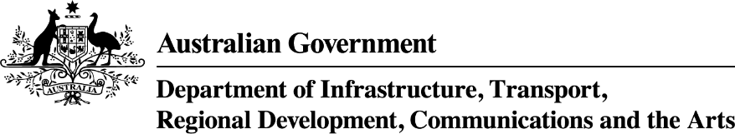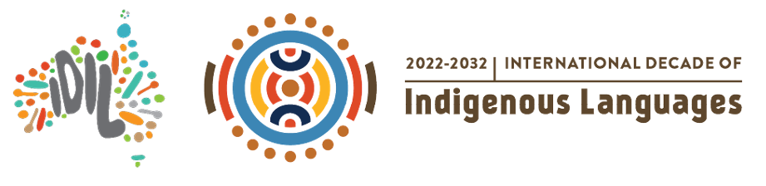

International Decade of Indigenous Languages Directions Group—terms of reference
  - Terms of reference
October 2022

The Australian Government and the Directions Group acknowledges the Traditional Custodians of Country throughout Australia and their continuing connections to land, waters and communities. We pay our respect to Aboriginal and Torres Strait Islander cultures and Elders past, present and future.

Overview
Following the 2019 International Year of Indigenous Languages, UNESCO announced the Decade of Indigenous Languages (International Decade). At an international level Australia is a member of the Global Taskforce for the International Decade. UNESCO released the Global Action Plan for the International Decade in November 2021. It outlines major actions and guidelines on implementation, monitoring and evaluation of activities for the decade.
Australia has committed to the National Agreement on Closing the Gap (Closing the Gap): Target 16; by 2031, there is a sustained increase in number and strength of Aboriginal and Torres Strait Islander languages being spoken, and Aboriginal and Torres Strait Islander Languages Policy Partnership (Clause 38 of Closing the Gap).
Aboriginal and Torres Strait Islander languages are severely endangered and there is a sense of urgency to progress this work. According to the latest National Indigenous Languages Survey (2018-19), there were 123 Aboriginal and Torres Strait Islander languages being spoken, with only 14 considered strong, that is, with fluent speakers across all age groups.
The Australian Government has committed to working in true partnership with Indigenous Australians as part of the Closing the Gap partnership agreement. This means working under the principles of “Nothing for us, without us” and transforming government ways of working to ensure Indigenous voices can be heard and reflected in policies that impact their lives. As part of this commitment, Office for the Arts (OFTA) has established the International Decade of Indigenous Languages Directions Group (Directions Group). Aboriginal and Torres Strait Islander Australians have been at the forefront of work to reawaken and maintain languages following hundreds of years of the devastating impacts of colonisation. The Directions Group have established Cultural Integrity as a core value operating under the principle that work is for the benefit of community and grassroots mob not a tokenistic gesture for Government. The Directions Group represents a true partnership guided by acknowledgement of the need for community led and driven responses to Indigenous language revival.

Vision and values
On the 10–11 May 2022 the Directions Group determined their vision and values to guide their priorities and aspirations. The Directions Group have strongly agreed that benefiting grassroots community voices needs to guide directions to Government.

The Directions Group Vision for Indigenous languages
All Aboriginal and Torres Strait Islander people across Australia have a right to access and use their traditional languages in all aspects of their lives without discrimination.
By 2032 we will have strong Aboriginal and Torres Strait Islander languages across Australia, with no language considered “endangered”. Our languages will be spoken across generations within homes and in the community.
Our languages will be recognised and protected through policy and legislation. Our traditional languages valued, protected and nourished to live and thrive in our families and communities in perpetuity
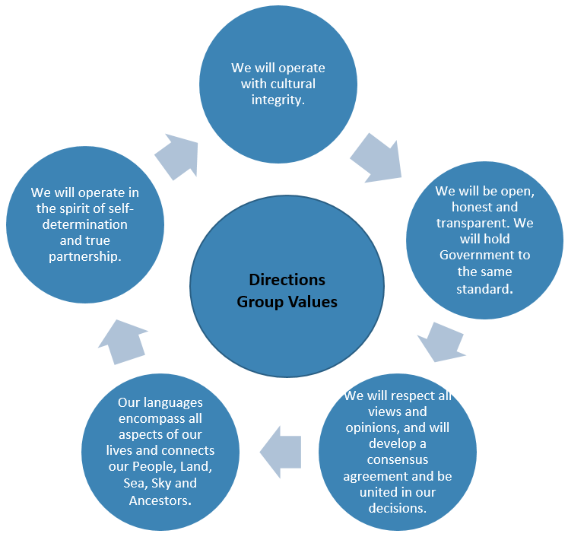

Purpose
- The Directions Group is established to direct the Government’s commitment to the International Decade on Indigenous Languages.
- The overarching principle of the Directions Group is to establish direct dialogue and partnership between Aboriginal and Torres Strait Islander people and decision makers within government, regarding activities to support Aboriginal and Torres Strait Islander languages over the course of the International Decade.
- The Directions Group will provide strategic language policy direction to Australian Government officials, which compliments Closing the Gap.
- The Directions Group is one element of the Government’s support for Aboriginal and Torres Strait Islander languages and is not considered the only form of engagement with Indigenous communities.

Key Activities
- The Directions Group will:
  - Co-author the National Action Plan for the International Decade in partnership with the Australian Government guided by the principle of community and language benefit.
  - Provide policy direction from the perspective of the lived experience of Aboriginal and Torres Strait Islander peoples’ communities, including identifying any cultural sensitivities that may exist in relation to stakeholders, programs or activities for the International Decade.
  - Identify opportunities and partnerships to influence long term and sustained focus on Aboriginal and Torres Strait Islander languages.
  - Share opportunities for engagement and information with Indigenous communities and networks if appropriate and in the interest of the Indigenous community.
  - Engage with government officials, and external members with specialised expertise as required, on priorities for Aboriginal and Torres Strait Islander languages.
  - Act as Champions here to serve for us and by us as Aboriginal and Torres Strait Islander people for languages and the International Decade.
  - Government representatives are ex-officio members and provide input and direction where necessary, and are champions of the Directions Group direction across the Government.
  - Work closely with the Department to provide advice to the Minister for the Arts in supporting Indigenous languages policy and programs.
  - Work with the Department to convene working groups for particular activities, as required.
  - Share stories and information that can be showcased through the International Decade in the spirit of partnership.
  - Develop and release communiques about each meeting.
  - Establish media protocols to facilitate interaction with social media that are based on the principle of respect to Members and the Directions Group.
  - Develop a Glossary of Terms to ensure a shared understanding.
  - Determine the Australian launch of the International Decade.
  - Provide recommendations regarding the Australian logo for the International Decade

Governance
- The Group will be chaired by a representative from First Languages Australia, the peak organisation for Aboriginal and Torres Strait Islander Languages, in their capacity as a representative of the Pacific Region advising the UNESCO Global Taskforce Steering Committee during its first rotation.
- The chair/co-chair will provide updates to the Cross Agency Working Group on the priorities of the Directions Group. The Chair of the Cross Agency Working Group will also provide updates to the Directions Group.
- The appointment of a co-chair will be a decision for the members.
- Secretariat support will be provided by OFTA who is responsible for providing timely and effective organisational support to the Directions Group and the Chair. The Secretariat will operate an action log on behalf of the Directions Group to capture actions to track and resolve crucial policy and implementation issues arising from discussions.

Cultural and Intellectual Property
The Cultural and Intellectual Property of members will be protected in line with Intellectual Property rights standards and guidelines using Terri Janke’s First Languages, Law & Governance Guide and Two Track Protocols outlined below as a guide for how IP issues need to be considered in the context of the cultural knowledge shared by the Directions Group to direct Indigenous languages policy for the International Decade of Indigenous Languages.
- Respect
- Self Determination
- Consent and Consultation
- Interpretation
- Cultural Integrity
- Secrecy and Privacy
- Attribution
- Benefit Sharing
- Maintaining Indigenous Culture
- Recognition and Protection.

Membership
- A voting member must be a person of Aboriginal descent and/or Torres Strait Islander descent, who identifies as Aboriginal and/or Torres Strait Islander and is accepted as such by the community in which they live and/or come from.
- The directions group members are Indigenous language experts across the nation who are well placed to provide a national voice to Indigenous language policy at a national and state level. The Directions Group members have been selected through a merit based process as individuals not as employees of their respective organisations or as representatives of specific language groups or communities. These experiences may need to be reflected upon to inform directions provided to the Commonwealth and members may need to consult networks when required but are not expected to speak on behalf of any languages groups, organisations or Indigenous communities.
- The Directions Group is comprised of up to 17 representatives, including 4 non-voting ex-officio members identified at Attachment A . Other members may be invited to participate, as determined by the Directions Group.
- In the event that a member can no longer participate in the initial twelve months of the membership OFTA & the Directions Group may approach applicants considered highly suitable throughout the Expression of Interest process or run a targeted EOI to ensure a geographical spread of members.
- All meetings must have a minimum of nine voting members (70%) to constitute a Quorum. If an item requires a decision, voting may occur out of session if agreed in writing by the Chair.
- If the Directions Group continues post twelve months, the Directions Group will determine the length of Membership terms and the process to recruit new members.
- Sub-committees to explore specific topics may be established as required. Sub-committees will present their actions and outcomes to the full Directions Group.
- Matters that cannot be agreed will be put through a voting process during meetings with the majority vote to determine the final outcome of the matter.
- Any complaints or disputes should be outlined in writing and provided to the co-chairs who can be reached at any of the below email addresses:
- beau@firstlanguages.org.au
- annalee@firstlanguages.org.au
- IndigenousLanguagesSecretariat@arts.gov.au.
The outcome of complaints/disputes will be at the discretion of the chair/s.
- If a member does not attend three consecutive meetings their membership will be forfeited to the next applicant found highly suitable through the selection process for the same State/Territory or region wherever possible. This does not apply if the co-chairs or secretariat (OFTA) are notified that a member is unwell or required for other family, cultural and/or community obligations.

Remuneration
- Members will be remunerated for official business and travel. Payment is in line with the Remuneration Tribunal (Remuneration and Allowances for Holders of Part-time Public Office) Determination 2021, commenced 1 July 2021, at the rate of “Other office holders”. Travel expenses will be paid at the Tier 2 rate of “Holders of Part-time Public Office” as determined by the Remuneration Tribunal Determination for Official Travel by Office Holders most updated determination.
- If relevant, it is the responsibility of Members to advise current employers of their membership on the Directions Group, and comply with Australian Tax Office requirements as appropriate.

Timeframes
- The Directions Group will meet at least 4 times in 12 months. It is anticipated they will be required to participate in out of session meetings.
  - A minimum of two in person meeting
  - A minimum of two online meetings
- The Directions Group is anticipated to run for 12 months from May 2022 unless otherwise altered.

Limitations
- The Australian Government retains executive powers for final decisions relating to expenditure of public funds. The Department commits to working transparently with the Directions Group to ensure members understand any limitations to shared decision-making, including providing enough information and time for members to understand any implications of decisions taken by government.

Confidentiality and Conflict of Interest
- Members may, on occasion, be provided with confidential material. Any confidential information acquired is to be handled in a secure manner and only used for the purposes of which it was received and without gaining personal advantage or promoting personal interests.
- Members of the Directions Group will ensure that no action or decision is taken that places their own interests ahead of the Group’s. All members will be required to disclose conflicts of interest to the Chair, they will be recorded in meeting minutes and the Chair will make the final decesion if a person must refrain from contributing to discussions on specific issues.
- Members will be required to complete a Deed of Confidentiality form and Conflict of Interest declaration.

Attachment A
Member name | Location | State | Language group
Mr Beau Williams  (Co-Chair) | Broken Hill | NSW | Murrawarri
Ms Annallee Pope  (Co-Chair) | Condon | QLD | Wakka Wakka
Mr Desmond Crump | Yamanto, City of Ipswich | QLD | Gamilaraay
Ms Joyce Bonner | Nikenbah (Fraser Coast Region) | QLD | Butchulla
Mr Phillemon Mosby | Poruma Island (Torres Strait) | QLD | Kulkalgaw Ya
Ms Jillian Mundy | North Hobart | TAS | Pakana
Mr Daryn McKenny | Newcastle | NSW | Gamilaraay
Mr Gawura Wanambi | Darwin | NT | Yolnu Matha
Ms Shania Armstrong | Alice Springs | NT | Pertame (Southern Arrente)
Mr Clayton Cruse | Leigh Creek (Far North Region) | SA | Adnyamathanta
Dr Vicki Couzens | Footscray, Melbourne | VIC | Keerray Wooroong
Ms Lorraine Injie | South Headland (Pilbara Region) | WA | Yinhawangka speaker
Ms Denise Smith-Ali | Belmont, Perth | WA | Noongar

Ex-Officio members
Name | Position | Department/agency
Ms Pauline Halchuk | Director, Indigenous Languages Policy Taskforce | Office for the Arts (OFTA)
Mr Peter Perfrement | First Nations Languages Policy | National Indigenous Affairs Agency (NIAA)
Dr Doug Marmion | Director, Australian Languages Team | Australian Institute of Aboriginal & Torres Strait Islander Studies (AIATSIS)
Ms Bec Allen | Director, Public Diplomacy Programs | Department of Foreign Affairs and Trade (DFAT)

Australian Government Department of Communications and the Arts, Aboriginal and Torres Strait Islander Peoples Protocols Guide, July 2017, pg 5.

