Logo: Australian Government, Department of Infrastructure, Transport, Regional Development and Communications.



www.infrastructure.gov.au
www.communications.gov.au 
www.arts.gov.au


# National Indigenous Visual Arts Action Plan

2021–2025

Ivy Laidlaw at staff sale. Ivy is standing in front of many art works displayed on the walls of the venue.
Image courtesy of the Spinifex Arts Project.

© Commonwealth of Australia 2021  
ISBN 978-1-922521-28-6

1 September 2021 / INFRASTRUCTURE 4648

Ownership of intellectual property rights in this publication

Unless otherwise noted, copyright (and any other intellectual property rights, if any) in this publication is owned by the Commonwealth of Australia (referred to below as the Commonwealth).

Creative Commons licence

With the exception of (a) the Coat of Arms; (b) the Department of Infrastructure, Transport, Regional Development and Communications photos and graphics; copyright in this publication is licensed under a Creative Commons Attribution 4.0 Australia Licence.

Creative Commons Attribution 4.0 Australia Licence is a standard form licence agreement that allows you to copy, communicate and adapt this publication provided that you attribute the work to the Commonwealth and abide by the other licence terms.

Further information on the licence terms is available from <https://creativecommons.org/licenses/by/4.0/>.

This publication should be attributed in the following way: © Commonwealth of Australia 2021.

Contact us

This publication is available in hard copy or PDF format. All other rights are reserved, including in relation to any Departmental logos or trade marks which may exist. For enquiries regarding the licence and any use of this publication, please contact:

Director—Publishing and Communications  
Communication Branch  
Department of Infrastructure, Transport, Regional Development and  
Communications  
GPO Box 594  
Canberra ACT 2601  
Australia

**Email:** [publishing@communications.gov.au](mailto:publishing@communications.gov.au)

**Website:** [www.arts.gov.au](http://www.arts.gov.au/)

**Front cover:** Ivy Laidlaw at staff sale. Image courtesy of the Spinifex Arts Project.

Contents

Foreword by Minister Fletcher 4

Foreword by Minister Wyatt 5

Introduction and Executive Summary 6

The Aboriginal and Torres Strait Islander Visual Arts Industry 7

Where we stand and how we arrived here 8

What the Government is already doing 9

Indigenous Visual Arts Industry Support Program 9

Indigenous Languages and Arts Program 9

Australia Council for the Arts support 10

Response to the 2018 Inquiry Report 10

Support during COVID-19 11

Sector support 11

What you told us 13

Theme 1: Sustainable Growth 13

Theme 2: Capacity Building 14

Theme 3: Access to Market 14

Theme 4: Legal Protections 14

The Action Plan objectives 15

The Actions 16

What does success look like? 19

Case Study 20

What we will deliver 22

Monitoring and Evaluation 31

Appendices 32

Those Consulted 32

Outline of past Indigenous Arts Programs and Reviews 35

## **Foreword**

### Minister Fletcher

**We are privileged to live on a land where Aboriginal and Torres Strait Islander cultures have flourished for 65,000 years. Today, Aboriginal and Torres Strait Islander art enriches the cultural and economic life of Australia and is recognised around the world for its vibrant creativity. It is vitally important that this expression of culture and art continues to thrive for future generations.**

The Australian Government is committed to supporting the Indigenous visual arts industry for its inherent artistic and cultural value; to deliver economic opportunities for Aboriginal and Torres Strait Islander peoples; to promote ethical dealing; and to ensure the sector is able to embrace opportunities for growth and increased stability. We are pleased to provide additional ongoing funding of $5.0 million per year to invest in this National Indigenous Visual Arts Action Plan: 2021-2025. This increases overall support to the Indigenous visual art sector to $27 million each year.

Many Indigenous artists work in some of Australia’s most remote locations. Despite numerous challenges, the Indigenous visual arts industry led by First Nations Australians has demonstrated its adaptability and resilience during the COVID-19 pandemic. It has been impressive to see how the industry has quickly increased its digital presence, with exhibitions, auctions and art fairs going online.

As we continue to live with COVID-19, we are looking to strengthen the sector, protect culture and diversify business models. This will help many Aboriginal and Torres Strait Islander artists, organisations and businesses to grow and will reinforce the ongoing economic viability of this important industry. Respect and flexibility will continue to be key to producing and selling art in a way and at a pace that new markets demand. This brings expanding opportunities for an industry that makes the creativity of the world’s oldest continuing cultures accessible to the world.

Indigenous visual art is integral to Aboriginal and Torres Strait Islander peoples’ identity and is vitally important to Australia and all Australians. It sustains and strengthens Aboriginal and Torres Strait Islander communities, is an important way to express culture, and provides opportunities for employment, skills development and income.

I look forward to seeing the benefits as this five year action plan works to support innovation and expansion in the Indigenous visual arts industry. We will conduct a mid-point assessment of the Action Plan in December 2023 and adjust as needed to continue addressing the most urgent priorities in this dynamic, creative and economic sector.

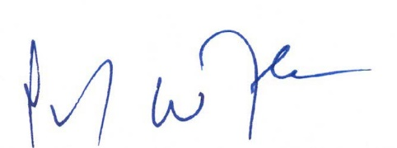

**The Hon Paul Fletcher MP**

Minister for Communications, Urban Infrastructure, Cities and the Arts

## **Foreword**

### Minister Wyatt

**Aboriginal and Torres Strait Islander visual art is a critical element of cultural sustainability for Indigenous Australia. Indigenous artists express their culture, identity and connection to their land and community through art.**

Investing in Indigenous cultures and building the Aboriginal and Torres Strait Islander community controlled sector is a priority for the Australian Government. A thriving Indigenous arts sector safeguards cultural practices and provides significant economic, social and cultural benefits. These benefits extend to Indigenous individuals and communities, and the wider Australian and international community.

I would like to acknowledge my colleague, the Minister for Communications, Urban Infrastructure, Cities and the Arts, the Hon Paul Fletcher MP, for leading the development of this Action Plan.

I also extend my sincere thanks to all who participated in the consultations that made the development of the Action Plan possible. The partnership of artists and the visual arts community has assured that the strategies developed in this Action Plan will contribute to the sustainable growth of our vibrant, unique Indigenous visual art sector.

The Indigenous visual arts sector is one of Australia’s greatest cultural attributes, physically representing and communicating stories from the world’s oldest living cultures. I look forward to seeing it continue to inspire and captivate people all over the world.

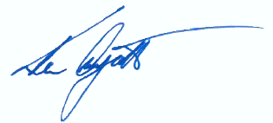

**The Hon Ken Wyatt AM MP**

Minister for Indigenous Australians

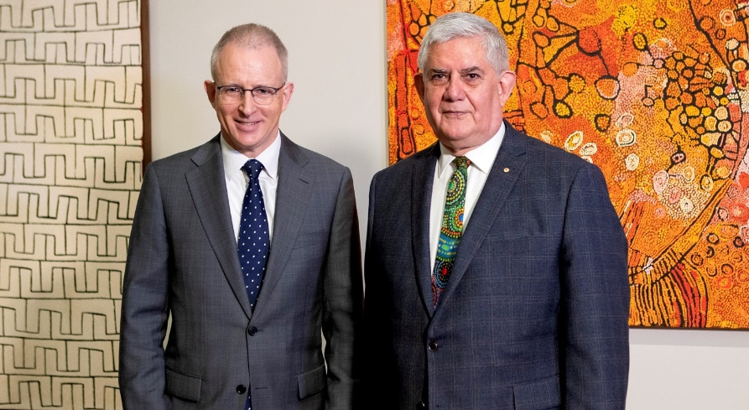

Image: The Hon Paul Fletcher MP (left) and the Hon Ken Wyatt AM MP (right) at the launch of the Growing the Indigenous Visual Arts Industry Consultation, National Gallery of Australia, 2 September 2020. Photo courtesy of National Gallery of Australia.

## Introduction and Executive Summary

#### Executive Summary – A Plan for Action 2021-2025

**Art is an important way for Aboriginal and Torres Strait Islander peoples to document and tell stories, maintain and share culture, promote the understanding of history and connection to Country, and drive economic opportunity.**

The Australian Government recognises that Aboriginal and Torres Strait Islander artists play leading and impactful roles within the global arts sector. We further recognise that the visual arts sector is diverse and that there are distinct and varied priorities and needs across it.

This National Indigenous Visual Arts Action Plan sets the Australian Government’s priorities to support the visual arts sector over the next five years. It will support Aboriginal and Torres Strait Islander artists, organisations and businesses in their ability to direct and decide on their cultural and economic interests, and the evolution of their industry.

In developing this action plan, we consulted widely with artists, art centres, Indigenous visual arts service organisations, commercial galleries, auction houses and state and territory governments (see Appendix 1). This consultation drew out four distinctive themes that have guided the focus of the action plan:

* Encouraging **sustainable growth**
* Prioritising the skills, knowledge and infrastructure needed for **capacity building**
* Recognising the potential for the industry to access **new markets** and encouraging this, and
* Considering how to strengthen the **framework of legal protections** for Indigenous cultural expressions.

For many Aboriginal and Torres Strait Islander artists, organisations and businesses there is an ongoing need to strengthen the sector, protect culture, diversify business models and increase opportunities to generate income.

Through the consultation process we heard that for successful and sustainable outcomes to be achieved for the sector there needs to be increased Aboriginal and Torres Strait Islander representation and voice at all levels in the industry.

This action plan is designed to support these objectives and recognises the challenges faced by the wider Indigenous visual art industry as it responds to the long term effects of the COVID-19 pandemic.

What the Action Plan will achieve over the next five years

The action plan includes ten initiatives to be delivered by the Australian Government over the next five years to grow the Indigenous visual arts industry. These initiatives have a strong focus on building economic opportunities and safeguarding cultural practices in a modern digital environment.

We will:

* Increase investment in: professional and digital capacity in the sector; infrastructure at Indigenous art centres; the promotion of Indigenous art fairs; and innovative projects to expand national and international markets.
* Increase opportunities for independent Indigenous artists who do not have access to support services through an Indigenous visual arts service organisation to gain market and professional development opportunities, in co-operation with arts fairs and other outlets.
* Work with NBN Co to improve access to digital infrastructure by Indigenous art centres.
* Support the increased professionalisation of the Indigenous visual arts industry by increasing knowledge of governance and financial administration, capacity to engage with philanthropy and access to business skills development.
* Fund the national rollout of digital labelling for artworks and products to support the market for Indigenous visual art created in Indigenous art centres.
* Promote the importance of ethically produced and authentic Indigenous art and related cultural tourism, particularly for the domestic tourism market.
* Promote Indigenous art internationally through Australia’s diplomatic posts and increase opportunities for cultural exchanges.
* Strengthen protections for Indigenous culture by working with Indigenous communities to consider the viability of certification trademarks (CTM) and the feasibility of new stand-alone legislation.
* Encourage an ethical marketplace that values authentic Indigenous artwork and products by supporting the Indigenous Art Code and assessing its outcomes.
* Expand the resale royalty right and financial returns for visual artists by seeking international reciprocal arrangements under the Resale Royalty Right for Visual Artists Act 2009.

## The Aboriginal and Torres Strait Islander Visual Arts Industry

**Australian Indigenous visual art is internationally recognised and sought after for its quality, innovation and cultural richness. Many Aboriginal and Torres Strait Islander artists have won critical acclaim and contemporary Indigenous art is represented in major public and private collections in Australia and overseas.**

Today, the industry is made up of a strong framework of art centres, commercial galleries, auction houses, wholesalers, art dealers, independent artists and designers working in a range of ways, including being represented by agents or commercial galleries, contracted as designers or operating as sole traders. Indigenous art centres not only support artists to create, exhibit and sell art work, they provide a valuable training ground for arts workers and arts administrators. Art centres are supported by service organisations that provide support ranging from advocacy to recruitment and professional development.

Importantly, many of the institutions involved, including art centres and service organisations, are led by Aboriginal and Torres Strait Islander people across roles including Chief Executive, Board Member, centre manager and arts workers. Independent artists and designers amplify their creative skills and cultural knowledge with business skills and entrepreneurship.

Artists and art centres are now essential contributors to important social and health initiatives on Country, strengthening community outcomes and investing in their communities’ futures. Many Aboriginal and Torres Strait Islander artists are also investing money earnt through their art back into their communities. This cycle contributes towards generating a sustainable sector in urban, regional and remote Australia and is creating the next generation of artists and art workers.

Indigenous art centres provide a useful gauge of the health of the whole sector. Until the COVID-19 pandemic, art centre sales had been growing for almost a decade. Between 2011-12 and 2018-19, the average sales of Indigenous art centres grew by 53.4 per cent.

This is still 11.7 per cent lower than at the market’s peak in 2007-08, before the Global Financial Crisis, which caused a drop in sales of work by Aboriginal and Torres Strait Islander artists. Today art centres are more financially independent, and the proportion of income from grants has fallen to its lowest level for over a decade at around 40 per cent of total average income.

The COVID-19 pandemic had an immediate impact on the Indigenous art sector. Desart Incorporated has documented that in the period after national lockdowns began, from 16 March to 30 June 2020, sales through Indigenous art centres fell by an average of 30 percent as compared to the same period in 2019. This was accompanied by a significant reduction in the number of artists who were active and the number of artworks produced. The impact remained significant, but eased to an 8 percent fall in sales in the period from 1 July to 31 December 2020. Many businesses and art centres have had to adapt to survive in this changing environment, including increasing their online presence and use of electronic commerce.

## Where we stand and how we arrived here

**The Australian Government has actively supported Aboriginal and Torres Strait Islander visual artists since the early 1970s. This sustained investment has evolved over the decades and has stood alongside work by state and territory governments to support Indigenous cultural and artistic expression.**

Through this action plan we are continuing our commitment to listen to the Indigenous visual arts industry and respond to the concerns and needs of its stakeholders. The action plan comes at a time when the uncertainty in the sector is matched by the potential opportunities. The action plan seeks to support the sector to take advantage of opportunities and navigate the challenges and sets out what the Government will do so that, with the sector, we can work together for better outcomes for the whole industry.

Key events in the past five years have also informed the direction of the plan. The action plan follows on from the work of the 2017 House of Representatives Standing Committee on Indigenous Affairs inquiry into the growing presence of inauthentic Aboriginal and Torres Strait Islander ‘style’ art and craft products and merchandise for sale across Australia. That inquiry arose in relation to the Fake Art Harms Culture Campaign, initiated in mid-2016 by the Indigenous Art Code, Copyright Agency and Arts Law Centre of Australia, which highlighted the prevalence of inauthentic products, particularly at the tourist or lower end of the market.

In response to the inquiry’s 2018 *Report on the impact of inauthentic art and craft in the style of First Nations peoples*, the Australian Government agreed to a number of recommendations, as outlined under the heading ‘What the Government is already doing’. Concurrent with the government response, in September 2020, a consultation paper was released on Growing the Indigenous Visual Arts Industry, seeking feedback from the sector to inform the development of this action plan.

## What the Government is already doing

**The Australian Government recognises that art is an important way for Aboriginal and Torres Strait Islander peoples to document and tell stories, maintain and share culture, promote the understanding of history and connection to Country, build community and drive economic opportunity.**

Given this importance, the Australian Government commits to support the practice and successful growth of Indigenous visual art, while safeguarding the cultural and economic interests of artists and their communities.

The Australian Government delivers significant support to the sector through a number of programs.

### Indigenous Visual Arts Industry Support Program

The Indigenous Visual Arts Industry Support program (IVAIS) helps fund the operations of around 80 Indigenous-led art centres, and a number of Indigenous art fairs, regional hubs and industry service organisations that are at the heart of Australia’s world-famous Indigenous visual art movement.

* The IVAIS program now provides approximately $27 million per annum to around 80 Indigenous-owned art centres and several Indigenous art fairs.
* This provides opportunities for approximately 8,000 Aboriginal and Torres Strait Islander artists and more than 500 Aboriginal and Torres Strait Islander arts workers.
* The IVAIS program also funds five service organisations that support artists and art centres. The service organisations work to raise professional and ethical standards across the industry. They are: Desart Inc.; Arnhem Northern and Kimberley Artists Aboriginal Corporation (ANKA); Indigenous Art Centre Alliance Incorporated (IACA); Ananguku Arts and Cultural Aboriginal Corporation (Ku Arts); and Aboriginal Art Centre Hub of Western Australia Aboriginal Corporation (AACHWA).

### Indigenous Languages and Arts Program

The Indigenous Languages and Arts (ILA) program supports Aboriginal and Torres Strait Islander peoples to express, preserve and maintain their cultures through languages and arts activities around Australia.

* The ILA program invests around $20 million per year to support Aboriginal and Torres Strait Islander peoples to express, preserve and maintain their cultures through languages and arts activities around Australia.
* The ILA program includes operational funding support to a network of 20 Indigenous Language Centres around the country working on capturing, preserving and maintaining Aboriginal and Torres Strait Islander languages.
* The ILA program also supports Aboriginal and Torres Strait Islander peoples to develop, produce, present, exhibit or perform Indigenous arts projects that showcase Australia’s traditional and contemporary Indigenous cultural and artistic expressions.

### Australia Council for the Arts support

The Australia Council for the Arts regards Aboriginal and Torres Strait Islander cultures as living forces with their own strengths and influences, not as remnants of the past. It aims to make these cultural expressions of Aboriginal and Torres Strait Islander people a source of pride for all Australians through funding, support and recognition.

* Australian Government funding delivered through the Australia Council supports Indigenous visual artists as well as Indigenous visual arts organisations, including industry bodies, art centres, galleries, festivals and cultural organisations.
* The Australia Council delivers the First Nations Arts Awards, including the prestigious Red Ochre Award recognising a senior male and senior female Aboriginal and Torres Strait Islander person for outstanding lifetime achievement in the arts.
* The Australia Council provides information on Indigenous cultural protocols through the *Protocols for using First Nations cultural and intellectual property in the Arts*. These protocols provide 10 key principles on ethical engagement and collaboration with First Nations artists and communities by the arts and cultural sector. The Australia Council is currently developing a range of accessible formats to support the communication and update of the protocols.
* The Australia Council has a dedicated First Nations Strategy Panel and First Nations team, providing self-determined leadership and investment in Indigenous visual arts.
* Australia Council funded organisations receive ongoing support and access to advice on best practice in management, governance and program delivery through dedicated Multi-Year Investment Managers as well as the Council’s Business Analysis team.
* The Australia Council supports research to advocate for the public value of First Nations Arts, including domestic arts tourism highlighting the power of First Nations arts to engage domestic tourists and address the effects of COVID-19 on First Nations arts and culture.

The Australia Council’s knowledge of the Indigenous arts sector will play an integral role in delivering the action plan and supporting investment in Aboriginal and Torres Strait Islander artists and arts organisations in remote and regional locations, as well as urban Australia.

### Response to the 2018 Inquiry Report

**The Australian Government’s response to the House of Representatives Standing Committee on Indigenous Affairs’ 2018 Report on the Impact of Inauthentic Art and Craft in the style of First Nations peoples outlines actions to protect Aboriginal and Torres Strait Islander artists’ economic, cultural, and intellectual property interests and encourage a fair and ethical marketplace.**

The Government committed to pursue a Productivity Commission study and to scope legislation to protect Indigenous intellectual property, as well as examining the value of a certification trade mark.

The Government, along with state and territory governments, has already provided additional funding to the Indigenous Art Code, starting in 2018-19, to substantially increase the Code’s capacity to support Aboriginal and Torres Strait Islander artists and arts organisations.

In addition, Desart Incorporated has been funded to undertake a 12 month trial of the use of digital product labelling. The trial started on 1 July 2019 with three Indigenous-owned art centres in Western Australia, the Northern Territory and Far North Queensland. The digital labels use QR Codes to provide consumers with access to information about the artist and artwork, including where it is from and the artist’s story for the art work.

The Government has consulted on terms of reference for a Productivity Commission study into the value, nature and structure of the markets for Aboriginal and Torres Strait Islander arts and crafts and policies to address deficiencies in the markets. The study will address issues across domestic and international markets, authentic and inauthentic products, and impacts of barriers and deficiencies in markets, as well as possible policy responses for government. To support this work the Government is undertaking research into the economic and social impact of Indigenous visual arts markets in a domestic and international context, using the expertise of Deloitte Touche Tohmatsu to support the Productivity Commission and further policy work in the sector. The Productivity Commission study is expected to commence in 2021 and conclude in 2022.

### Support during COVID-19

**In response to the COVID-19 pandemic, on 9 April 2020 the Australian Government announced an additional $7 million to assist Indigenous art centres and art fairs funded through the Indigenous Visual Arts Industry Support program so that they are well-placed to re-enter and build the market following the COVID-19 pandemic.**

In May 2021, a further $5 million funding was provided to Indigenous art centres and art fairs, taking the total Relief and Recovery Funding to the Indigenous Visual art sector to $12 million, in addition to IVAIS and other funding.

### Sector support

The Australian Government funds initiatives that directly support the promotion and protection of the sector:

* The Arts Law Centre of Australia is supported for its Artists in the Black program, a specialised legal service for Aboriginal and Torres Strait Islander artists, communities and arts organisations.
* The Indigenous Art Code receives operational support for its work to promote ethical trading and action in relation to inauthentic Indigenous ‘style’ products.
* The *Resale Royalty Right for Visual Artists* Scheme was introduced in 2010, giving visual artists five per cent of the price of eligible artworks resold commercially for $1,000 or more. To date, 65 per cent of artists benefiting from the scheme are Aboriginal and Torres Strait Islander people who have received 38 per cent of the royalties by value.
* The Visions of Australia regional exhibition development and touring program provides funding to eligible recipients from a broad range of cultural organisations across Australia including large National Collecting Institutions, regional museums and galleries, and Indigenous arts centres. Since 2015, the Visions program has funded 28 projects that focus on Aboriginal and Torres Strait Islander history, art and culture with a total investment of $946,540.
* The National Collecting Institutions have a long history of promoting the Indigenous visual art sector and the rights of Aboriginal and Torres Strait Islander artists. They support the sector by collecting, commissioning and displaying works of Aboriginal and Torres Strait Islander art and culture, employing specialist Indigenous art and museum workers, collaborating with Indigenous artists, and developing Indigenous exhibitions and programs that tour across Australia, and internationally. The National Collecting Institutions demonstrate the value of industry standards to safeguard the rights of Indigenous Australian artists, including through the implementation of protocols and best practice approaches such as the Indigenous Australian Art Charter of Principles for Publicly Funded Collecting Institutions.
* The National Collecting Institutions Touring and Outreach (NCITO) program provides $1 million annually to support eligible National Collecting Institutions to develop and tour exhibitions of cultural material within Australia, especially to regional communities. It also helps tour Australian works overseas. Since it began in 2009-10, approximately 20 per cent of NCITO funding has supported Indigenous visual arts projects, encompassing 12 exhibitions that toured to more than 35 Australian and two international venues.
* Artbank continues to grow its Indigenous art collection and promote it internationally, particularly through Australian Government overseas posts.

The Australian Government will continue to coordinate support for the Indigenous visual art sector across government, including working with state and territory governments to target actions, reducing duplication and gaps in support to the sector. Further, this support will complement actions under the National Agreement on Closing the Gap, in which all levels of Australian government and Indigenous Peak Organisations agreed to a target that Aboriginal and Torres Strait Islander cultures and languages are strong, supported and flourishing.

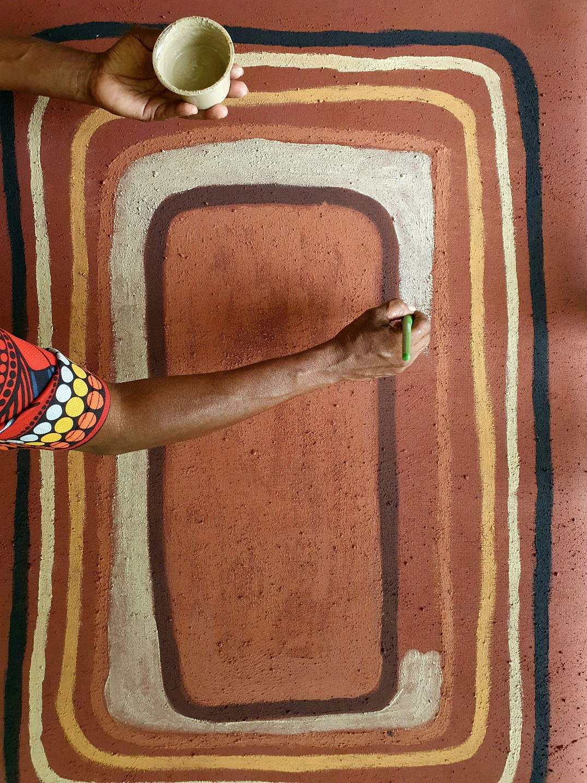

Image: Artist Anne Nunn painting her Kunjuri (shield), at an earth pigment workshop, 2021 held at Bana Yirriji Art Centre. In this workshop the artists experimented with mixing paint made from locally collected and prepared earth pigments. Image: Copyright Bana Yirriji Art Centre, Edwina Circuitt.

## What you told us

**In September 2020, the Australian Government released a consultation paper, titled *Growing the Indigenous Visual Arts Industry*. As well as taking submissions, the Government conducted roundtable discussions and accepted survey responses. Here is a summary of what you told us.**

### Theme 1: Sustainable Growth

Indigenous cultures and artistic expressions are interconnected and can be leveraged to support better economic and social outcomes for Aboriginal and Torres Strait Islander peoples. Advancing the industry in a sustainable manner needs increased Indigenous representation and voice.

Professional Aboriginal and Torres Strait Islander visual artists should have access to support regardless of how and where they practice their art. Investment in people such as training and career pathway development for artists and the arts workforce is vital to support current practitioners and the next generation.

Increasing availability of information on how to navigate and be part of an ethical market is also important. Key considerations include expanding artist access to information on their rights and increasing consumer awareness on how to support ethical practices.

Understanding funding opportunities, both what is available and how to make the most of them, is important to increasing growth in the sector.

### Theme 2: Capacity Building

Skills training and professional development for the industry’s artists and workforce is central to building capacity in the sector. Key areas of development are increasing the delivery of training for artists and arts workers in art centres. For independent artists assistance is needed to access skills development, professional pathways and establish relationships with commercial galleries. The benefits of more involvement from the collections sector in capacity building is also important.

The leadership of Indigenous people is a significant feature of the Indigenous visual arts industry, however, there is more to be done and opportunity to develop the governance skills and experience that will provide the capacity and choice for Indigenous people to take up leadership roles in all aspects of the sector.

The industry needs to adapt to the opportunities presented by an increasingly digital world and be open to the potential offered by the domestic and international tourism markets.

### Theme 3: Access to Market

Greater promotion of ethical practices for both consumers and the supply chain was identified in the consultations as the most pressing need in expanding access to markets.

Increasing the industry’s digital capabilities and resourcing will increase access to markets. In order to respond to increasingly online ways of doing business, the industry needs to increase digital infrastructure, connectivity and implement necessary technology upgrades. More online skills training and opportunities are needed to deepen social media and marketing skillsets.

The industry seeks support to expand in domestic and international markets, including through promotions to create greater appreciation of Aboriginal and Torres Strait Islander art and culture and a more deeply connected consumer base.

Physical and online arts fairs offer a significant opportunity for artists and the industry to grow. Those that facilitate art fairs indicated that, in responding to growth, the industry would need to increase resourcing to meet the new strains of demand.

Devices such as a certification trade mark or labelling scheme may help boost market confidence. Further consultation and investigation is needed to explore how such a system would work and how to avoid creating an undesirable burden on artists or art centres.

### Theme 4: Legal Protections

It is vitally important that Aboriginal and Torres Strait Islander artists have readily available access to resources, advice and support to make informed decisions about their work, regardless of how or where they practice their profession. The current work that Arts Law and the Indigenous Art Code do in this area is valued by the industry.

There is support for reciprocal international arrangements in the Resale Royalty Scheme for visual artists given increasing international sales being made online. There is also some support for greater inspection powers for the collecting society.

Some industry representatives call for robust protections mechanisms with the powers of enforcement, such as a mandatory Indigenous art code.

Many submissions indicated the need for further exploration of potential models for legislation to protect Indigenous Cultural and Intellectual Property. Some submissions, including collections representatives, outlined the complexities of Indigenous Cultural and Intellectual Property laws and that all changes to existing laws would need due consideration.

## The Action Plan objectives

Through this action plan, the Australian Government is seeking to support a professional, viable and ethical Indigenous arts industry based on strong participation and economic opportunities for Aboriginal and Torres Strait Islander peoples. A successful industry will see the continued production, exhibition, purchase and collection of Indigenous visual art.

The action plan contributes towards the *Closing the Gap* targets and outcomes and acknowledges the ongoing strength and resilience of Aboriginal and Torres Strait Islander people in sustaining the world’s oldest living cultures. Increased employment, career pathways and training opportunities are provided concurrently with support to ensure Aboriginal and Torres Strait Islander cultures and languages continue to be strong and flourishing.

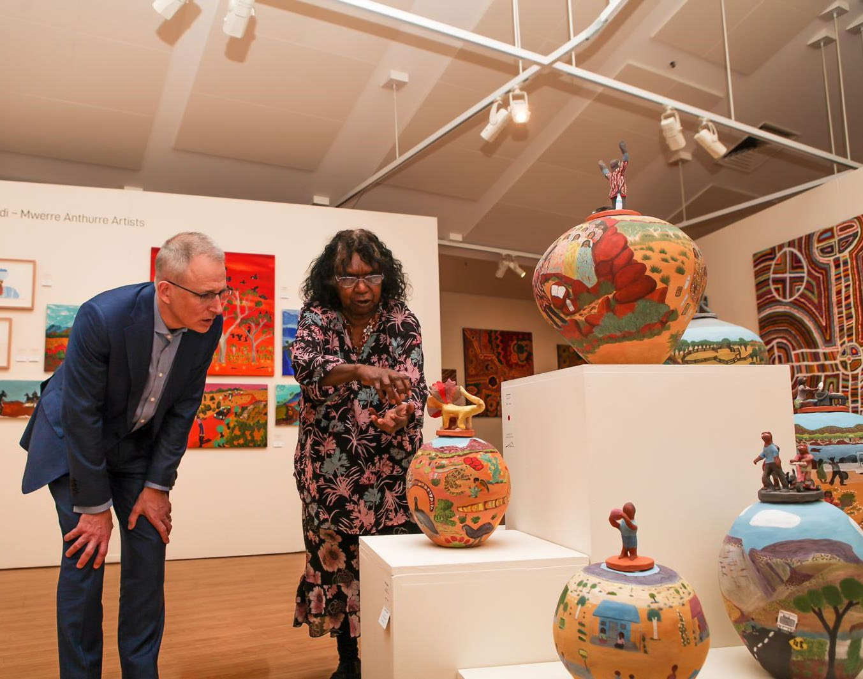

Image: Paul Fletcher and Judith Inkamala from Hermannsburg Potters at the Desert Mob Exhibition, Alice Springs, September 2019. Photo: Minister Fletcher’s Office.

## The Actions

#### Action 1

We are increasing investment in core infrastructure that will support Aboriginal and Torres Strait Islander artists to produce new art, generate income, develop professional skills and connect to the commercial art market, including through partnerships with dealers and galleries, online sales and marketing.

By doing this, we are encouraging innovation, sustainability and new markets for Indigenous visual artwork, in Australia and internationally. We are also increasing employment and professional development opportunities for Indigenous artists and arts workers.

We will:

* Build the capacity of up to 40 Indigenous art centres to operate effectively in regional and remote locations by investing to attract and retain professionally qualified staff including art centre managers, new Indigenous arts workers and studio manager positions.
* Improve the amenity and working conditions of Indigenous art centres by investing in up to 20 urgent capital infrastructure projects each year. This includes supporting basic upgrades for Indigenous art centres such as: equipping art studios, creating storage and exhibition spaces; providing enhanced office and administrative facilities; and, in some instances, improving accommodation and visitor facilities to attract tourism.
* Invest in Indigenous visual art fairs to attract more Australian tourists and reach to international tourists in the future, thereby increasing economic returns to artists and broader regional Indigenous arts tourism.
* Support up to 10 innovative projects each year to increase access for Aboriginal and Torres Strait Islander artists to national and international markets. This may include access to exhibitions that travel internationally and projects that connect buyers with Indigenous art to build on the online market opportunities established during COVID-19.
* Invest in up to 20 projects each year to increase digital literacy and infrastructure in art centres and art fairs through training, information technology infrastructure and improved online platforms.

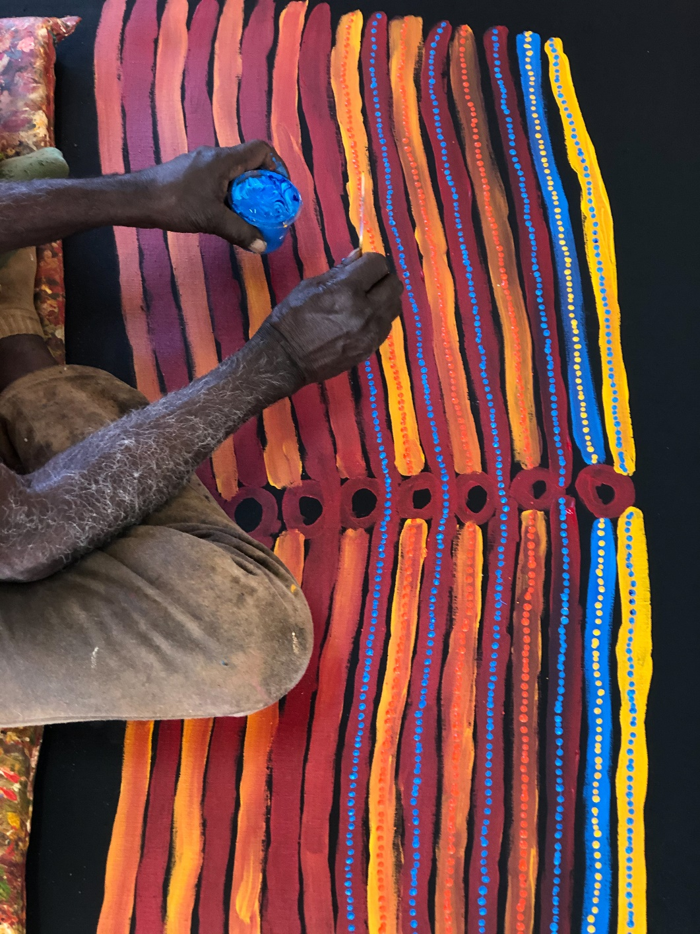

Image: Lennard Walker at work. Photo: Courtesy of The Spinifex Arts Project, WA.

#### Action 2

We will work with art fairs, art centres, artists and the commercial visual arts sector to help create stronger markets and opportunities for Aboriginal and Torres Strait Islander artists in regions that do not currently have access to support services through an Indigenous visual arts service organisation.

By doing this we will increase opportunities for Aboriginal and Torres Strait Islander artists, including independent artists, to engage in visual arts markets domestically and internationally, develop professional skills and generate income from their work.

#### Action 3

With NBN Co, we will improve access to digital infrastructure and capacity for Indigenous visual art centres. As a first step, we will assess the internet connection, hardware and digital knowledge capacity of Indigenous art centres. We will work with up to 80 Indigenous art centres in a targeted way to connect them with the NBN, retail service providers and professional expertise that will be fundamental to robust e-commerce capacity across the Indigenous visual arts sector.

#### Action 4

We will increase professionalisation of the Indigenous visual arts industry, which is essential to market growth, by encouraging clear career pathways and retention of the best people in the industry. We will do this through:

* Targeted and tailored training for Indigenous art centres, provided by the Office of the Registrar of Indigenous Corporations (ORIC) in collaboration with Indigenous visual arts service organisations, to support art centres in improving financial and governance capacity and outcomes.
* Increasing the capacity of artists and art centres to engage with philanthropy and develop partnerships, with support from Creative Partnerships Australia (CPA). This will include piloting a fund-raising approach and associated guide to encourage greater philanthropic support for art centres, led by Creative Partnerships Australia.
* Connecting artists to available initiatives that will develop business skills, such as targeted promotion of the New Business Assistance with NEIS program that offers business assistance, training and mentoring, as well as supporting Indigenous visual arts service organisations, art centres and businesses to refer Indigenous artists to NEIS providers.

#### Action 5

We are funding the national rollout of digital labelling for artworks and products, including support for project management, digital and financial infrastructure, content creation and marketing, product support, training and resources, and evaluation.

#### Action 6

We will promote the importance of ethically produced and authentic Indigenous art and related cultural tourism, particularly for the domestic tourism market. The awareness strategy will promote consumer information about Aboriginal and Torres Strait Islander art, where and how to buy authentic art, information about key Indigenous art fairs and events, and the Indigenous Art Code.

#### Action 7

We will promote cultural exchanges for the Indigenous visual arts sector in overseas markets working with the Department of Foreign Affairs and Trade, including establishing communications between diplomatic missions and relevant Indigenous art organisations.

#### Action 8

We will investigate new ways to strengthen economic opportunities for Aboriginal and Torres Strait Islander artists by working with Indigenous communities to consider the viability of a labelling scheme, potentially with broader application for authentic Indigenous products, including certification trade marks. We will undertake a scoping study to identify possible models of stand-alone legislation to protect Indigenous Knowledge.

#### Action 9

We will encourage an ethical marketplace that values authentic, ethically produced Indigenous artwork and products. We will support the Indigenous Art Code and together work to build consumer confidence and boost implementation of the Code. This will involve evaluating the functions of the Indigenous Art Code to assess whether it is meeting government objectives as well as industry and consumer expectations.

#### Action 10

We will seek international reciprocal arrangements under the *Resale Royalty Right for Visual Artists* scheme to increase financial returns to rights holders when their work is sold overseas in countries with established resale royalty schemes.

## What does success look like?

**The ten actions in this plan seek to address specific issues and to work together to achieve a stronger, sustainable Indigenous visual arts sector. The actions respond to issues of sector infrastructure, professional development, support for independent artists, building digital capacity, reaching new markets in Australia and overseas and protecting Indigenous artists intellectual property and income.**

#### Sustainable Growth

Success means:

* Aboriginal and Torres Strait Islander artists direct and determine the growth of their industry and how their culture is represented nationally and internationally.
* The Indigenous visual arts industry continues to grow in a way that supports the production of authentic and ethically-produced art work by Aboriginal and Torres Strait Islander artists.
* Increased economic participation and opportunities for Aboriginal and Torres Strait Islander artists and arts workers.
* A healthy, diverse Indigenous visual arts industry that includes growth in success of independent artists and commercial opportunities for authentic Indigenous art.
* The social and economic value of the Indigenous visual arts industry is well understood, with a clear set of measures that are regularly updated.

#### Capacity Building

Success means:

* Increased opportunities for Aboriginal and Torres Strait Islander artists and arts workers to expand their professionalism and have better access to markets across Australia.
* There is increased digital capability, digital connection and infrastructure to support e-commerce within the Indigenous visual art sector.
* There are strong financial, administrative governance and business skills across the sector that support a professional and sustainable industry.
* Improved sector engagement on developing strategies to attract support through partnerships, philanthropy and donors.

#### Access to Market

Success means:

* Domestic and international consumers are able to easily and readily purchase authentic and ethically-produced Indigenous artwork.
* There is a strong understanding among consumers about the importance of purchasing authentic and ethically-produced Indigenous artwork.

#### Legal Protections

Success means:

* Inauthentic products are no longer able to be produced or sold in the Australian market.
* Aboriginal and Torres Strait Islander artists and rights holders have avenues for recourse when their rights are infringed.

## Case Study

#### Worker to Art Centre Manager Career pathways

Joann Russo, a Kuku Yalanji woman from Ingham North Queensland, has successfully chartered her career progression drawn from her skills acquired as an arts worker to become the first Aboriginal woman to be appointed as Manager of Girringun Aboriginal Art Centre, Cardwell, Queensland.

Joann has been employed at the Girringun Aboriginal Art centre since 2016, starting as an arts worker then moving on to managing the ethically licensed products and various other projects. She works with Elders and members from the Djiru, Jirrbal, Warrgamay, Girramay, Nywaigi, Gulnay, Gugu Badhan, Bandjin and Warungnu Tribal groups.

Joann says, “The Elders and members of Girringun have been my biggest supporters, they are the ones who gave me the opportunity to step up into my current role. I am forever grateful for their support and know I can confidently continue to honour their vision with them.

My appointment is an opportunity for all of the community to be heard and be represented on their terms. I am excited to see what the future holds for the art centre considering it’s the first time an Aboriginal person has taken the helm. I hope that I can inspire and be an example for other Mob to step up and become leaders within their own communities and art centres.”

During her tenure she has driven innovative change within the Girringun Aboriginal Art Centre, by launching Virtual Girringun, an online virtual gallery that is open to national and international visitors to learn about North Queensland Rainforest Aboriginal Culture. Joann takes the participative leadership approach which has shown much success to the art centre and has fostered career growth to the other arts workers within the team.

Joann is an alumni of the National Gallery of Australia’s Arts Leadership program, having participated in 2018. The program helped her to understand her leadership role within the community. She values the importance Indigenous voices and culture have played in the arts sector and continues to advocate for that voice to be heard. In 2019, Joann was appointed as a Director of the Darwin Aboriginal Art Fair Foundation Board and in 2020 Joann was appointed to a position on the Indigenous Art Centre Alliance management committee.

Since 2015-16, the IVAIS program has delivered funding to art centres for the employment of Indigenous arts workers. Arts workers typically support the day-to-day functions of an art centre including administrative assistance, studio technical assistance, artist support, art centre maintenance and community liaison. Many IVAIS funded arts workers are now long-term employees who hold significant corporate knowledge about their art centre’s operations. Building the professional skills that assist arts workers to step into art centre manager roles is essential to strengthen the sector.

## Case Study

#### Successful Licensing Resources for artists, designers and art centres

In 2020, the Arts Law Centre of Australia was successful in securing IVAIS project funding for its *Licensing the Right Way* project. Arts Law is Australia’s independent, not-for-profit national community legal centre for the arts and the project aims to improve licensing outcomes for Indigenous artists and build best practice within the Indigenous arts industry.

The *Licensing the Right Way* project includes enhanced legal support for Indigenous artists needing licensing advice, help with problems, contracts, referrals to pro bono lawyers and ‘how to licence’ training. It also includes the development of tools to assist licensees wanting to license artworks in an ethical way.

Many artists have become aware that they have not been paid properly, or at all, for their artwork, which has been reproduced on signiﬁcant quantities of merchandise and fabric. Since launching the Licensing the Right Way project, Arts Law has had a 50 per cent increase in the number of Indigenous artists contacting them for support with licensing and copyright infringement issues. Arts Law has been able to achieve better outcomes by supporting the artists in understanding, acting or negotiating a better deal.

Arts Law continues to address Indigenous artists’ needs arising out of increased interest in licensing Indigenous artists’ work on various products. It provides free or low cost specialised legal advice, education and resources to Australian artists and arts organisations on a range of arts related matters. Arts Law’s *Artists in the Black* program delivers targeted services to Aboriginal and Torres Strait Islander artists nationally.

## What we will deliver

**The Office for the Arts in the Department of Infrastructure, Transport, Regional Development and Communications, in collaboration with the Australia Council, will work with partner agencies and key stakeholders to achieve these deliverables against each action.**

|  |  |  |  |  |  |
| --- | --- | --- | --- | --- | --- |
| **Deliverables** | Year One | Year Two | Year Three | Year Four | Year Five |
| 1. Investment in support to artists, innovation and expanding market reach. | Through the IVAIS program we will invest in up to an additional:  ⦁ 8 Indigenous art centres in regional and remote locations to increase jobs.  ⦁ 20 projects for infrastructure upgrades at Indigenous art centres.  ⦁ 3 promotional projects with Indigenous art fairs  ⦁ 10 innovative projects to increase market access. | Through the IVAIS program we will invest in up to an additional:  ⦁ 8 Indigenous art centres in regional and remote locations to increase jobs.  ⦁ 20 projects for infrastructure upgrades at Indigenous art centres.  ⦁ 3 promotional projects with Indigenous art fairs  ⦁ 10 innovative projects to increase market access. | Through the IVAIS program we will invest in up to an additional:  ⦁ 8 Indigenous art centres in regional and remote locations to increase jobs.  ⦁ 20 projects for infrastructure upgrades at Indigenous art centres.  ⦁ 3 promotional projects with Indigenous art fairs  ⦁ 10 innovative projects to increase market access  ⦁ 20 projects to increase digital literacy and infrastructure in art centres and art fairs through training, information technology infrastructure and improved online platforms. | Through the IVAIS program we will invest in up to an additional:  ⦁ 8 Indigenous art centres in regional and remote locations to increase jobs.  ⦁ 20 projects for infrastructure upgrades at Indigenous art centres.  ⦁ 3 promotional projects with Indigenous art fairs  ⦁ 10 innovative projects to increase market access  ⦁ 20 projects to increase digital literacy and infrastructure in art centres and art fairs through training, information technology infrastructure and improved online platforms. | Through the IVAIS program we will invest in up to an additional:  ⦁ 8 Indigenous art centres in regional and remote locations to increase jobs.  ⦁ 20 projects for infrastructure upgrades at Indigenous art centres.  ⦁ 3 promotional projects with Indigenous art fairs  ⦁ 10 innovative projects to increase market access  ⦁ 20 projects to increase digital literacy and infrastructure in art centres and art fairs through training, information technology infrastructure and improved online platforms. |
| 2. Stronger market opportunities and professional support to artist and art centres in regions without an Indigenous visual arts service organisation. | Through the IVAIS program we will invest in up to 2 art fairs that undertake work specifically to showcase the work of and provide professional development to at least 3 Indigenous visual artists. | Through the IVAIS program we will invest in up to 3 art fairs that undertake work specifically to showcase the work of and provide professional development to at least 3 independent artists and/or an organisation that supports the professional development of independent artists, including international opportunities. | Through the IVAIS program we will invest in up to 3 art fairs that undertake work specifically to showcase the work of and provide professional development to at least 3 independent artists and/or an organisation that supports the professional development of independent artists, including international opportunities. | Through the IVAIS program we will invest in up to 3 art fairs that undertake work specifically to showcase the work of and provide professional development to at least 3 independent artists and/or an organisation that supports the professional development of independent artists, including international opportunities. | Through the IVAIS program we will invest in up to 3 art fairs that undertake work specifically to showcase the work of and provide professional development to at least 3 independent artists and/or an organisation that supports the professional development of independent artists, including international opportunities. |
| 3. Working with NBN Co, improve digital infrastructure and capacity for Indigenous visual arts centres and support stronger e‑commerce capacity. | With NBN Co we will assess online capacity of Indigenous art centres (including existing internet connectivity, hardware and IT knowledge) with a view to NBN Co developing and implementing a targeted connectivity solution and related support to art centres. | NBN Co will continue targeted and staged delivery of a connectivity solution and related support to art centres.  Over year one and year two, NBN Co will support improved internet connection solutions to up to 80 art centres and art fairs. | Mid-year assessment of the Action Plan with any refinements to this action to be implemented in year 4 and 5. | Subject to mid-term assessment. | Subject to mid-term assessment. |
| 4. Increased professionalisation of the Indigenous visual arts industry through training and connection to skills development opportunities | | | | | |
| 4A. Targeted and tailored training for Indigenous visual arts service organisations, provided by the Office of the Registrar of Indigenous Corporations (ORIC), to support their role in improving financial and governance capacity and outcomes. | ORIC to determine the governance support that needs to be developed to increase the knowledge of art centre staff and board members to improve financial and governance outcomes, including in consultation with Indigenous visual arts service organisations. | ORIC to implement increased support for art centre staff and board members, including in consultation with at least 2 Indigenous visual art service organisation.  ORIC to attend at least 2 key Indigenous art events to promote understanding of governance issues. | ORIC to implement increased support for art centre staff and board members. | ORIC to implement increased support for art centre staff and board members. | ORIC to seek feedback from art centres on whether additional support is needed. |
| 4B. Increasing the capacity of artists and art centres to engage with philanthropy and develop partnerships, with support from Creative Partnerships Australia (CPA). This will include piloting a fund-raising approach and associated guide to encourage greater philanthropic support for art centres, led by Creative Partnerships Australia. | CPA will undertake a pilot mentorship project focussed on fundraising and involving three art centres. Through these mentorships, art centres and Indigenous arts workers will learn the skills to maximise fundraising outcomes and connect with people that may be able to assist the art centres to secure new supporters. Through the mentorship, CPA may be able to provide additional professional development support to the mentees as appropriate.  CPA will publish a fundraising guide tailored to the needs of art centres, including case studies that illustrate successful fundraising strategies. | CPA will deliver up to three further mentorships directed at Indigenous arts workers and artists, along with other professional support for fundraising as appropriate. CPA will evaluate the mentorships program and use it to develop further case studies and to inform future mentorships and other capacity building opportunities. | CPA will deliver up to three further mentorships directed at Indigenous arts workers and artists, along with other professional support for fundraising as appropriate. | CPA will deliver up to three further mentorships directed at Indigenous arts workers and artists, along with other professional support for fundraising as appropriate. | CPA will deliver up to three further mentorships directed at Indigenous arts workers and artists, along with other professional support for fundraising as appropriate. |
| 4C. Connecting artists to available initiatives that will develop business skills, such as the New Business Assistance with NEIS program that offers business assistance, training and mentoring, and supporting Indigenous visual arts service organisations, art centres and businesses to refer Indigenous artists to NEIS providers. | Promotion of NEIS program to Indigenous visual artists commences through National NEIS Association, NEIS providers and other media.  Increased linkages at the local level result in increased awareness of the NEIS program. | Promotion of NEIS program to Indigenous visual artists continues through the National NEIS Association, NEIS Providers and other media.  Increased linkages at the local level result in increased awareness of the NEIS program. | Promotion of NEIS program to Indigenous visual artists continues through the National NEIS Association, NEIS Providers and other media.  Increased linkages at the local level result in increased awareness of the NEIS program. | Promotion of NEIS program to Indigenous visual artists continues through the National NEIS Association, NEIS Providers and other media.  Increased linkages at the local level result in increased awareness of the NEIS program. | Promotion of NEIS program to Indigenous visual artists continues through the National NEIS Association, NEIS Providers and other media.  Increased linkages at the local level result in increased awareness of the NEIS program. |
| 5. National rollout of digital labelling for art works and products | An independent evaluation of the digital labelling trial is undertaken. | Subject to the findings of the evaluation, an announcement will be made on the next stage of the digital labelling project and set performance measures. | Roll out of digital labelling commences to up to 20 art centres (subject to review findings) | Roll out of digital labelling continues (subject to review findings) | Roll out of digital labelling concludes (subject to review findings) |
| 6. Increased awareness of authentic Indigenous Australian visual art cultural and tourism experiences. | Establish a working group that will include Indigenous visual arts sector and relevant agencies including Australia Council, Tourism Australia, Australian Competition and Consumer Commission to develop a strategy to promote Aboriginal and Torres Strait Islander visual arts experiences and consumer information on the purchase of Indigenous art and other products. | Awareness strategy finalised and commenced. | Strategy to be reviewed in the midyear assessment of the Action Plan with any refinements to this action to be implemented in year 4 and 5. | Consumer awareness strategy underway | Consumer awareness strategy underway. |
| 7 Promotion of cultural exchanges for the Indigenous visual arts sector in overseas markets through Department of Foreign Affairs and Trade (DFAT) | DFAT, in collaboration with the Indigenous arts sector and relevant agencies, to promote Indigenous art fairs occurring in Australia and Indigenous art exhibitions that are occurring overseas through its international networks in at least 4 posts to capitalise on existing markets and assist to foster new markets for Indigenous art. | DFAT, in collaboration with the Indigenous arts sector and relevant agencies, to promote Indigenous art fairs occurring in Australia and exhibitions that are occurring overseas through its networks in at least 2 new posts to expand potential markets and foster new collectors of Indigenous art.  DFAT will continue to provide guidance through its international networks on the ethical purchase of Indigenous art and; if travel restrictions due to COVID-19 lessen, DFAT will support inbound travel for arts and culture leaders and collectors to engage with the sector and outbound travel for Indigenous artists and arts workers | DFAT, in collaboration with the Indigenous arts sector and relevant agencies, to promote Indigenous art fairs occurring in Australia and exhibitions that are occurring overseas through its networks in at least 2 new posts to expand potential markets and foster new collectors of Indigenous art.  DFAT will continue to provide guidance through its international networks on the ethical purchase of Indigenous art and; if travel restrictions due to COVID-19 lessen, DFAT will support inbound travel for arts and culture leaders and collectors to engage with the sector and outbound travel for Indigenous artists and arts workers | DFAT, in collaboration with the Indigenous arts sector and relevant agencies, to promote Indigenous art fairs occurring in Australia and exhibitions that are occurring overseas through its networks in at least 2 new posts to expand potential markets and foster new collectors of Indigenous art.  DFAT will continue to provide guidance through its international networks on the ethical purchase of Indigenous art and; if travel restrictions due to COVID-19 lessen, DFAT will support inbound travel for arts and culture leaders and collectors to engage with the sector and outbound travel for Indigenous artists and arts workers | DFAT, in collaboration with the Indigenous arts sector and relevant agencies, to promote Indigenous art fairs occurring in Australia and exhibitions that are occurring overseas through its networks in at least 2 new posts to expand potential markets and foster new collectors of Indigenous art.  DFAT will continue to provide guidance through its international networks on the ethical purchase of Indigenous art and; if travel restrictions due to COVID-19 lessen, DFAT will support inbound travel for arts and culture leaders and collectors to engage with the sector and outbound travel for Indigenous artists and arts workers |
|  |  |  |  |  |  |
|  |  |  |  |  |  |

|  |  |  |  |  |  |
| --- | --- | --- | --- | --- | --- |
| **Deliverables** | Year One | Year Two | Year Three | Year Four | Year Five |
| 8. Strengthen Aboriginal and Torres Strait Islander economic rights, through appropriate intellectual property responses | | | | | |
| 8A. Working with Indigenous communities consider the viability of a labelling scheme potentially with broader application for authentic Indigenous products, including Certification trademarks. | Consultation with Indigenous communities, businesses and industry service organisations to consider whether a labelling scheme should be developed to promote authentic products for Indigenous industries, including the Indigenous visual art industries. | Consideration of consultation outcomes. | Further action subject to consideration of consultation outcomes. | Further action subject to consideration of consultation outcomes. | Further action subject to consideration of consultation outcomes. |
| 8B. Undertake scoping study to identify possible models of standalone legislation to protect Indigenous Knowledge. | Complete study of possible models of stand-alone legislation. | Consideration of scoping study outcomes. | Further action subject to consideration of scoping study outcomes. | Further action subject to consideration of scoping study outcomes. | Further action subject to consideration of scoping study outcomes. |
| 9. Enhanced ethical marketplace, build consumer confidence and boost implementation of the Indigenous Art Code. | The Australian Government will continue to provide funding to the Indigenous Arts Code to support its work to better promote ethical art dealing and continue its work in relation to inauthentic products.  Consulting with the Indigenous Arts Code, Indigenous visual arts service organisations and commercial Indigenous visual arts sector stakeholders settle terms of reference and commence evaluation of the functions of the Code. | Evaluation of the Indigenous Art Code’s achievements and challenges in respect of ethical art dealing and its work on inauthentic products.  This will include an analysis of the outcomes from its increased funding from the Australian Government and states and territories since 2019-20 and report back to cultural ministers. | The assessment of the Indigenous Art Code will inform the mid-way assessment of the Action Plan and identify any further actions for year 4 and 5. | To be identified. | To be identified. |
| 10. Progress towards international reciprocal Resale Royalty arrangements, extending the resale royalty right and potential for resale payments for Australian visual artists from international sales of their work. | Undertake a regulatory impact statement to assess the costs to art market professionals and benefits to individual artists as part of the process of establishing international reciprocals rights through the *Resale Royalty Right for Visual Artists Act 2009*. | Subject to the outcomes of the assessment, commence the process of making legislative changes to the *Resale Royalty Right for Visual Artists Act 2009* to allow for international reciprocal arrangements. | Legislative changes come into effect to the *Resale Royalty Right for Visual Artists Act 2009*. Countries can be prescribed as a reciprocating country. Australian visual artists will begin to receive resale payments when there is an eligible resale of their artwork in a reciprocating country. Collection arrangements established and sales of artworks from international artists from a prescribed country in Australia will also attract a resale royalty. | Ongoing negotiation to prescribe additional countries and establish reciprocal arrangements as appropriate.  Sales of artworks from international artists from a prescribed country in Australia will also attract a resale royalty. | Ongoing negotiation to prescribe additional countries and establish reciprocal arrangements as appropriate.  Sales of artworks from international artists from a prescribed country in Australia will also attract a resale royalty. |
|  |  |  |  |  |  |

## Monitoring and Evaluation

The monitoring and evaluation of the National Indigenous Visual Art Market Action Plan will be an ongoing activity led by the Office for the Arts, working closely across federal, state and territory governments, Aboriginal and Torres Strait Islander organisations, individuals and visual art service organisations.

There will be a mid-way assessment of this action plan in December 2023. This assessment will review whether the action plan is continuing to support the sector with its most urgent priorities and achieving its intended outcomes.

The assessment will consider changes in the sector, implemented actions and stakeholder feedback. The assessment may give rise to changes in the action plan.

In implementing and assessing the outcomes of the action plan, the Government will seek independent advice, such as from the Creative Economy Taskforce and other professional and Indigenous leaders.

Information on implementation of the action plan will be published on the arts.gov.au website.

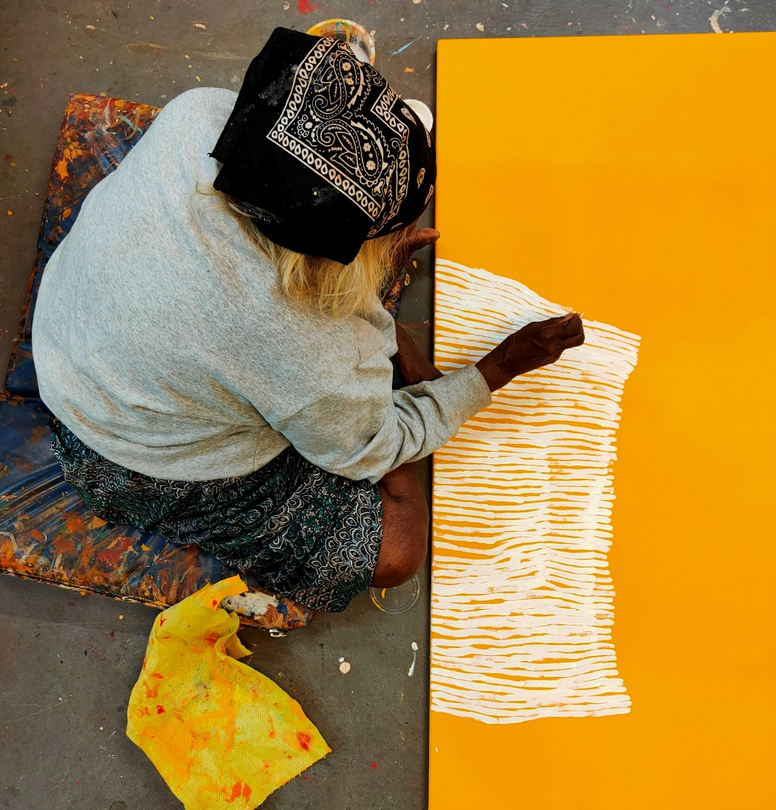

Image: Eunice Napanangka Jack in the studio working on her painting ‘Kuruyultu’. Photo by Ikuntji Artists.

## Appendix 1

### Those Consulted

**The government received 32 submissions, conducted 13 roundtable discussions and accepted 33 survey responses.**

#### Submissions in Response to Consultation Paper

A total of 32 submissions were received from a range of stakeholders. Stakeholder groups included: industry service organisations, service organisations and advocacy bodies; independent artists; art centres (representing Indigenous artists); business and policy consultants; commercial gallerists; organisations that coordinate and run Indigenous visual art fairs and events; copyrighting organisations; universities and researchers; tourism bodies; national and state level arts and collections organisations (for galleries, libraries, museums); local government entities, and; social media organisations. A number of submissions were identified as being confidential. Listed are those who did not ask for their submission to be treated as confidential.

Individual/ Organisation Name (Alphabetical Order)

Aboriginal Art Assoc. of Australia (AAAA)

Aboriginal Art Centre Hub of Western Australia

(AACHWA)

Agency Projects

Arnhem, Northern and Kimberley Artists (ANKA)

Artitja Fine Art

Arts Law Centre of Australia

Australian Libraries Copyright Committee (ALCC)

Australian Museums and Galleries Association

Brisbane City Council

Copyright Agency

Creative Economy Pty Ltd

Darwin Aboriginal Art Fair Foundation Limited

Desart Incorporated

Facebook

FORM building a state of creativity

Fremantle Art Centre

Ku Arts (Ananguku Arts and Cultural Aboriginal

Corporation)

Lyne Walshe

Marcus Wright

National Association for the Visual Arts (NAVA)

NSW Aboriginal Culture, Heritage and Arts

Association (ACHAA)

Papulankutja Artists

Public Galleries Association of Victoria

Queensland Tourism Industry Council

Queensland University of Technology

Stephen Cassidy

Suzanne O’Connell Gallery

Tjanpi Desert Weavers

Umi Arts

Warmun Art Centre

#### Roundtable Discussions

Roundtable discussions were held with 54 organisations, through 13 online forums with stakeholders representing different regions and industry functions. Stakeholder groups included representatives for artists based in Central Australia, Western Australia, Queensland and Torres Strait Islands, Northern Territory and Tiwi Islands, South Australia and southeast Australia. Discussions were also held with Indigenous art fairs, product designers, wholesalers, commercial gallerists and auction houses. Organisations consulted included the Office of Registrar of Indigenous Corporations, Indigenous Art Code, Arts Law Centre of Australia and Copyright Agency Limited. An alphabetical list of stakeholders that participated in roundtable discussions is below:

Representative Name (Alphabetical Order)

Aboriginal Art Association of Australia*

Aboriginal Art Centre Hub of WA

Agency Projects*

Alcaston Gallery*

Alperstein Designs*

APY Art Centre Collective Ku Arts*

Arnhem, Northern and Kimberley Artists

Arts Law Centre of Australia*

Arts North West

Arts Northern Rivers

Arts Out West

Babbarra Women’s Centre*

Baluk Arts

Bawinanga Aboriginal Corporation

Buku-Larrnggay Mulka Centre

Bula’bula Arts

Cairns Indigenous Art Fair*

Copyright Agency*

D’Lan Contemporary*

Darwin Aboriginal Art Fair*

Desart Spinifex Arts Project

Desert Mob*

Durrmu Arts

First Hand Solutions (Blak Markets) *

FORM building a state of creativity

Iltja Ntjarra Many Hands

Indigenous Art Centre Alliance

Indigenous Art Code*

Injalak Arts

Japingka Aboriginal Art*

Kate Owen Gallery

Koorie Heritage Trust

Ku Arts*

Martumilli Arts

Moa Island Arts

Mornington Island Arts

Munupi Arts

National Indigenous Art Fair (First Hand Solutions) *

Ngarga Warendj*

Numburindi Corporation

Office of Registrar of Indigenous Corporations

One of Twelve*

Outstation Gallery*

Papunya Tula Artists*

Pormpuraaw Art

Revealed: WA Aboriginal Art Market*

SOUTHEAST Aboriginal Arts Market (Carriageworks) *

Spinifex Arts Project

Tjanpi Desert Weavers

Umi Arts

Walkatjara Arts

Waringarri Arts

Warlukurlangu Artists

Warmun Art Centre

*Organisations that met with the Hon Paul Fletcher MP, Minister for Communications, Urban Infrastructure, Cities and the Arts as part of consultation.

#### Summary of Surveys

The survey was promoted through @communications social media platforms (Facebook, Twitter and LinkedIn), promoted several times through the ART/Works monthly newsletter, sent to 3,400 subscribers, through direct stakeholder invitations to participate, and Office for the Arts website. Also through National Indigenous Australians Agency’s Indigenous.gov.au weekly newsletter, verbally through consultation roundtables and in conversation with stakeholders and on outgoing signature blocks. The closing date for the survey was 18 December 2020.

|  |  |
| --- | --- |
| **Participant Count** | Number (percentage) |
| Indigenous visual artist | 6 (18%) |
| Indigenous visual arts facilitator | 19 (58%) |
| Indigenous visual art buyer/prospective buyer | *5 (15%) |
| Indigenous visual art seller | 11 (33%) |
| Not part of Industry | 4 (12%) |
| People that had more than one role | 8 |
| Number of survey responses from individuals | 33 |

* Total 7, however 2 did not choose to answer buyer questions.

|  |  |
| --- | --- |
| Distribution | Number (percentage) |
| New South Wales | 8 (24%) |
| Australian Capital Territory | 7 (21%) |
| Northern Territory | 5 (15%) |
| Victoria | 5 (15%) |
| Queensland | 5 (15%) |
| Tasmania | 2 (6%) |
| Western Australia | 1 (3%) |

|  |  |
| --- | --- |
| **Participant Count** | Number (percentage) |
| Identified as having Aboriginal origins | 8 (24%) |
| Identified as neither having Aboriginal and/or Torres Strait Islander origin | 24 (73%) |
| Preferred not to say | 1 (3%) |
| Gender |  |
| Female | 20 (61%) |
| Male | 12 (36%) |
| Preferred not to say | 1 (3%) |

## Appendix 2

### Outline of past Indigenous Arts Programs and Reviews

**The Australian Government has Supported Aboriginal and Torres Strait Islander visual artists in some form since 1971.**

From 1992, a grant opportunity was established as the *Arts and Crafts Industry Support Strategy* (ACISS), administered by the Aboriginal and Torres Strait Islanders Commission. It was renamed in 1995 as the *National Arts and Crafts Industry Support* (NACIS) program and transferred to the arts portfolio in 2004. In 2012, the grants program was renamed the Indigenous Visual Arts Industry Support (IVAIS) program and from 2015-16 it has included funding for employment of Indigenous art workers.

The Action Plan builds on the learnings of a long history of program delivery and research.

* Australia Council for the Arts *Protocols for using First Nations Cultural and Intellectual Property in the Arts*, released September 2020
* Department of Communications and the Arts Post- Implementation Review – *Resale Royalty Right For Visual Artists Act 2009* and the *Resale Royalty Scheme*, published December 2019
* House of Representatives *Report on the impact of inauthentic art and craft in the style of First Nations peoples*, tabled December 2018
* Council of Australian Governments Legislative and Governance Forum on Consumer Affairs report *Taking action, gaining trust; A National Indigenous Consumer Strategy Action Plan 2017-19*, published March 2017
* House of Representatives report *Our Land Our Languages*, tabled September 2012
* The Senate report Indigenous *Art - Securing the Future Australia’s Indigenous visual arts and craft sector*, tabled June 2007
* Attorney-General’s Department report *Stopping the Rip Offs – Intellectual Property Protection for Aboriginal and Torres Strait Islander Peoples Issues Paper*, published October 1994