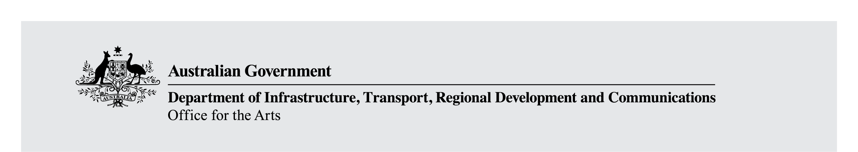

Protection of Cultural Objects on Loan Scheme Annual Report—2020–2021
2020–2021
Borrowing institutions approved under the Protection of Cultural Objects on Loan Act 2013 (the Act) are required to report annually by providing information on objects that have been or are proposed to be imported into Australia for temporary public exhibition and protected under Part 2 of the Act. Annual reports for the preceding financial year are due to the Minister for Communications, Cyber Safety and the Arts by 31 October each year, therefore reports should be submitted to the Department of Communications and the Arts by no later than Wednesday 6 October 2021.
Annual reports (including any attachments) should be submitted by email to the Program Officer: ProtectionofLoans@arts.gov.au.

1. Organisation details
Name of organisation:
Street number and name:
Suburb / city:
State / territory:
Postcode:
Mailing address, if different from above:

2. Primary contact
(Appropriate person in the organisation to discuss the annual report if required.)
Title, name:
Position:
Phone:
Email:

3. Activity information
Please copy this section (3a–3f) and fill out applicable fields for each object, group of objects or exhibitions your institution borrowed/held and which were protected under the scheme.

3.a Exhibition details
Object name/ Exhibition title
Dates of import and export or proposed date of export
Object listing attached (optional) | Yes  No

Venue | Exhibition/ display dates | Number of visitors  (1 July 2020 to 30 June 2021)

3.b Partnership arrangements
If applicable, please provide information on any partnerships with exhibition facilitators or institutions that are not approved under the Act which allowed objects to be protected while on temporary exhibition in Australia. Please do not include institutions that are only a venue for the exhibition rather than a partner involved in providing protection for loans.
Partner name (s) | Name of exhibition held with partner institution

3.c Provenance and due diligence
Please provide details on provenance checking and due diligence research conducted in accordance with the institution’s policies and procedures.
Did the lender provide sufficient provenance documentation? | Yes  No
If the provenance documentation was insufficient, what due diligence was undertaken?

3.d Consultation
Please provide details of consultation undertaken for each object or group of objects. Supporting information such as summaries of consultation outcomes may be attached.
Object name/ Exhibition title
Was consultation completed prior to import? | Yes  No
If no, please explain why
Please provide a brief summary of consultation undertaken and its outcomes.
Eg. has consultation developed relationships between communities and overseas institutions?
Has it improved relationships? Were any issues raised?
Supporting information attached

3.e Publication of information
Please provide a copy of the information that was published for each imported object as required under the scheme. Please also provide a statement that this information was publically available for the entire publication period via a link from your exhibition webpage. Material which supports this statement may also be attached.
Example statements:
The information regarding the objects on loan for the [name of exhibition] was published online from [date] to [date] for the prescribed minimum four week timeframe.
If applicable:
A hyperlink to information about the objects was also included on the website of [name of institution/venue] as the partnering institution and participating venues for the prescribed timeframe.
Copy of exhibition object list/descriptive information/screenshot of webpage link is attached | Yes  No
Was the information published at least four weeks prior to importation into Australia? | Yes  No
If no, what was the reason?
Was an exemption from publishing sought for any objects imported under the scheme? | Yes  No
If so, please name the object(s)/ exhibition.
Date Department approved publication exemption

3.f Claim and enquiries
Please provide details of any claims or significant enquiries made during consultation, publication or exhibition periods and the action taken by your institution. Please indicate if the action is still ongoing. Please include the date the claim/enquiry was made and information about the claim or enquiry.
Claim / enquiry | Yes  No  N/A (Not applicable)
If yes, please provide details below:
Claim was raised during (please tick): | Consultation  Publication  Exhibition
Action taken (please advise if the Arts Division was notified and indicate if matter is ongoing)

4. Opt-out and extensions
Did you apply for any Opt-outs in the reporting period? | Yes  No  N/A
If yes, please provide details
Please provide details of any object, group of objects or exhibition for which you opted-out.
Exhibition or object name
Details—reason for opting-out and date of notification to the Department
Were Opt-out notifications acknowledged by the Department? | Yes  No
Date:
Did you apply for any extensions to protection in the reporting period? | Yes  No  N/A
If yes, please provide details of any applications for extension to protection beyond the two-year period. Why was an extension sought?
Date/s of request to the Department
Were Extension requests approved? | Yes  No
If no, please provide details:

5. Updates and reviews of policies and procedures
Please indicate if any changes have been made to your institution’s policies and procedures. Please also indicate if there are planned reviews/changes to your institution’s policies and procedures in the coming year. Please outline the changes that have been made, attach updated policies and procedures and reference the relevant pages.
Changes made to policies and procedures:
Updated policies and procedures attached:

6. Updates on PCOL exhibitions reported previously
Please report on final audience numbers for exhibitions since PCOL approval that may not have been captured in previous Annual Reports.
Venue | Exhibition/ display dates | Total number of visitors
Please provide details on any other matters related to past exhibitions that may not have been captured in previous Annual Reports, i.e. new claims, new community engagement/information about objects while on exhibition etc.
Details on any other matters related to past exhibitions that may not have been captured in previous Annual Reports:

7. Feedback
Please provide any feedback on matters you feel we should know in relation to the operation of the scheme.
Feedback on matters in relation to the operation of the scheme:

8. Certification
This certification should be made by the Director, CEO or equivalent.
I certify that:
- The information provided in this annual report;
- gives an accurate account of the institution’s participation in the scheme;
- is true and correct; and
- is not misleading or deceptive in any way.
- I am authorised to sign this annual report on behalf of the organisation as specified above.
Signature:
Printed name:
Position/title:
Date:

