
OFFICE FOR THE ARTS

Significance: a guide to assessing cultural collections
  - Third edition
November 2026
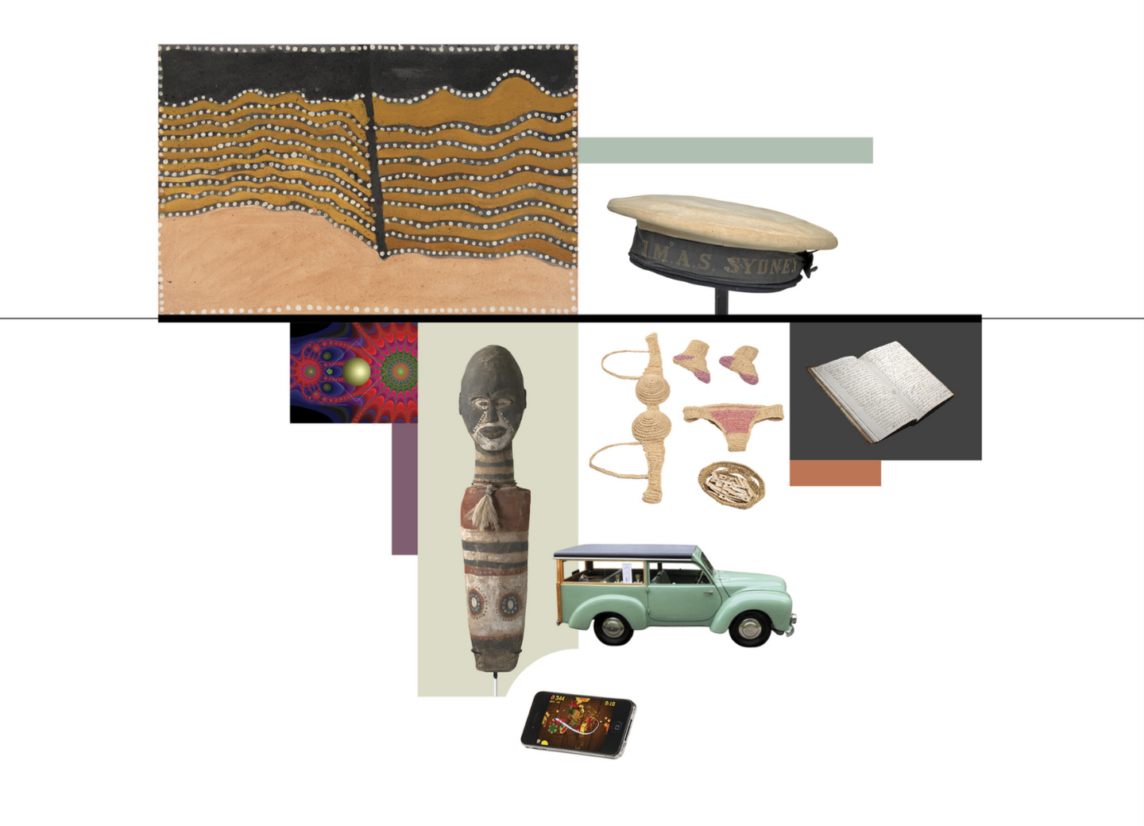

Fruit Ninja by Halfbrick Studios on smartphone, 2010. Collection of the National Film and Sound Archive of Australia. Kindly donated by Halfbrick Studios Pty Ltd. Photographer: Sian Fay Kerr.
Hartnett Estate ‘Woody’ wagon motor car built circa 1952–53 by Hartnett Motor Company Ltd. Trafalgar Holden Museum.
Sailor cap, navy blue and white sailor’s hat, no brim, with the words ‘HMAS Sydney.’ Tasmanian Museum and Art Gallery.
Hung out to Dry, by Madi Mercer, 2022, natural dyed raffia, 140 x 100 x 30 cm (overall). Koorie Heritage Trust. Image courtesy of Koorie Heritage Trust, Narrm (Melbourne).
Journal of Commandant James Boyd, 1839–1853. Collection of Port Arthur Historic Site. Photograph by Michael Smith.
Cover image credits
Ribbon Rock Country, created by Jack Britten, 2002, natural (Kimberley) ochres and binder on canvas, 45 x 70 cm. Red Rock Collection, Western Australian Museum.
PRG919_107_504_Newton5c, An example of Stan Ostoja-Kotkowski’s pioneering digital artworks, recovered from obsolete 3.5-inch floppy disks at the State Library of South Australia. Ostoja-Kotkowski, S. (1992) Newton5c. Digital artwork, PRG 919/107/503/NEWTON5C. Adelaide: State Library of South Australia.
Djan’djari figure, created by Fred Embrey (c.1880–1939), Kabi Kabi people, Queensland, Australia, 1930s, carved softwood with natural pigments, emu feathers bound with bush string and resin, 65.5 x 14 x 14 cm. Collection: Queensland Art Gallery | Gallery of Modern Art. Purchased 2020 with funds from the Mather Foundation through the Queensland Art Gallery | Gallery of Modern Art Foundation.

© Commonwealth of Australia 2026
ISBN: 978-1-923111-38-7
Ownership of intellectual property rights in this publication
Unless otherwise noted, copyright (and any other intellectual property rights, if any) in this publication is owned by the Commonwealth of Australia (referred to below as the Commonwealth).
Disclaimer
The material contained in this publication is made available on the understanding that the Commonwealth is not providing professional advice, and that users exercise their own skill and care with respect to its use, and seek independent advice if necessary.
The Commonwealth makes no representations or warranties as to the contents or accuracy of the information contained in this publication. To the extent permitted by law, the Commonwealth disclaims liability to any person or organisation in respect of anything done, or omitted to be done, in reliance upon information contained in this publication.

Creative Commons licence

With the exception of (a) the Coat of Arms; (b) the Department of Infrastructure, Transport, Regional Development, Communications, Sport and the Arts photos and graphics; (c) content supplied by third parties; (d) content otherwise labelled; copyright in this publication is licensed under a Creative Commons BY Attribution 4.0 International Licence.
Use of the Coat of Arms
The Department of the Prime Minister and Cabinet (PM&C) sets the terms under which the Coat of Arms is used. Please refer to the Commonwealth Coat of Arms Information and Guidelines | PM&C.

Contact us
This publication is available in PDF and Word formats. All other rights are reserved, including in relation to any departmental logos or trademarks which may exist. For enquiries regarding the licence and any use of this publication, please contact:
Email: Significance@arts.gov.au
Website: https://www.arts.gov.au/
Version 3. Last updated 2 November 2026.

Contents
Significance: a guide to assessing cultural collections 1
Contents 3
Acknowledgement of Country 5
Minister for the Arts’ Foreword 6
How to use this guide 8
Introduction 9
Part 1: The Significance framework 12
What significance assessment means 12
Why significance assessment matters 13
Who should assess significance 13
When to assess significance 14
A note on artificial intelligence (AI) 15
Part 2: The assessment process 17
Variations for items versus collections 17
Stages of significance assessment 17
The assessment criteria 18
Recording and sharing results of significance assessment 23
Levels of significance 24
Summary of significance assessment process and criteria 27
Case study 1: Example of how to conduct a significance assessment 29
Case study 2: A statement of significance for a single item 33
Case study 3: A statement of significance for a collection 35
Part 3: Key considerations when assessing significance 37
Guidance on assessing the significance of First Nations cultural heritage materials 37
Case study 4: A statement of significance developed with a First Nations community 42
Consultation with relevant parties 44
Case study 5: A significance assessment informed by consultation 46
Contextual research 48
Case study 6: A significance assessment informed by contextual information 52
Provenance and provenance research 54
Case study 7: An assessment of provenance and significance 59
Significance across collections 62
Significance approaches in the archives sector 67
Case study 8: A statement of significance for an archive 69
Significance approaches for operating heritage 71
Case study 9: A statement of significance for a large operating technology item 77
Case study 10: A statement of significance for a playable musical instrument 79
Part 4: Significance in action 81
Strategic collection management 81
Case study 11: Significance and strategic collection management at the regional level 84
Case study 12: A Significance-informed collecting strategy 88
Case study 13: A statement of significance for an exhibition project 91
Case study 14: A Significance-informed approach to digitisation 94
Cultural heritage funding programs in Australia 96
Case study 15: A statement of significance on items from a Community Heritage Grants recipient 100
Case study 16: A statement of significance on a single item from a Community Heritage Grants recipient 102
Case study 17: A statement of significance on a single item supported by the National Cultural Heritage Account 104
Relevant legislation 107
Part 5: Further case studies 113
Case studies 18–32: Statements of significance on cultural items 113
Case studies 33–37: Statements of significance on collections 142
Case studies 38–40: Significance-informed collecting and collection management projects 153
Part 6: Resources 159
Relevant publications and websites 159
Glossary 166

Acknowledgement of Country
The Australian Government acknowledges Australia’s First Nations peoples as the Traditional Custodians of Country throughout Australia and recognises and respects their continuing connections to lands, waters and communities.
The Government pays respect to Elders past and present, emerging leaders, and all First Nations peoples, and recognises the continuation of diverse cultural, spiritual and educational practices.
The Government acknowledges that self-determination is a human right for First Nations peoples, as enshrined in the United Nations Declaration on the Rights of Indigenous Peoples. The Government thanks all First Nations peoples who have generously shared their valuable knowledge and expertise to inform the development of Significance: a guide to assessing cultural collections.

This publication may contain images or references to First Nations people who are deceased. The Australian Government does not wish to cause distress to any First Nations community members.

Minister for the Arts’ Foreword
Australia’s national cultural policy, Revive, seeks to ensure there is a place for every story, and a story for every place. Revive recognises that many of our stories are embedded within our rich collections of movable cultural heritage. These collections include historical and contemporary items, from First Nations cultural objects to historical documents, technological devices, natural history specimens, art, instruments, and objects from everyday life.
This cultural material is essential to understanding our environment, history and relationships, who we are, what is important to us, how we can learn and how we can grow. It allows us to remember and share our stories with each other and the world. Collections can remind people what it felt like to live at a certain time. They can demonstrate what made people laugh, think and reflect, as well as what challenged and entertained them. Capturing this insight helps to build a more confident, cohesive and creative nation.
This new edition of Significance is for the many people who work in our cultural heritage sector, researching, interpreting, caring for and providing access to this unique material.
An action under Revive, this publication builds on previous iterations of Significance to raise awareness of the extraordinary collections held in Australia, their stories, and the work being done to ensure they are understood for generations to come. It also responds to sector feedback by better reflecting contemporary collections, aligning the framework with current collection management practices, and addressing key issues facing collecting organisations.
This edition of Significance features advice from sector experts on matters ranging from the ethical management of First Nations cultural heritage material to consultation, and the assessment of archival material and operating heritage. Collecting organisations across Australia contributed 40 case studies, demonstrating the diversity of our collections and the many ways in which the Significance methodology can be used and adapted to suit a variety of cultural collections.
Thank you to everyone involved in strengthening the Significance framework so we continue to ensure our stories are responsibly collected, understood and shared.

Minister for the Arts
The Hon Tony Burke MP

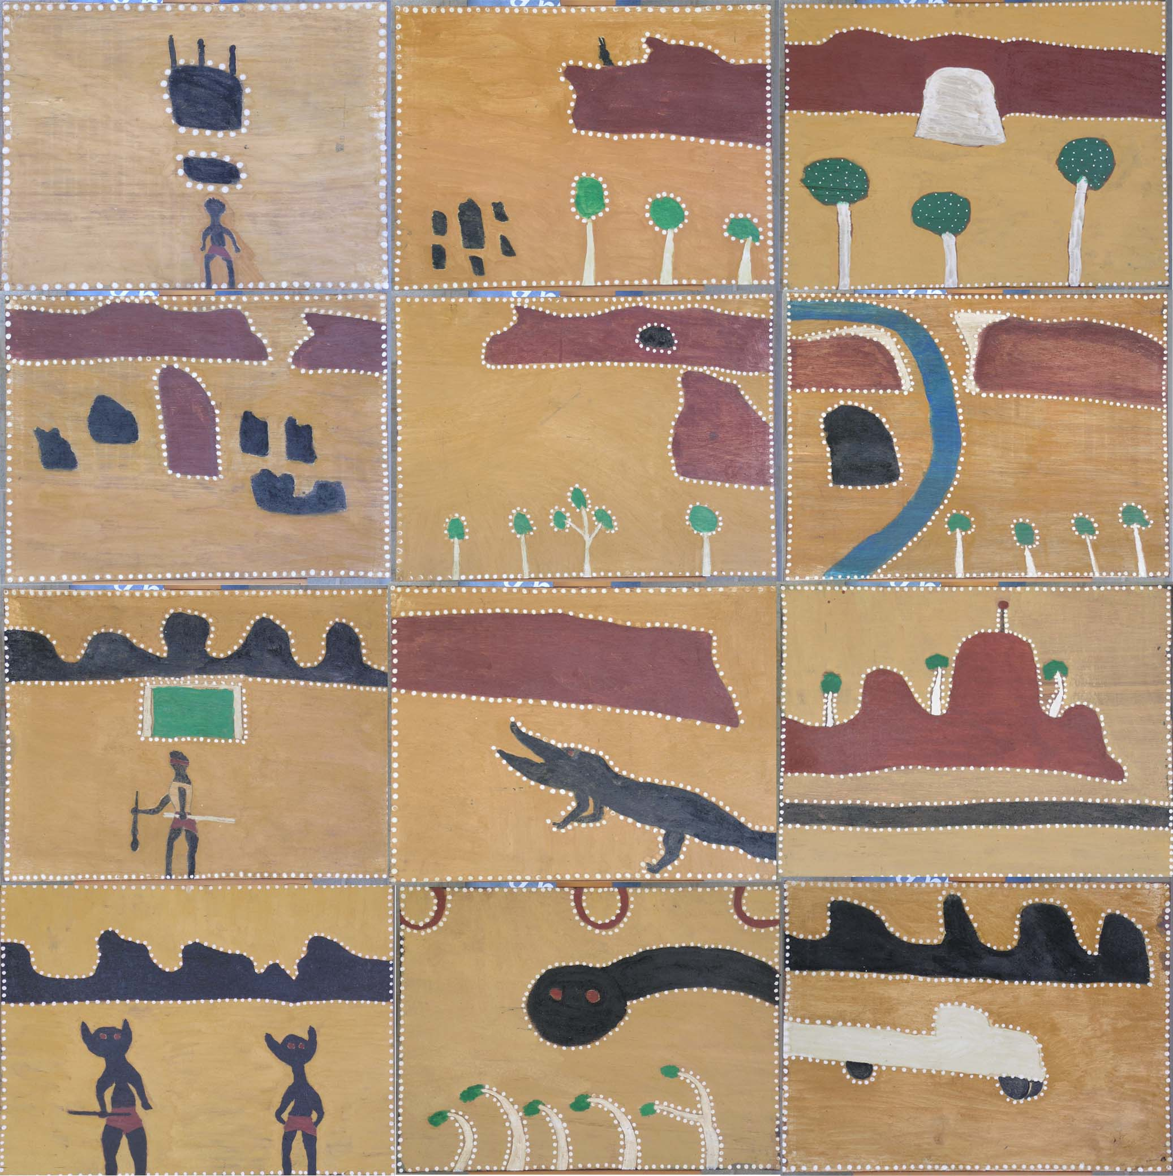
A set of 12 Gurirr Gurirr dance boards, created by Tiger Moore with Rover Thomas, East Kimberley, Western Australia, 1995, natural (Kimberley) ochres and binder on composition board, 60 x 80 cm each. Red Rock Collection, Western Australian Museum.

How to use this guide
This guide is in 6 parts:
- Part 1 provides an explanation of the Significance framework, its key principles and applications.
- Part 2 outlines how to conduct a significance assessment, record and report on findings, and develop a statement of significance. It includes a simplified version of the assessment process and criteria on page 27, along with a description of a model significance assessment process. This is supported by 2 sample statements of significance: one about a single item and one about a collection.
- Part 3 provides guidance on topics that have direct relevance to the significance assessment process, along with examples and case studies.
- Part 4 looks beyond the assessment process to explain applications of the Significance framework and its interactions with other systems, including collection management strategies, funding programs and legislation.
- Part 5 comprises a series of case studies contributed by Australian collecting institutions. These include statements of significance on a range of traditional and digital items, collections and cross-collection projects, as well as examples of how significance assessment applies to other aspects of collection management.
- Part 6 provides additional resources to assist with significance assessment, including a glossary of key terms, and a list of relevant publications and websites.
If you are new to Significance or a first-time user of this edition, it will be beneficial to carefully read Parts 1 to 3 before conducting a significance assessment. Then consult any sections of Parts 4 to 6 that relate to your specific circumstances. If you are familiar with the Significance methodology and contemporary collection management issues, you may wish to progress immediately to assessing items or collections and preparing significance assessments and reports using the model outlined in Part 2 and summarised on page 27.
This guide is specifically concerned with the assessment of significance. While it touches on other matters, please refer to the publications and resources listed in Part 6 if you need more comprehensive guidance on collection management practices.

Introduction
Significance: a guide to assessing cultural collections offers simple, practical and adaptable guidance. It explains how to assess the significance of cultural items and collections, and apply that information to achieve better collection management outcomes. The guide aims to assist anybody who works with cultural items. This includes individual and family custodians and collectors, traders and dealers (including auction houses), researchers, teachers and students, and the professionals and volunteers who run our community heritage organisations, historical societies, First Nations community-controlled organisations, cultural and knowledge centres, keeping places, galleries, libraries, archives and museums.
Significance focuses on the assessment of movable cultural heritage, meaning any reasonably portable item or collection of cultural significance. This includes everything from natural history specimens to fine and decorative art, documents, coins, medals, stamps, items of science and technology, archaeological items, and audiovisual and digital material.
Movable cultural heritage is deeply entwined with immovable cultural heritage (places, cultural landscapes, historic and archaeological sites, monuments, and buildings) and intangible cultural heritage (oral traditions, expressions, language, performing arts, social and cultural practices, knowledge, creative skills and artisanship). For First Nations items and collections in particular, meaning is often formed through connections to place, community and continuing cultural practice. As a result, this guide regularly prompts users to recognise, research and reinforce the enduring interrelationships between movable, immovable and intangible cultural heritage.
This edition of Significance builds on the theoretical framework developed by Dr Roslyn Russell, Kylie Winkworth and other cultural heritage specialists in Significance: a guide to assessing the significance of cultural heritage objects and collections (2001) and Significance 2.0: a guide to assessing the significance of collections (2009) https://www.arts.gov.au/sites/default/files/documents/significance-2.0.pdf. The Significance framework evolved from the Burra Charter (1979, revised 1981, 1988, 1999 and 2013) https://australia.icomos.org/publications/burra-charter-practice-notes/. The Burra Charter outlines the principles for evaluating and managing places of cultural significance. The first editions of Significance addressed the need for complementary principles for movable cultural heritage. Both editions were published with Australian Government support following extensive collaboration with professionals from across the collections sector.
Since its publication, Significance 2.0 has been in continuous use in Australia. It has also been translated into Indonesian, Portuguese, Spanish and Swedish, and inspired related international assessment processes.
In its submission to the National Cultural Policy, Revive, the Australian Museums and Galleries Association (AMaGA) noted that Significance 2.0 continues to be a highly regarded publication that supports capability within the cultural sector. Updating the guide was subsequently included as a Revive action (https://www.arts.gov.au/publications/revive-place-every-story-story-every-place).
Like its predecessors, this edition draws on sector expertise. To ensure continuity, Dr Roslyn Russell, an author of Significance 2.0 and an experienced significance assessor, was engaged to edit the guide in collaboration with the Australian Government’s Office for the Arts. The Office for the Arts sought feedback through a public consultation and targeted stakeholder engagement. Based on this input, this edition incorporates the following adjustments to the Significance framework:
- Adds the word ‘cultural’ to the ‘social or spiritual’ primary assessment criterion to ensure it captures ideas about non-religious cultural practices and expressions.
- Changes the primary assessment criterion of ‘historic’ significance to ‘historical’ significance.
- Expands the ‘artistic or aesthetic’ primary criterion to include ‘creative’ and ‘technical’ to better apply to non-art items and items that are significant due to their form and design.
- Emphasises that users can apply the framework flexibly and may regard provenance as a primary criterion in certain contexts, including in the archives sector.
- Separates the comparative criterion ‘rarity or representativeness’ into 2 distinct criteria to reduce confusion, as the terms can be seen as contradictory.
This edition responds to requests for information about a wider range of historical and contemporary items and collections relevant to a broader cross-section of society, including Culturally and Linguistically Diverse communities, and additional focus on First Nations cultural material. It also provides guidance by sector experts.
- Dr Kirsten Thorpe, Professor, Indigenous Archives and Data Stewardship Hub, Jumbunna Institute for Indigenous Education and Research at the University of Technology Sydney, has contributed a section on best-practice management of First Nations cultural heritage material (Part 3).
- Bronwyn Campbell, Senior Curator of Provenance at the National Gallery of Australia, has revised the information on provenance to ensure that it aligns with contemporary standards (Part 3).
- Dr Jessie Lymn, Senior Manager, Special Collections and Archives of the University of Newcastle Library, has contributed a section on significance assessment in archives (Part 3).
- Dr Roslyn Russell has provided a section on how to conduct a significance assessment (Part 2) and addressed calls to provide additional guidance about operating heritage (Part 3).
- Bridget Guthrie, Director of Tamworth Regional Gallery and Museums, has contributed a case study on how the Significance framework can help shape strategic responses to resource constraints (Part 4).
- Part 4 includes information on relevant legislation, and a section on funding by Rochelle Armstrong and Fiona Clarke, who manage the Australian Government Community Heritage Grants program.
Case studies, generously contributed by diverse Australian cultural heritage groups and organisations, are integral to the guide and help shape its message. The scope of these studies expands on previous editions to cover a more diverse, representative and balanced range of themes, perspectives, items and collections. Collectively, this material reflects Australia’s tremendous cultural diversity, and provides real-world examples of the value and adaptability of the Significance framework.
Finally, Significance has been updated to be more accessible and inclusive, and to align with the 5 pillars of Revive. It seeks to put First Nations First, help ensure there is A Place for Every Story, reinforce the Centrality of the Artist, provide support for Strong Cultural Infrastructure, and assist our cultural heritage managers in Engaging the Audience.

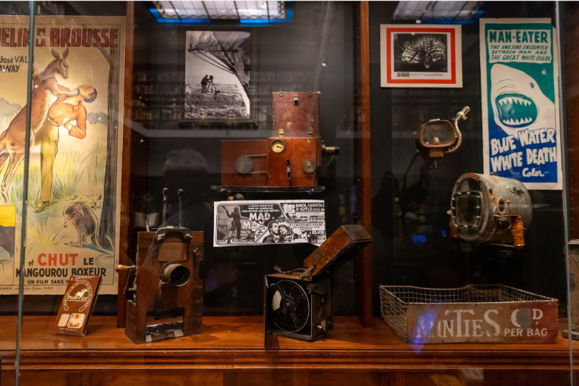
Display at the National Film and Sound Archive of Australia (NFSA) in Canberra, Australia

Part 1: The Significance framework
Significance refers to the meanings that cultural heritage items and collections have for people and communities – the stories they hold, why they are considered important, and what they can help us understand and experience. Significance can also be explained as the non-monetary values that items and collections have for past, present, and future generations. These values may be broadly described in more specific terms. For example, they may be cultural, social, spiritual, historical, artistic, technical, creative or scientific in nature, with individual items and collections often significant in more than one of these categories.

What significance assessment means
Significance assessment is the process of researching and understanding the meanings and values of items and collections. It seeks to explore all the elements that contribute to significance, including history, context, provenance, associations with people, activities, events and places, cultural and community knowledge, related memories and relationships with similar items. Beyond conventional catalogue description, significance assessment seeks to explain how and why the item or collection is important and what it means.
The Significance framework outlined in this guide provides a method to understand and express these meanings and values through research, analysis and assessment against a standard set of criteria. This information can then inform significance assessment reports and be synthesised into a statement of significance. A model statement of significance will present a readily comprehensible summary of the values, meanings and importance of the item or collection.
This framework is designed to:
- Apply to the full spectrum of movable cultural heritage collections in Australia.
- Encourage a multi-source, evidence-based approach to researching items and collections that includes respectful consultation with relevant individuals, groups and communities.
- Respect the rights, protocols, and decision-making authority of First Nations peoples in relation to their cultural heritage.
- Provide a structured and consistent way of expressing significance and comparing relative significance within and across collections.
- Be adapted to specific needs and contexts.
- Be applied critically and iteratively.
- Provide a useful tool for the effective management of items and collections.
The framework helps people to express the specific reasons and ways items and collections are important. It is broad enough to apply to multiple collection types. Its consistent structured approach facilitates accurate assessments, while allowing for meaningful comparisons with other items and collections. It is not intended to be prescriptive. Users are encouraged to apply the main principles of the framework and adapt the details to suit their own requirements, including understanding cultural protocols and community expectations.
This guide seeks to bring greater rigour and transparency to significance assessment. However, significance can be subjective and contested and should not be treated as static. Significance assessments are likely to change over time, with the emergence of new information, and in relation to broader shifts in social, cultural, political, legal, ethical and institutional values. Understanding and appreciation of significance will vary between people, depending on their perspective and relationship to the item or collection. As a result, this guide advocates that significance assessment should be an iterative process of ongoing research, critical reflection, and periodic re-evaluation. Anyone thinking about or assessing significance should also be mindful of potential biases in the information they obtain and their own evaluations.

Why significance assessment matters
Cultural heritage items and collections form a memory bank and a vital resource for current and future generations. They hold information about people, history, culture, societies, science, environment, technology and multiple forms of creativity. They give a sense of our place in the world and help explain how people, lands and identities have changed and evolved. It is essential that items and collections are not only looked after, but understood, interpreted and used in meaningful ways.
Significance assessment helps articulate and document the values and meanings of items and collections, which often reside with the people and communities connected to them. When it is appropriate to do so, this information can then be shared with others through publications, displays, exhibitions, educational resources and public programs that facilitate knowledge-sharing, enrich people’s lives and promote social cohesion and intercultural understanding.
Once the significance of an individual item is understood and documented, it is possible to make reasoned decisions as to whether it is appropriate for inclusion in a collection and how it should be managed, stored, conserved, interpreted and made accessible. When applied to multiple items in a collection, significance assessment becomes a powerful tool of sustainable collections management. By enabling comparison of the relative significance of items, it assists collection managers to identify areas of under- or over-representation in a collection, allocate resources effectively, rationalise storage and identify priorities for acquisition, deaccession, return or repatriation, exhibition, research, conservation and disaster preparedness.
Significance is a proven persuader. Clear statements of significance are commonly used to support successful acquisition and funding proposals, and to lobby for additional resources. Several Australian Government funding programs closely relate to Significance, including the Community Heritage Grants program and National Cultural Heritage Account. When adopted by multiple organisations, significance assessment can help foster collaboration between experts and organisations. In some cases, it has enabled institutions to work together to coordinate collecting activities across regions and networks. For more information on the strategic applications of significance assessment, refer to Part 4.

Who should assess significance
This guide equips anyone with the basic tools to undertake significance assessments of items and collections and prepare statements of significance, regardless of their professional background or experience with collections.
However, the assessment process will almost always involve working with others. For First Nations items and collections, assessments should be undertaken with, or ideally led by, the relevant communities who hold authority over their cultural heritage. Some First Nations cultural knowledge is restricted, and communities may choose not to share certain information or share it on the condition it is not made public. Information shared during consultation should only be recorded and used with the agreement of the community concerned and with a clear indication of how it can be used. Part 3 includes information on how to work with First Nations communities.
In cultural organisations, significance assessments are commonly conducted by trained heritage or collections professionals, such as historians, researchers, librarians, archivists, curators, First Nations cultural heritage workers, collection managers, registrars, and conservators. These professionals will often work together to complete assessments.
Individual custodians and collectors of cultural material can confidently manage the process themselves by adhering to the guidance in Part 2 and seeking advice and assistance as needed. Alternatively, they may wish to engage an experienced researcher or significance assessor where they have sufficient resources, and this is justified by the nature of the item or collection. In seeking assistance, it may be beneficial to first approach a local cultural organisation, such as a museum, library, archive, or art gallery, for advice on sources of information and general assessment processes. For First Nations items and collections, advice should be sought on identifying and engaging with the relevant community before the assessment begins.
Australia has a network of professionals with experience and specialist knowledge in significance assessment who can be engaged to carry out significance assessments based on a negotiated fee. As discussed in Part 4, some processes related to significance require qualified assessors, including:
- Export permits under the Protection of Movable Cultural Heritage Act 1986 are assessed by expert examiners.
- The Community Heritage Grants program provides funding for collecting organisations to engage independent assessors to determine the significance of items and collections
- Assessment by experts is part of the approval process for support under the National Cultural Heritage Account and Cultural Gifts Program.
There are various ways to identify suitable assessors. Good starting points include the coordinators of relevant funding programs, organisations that have completed a significance assessment, professional associations and registers of consultants maintained by peak bodies. Examples include the registers kept by Professional Historians Associations (https://www.historians.org.au/registers-of-consultants) and Museums and Galleries New South Wales (https://mgnsw.org.au/expertise/significance-assessment/). Some registers are only accessible to members of professional organisations, which may be worth joining to find the right assessor for an item or collection.
Regardless of who is leading the process, significance assessment is an opportunity to involve people in discussions about the meaning of items and collections. For many items and collections, relevant information is simply not available in books and published references and can only be discovered through consultation. The people to consult with will vary on a case-by-case basis but may include members of the community to which the item or collection relates (essential for First Nations items and collections), its maker, owner, donor or seller, scholars and experts in relevant fields, or collectors of similar material. More information on how to get the best out of consultation is provided in Part 3.

When to assess significance
Significance assessments may be conducted at any time. For private collectors, significance assessment is often most useful prior to or immediately after acquiring an item, or when seeking to sell, insure, import, export, donate or bequeath an item or collection.
In organisations, significance assessment will typically be used in tandem with other procedures. For example, it can be built into routine collection management activities relating to acquisition, cataloguing and documentation, digitisation, exhibition development, loan management and deaccessioning. See Part 4 for additional information on these processes and Part 6 for a glossary of key terms.
Ideally, significance assessment will be integral to broader strategic collection management processes. These include the development of collecting policies, storage and conservation audits, valuation activities and disaster planning. It is often useful to conduct significance assessments when applying for funding or seeking official recognition of items or collections through mechanisms such as local, state, or international heritage registers. For links to relevant registers, see Part 6.

A note on artificial intelligence (AI)
AI is now embedded in many significance assessment tools. Searching the internet will return AI results. There are increasing numbers of publications and digital resources written by or with the assistance of AI. Many repositories of research material use machine learning-enabled tools for cataloguing, image analysis, audio and video transcription and search functions.
AI can help make significance assessment easier by assisting assessors to find information and revealing links between cultural items and collections that were previously difficult to identify. However, it is important to be aware of the pervasiveness of AI and use AI tools with care. Always check the sources of information and quotations obtained with the assistance of AI. Wherever possible, consult the original publication or document. Seek multiple sources of research claims to check their validity and academic rigour.
It can be useful to apply AI to refine or summarise writing, but it is unlikely to provide a reliable assessment of significance. If using AI in this way, assessors should first develop informed opinions about the significance of items or collections, following the processes outlined in Part 2, so that they can judge the accuracy of AI-assisted content. Significance assessors may wish to record a statement on AI use, including where AI was not used, to promote rigour, transparency and accountability. Where AI is used to support a decision-making process, it is best practice to explicitly note how it has been used and ensure there is human verification and validation of that process. For further guidance on the use of AI in collection management, refer to the toolkit developed by the Museums + AI Network, a 12-month research project funded by the Arts and Humanities Research Council of the United Kingdom (https://themuseumsai.network/).
Care is required when using AI tools with respect to First Nations cultural material. Many AI systems are trained on large volumes of data scraped from the internet and digitised collections. They can ingest, reproduce, or generate content drawn from First Nations knowledge, including material that is restricted or sacred, without the consent of the communities to which it belongs. AI tools can also decontextualise, misattribute or flatten cultural knowledge in ways that misrepresent its significance.
As set out in the section on Indigenous Cultural and Intellectual Property (ICIP) in Part 3, communities hold the right to determine how their cultural material is accessed, used, reproduced and shared. This right extends to decisions about whether their material is entered into AI systems at all. Assessors should not upload, process, or generate First Nations cultural material using AI tools without the guidance and consent of the relevant community. They should be guided by the principles of Indigenous Data Sovereignty and the CARE Principles for Indigenous Data Governance (Collective benefit, Authority to control, Responsibility, and Ethics). For more information, refer to the website of the Maiam nayri Wingara Indigenous Data Sovereignty Collective https://www.maiamnayriwingara.org/.

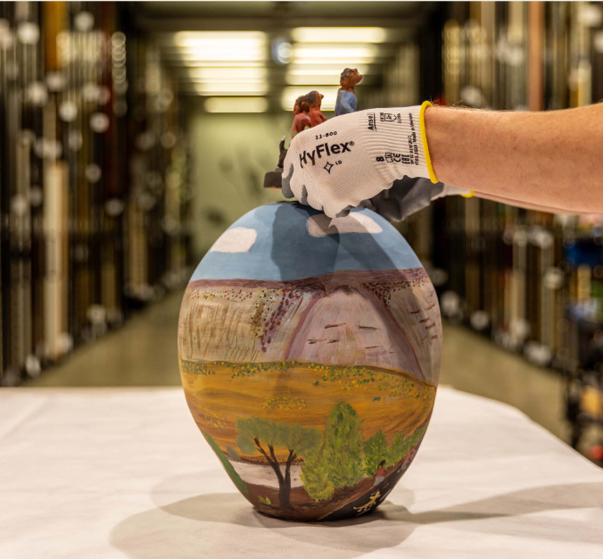
Conservator handling a ceramic work in the Artbank archives. Art credit: Delrose Armstrong, Walking With Family, 2019, terracotta and underglazes, 44.0 x 26.0 cm. Artbank Sydney collection store, 2024.

Part 2: The assessment process
Significance assessment should be a transparent, collaborative and iterative process. It involves bringing together diverse knowledge, research and expertise relating to items and collections, assessing this information comparatively and consistently, and developing a clear and meaningful statement of significance.
This guide does not aim to compete with or replace established collection practices, methods and procedures. Instead, it is intended to complement or enhance discipline-specific systems, such as the protocols and ethics that guide work with First Nations collections, standard cataloguing, archiving, and data management systems of archives, galleries, libraries and museums, and the practice notes used to manage technological, engineering and operating heritage.

Variations for items versus collections
Significance can be assessed for a single item, a group of related items, a discrete part of a collection, or a whole collection. A collection may comprise all the items held by an individual, family or organisation, or a selection of those items. It is common for collectors to identify a selection of the items they hold as a specified collection due to one or more factors. For instance, the items may have been assembled by the same individual, share an origin, be in the same media, or reflect a common concept or theme. In some cases, a collection may be split across more than one custodian or organisation.
The process outlined below applies to items and collections, with some variations when examining a collection. Assessing a collection will include analysis of some or all the items within that collection, and the details of how the collection was assembled. Assessors should identify and assess the most significant items in the collection, as well as the rationale for the collection, its intended scope, purpose, themes, and the people involved in its development and maintenance over time.
In some cases, a group of items will have additional significance because it is a collection. For example, ordinary items can assume greater significance if they were assembled by a prominent historical figure or relate to an important event. The items in a collection may also have enhanced meaning when they are considered collectively, such as the contents of a house illuminating the daily life of an era, or a selection of items demonstrating evolution in an artist’s work, or in a craft, trade or technological form.

Stages of significance assessment
The main steps in a typical significance assessment process include:

Stage 1: Research and information gathering
This includes:
- Documenting, describing and analysing the item or collection, including its condition.
- Consulting with relevant parties (see Part 3 for guidance).
- Researching the history, context and provenance of the item or collection (see Part 3 for guidance). This may include identifying gaps in information concerning the item or collection and further research or consultation that may need to be conducted.
- Comparing with similar items or collections.
- Collating all relevant information, including updating databases where relevant.

Stage 2: Assessment against the criteria
This includes:
- Drawing on information gathered to assess the item or collection against a consistent set of primary and comparative criteria.
- Recording outcomes of assessment.

Stage 3: Articulation of significance
This includes:
- Developing a statement of significance.
- Documenting findings in a significance assessment report, where appropriate.

Stage 4: Monitoring and evaluation
- Conducting additional research and considering any new information to determine whether a new significance assessment should be conducted. This evaluation may be conducted periodically, or as more information becomes available. Repeat the above steps as needed.
Items and collections often hold different meanings and values for different communities, professions, interest groups, and individuals. The significance assessment process encourages consideration of a range of sources so that multiple perspectives can be investigated and documented. Consultation is an essential part of this process that recognises the rights and interests of communities in their cultural heritage. It can reveal information that is not readily available in the public domain, as well as potential issues and sensitivities. This is especially the case when assessing cultural, social and spiritual significance, and when assessing material related to First Nations communities and material related to Culturally and Linguistically Diverse communities. Part 3 provides more detail on consultation, as well as specific considerations for consultation with First Nations community members.
There are example significance assessment case studies to support various aspects of the process in Parts 2 to 4 of this guide, and numerous further studies in Part 5. These include detailed examples of the assessment process in action, and information about the variations that can occur when assessing single items, collections and cross-collection projects.

The assessment criteria
This guide advocates using a simple and consistent set of primary and comparative assessment criteria to examine the cultural and natural values of items and collections. These criteria are detailed below, and a simplified version is on page 27. The primary assessment criteria assist in defining the reasons for which an item or collection has meaning and value – its inherent cultural significance. The comparative criteria moderate the primary criteria and help to evaluate the degree of significance.
When assessing significance, you should consider all the primary and comparative criteria. However, not all criteria will be relevant to every item or collection. It is not necessary to find evidence under all criteria to justify an item is significant. One or more primary criteria may apply and be interrelated. An item may be significant under all primary criteria, or only one. Any findings under the primary assessment criteria will be modified by any or all the comparative criteria, as they relate to the item or collection. The criteria are best applied in ways that reflect how the relevant community understands and expresses the significance of their cultural heritage, and this should always be the approach when assessing First Nations items and collections.

Primary assessment criteria
The primary criteria are listed below, accompanied by simple explanations and example questions to guide understanding and assessment.

Cultural, social, or spiritual significance
The ongoing cultural, social, spiritual, or religious values and meanings an item or collection has for an identified group of people, which will often be part of a longstanding tradition. Note that the group may be formal or informal and united by diverse factors, including identity, place, beliefs, languages, interests, or social issues.
- Does the item or collection have special value for a specific community, group, or sector of society? Why is it important to them?
- How is its significance demonstrated or kept alive by the community?
- Does it have a strong link to intangible cultural heritage (beliefs, ideas, customs, traditions, practices, language, stories) that are important for a specific community or group?
- Does it have a strong link to forms of immovable cultural heritage (cultural landscapes, sites, places, or monuments) that are important for a specific community or group?
- When consulting the relevant community, how do they explain the item or collection and its importance?

Historical significance
The values and meanings an item or collection has in relation to a known person, group, place, event, activity, or period in history, and how it assists understanding of the past. Note that items or collections that do not have ongoing significance under the other primary criteria may still have historical significance, such as a religious item that is no longer in active use or an obsolete technological item.
- Is the item or collection associated with a historical person, family, community, group, industry, event, activity, or place, and how and why is this important?
- Does it tell us something about a historical event or theme?
- Does it represent or contribute to understanding of a historical period, place, or language?
- Does it have a strong link to immovable cultural heritage of historical relevance, such as a historic site, monument, or building?
- For First Nations items and collections, does its historical significance rest on oral tradition or continuing connection as well as documentary evidence?

Aesthetic, artistic, creative, or technical significance
The value an item or collection has due to its visual impact, artistic quality, technical accomplishment, artisanship, design, or power to evoke an emotional response. While this criterion is most often associated with art, craft, and design, it can apply to any item or collection. Equally, a work of art can have little or no significance under this criterion.
- Is the item well designed, crafted or made?
- Is it original or innovative?
- Does it exemplify a style, design, art movement, or the work of an artist, craftsperson or collective?
- Does it show a high degree of creative or technical accomplishment?
- Does it creatively depict a subject, person, place, activity or event that is of interest or importance?
- For First Nations material, are its aesthetic or design qualities connected to cultural meaning, knowledge, or Indigenous Cultural and Intellectual Property held by the community?

Scientific or research significance
The current significance, or research potential, an item or collection has for a field of research, such as the sciences, social sciences, humanities, linguistics, or the arts. This criterion focuses on the item’s capacity to advance knowledge through ongoing investigation.
- Do researchers have an interest in studying, collecting, or obtaining data from the item or collection?
- How is it of interest or value to science or another field of research?
- Does it have research potential, and in what way?
- Which aspects of the item or collection constitute its scientific or research interest and value?
- Does the relevant community support or wish to lead research involving the item or collection?
Research involving First Nations items and collections should proceed with the consent and agreement of the relevant community and in accordance with community protocols. Communities may also identify their own research priorities for their cultural heritage.

Comparative assessment criteria
The comparative criteria are listed below, accompanied by simple explanations and example questions to guide understanding and assessment.

Provenance
Provenance may be considered a primary assessment criterion in some contexts. For example, in the archives sector, items or collections with little or no intrinsic value under the 4 primary criteria may have considerable overall significance due to their provenance. In other collecting areas, provenance is also becoming an increasingly important factor in determining whether an item is significant in and of itself.
Provenance refers to the history and ownership of an item from the time of its creation to the present. It includes information about its origin, movements, chain of ownership and contexts of use. In many cases it will not be possible to reconstruct a complete, fully documented provenance of an item, but any information can be relevant.
- When, where, why and by whom was the item or collection made, found, assembled, or established?
- What documents support its provenance and how reliable are they likely to be?
- How does provenance information shape the meanings and values of the item or collection?
- How was the item or collection removed from its community or place of origin, and was this with community consent?
- Are there any legal or ethical questions or issues related to the transfer and ownership of the item or collection over its history?
Establishing the provenance of a collection requires research into the items in the collection and the collection itself. Part 3 provides guidance on how to conduct provenance research.

Rarity
The relative rarity of the item or collection.
- Is this item or collection singular, unique or endangered?
- Does it have special qualities that distinguish it from similar examples?
- What sets it apart from other examples?
- Is it one of few surviving examples of this specific item or collection?

Representativeness
How well the item or collection exemplifies its type, era, or cultural or social context.
- Is the item or collection a typical or characteristic example of its type or class?
- Is it particularly well documented for its class or group?
- Is it representative of an item used in a specific context or era?

Condition or completeness
The physical state the item or collection is in, and how complete it is in relation to its original condition. An item in its original unrestored condition will often be considered more significant than a heavily restored example. However, items that have been appropriately conserved can be just as significant as original examples, or more so when the original has degraded. There can also be value in restoration that enables an item to continue to operate as originally intended. For more discussion on this topic, see the section on operating heritage in Part 3.
- Is this item or collection in good condition for its type?
- Is it intact or complete?
- Does it show evidence of the way it was used?
- Does it show repairs or alterations, and do these contribute to or detract from its significance?
- Is it still operational?
- Is it in an original and unrestored condition?
- Does the condition of the item affect its interpretation?
- Does the condition of the item indicate its importance to the community?

Interpretive capacity
The potential or capacity of an item or collection to effectively demonstrate, illustrate, teach, or communicate themes, stories, concepts and historical narratives to an audience.
- Does the item or collection assist in explaining or interpreting an aspect of culture, history, science, or research?
- Does it have the capacity to support the relevant community to revitalise a tradition or cultural practice, including an art form, craft or trade that is no longer widely practised or endangered?
- Does it assist in telling the story of a person, place, historical period, or creative process?
- Is it relevant to the mission or purpose of the organisation that holds it, and does it help communicate that mission or purpose?

Examples of simple assessments against the criteria

Ornamental mantelpiece clock, collection of the Museum of Australian Democracy at Old Parliament House
This ornamental mantelpiece clock was presented to Sir Edmund Barton (1849-1920), Australia's first prime minister (1901-1903), by officers of his department, the Department of External Affairs. It is inscribed to Barton personally and was given as a retirement gift in 1903, when he left office to become a founding judge of the High Court of Australia. The clock is of historical significance through its association with Barton and its reflection of the esteem in which he was held by his department. As Australia’s first prime minister, the Minister for External Affairs and the leading figure of the federation movement, Barton helped to define and shape Australia’s democracy and its place on the world stage. The clock is of aesthetic and technical significance as a good example of a clock in the French champlevé enamel style. This significance is enhanced by the item’s provenance, condition and interpretive capacity.

Yowah Moon, National Mineral and Fossil Collection, Geoscience Australia
Yowah Moon is an exceptionally large and well-formed example of a Yowah Nut, a rare type of opal found in natural ironstone nodules near the remote outback town of Yowah, southwest Queensland, Australia. It was discovered in 2020 by David Darby, a Waanyi/Garawa First Nations miner whose father started mining Brandy Gully in the 1970s. The opal has historical and cultural significance due to its connection with Australian opal mining and associations with Yowah, and spiritual significance for First Nations peoples (ABC News, 10 March 2024: https://www.abc.net.au/news/2024-03-10/rare-yowah-nut-opal-queensland-national-museum-canberra/103548960). The opal also has research significance as a specimen of Australia’s geology and aesthetic significance due to its avocado-like shape and vibrant colours, with flashes of blue and green. Its rarity and provenance increase its significance relative to other opals.
The Yowah Moon was acquired by Geoscience Australia in 2024 for the National Mineral and Fossil Collection with the support of the National Cultural Heritage Account, which is discussed in Part 4.
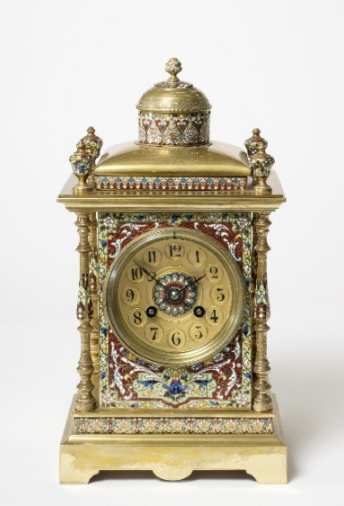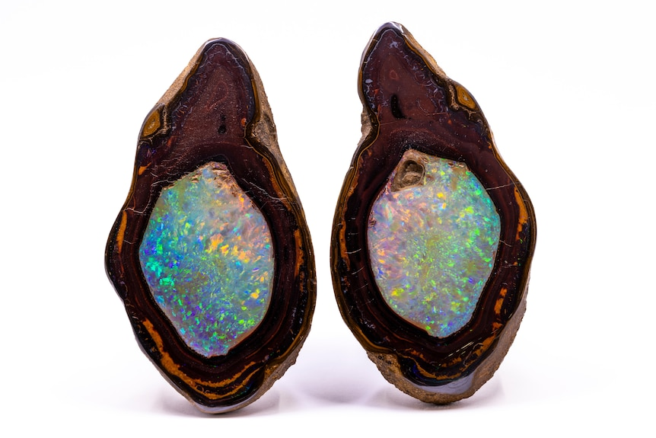
Left: Ornamental mantelpiece clock, c. 1903, presented to Australia’s first prime minister, Sir Edmund Barton. Museum of Australian Democracy at Old Parliament House (IL14.15.01).
Right: Yowah Moon opal, precious opal infilling an ironstone concretion known as a ‘Yowah Nut’, found by David Darby at Brandy Gully Mine near Yowah, Queensland, 2020, opal and ironstone, approximately 400 grams. Purchased by Geoscience Australia with funding from the National Cultural Heritage Account. Image copyright Geoscience Australia CC BY 4.0.

Recording and sharing results of significance assessment
It is important to keep good records of the full significance assessment process. This includes notes on the outcomes of all research and consultation, details of when, where, and by whom the assessment was made, and information on all sources consulted, through references and copies of relevant images and original documents. This information provides evidence of claims about significance, and a strong foundation for the monitoring and evaluation step of the assessment process. It may also be helpful to document any inconclusive findings, or gaps in knowledge, to further support monitoring and evaluation.
For private collectors, this type of information can be stored in hard-copy or digital formats. It is helpful to group information in files named to enable easy identification and retrieval. Most collecting organisations will keep digital records and track information about collections in spreadsheets or databases. These systems usually include fields for different aspects of the significance assessment process and may allow the attachment of files and supporting documentation. Some organisations will be able to keep all relevant information on a central collection management system. When this is not possible, collection managers should follow logical filing systems and naming conventions to ensure all relevant information can be easily found and linked.
Material relating to significance assessments of First Nations items or collections may be subject to specific cultural access protocols, such as women’s or men’s business, and some communities may not want material accessed or shared publicly. Access protocols should be recorded. Where they are not known or unclear, it is important to consult relevant communities. Further guidance on this process is provided in Part 3.
How information regarding significance is shared will depend on the individual custodian or collecting organisation and may include print or digital publications and interpretation material. Outcomes of assessments are often modified or truncated for use in labels, wall texts and online listings. To make items and collections more discoverable, and to promote connections across collections, organisations typically follow structured naming conventions and use keywords. Some of the statements of significance in this guide include keywords to exemplify this practice.
Some significance assessments are shared through cultural heritage registers. Different registers will structure the information differently. Examples include the United Nations Educational, Scientific and Cultural Organization (UNESCO) Australian Memory of the World Register and state and territory heritage registers, which are listed in Part 6.

Significance assessment reports
To record all findings of a significance assessment, it is often useful to produce a significance assessment report. The formality, structure and length of this report will depend on the context and purpose of the assessment. A useful report will include:
- A clear description of the item or collection.
- Information about the broader collection in which it is held.
- A summary of all relevant information collated through the research and information gathering stage.
- A statement of significance that references the primary and comparative assessment criteria.
- A list of all relevant sources and references that includes authors and dates, so that conclusions are supported by research and evidence.
- Additional supporting evidence, including copies of relevant documents and images.
- A list of recommendations regarding the care, interpretation, or promotion of the item or collection.
For collecting organisations, a significance assessment report will often bring together information held in various fields of a centralised collection management system or database. Where possible, it is good practice for the full report to be kept on the database as an attachment.
As significance assessment reports are tailored to meet various needs, this guide does not recommend a specific format. Where reports are required for a purpose such as a cultural heritage register or funding program, seek guidance on the preferred reporting style. In many cases, there will be a set template to follow, as is the case for the Australian Government’s Community Heritage Grants program discussed in Part 4. Published reports can serve as useful guides, with a range of examples listed in Part 6.

Statements of significance
A statement of significance is a useful tool with a range of applications. An effective statement is a reasoned and readily understandable summary of the values and meanings of an item or collection that explains how, why and to whom it is important. It is more than a description of the physical qualities of an item or collection and when and where it was made. It is an argument about the significance of the item or collection, which incorporates all the elements that contribute to meaning, including appearance, fabric, design, context, environment, history, provenance, uses, function, social relevance, cultural and community knowledge, and connections to immovable and intangible cultural heritage.
Statements of significance are supported by the research, evidence and analysis assembled through the first 2 stages in the assessment process – conducting research on the item or collection, its history, context and provenance, consulting with relevant parties, looking at how the item compares with similar items, and considering the relevant assessment criteria.
Part of stage 3 of the assessment process, a statement of significance may be a few sentences, a single succinct paragraph, several concise paragraphs, a page, or longer. The length and level of detail will depend on the nature, size, and complexity of the item or collection, the circumstances and purpose of the assessment, and the available time, skills and resources of the assessor.
A statement of significance can serve as a reference point for the policies, actions, and decisions regarding an item or collection. It is a means of sharing knowledge about why an item is important and why it has a place in your collection. Ideally, the statement of significance should be developed and finalised with individuals, groups and communities that have an ongoing relationship with the item or collection, and this should always be the approach when assessing First Nations items and collections. Statements of significance should be reviewed from time to time as circumstances change and new information is known. This review process is part of the monitoring and evaluation (stage 4) of significance assessment.

Levels of significance
When assessing significance, it is important to think about the people that the item or collection is significant to. An item may have significance to only a narrow sector of society or much broader significance. Some items and collections will have a level of significance that can be described as national or international significance. This guide is designed to assist in assessing all levels of significance. An item does not have to be nationally or internationally significant to hold meanings and values. For First Nations items and collections in particular, significance to the relevant community is primary and not diminished by whether the item is also significant at a state, national or international level. However, in some circumstances it will be important to clearly establish what level of significance an item has.
In Australia, there are mechanisms to help protect and conserve highly significant items for the benefit of all Australians, now and in the future. These include legislation, funding programs, and heritage registers that apply only to items and collections at specified levels of significance. As explained in Part 4, the Protection of Movable Cultural Heritage Act 1986 prevents the export of certain items and collections that are determined to be of such importance to Australia, or a part of Australia, that their removal would significantly diminish the cultural heritage of Australia. The Community Heritage Grants program provides funding for items and collections that demonstrate national significance. Heritage registers have a range of thresholds. For example, the UNESCO Australian Memory of the World Program honours documentary heritage of significance for Australia and the world.
These mechanisms have their own objectives and functions and there is currently no single definition of national or international significance. This can make it difficult to identify what makes something significant at the national and international levels, or so significant to Australia that it must be retained. An item will not be nationally significant just because it was made in or relates to Australia. To be nationally or internationally significant, an item or collection will have special meanings and values, outstanding qualities or a demonstrated influence on other aspects of life, history and culture.
Determining national or international significance in accordance with the Significance framework requires research, analysis, and assessment against the primary and comparative criteria. A thorough understanding of the context, cultural values, history and provenance of the item or collection is vital, enabling it to be placed in a broader national or international context. An item or collection of national significance will often be significant under more than one criterion, enhanced by one or more of the comparative criteria. The item or collection will generally also be significant to a broad range of people.
A well-argued assessment of national significance involves high-level research and a deep knowledge of the subject, supported by references, comparative examples, and consultation with appropriate people and communities. Comparative assessment is a particularly important element in establishing national significance because it demonstrates how an item or collection compares with similar material. Where a level of significance is identified, it is recommended that the reasons for this be clearly articulated in the statement of significance.
In deciding whether something is nationally significant, it can be useful to first consider whether it is important to:
- Only select individuals or families
- A specific or niche interest group
- A localised community
- Communities across larger regions, including states and territories
- People across the nation, or to national identity
- People across the world.
Once this is established, further guiding questions to determine potential national significance include:
- What impact has this item or collection had on Australian or world history and culture?
- Why is this item or collection important to Australians?
- Is the item or collection of broad significance to First Nations peoples, or to the nation's understanding of First Nations histories, cultures, and continuing connection to Country?
- What impact has it had on life, culture, and identity beyond the boundaries of a state or region?
- Why is it important to the memory of Australia, and why would its loss diminish the nation's heritage?
- Is the item or collection exceptional in comparison to other examples due to its provenance, condition, rarity, or opportunity for interpretation?
- How can the item or collection be further investigated or researched to reveal new information that relates to the nation, or the national interest?
- Is there an active interest in and use of the item or collection by Australians?

An example of a nationally significant item: Crab Creek, Bow River Station, created by Freddy Timms, East Kimberley, Western Australia, 2012, natural (Kimberley) ochres and binder on 3 canvases, 120 x 90 cm each. Red Rock Collection, Western Australian Museum.
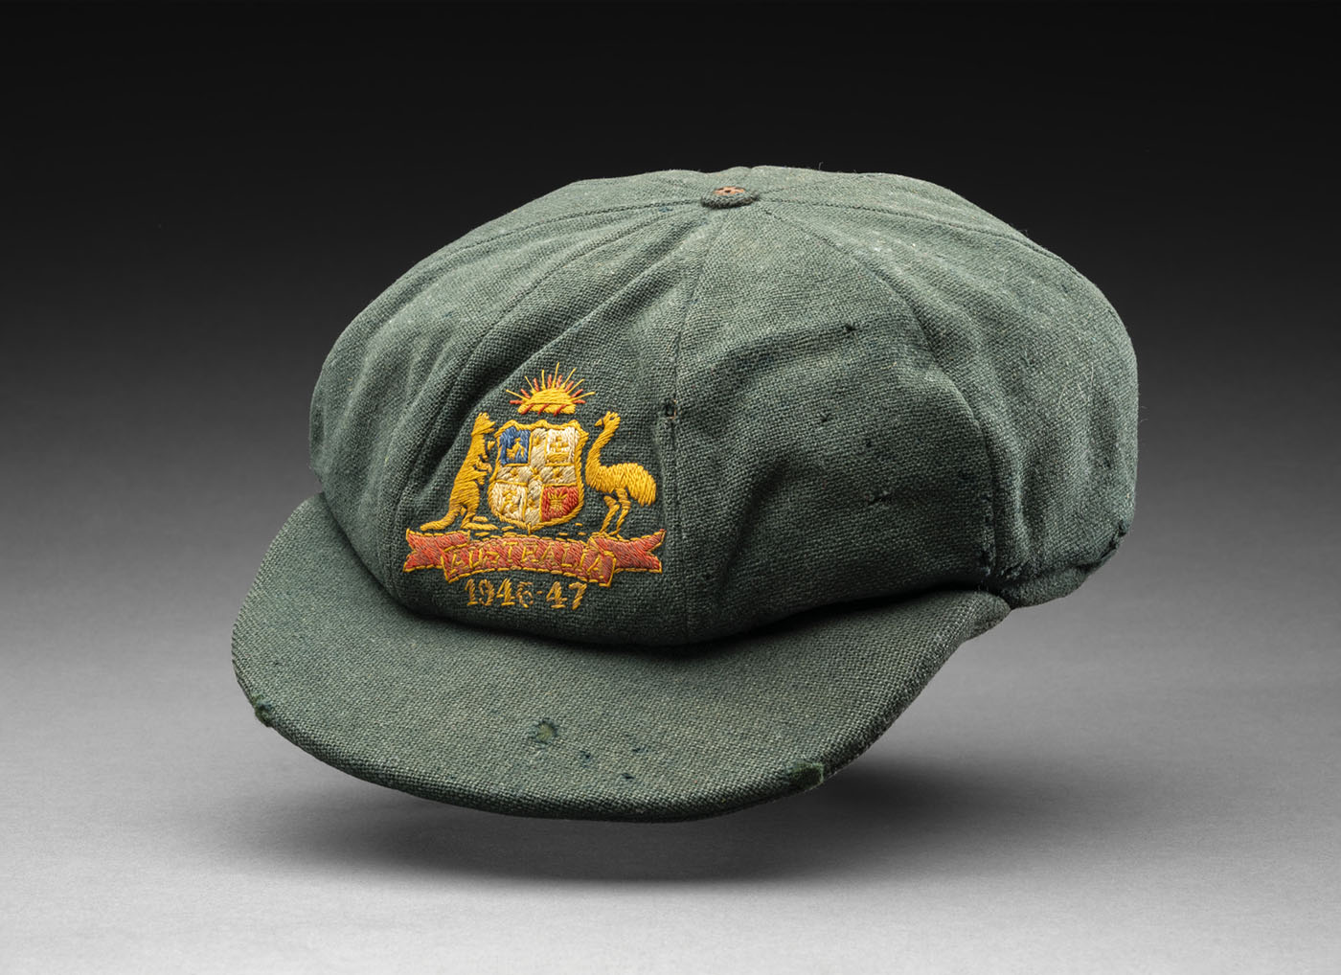
An example of a nationally significant item: Baggy green, a cricket cap worn by Sir Donald Bradman during the 1946–47 Ashes tour of Australia. Acquired with the support of the National Cultural Heritage Account. Collection of National Museum of Australia, Canberra.

Summary of significance assessment process and criteria

Stage 1: Research and information gathering
- Document, describe and analyse the item or collection, including its condition.
- Consult with relevant parties.
- Conduct research into the history, context and provenance of the item or collection.
- Compare with similar items or collections.
- Collate all relevant information, including references and supporting evidence.

Stage 2: Assessment against the criteria
- Assess the item or collection against the primary assessment criteria. Determine whether its significance fits in one or more of the following categories:
  - Cultural, social, or spiritual
  - Historical
  - Aesthetic, artistic, creative, or technical
  - Scientific or research.
- Determine the relative level of significance of the item or collection by assessing it against the following comparative assessment criteria:
  - Provenance
  - Rarity
  - Representativeness
  - Condition or completeness
  - Interpretive capacity.
- Record the outcomes of your assessment.

Stage 3: Articulation of significance
- Develop a statement of significance.
- Document findings in a significance assessment report, where appropriate.

Stage 4: Monitoring and evaluation
- Conduct additional research and consider any new information to determine whether a new significance assessment should be conducted. Repeat the above steps as needed.

General hints on significance assessment
- It is important to conduct research and consultation and assemble all relevant information on the item or collection before starting the statement of significance. This will help ensure that the supporting material functions as a reference point for crafting the statement of significance, rather than the other way round.
- Gather descriptive, contextual, and provenance information about the item or collection, as well as relevant texts, images, references to similar items, and material about the period, and related immovable and intangible cultural heritage.
- Think about the individuals, groups, and communities to whom the item is significant, and how broadly that significance applies, and include this information in your statement.
- Significance assessment is a collaborative process. Confer with knowledgeable people or form working groups to seek ideas and obtain feedback on draft statements.
- The final statement of significance will be most useful if it synthesises the whole story of the item or collection into a readable and accessible summary.
- While the most effective statements of significance are in simple accessible language, it can be useful to use sub-headings and dot points during the drafting process to assist in capturing the key elements of significance.
- When developing the statement, it can be beneficial to explain the significance of an item or collection under headings listing each of the applicable primary and comparative assessment criteria.
- If you consulted with anyone in developing a statement of significance, it is best practice to share it with them and check that their views are accurately represented prior to finalisation. For First Nations items and collections, the statement should be finalised in partnership with the relevant community.
- List all relevant sources and references so that the conclusions in the statement of significance can be supported by research and evidence.
- Identify key contributors and the author of the significance statement and note when it was written.
- In some cases, you may wish to specify whether an item or collection is significant at a local, regional, state, national or international level, such as when applying for grants, considering the applicability of legislation, or seeking inclusion on a heritage register (see Part 4 for more information).

Case study 1: Example of how to conduct a significance assessment
The following case study outlines the process of assessing the significance of a single item. It uses the example of an assessment of Mary Taylor’s wedding dress from 1800 in the collection of the Bathurst District Historical Society (BDHS), which was supported by the Community Heritage Grants program.

Stage 1: Research and information gathering
The first steps in the process of a typical significance assessment include assembling all the available information about an item, through research, consultation and comparison with similar items.

Document, describe and analyse the item
Write a description of the physical characteristics of the item, including its condition.
The oldest garment in the BDHS Textile Collection is a wedding dress in white cotton muslin in classic empire-line style. The wedding dress features 3 motifs, consisting of 3 dots, a bulrush and sprigs, incorporated into the material. It measures 60 cm at the chest, and 101 cm from the front waist to the hem. The dress is unusual in that it does not have a front. Instead, a lace shawl or fichu would have been worn to cover the breasts, fastened with a brooch. While this dress is not of Australian origin, and there is no proof it was worn in Australia until the century after its first wearing in 1800, it is believed to be the oldest extant wedding dress in an Australian collection.
The excellent condition of the dress was ascertained in a physical examination of the garment in the BDHS storage annex.
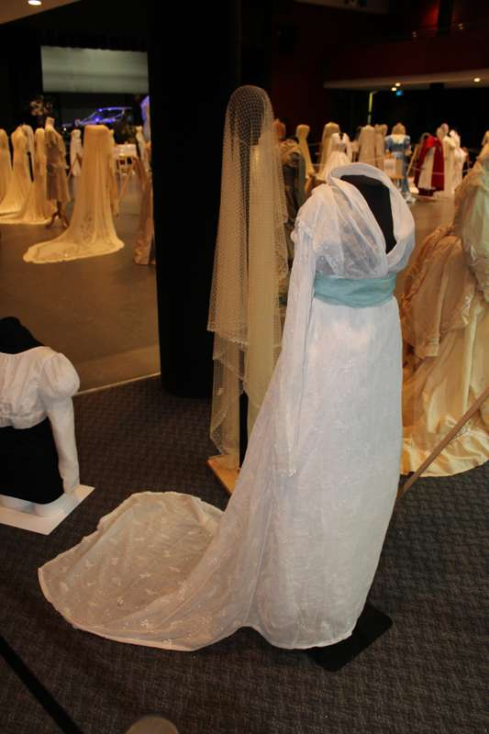
Wedding dress of Mary Taylor, created in the United Kingdom, 1800 or before, cotton muslin, 60 cm at chest; 101 cm from front waist to hem. Collection of the Bathurst District Historical Society.

Consult with relevant parties
Obtain information from people with knowledge of, or a connection to, the item or collection.
The dress is cared for by a dedicated team of volunteers in the BDHS Textile Group, who shared their views of its significance with the significance assessor. A member of the Houghton family (see provenance information below) who works in the heritage area and is familiar with both the dress and the provenance to the Houghton family was also consulted as a knowledgeable person.

Conduct research into the item’s history, provenance and context
Establish provenance. Providing details of the provenance of an item is a vital step in assessing its significance. Provenance is also a comparative criterion. Telling the life story of the item, from its creation and first use to its place in a collection, is key to establishing its significance.
The information on the item was primarily researched using a book by Sarah Swift, 75 Treasures: Celebrating 75 years of the Bathurst District Historical Society (2023), as well as by consulting catalogue records. Other documentation on historical costumes, including the significance assessment of the National Trust of Australia (NSW) Costume Collection, was also consulted.
Provenance research revealed that the dress was worn by Mary Taylor (1777–1832) when she married Benjamin Boden (1770–1838), a jeweller, at St Martin’s Church in Birmingham, United Kingdom, on 14 July 1800. The description of Mary Taylor’s wedding dress and its detailed provenance is found in the 75 Treasures: Celebrating 75 years of the Bathurst District Historical Society (2023). BDHS holds the provenance documentation for the dress.
George Dudley Houghton, Mary Taylor’s great-grandson (1872–1911), brought the dress to Australia when he emigrated to Western Australia from the United Kingdom. In 1902, George married Ethel Smith, a granddaughter of Samuel and Ethel Smith from the Mulgunnia property in the Bathurst district. Family members believed that the dress had been worn there at garden parties. The dress stayed in family ownership until one of George and Ethel Houghton’s 2 daughters, Joyce, donated it to the BDHS collection in 1962. Members of the Houghton family outside Bathurst retain a keen interest in their ancestor’s wedding dress and have visited the collection to view it.
Interpret the item. One of the key uses of collection items is their display to the public. This depends on 2 major factors: is a collection item in a sufficiently good, or interesting condition, to be put on display? And does it have a story that will interest visitors? Even if the item is in a fragile condition, are there other ways in which its story could be told, including using digital media? This research or analysis is useful for indicating the interpretive capacity of the item.
Mary Taylor’s wedding dress is an attractive garment in excellent condition, indicative of wedding dress designs of the early 19th century and is very suitable for display. The story of its journey from England to Australia, and its subsequent life here as an item valued and worn by members of the Houghton family, also interests visitors. The wedding dress has been displayed in exhibitions including Love, Desire, Riches at Old Government House, Parramatta in 2015, National Trust of Australia (NSW); Reflections, celebrating Bathurst’s centenary in 2015; and Getting Hitched: 200 Years of Wedding Gowns and Paraphernalia 1800–2012, Bathurst, May 2018. It is also displayed at Bathurst District Historical Society Museum.

Compare with similar items
Comparing the item with similar examples is another important step in determining its significance. Information about many collection items is online, making searching for comparative examples much easier than was the case in the past.
A search for comparative examples for Mary Taylor’s wedding dress in other collections that hold dress items of a similar age located a dress worn by Anna King, wife of New South Wales Governor Philip Gidley King. This dress, dated to 1805, is claimed to be one of the earliest-known surviving garments worn in colonial Australia, and ‘provides evidence of British dress codes maintained by genteel members of the penal colony that reflects status and privilege.’ It also ‘records the trade networks between Australia and India, the home of fine muslin production’ (Cramer 2023: 9). The dress is in the collection of the National Trust of Australia (NSW).

Stage 2: Assessment against the criteria
Consider how and why your item meets the significance criteria. Study the primary and comparative criteria set out in the framework carefully and decide whether your item relates to one or more of them. Only the significance criteria that are applicable to an item should be cited in the statement of significance.
In the case of Mary Taylor’s wedding dress, the relevant primary criterion is historical significance, while the comparative criteria that apply are provenance, rarity, representativeness, condition, and interpretive capacity. The statement of significance below demonstrates the way in which these criteria are described in relation to Mary Taylor’s wedding dress.

Stage 3: Articulation of significance
Summarise your findings and write a clear statement of significance. While the assessment may result in a lengthy report, try to keep the statement of significance brief and use accessible language. Include the name and qualifications of the assessor and the date of assessment. It may be useful to list significance assessment criteria and keywords. References can be included with the statement or recorded elsewhere.
Statement of significance
Contributed by: Dr Roslyn Russell, Independent significance assessor
Organisation: Commissioned by Bathurst District Historical Society
Dated: June 2026
This wedding dress in white cotton muslin in classic empire-line style was worn by Mary Taylor when she married Benjamin Boden in Birmingham, United Kingdom, in 1800. The dress was brought to Australia by Mary Taylor’s great-grandson, George Houghton, and was donated to the Bathurst District Historical Society by a Houghton family member in 1962.
The dress is of national historical significance as the oldest documented wedding dress in an Australian collection. It is an example of a classic empire-line style, and made of muslin, a popular fabric at that time.
A dress of this age is a rare survivor in Australian museum collections, and it is also a representative example of wedding dress fashions at the beginning of the 19th century in England. It is significant for its well-documented provenance that can be traced through the Houghton family line. It can be compared to a dress from 1805 in the National Trust of Australia (NSW) collection that is another early surviving garment from colonial Australia. The dress has been well cared for over its 2 centuries of existence and is in excellent condition. It has considerable interpretive capacity and has featured in several survey exhibitions of historical textiles in New South Wales.

Keywords:
Wedding dress, textile, costume, garment, Bathurst, New South Wales, historical society, Community Heritage Grants, national significance.
Significance criteria:
Primary criteria: Historical
Comparative criteria: Provenance | Rarity | Representativeness | Condition | Interpretive capacity
References
- Cramer L (July 2023), Significance Assessment – Dress Collection, National Trust of Australia (NSW).
- Swift S (2023), 75 Treasures: Celebrating 75 years of the Bathurst District Historical Society.

Stage 4: Monitoring and evaluation
Conduct additional research and consider any new information to determine whether a new significance assessment should be conducted. Repeat the above steps as needed.
While following the significance assessment process has resulted in the development of a clear and accurate statement of significance for this item, the significance assessment process is never truly over. As new information becomes known, societal attitudes and values shift, and new custodians encounter items, it is important to revisit – and in some cases redraft – significance statements to ensure they reflect these changes.

Case study 2: A statement of significance for a single item

The Hobbit (1982), a computer game for Sinclair 48K ZX Spectrum, in the collection of ACMI (Australian Centre for the Moving Image)
Contributed by: Ben Abbott, Time-based Media Conservator, Registration & Collections
Organisation: ACMI
Dated: January 2026
The Hobbit is an illustrated interactive computer game, first released in 1982, adapted from JRR Tolkien’s original 1937 classic fantasy novel. Players take on the role of the novel’s central character, Bilbo Baggins, and roam freely through Middle-earth on a dangerous and exciting adventure.
Developed by Beam Software and published by Melbourne House, The Hobbit was one of the first highly successful commercial computer games produced in Australia. Originally released on cassette tape for the Sinclair 48K ZX Spectrum microcomputer, the game was subsequently adapted and updated for other systems including Amstrad CPC, BBC Micro and Commodore 64. In accordance with the licensing arrangement between Melbourne House and the Tolkien estate, a copy of the original novel was included with every purchased game.
The Hobbit was notable for its sophisticated technical features that set it apart from earlier text adventure games, such as the influential Colossal Cave Adventure. A complex ‘Inglish’ language database and message engine enabled full sentences and questions in the game’s interface, possibly the first to allow the use of adverbs (Maher 2012). A text-based physics system was also developed whereby in-game objects had associated sizes, weights, and the ability to be placed on top or inside other objects, making for more dynamic interactivity (Megler 2014). Beam Software’s co-founder, Alfred Milgrom, said ‘the environment had its own logic’ (ACMI 2006). Non-playable characters (NPCs) were programmed to move and behave independently in real-time with a degree of randomisation, in what is considered an early example of emergent gameplay, producing unexpected variations between multiple play attempts.
Known for having a multitude of bugs, the game presented a persistent challenge for the developers and players alike. The complex game world and autonomous NPCs meant specific situations were not easily replicated, making the job of detecting and eliminating programming issues exceedingly difficult. The instruction manual addressed this issue, stating ‘it is impossible to guarantee that it will ever be completely error-free.’ An updated Version 1.1 was developed and released with some issues resolved. However, this version also introduced a new critical error which prevented players from winning the game, prompting Version 1.2 to follow shortly after (Maher 2012). In 1985, a dramatically enhanced version of the game was developed and released, using the expanded data capacity of floppy disk technology. This version features illustrations with greater detail, extra locations to explore, and an added music track, but the underlying mechanics remained true to the original.
The game was a huge commercial and critical success, selling over 100,000 copies in its first 2 years and receiving a Golden Joystick Award from the Computer and Video Game UK Magazine in 1983 for Best Strategy Game and second place in Game of the Year (Gerrard 1984).
ACMI acquired the game in 2016 as part of a donation from Flinders University associated with the Play It Again collaborative research project (2012–2015). Previously, interviews had been conducted for an ACMI exhibition in 2006 with Melbourne House and Beam Software co-founder, Alfred Milgrom, as well as game designer for The Hobbit, Veronika Megler, who provided first-person accounts of their involvement in creating the game.

Statement of significance
The significance of The Hobbit computer game in the ACMI collection is primarily historical and artistic. The game is representative of early technical innovation and creativity in software development, imbued with research significance and particular importance to the computer game creator and player communities. It is an item of moderate rarity and appears to be in good condition. While the novel that was sold with the game is no longer included, an original purchase receipt offers a higher degree of provenance than is typically demonstrated in computer games of the era and provides additional interpretive capacity to reflect the early computer game consumer experience.
Keywords:
Computer games, software innovation, cassette tape, emergent gameplay, adventure game, interactive game, computer bugs, Australian innovation, Melbourne, Beam Software, The Hobbit, JRR Tolkien, ACMI (Australian Centre for the Moving Image)
Significance categories:
Primary criteria: Historical | Artistic
Comparative criteria: Provenance | Representativeness | Rarity | Condition | Interpretive capacity
References
- ACMI (Australian Centre for the Moving Image) (28 April 2006) Interview with Alfred Milgrom: Beam Software [interview video file], ACMI, accessed 29 January 2026, https://www.acmi.net.au/works/117252--beam-software-interview-with-alfred-milgrom/
- Gerrard M (30 August 1984) ‘Adventuring into an Unknown World’, The Guardian (London).
- Maher J (2012) ‘The Hobbit’, The Digital Antiquarian, accessed 29 January 2026, https://www.filfre.net/2012/11/the-hobbit/
- Megler V (19–20 June 2014) ‘There and back again: a case history of writing “The Hobbit”’ [conference paper], Born Digital and Cultural Heritage Conference, accessed 29 January 2026.

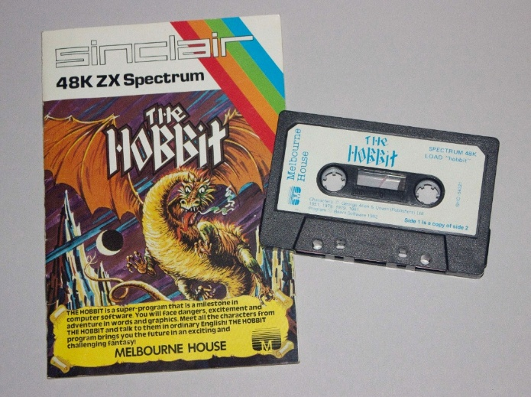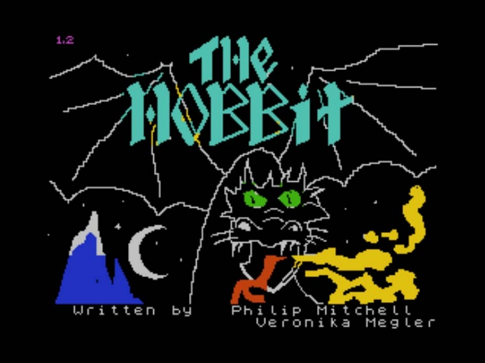
The Hobbit, computer software for Sinclair 48K ZX Spectrum, created by Beam Software in Melbourne, Australia, 1982. Left: instruction manual and cassette, 6.5 x 10.1 x 1.3 cm (cassette); 16.5 x 11.3 x 0.2 cm (instruction manual, cover art illustration by Con Aslanis). Right: Image showing in-game graphics. ACMI Collection.

Case study 3: A statement of significance for a collection

The James Boyd Collection, Port Arthur Historic Site Management Authority
Contributed by: Michael Smith, Conservation Project Officer – Collections
Organisation: Port Arthur Historic Site Management Authority
Dated: January 2026
James Boyd (1815–1900) was a key figure in the history of the Port Arthur Convict Settlement. His appointment as Commandant in 1853 coincided with the end of convict transportation to Tasmania, requiring major changes to the administration and purpose of the settlement. The James Boyd Collection, held by the Port Arthur Historic Site Management Authority in Tasmania, comprises more than 250 items. It is the largest-known collection of Boyd’s personal material and provides important context to the official record of his career in Tasmania from 1845 until his resignation as Commandant of the Port Arthur Convict Settlement in 1871.
The collection includes a journal, testimonials and extracts from the Port Arthur Visitors’ Book, photographs, postcards, and includes personal and official correspondence. Together, these materials document Boyd’s professional responsibilities, personal experiences and the broader operation of Port Arthur Convict Settlement during a period of significant change.
The collection has historical significance due to its direct connection with Boyd and his role at the Port Arthur Convict Settlement. Boyd was the longest-serving Commandant of Port Arthur’s secondary punishment station, serving during a period of major change in Australia’s penal system. His tenure coincided with the contraction and consolidation of convict transportation, including the cessation of convict arrivals to New South Wales, the closure of Norfolk Island’s penal settlement and the transfer of remaining convicts to the Tasman Peninsula.
Boyd played a key role in implementing new approaches to convict management at Port Arthur. Drawing on his experience in British prisons, particularly the ‘separate’ system exemplified by London’s Pentonville Prison, he oversaw the establishment and operation of Port Arthur’s panopticon-inspired Model Prison. This institution embodied emerging penal philosophies that sought to reform offenders through isolation, surveillance, discipline, and moral instruction rather than through physical punishment alone. The collection offers firsthand evidence of changing approaches to prison management, including greater attention to psychological discipline, and increased concern for prisoner welfare. It is therefore significant for understanding broader developments in colonial governance and penal reform in Tasmania and Australia.
The James Boyd Collection has research significance as an important resource for understanding 19th-century penal administration, social attitudes and institutional reform. As a body of primary source material created during Boyd’s lifetime, it supports original research into the daily operation of Port Arthur Convict Settlement’s leadership practices and the lived experience of those who worked within the penal system. The collection provides insights not commonly found in official government records, particularly in relation to personal decision-making, professional networks and social values.
The significance of the James Boyd Collection is heightened by its clear provenance. Most of the collection was brought together because of James Boyd’s successful superannuation claim of 1871. Boyd later added personal journals and photographic material before the collection passed to his grandson, Josiah Tyssen, who contributed additional series of images that reflected Josiah’s ecclesiastic calling. The collection was subsequently preserved through associated estates, maintaining a clear and well understood chain of ownership before being donated to the Port Arthur Historic Site Management Authority in 2011.
Many records relating to Australia’s convict past were lost before modern archival practices were legislated. As a result, personal collections that document both administrative and social aspects of penal life are uncommon. The James Boyd Collection is rare in its depth, perspective, and survival. The collection remains largely intact and in original condition. Where copied material appears, it is clearly identified, and the provenance of later additions is evident. Overall, the collection demonstrates a high level of integrity and completeness.
The material has strong interpretive capacity. It supports key themes including punishment, reform, governance and social change, while offering insight into the personal life of James Boyd as a husband and father. The collection offers significant unrealised interpretive potential through ongoing research that can enhance public understanding of convict experiences and contribute to the growing scholarship on global convictism and its legacies.
Statement of significance
The James Boyd Collection has great historical and research significance as a body of primary source material relating to the longest-serving Commandant of the Port Arthur Convict Settlement. Drawing on Boyd’s earlier experience in prison administration in England, the collection documents his leadership during a critical period of transition following the end of convict transportation. The collection provides clear evidence of institutional change and contributes to understanding 19th-century penal reform and social attitudes. The relative significance of the collection is amplified by its clear provenance, rarity, excellent condition, and interpretive capacity. These factors mean that the collection can serve as an important, long-term resource for understanding Australia’s convict heritage.
The James Boyd Collection is managed by the Port Arthur Historic Site Management Authority (PAHSMA), whose movable heritage collections contribute to the heritage values recognised through state and national heritage listings, and form part of the attributes that support the UNESCO World Heritage-listed Australian Convict Sites. Within the context of the Tasmanian Heritage Register, the National Heritage List, and the Australian Convict Sites World Heritage serial listing, the James Boyd Collection is of state, national, and international significance.
Keywords:
James Boyd, documentary heritage, personal material, personal collections, convict history, prisons, colonial Australia, Port Arthur Convict Settlement, historic site, World Heritage, Tasmania.
Significance categories:
Primary criteria: Historical | Research
Comparative criteria: Provenance | Rarity | Condition and Completeness | Interpretive capacity
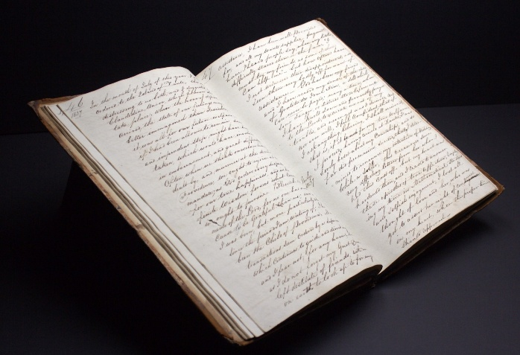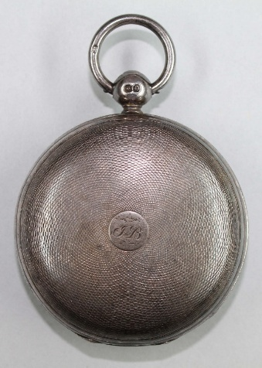
Left: Journal of Commandant James Boyd, 1839–1853. Right: Pocket watch belonging to Commandant James Boyd, created by Mr John Chapman in England, c. 1840. Collection of Port Arthur Historic Site. Photographs by Michael Smith.

Part 3: Key considerations when assessing significance
The following sections build on the concepts and processes outlined in Parts 1 and 2, providing practical information on the concepts and practices that underpin contemporary best-practice in significance assessment.
The first section outlines ethical approaches to managing material related to First Nations peoples. While anyone who collects or trades in First Nations material should carefully follow this guidance, its principles apply to the responsible management of all cultural heritage in Australia. Collecting organisations should engage with local First Nations communities to understand the evolving relationships between collections, places and peoples. The next sections explain important elements of any significance assessment process: consultation, contextual research, provenance research and cross-collection research. The final 2 sections discuss specific information on the issues and considerations relating to archives and operating heritage.

Guidance on assessing the significance of First Nations cultural heritage materials
Aboriginal and Torres Strait Islander peoples belong to the world’s oldest continuing living cultures. First Nations cultural heritage takes many forms, physical and digital: objects, records, images, recordings, designs, data, language and knowledge. It includes both historical collections and what is created through the living cultural and creative practice of First Nations people today. All these forms stay connected to people and communities, to Country, and to ongoing cultural practice and responsibilities.
The significance of First Nations material cannot be determined by an assessor working alone. Assessing First Nations material requires applying the framework in this guide alongside a community-led approach grounded in community values. This is because significance is defined and expressed by the communities and peoples connected to the material and is often passed on through oral tradition. Approached well, assessment can support community priorities such as connection to Country and cultural revitalisation. More broadly, this work can also contribute to national reconciliation by supporting a fuller and more accurate account of Australia's history.
For First Nations material, significance is often relational. The meaning of an item can be inseparable from the Country, story, song, language or cultural practice it belongs to, and from the intangible heritage it carries.

A trauma-informed and healing-centred approach to assessment
Many First Nations cultural materials are linked to histories of colonisation. Engaging with these materials can bring feelings of grief and harm for those connected to them. Done with care, it can also support healing.
Being trauma-informed means working at the community’s pace, being transparent about intentions, offering people choice about how and whether they take part, ensuring they have access to support of their choosing, including someone independent of the assessment, and handling histories and records with care and sensitivity. It also means recognising when material is too sensitive to proceed with at a given time and being willing to slow down or pause the work when needed.

Consultation and Free, Prior and Informed Consent
Any work involving First Nations cultural material must be based on free, prior and informed consent (FPIC). Consent should be sought before work begins (prior), without pressure or assumption (free), and with a full and clear explanation of what is proposed and how the results will be used (informed). Consent is also ongoing: it can be revisited, qualified or withdrawn as circumstances change. Rather than a one-off approval gained at the outset, consent shapes the whole assessment, including how it is approached and who should lead it.
Consultation with the relevant communities is central to this. Its purpose is to understand the significance of the material from the people connected to it, with support offered throughout. Where community members have been involved, the resulting statement of significance, including the descriptions, images, attributions and knowledge it contains, should reflect what has been agreed can be recorded and shared, and should respect any restrictions on access or use. Until that guidance is available, do not reproduce or widely share material that may be sensitive or restricted.
Good consultation for a significance assessment usually involves:
- Starting early – building in consultation from the beginning, not seeking sign-off at the end.
- Identifying the right people and approaching them through local Aboriginal and Torres Strait Islander organisations, Land Councils, native title holders or their representative bodies, or local keeping places.
- Being transparent from first contact – explaining who you are, what you are proposing, and why and how the information will be used.
- Allowing enough time and working at the community’s pace. Proper introductions and processes cannot be rushed.
- Recognising people’s time and expertise and remunerating it where possible.
- Being led by the people you consult – letting them shape what the material means and how it is described.
- Applying what is learned to how the item is managed, including its conservation, storage, handling and display, in line with cultural protocols.
- Recording only what has been agreed can be shared and checking back that community views are represented accurately.
- Returning the outcomes to the community.
Full engagement is not always possible due to limitations such as time, resources, or challenges in identifying and connecting with the appropriate individuals or organisations. When this happens, acknowledge that community input was not gathered, document the reasons for this, and seek guidance from published resources, preferably those developed by Indigenous people and organisations, and regional or peak Aboriginal and Torres Strait Islander organisations.

Indigenous Cultural Authority
The Significance framework relies on judgements about meanings, values and connection. In a First Nations context, identifying people who hold the cultural authority to speak for the significance of material is an important additional consideration. This authority may belong to Elders, knowledge holders, families, Traditional Owners or community organisations. It varies from Country to Country and community to community, and sometimes according to gender, kinship or cultural standing.
Avenues for identifying cultural authority include consulting an Indigenous advisory group or committee (where one exists), the relevant Land Council or native title body, local Aboriginal and Torres Strait Islander organisations and keeping places, and qualified researchers.

Indigenous Cultural and Intellectual Property
Indigenous Cultural and Intellectual Property, or ICIP, grounded in the right to self-determination, refers to the rights that First Nations peoples hold or wish to hold over their cultural heritage and knowledge.
This includes the right to own and control their cultural materials and to determine how these materials are accessed, used, described, attributed, reproduced and shared. Assessing significance is itself an act of accessing, describing and often reproducing and sharing cultural material, so these rights apply directly to how an assessment is conducted, recorded and published. Decisions about access and publication belong with community. Until that guidance is available, do not reproduce or widely share material that may be sensitive or restricted. A more complete list of ICIP resources is provided in the resources section in Part 6.
Recognising and accommodating differing views
The impacts of colonisation, dispossession and historical government policies have disrupted cultural practices and the transmission of knowledge in many First Nations communities. As a result, different individuals, families, or cultural groups may hold different understandings, memories, or interpretations of the significance of records, objects, or collections.
A significance assessment should acknowledge that these various perspectives may all be culturally valid within their specific contexts. Where knowledge is contested or views differ, the assessment should acknowledge that multiple perspectives exist and document them respectfully and accurately.
Culturally sensitive materials and restricted knowledge
Some First Nations material is restricted under customary law. Secret or sacred material may only be seen, handled or known by people with particular cultural authority or standing. Some material relating to deceased people should not be named, shown or accessed, particularly during periods of mourning. These are common protocols, but they vary from community to community, and what applies to particular materials is not something that can be assumed from other contexts. Checking with the people who hold authority for the material is itself part of the assessment.
Importantly, some First Nations material will be subject to cultural protocols that shape what can be discussed or recorded. In practice, this may mean that certain details are not described in the assessment, or that material is flagged as culturally sensitive rather than set out in full. Assessors should recognise that an absence of openly available information may itself reflect knowledge that is deliberately restricted, rather than a gap to be filled.

Questions of provenance and requests for return or repatriation
For First Nations material, provenance includes how an item came to be in a collection. In some cases, this history involves removal, dispossession or acquisition without consent. In others it is shared, where knowledge was given to a researcher or collector and community are co-originators who retain rights in it. That history is part of the item's significance and can raise questions about return and repatriation. Where an assessment surfaces material that may have been taken without consent, or that a community may wish to see returned, this should be raised openly and handled through the relevant protocols and programs rather than set aside.
Ancestral remains and secret or sacred objects are dealt with under specific repatriation frameworks, and specialist advice should be sought. More information on Indigenous Repatriation is available at: https://www.arts.gov.au/what-we-do/cultural-heritage/indigenous-repatriation.

Writing up an assessment with appropriate terminology and language
When writing an assessment, the choice of language is important. Use current and community-preferred terms and, whenever possible, mention specific communities or language groups instead of relying on general labels. Preferred terms vary between communities and regions. If you are uncertain about terminology, consult community guidance and published resources for assistance.
Be aware that historical records may contain outdated, inaccurate or offensive language. If you need to quote or reference such material, ensure you provide context and apply a content warning. In this way, you can preserve the evidential value of the record while minimising the risk of causing harm.

Resources to guide your approach
Assessing the significance of First Nations materials depends on an understanding of the relevant histories, protocols and responsibilities, and that understanding develops over time through learning and respectful relationships with First Nations people and their communities.
Cultural awareness and competency training, ideally local and community-led, helps build understanding of First Nations approaches to cultural significance, though it does not replace engaging the right people for a particular assessment.
Established resources can assist you in guiding your practice. Useful starting points include:
- The AIATSIS Core cultural learning online training: https://aiatsis.gov.au/about/what-we-do/core-cultural-learning.
- The AIATSIS Code of Ethics for Aboriginal and Torres Strait Islander Research, online at: https://aiatsis.gov.au/research/ethical-research/code-ethics.
- Indigenous Cultural and Intellectual Property protocols, such as the True Tracks principles developed by Terri Janke and Company https://www.terrijanke.com.au/true-tracks; and the protocols of the National Library of Australia https://www.library.gov.au/first-australians/indigenous-cultural-and-intellectual-property.
- The ATSILIRN Protocols for Libraries, Archives and Information Services, online at: https://atsilirn.aiatsis.gov.au/protocols.php.
- The Australian Museums and Galleries Association's Indigenous Roadmap, online at: https://www.terrijanke.com.au/mga-indigenous-roadmap; https://amaga.org.au/Web/Web/Resources/Indigenous-Roadmap.aspx.
- AUSTLANG Language Codes, online at: https://aiatsis.gov.au/research/languages/austlang.
- Indigenous Referencing Guidance for Indigenous Knowledges, online at: https://www.caval.edu.au/referencing-toolkit/.
- First Nations Engagement: the principles of Free, Prior and Informed Consent, online at: https://www.dcceew.gov.au/sites/default/files/documents/free-prior-informed-consent-guidelines.pdf
Local and regional Aboriginal and Torres Strait Islander organisations remain the most important source of guidance for material connected to their communities. Where an assessor has had little or no previous contact with community, useful starting points include AIATSIS's directory of native title bodies and key contacts, state and territory Aboriginal affairs agencies, and the local council or regional Aboriginal land council. Making contact and building the relationship is itself part of the work and takes time.
Further resources are provided in Part 6 of this guide.

Guiding questions when assessing the significance of First Nations cultural material
Having read the information in this section, you may wish to use the following questions to guide the process of understanding and articulating the significance of First Nations cultural material:
- Have you appropriately considered where this material comes from and who it is connected to? Might more than one person, family or group hold a connection to this material, and how will you record each view?
- How did this material come to be in the collection? What is already documented about this material and who holds the authority to speak for it?
- Who holds the cultural authority to speak for the significance of the material? Might any of this material be culturally sensitive or restricted, and do you know who to ask before recording or sharing it?
- Have you adopted a FPIC approach by seeking consent before work begins, without pressure or assumption, and with a full and clear explanation of what is proposed and how the results will be used?
- Is this work affecting the people involved, have you been transparent in your intentions, and are you going at a pace that allows for care and choice in how people participate? Have you allowed the process to be led by the people you have consulted?
- Have those consulted been appropriately recognised for their time and expertise?
- Have you only recorded what has been agreed? Is your language current and community-preferred, and have you flagged any offensive material quoted from historical records?
- Do the descriptions, images and knowledge in this assessment reflect what the community has agreed can be recorded and shared? Has consent been given for how this material is researched, recorded and shared?
- Have you returned the outcomes to the community?

Case study 4: A statement of significance developed with a First Nations community

Macassan prau in the collection of the University of Melbourne
Contributed by: Lisa Slade, Hugh Ramsay Chair in Australian Art History, University of Melbourne, with input from Will Stubbs, Co-ordinator, Buku-Larrnggay Mulka Centre and Judith Ryan AM, Senior Curator, Art Museums, University of Melbourne.
Organisation: University of Melbourne
Dated: July 2026
This painting on gaḏayka (stringybark) by Gupa-Djapu' artist Wuluwirr Munuŋgurr (c. 1920–c. 1940) depicts a Macassan prau (sailing vessel). The 3 main components of the composition – the prau with its crew, the rectangular sail and the line of triangles at the bottom – are painted mainly with white-ochre pigment on a red-ochre ground. The composition is framed by a double border. Wuluwirr has painted the finer details with a marwat (brush made of human hair) dipped into blue pigment derived from laundry powder introduced to Arnhem Land by balanda (outsiders).
This work was painted in July 1935 by Wuluwirr, a younger son of Gupa-Djapu' artist and cultural leader Woŋgu Munuŋgurr. According to notes from a discussion between Minyipa Munuŋgurr (c. 1950–2016) and curator Lindy Allen at Yirrkala in 2002, it shares with balanda a Munyuku subject from the artist’s grandmother’s clan, which is associated with Yarrinya (Point Blane) within Blue Mud Bay in north-east Arnhem Land. Titled Macassan prau, the bark painting provides a cultural memory of Yolŋu contact with the Macassan traders from southern Sulawesi, in present-day Indonesia. These traders made annual visits to northern Australia from as early as the 16th century until 1907, when they were excluded by the South Australian government’s licence regime. While visits focused on the collection of trepang (sea cucumber), which was traded to China, other exchanges included tobacco, tamarind tree seeds, the dugout canoe and words now incorporated into local languages.
Until they were outlawed, the Macassan visits occurred in the wet season between December and February, when monsoonal winds are sufficient to aid travel. The monsoon coincides with the bark harvesting period when bark can be more easily prised from the gaḏayka. During consultation with Lindy Allen, Djapu' artist and cultural leader Minyipa Munuŋgurr identified the white triangles shown in the painting as gunyil (clouds). The seasonal winds, depicted as the line of triangular shapes, are the hero subject of the work. Similar triangular shapes are found in the work of contemporary artists such as Nawurapu Wunuŋmurra (1952–2018) and Bulthirrirri Wunuŋmurra (c. 1981–).
Wuluwirr made this painting for University of Melbourne anthropologist and then research fellow Donald Thomson (1901–1970). Although the Macassan period predates Wuluwirr’s birth, it would have been in the living memory of his father Woŋgu Munuŋgurr, who painted 3 Macassan prau barks for Thomson in 1935, the very same year as his son’s painting. Moreover, following what is referred to as the Caledon Bay Crisis, when 5 Japanese trepang fishermen were killed by Yolŋu, Woŋgu met with Thomson. The latter aided in brokering an uneasy peace and negotiating release of Woŋgu’s 3 sons from Fannie Bay gaol in Darwin. Woŋgu made a message stick and instructed Thomson in matters of Yolŋu law and, after his sons’ release, created bark paintings for Thomson, encouraging others to follow. The Macassan theme of these 4 paintings suggests their instructive or pedagogical intent at a time of intense diplomatic negotiation regarding fishing and maritime rights. During World War II, Woŋgu was instrumental in supporting Thomson to establish the Northern Territory Special Reconnaissance Unit to protect Arnhem Land from Japanese invasion.
On 28 April 2023, this bark was again the subject of community consultation. In the lead up to the exhibition 65,000 Years: A Short History of Australian Art, Professor Brian Djaṉgirrawuy Gumbula-Garawirrtja viewed this bark and changed its title from Barrawan to Macassan Prau. Senior Curator Judith Ryan remarked that ‘such viewings and guidance are of vital importance for our curatorship and care of our collection and to enable artists…to view their relatives’ works’ (University of Melbourne file note, 3 May 2023).
Although this painting is by a lesser-known artist, Wuluwirr’s connection to Woŋgu Munuŋgurr, Donald Thomson, and the Caledon Bay crisis contribute to its cultural, historical and research significance. This is accentuated by its known provenance and material rarity, including that it features Reckitts Blue pigment that is also found in rock art in West Arnhem Land. These factors enhance its interpretive capacity and position it as a vital resource for scholarship, exhibitions, and teaching. Its link to the work of contemporary artists, including Djapu’ artist Dhambit Munuŋgurr (1968–) who uses blue acrylic paint to depict Macassan subject matter, also extends its artistic significance.
Wuluwirr’s Macassan prau is part of a uniquely important interdisciplinary collection of art, material culture, biological and botanical specimens, photographs, and field notes amassed by Professor Donald Thomson. In 1973, this collection was donated to the University of Melbourne by his widow, Mrs Dorita Thomson. The University then placed it on long-term loan to Museums Victoria, where it remained inaccessible in storage and largely unpublished for over 50 years. The painting was returned to the University in 2024–25, where it has entered an important phase in its history. Intensive consultation with communities of origin, research, and exhibition is making Wuluwirr’s work, and the history of Yolŋu and Macassan interaction, far better known in Australia and throughout the world.
Keywords:
First Nations, art, maritime trade, north-east Arnhem Land, Macassan people, Caledon Bay Crisis, World War II, Yolŋu, gaḏayka (stringybark), prau (sailing vessel).
Significance categories:
Primary criteria: Cultural | Historical | Artistic | Research
Comparative criteria: Provenance | Rarity | Interpretive capacity
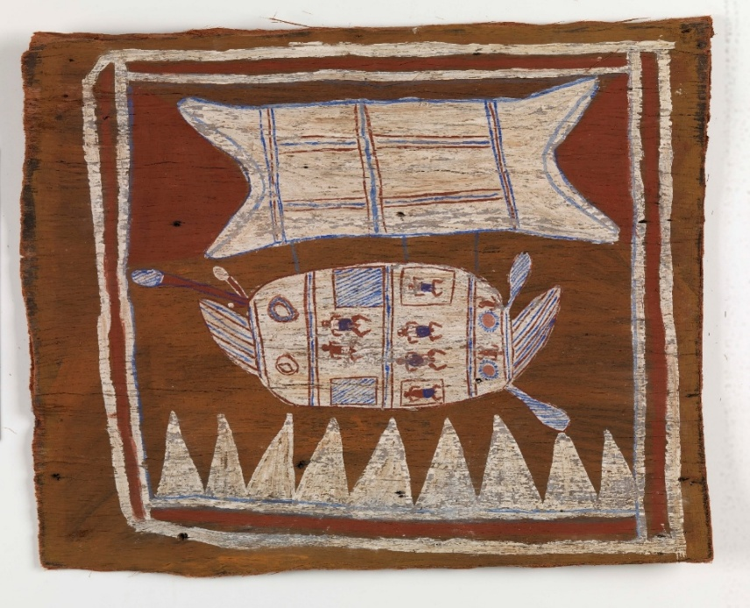
Macassan prau, created by Wuluwirr Munuŋgurr (c. 1920–c. 1940), Gupa-Djapu’ clan, Dhuwa moiety, in Caledon Bay, Arnhem Land, Northern Territory, Australia, 1935, earth pigments and Reckitts blue on stringybark, 83 x 97.8 cm. Donald Thomson Collection, University of Melbourne, Gift of Mrs Dorita Thomson, 1973.

Consultation with relevant parties
Consultation is essential when assessing the significance of all First Nations items and collections. It is also a necessary or valuable means of obtaining information on most other items and collections, particularly when the relevant cultural and social knowledge has not been recorded in books, archives, or published sources. The following section provides general advice on responsible and ethical consultation. Many of the points intersect with the guidance in the preceding section.

When to consult and who to consult with
Consultation should occur when items or collections closely relate to an identified individual, group or community, especially when they have ongoing contemporary significance or relate to a living cultural practice. A community may be a group of people who come from a particular family, cultural group or place, share a common ideology, religion or set of experiences, identify in a similar way, or share a defined interest. Examples include migrant and diaspora groups, members of a religion, LGBTIQA+ communities, and interest groups such as motoring enthusiasts, supporters of a sporting team and specialist collectors. For items without such relationships, consultation can be a useful way to gather information from experts, other collectors, or descendants of prior owners and custodians.
The first step in consultation is determining who to consult with. For material that relates to a known community or group, good places to start include the relevant peak body, advocacy group, or community organisation. Many groups will have an internet or social media presence through which to obtain contact information. Where the community of origin is unknown, consulting experts or organisations with established community relationships may assist in identifying the appropriate people to approach. Subject-matter experts and collectors can often be identified through internet searches, or by seeking advice from universities, libraries, and other collecting institutions. In some cases, there may be difficulties in finding appropriate people, or they may be reluctant to engage. If that happens, it is worth documenting the efforts to consult and considering the reasons for any barriers.

Principles of consultation
In all cases, consultation should be conducted transparently and in good faith. Consultation should be respectful, culturally appropriate and ethical, seek to mitigate potential sensitivities, and allow sufficient time for consideration and feedback. As for processes involving First Nations communities, consultation should follow the principles of free, prior, and informed consent, with participants able to cease involvement at any time and revise or withdraw input.
Where possible, seek to compensate and credit people for their time and advice. Where it is inappropriate or unfeasible to provide remuneration, ensure that the people consulted are properly thanked, adequately acknowledged and reimbursed for any expenses incurred.
Throughout the process, consider how to appropriately handle and store sensitive, personal or confidential information. Where information provided through consultation is subject to cultural protocols or restrictions, ensure it is managed in line with agreed terms.

Forms of consultation
Initial contact will usually be through an email or telephone conversation. At this point, it is important to provide clear, accessible information about the item or collection being assessed, the reasons for consultation, the types of information being sought and the anticipated outcomes. But avoid giving too much information, especially if it is complicated or in multiple formats. Additional information should be shared once the parameters for consultation have been agreed.
If the individual or group agrees to be consulted, negotiate the form and timeframe of consultation. Consultation should be tailored to the context and the preferences of those being consulted. It can include communicating through correspondence, online or face-to-face interviews, informal conversations, meetings, accessing items or collections together, or attending on-Country or in-community cultural activities. Approaches to consultation should remain flexible and responsive to cultural protocols, community expectations, and local circumstances. Ideally, consultation should be conducted in a language that the people being consulted with are comfortable speaking. Where consultation requires the services of a translator, ensure those being consulted do not bear the resourcing or financial costs.

Follow-up and ongoing relationships
Responsible consultation does not end when a project is over or a decision is made. Providing follow-up communication is an important part of respectful engagement and may include acknowledging participation, sharing information about outcomes, reports and significance assessments and being available for ongoing exchanges. In collecting organisations, it is common for consultation regarding significance assessment to lead to meaningful ongoing relationships and collaborations. It can develop new audiences, strengthen support, and assist in building inclusivity and community cohesion.

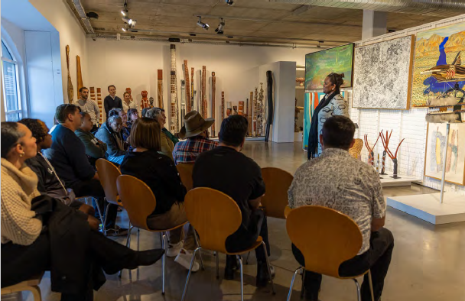
Patricia Adjei, Director of Standalone Legislation, Australian Government Department of Infrastructure, Transport, Regional Development, Communications, Sport and the Arts, speaking on Indigenous Cultural and Intellectual Property (ICIP) at the exhibition First Voices: Indigenous Artworks from the Artbank Collection, Artbank Sydney 2024. Photo by Declan Shrubb.

Case study 5: A significance assessment informed by consultation

The Joshua Cavallo collection at the National Museum of Australia
Contributed by: Craig Middleton, Senior Curator
Organisation: National Museum of Australia
Dated: March 2026
The Joshua Cavallo collection is part of the National Historical Collection held by the National Museum of Australia (the Museum). It comprises the A-League Rising Star Award received by Cavallo after his first season with the Adelaide United Football Club (AUFC), the football boots he wore in the first match he played after coming out as gay to his teammates, and his jersey from the first A-League Pride Round in Australia.
In 2021, Joshua Cavallo (born 1999) became the first openly gay player in the Australian men’s A-League and, at the time, the only openly gay male professional footballer in a top league anywhere in the world. Initially, Cavallo did not reveal his sexuality, believing it was incompatible with his sporting career. However, when he was awarded an A-League Rising Star Award after his first season with the AUFC, he experienced a turning point. Cavallo decided to come out, first to his AUFC teammates, and then publicly. On 27 October 2021, he posted a video on his social media accounts telling the world: ‘I am a footballer, and I am gay.’ The video went viral. While the announcement was met with some negativity, his followers and others flooded his public comments with messages of love and support. The following year, in support of Cavallo, AUFC hosted the first Pride Round organised by an Australian football club. Other clubs followed, and in February 2023 a national A-League Pride Round was held.
The acquisition of the Joshua Cavallo collection was part of a priority collecting project designed to identify and address gaps and exclusions in the National Historical Collection (NHC) relating to Lesbian, Gay, Bisexual, Transgender, Intersex and Queer+ (LGBTIQ+) people and communities. These communities have been historically marginalised by museums internationally, and active engagement and collecting is required to address this. Acknowledging the complex relationships LGBTIQ+ people and communities have had with public institutions, the priority collecting project was underpinned by several key principles. The first was face-to-face community engagement with LGBTIQ+ individuals in their own places and spaces. Curators travelled to cities across Australia to meet potential donors, listen to their stories, and build trusting relationships. This was important for communities whose lives and experiences have been historically excluded by museums. The second was that significance would be identified through these conversations by those whose stories the Museum was trying to represent. This was about creating collections that were not only meaningful but relevant to the communities the collections were intended to represent. The third was a recognition that LGBTIQ+ or queer objects are not always self-evident and it is the meaning applied to collections by individuals and groups that determine their status as queer. Objects collected through this project were also selected to challenge assumptions about what an LGBTIQ+ object is or is not.
Guided by these principles, Joshua Cavallo was identified as a significant figure in contemporary LGBTIQ+ experience in Australia. Curators subsequently contacted his management to explore if and how Cavallo would like to be represented by the National Museum of Australia. They travelled to Adelaide, South Australia, where they conducted an interview with Cavallo. During this conversation, several objects emerged as particularly meaningful to him. Among them was Cavallo’s Rising Star Award. Cavallo had not considered the trophy relevant to the Museum’s collecting activities until he spoke with curators, who recognised its significance and connection to a complex human moment of reflection and reconciliation of sexual and professional identities.
The collection has historical significance due to its direct association with Cavallo, a professional male footballer, publicly coming out despite a long history of discrimination against homosexual men in sport, where expectations of masculinity have reinforced homophobia. The items reflect a story of an individual who actively contributed to social change through the decision to risk his career to live openly and honestly.
The collection also holds social significance because it reflects the personal experiences of Joshua Cavallo, which holds broader meaning for LGBTIQ+ communities in Australia. The story of the collection highlights LGBTIQ+ visibility, representation, and progress in sport and public life. At the same time, Cavallo’s coming out created space for other LGBTIQ+ identifying people to see a way for a professional sporting career and diverse sexuality and gender expression to coexist.
The significance of the collection is enhanced under the comparative criteria of the significance assessment framework. The items in the collection are in excellent condition, having been created just years prior to the acquisition. They also have strong provenance as they were acquired directly from Joshua Cavallo, who was given or awarded the objects. The collection has high interpretive capacity because it represents a major Australian historical sporting moment and enables the Museum to explore themes of identity, masculinity, discrimination, and inclusion in sport through display and interpretation. Assessing the significance of the Joshua Cavallo collection reinforces its place in the National Historical Collection, which seeks to represent the diversity of Australia’s stories. The collection enhances the Museum’s ability to contribute meaningfully to future research and interpretation about sport and LGBTIQ+ experiences.
Keywords:
Joshua Cavallo, LGBTIQ+ experiences, queer stories, social change, diversity and inclusion, soccer, football, Australian sport, Adelaide United Football Club, Pride Round
Significance categories:
Primary criteria: Historical | Social
Comparative criteria: Condition | Provenance | Interpretive capacity
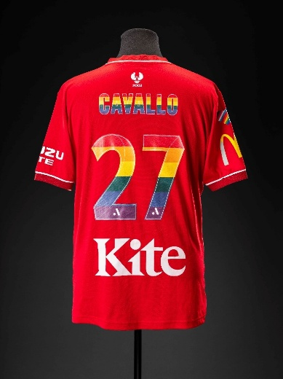
Left: Nike boots worn by Joshua Cavallo, in use 2020-21. Right: Adelaide United Football Club Pride Round uniform worn by Joshua Cavallo in 2022. Both items donated by Joshua Cavallo. Photographs by Jason McCarthy, National Museum of Australia.

Contextual research
This section explores how context contributes to our understanding of the significance of items and collections. Conducting research into the context of an item or collection is a critical aspect of research and information gathering, which is the first stage in assessing significance.

What context means
Context refers to the circumstances and conditions that may have influenced the formation, production, use, reception and interpretation of an item or collection. While these circumstances and conditions are often external to the item or collection, others may be intrinsic to it, particularly for First Nations cultural heritage. Context also covers the relationships an item or collection has to people, communities, places, events, activities, ideas, and other items and collections. This may include information about an item’s maker or time and place of creation, the community it originates from, or which holds continuing responsibility for it, and the details of how it was or continues to be used, kept and interpreted.
The environment from which an item or collection derived, and the circumstances in which it was identified and found, are particularly important aspects of context when considering natural history specimens and archaeological objects. When considering collections, it is relevant to examine details about the collector and the circumstances of collection.
Contextual elements of items may have multiple interrelated aspects, which may be living and continuing rather than fixed at a single historical point. The historical context of an item or collection may relate to, or be inclusive of, specific social, political, economic, cultural, and technological or industrial contexts and themes. In addition, an item may relate to a specific point within the maker’s career or body of work, or within a broader movement, or to a particular place or time. It may indicate something important about the broader historical context in which it was created and used. In some cases, an object may depict or serve as a reference point for another item or collection. For example, a painting may illustrate how a functional object was used or viewed at a particular point in time.

Why context matters when assessing significance
Understanding context helps place an item or collection within wider historical, artistic or cultural patterns, movements, ideas or themes, and reinforce any connections to specific people, groups, environments and localities. The aim of contextual research is to reveal how and why an item was or continues to be made, used or positioned within society, and to understand its meanings for the people and communities connected to it. Once this is understood, it is easier to accurately assess an item’s significance against the primary and comparative criteria and develop a clear statement of significance.
An accurate assessment of an item’s significance and future research potential may depend on a well-documented context. As a result, the guides, codes of practice and ethical standards used by collecting organisations commonly emphasise the importance of thoroughly researching and documenting context, in accordance with cultural protocols and the consent of relevant communities.

General tips on conducting contextual research
Contextual research should be conducted alongside research into the history, provenance, environment and community associations of an item or collection. These avenues of enquiry will often be interrelated and may inform one another. In a First Nations context, community relationships and connections are central. It is best practice to carefully document all research conducted on an item or collection, including recording details of information sources and outcomes of consultation.
Contextual research involves consulting a range of sources. These may include primary documents (diaries, letters, official reports, contemporaneous newspaper references, inventories, and recorded oral histories), and secondary sources (academic or non-academic books and articles published in print or online, websites and blogs).

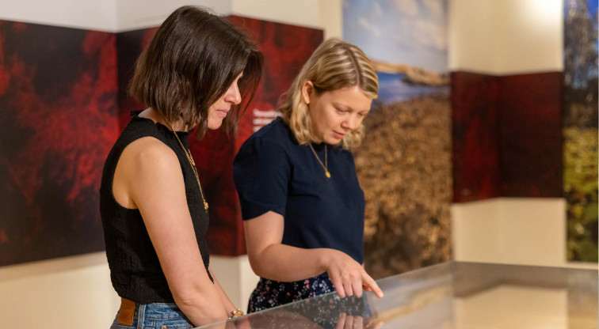

In many cases, the most useful and accurate information about context will be obtained by consulting with knowledgeable individuals and communities. Exploring the context of an item or collection taps into information, knowledge and ideas that are not always part of formal collection documentation practice. However, experts inside collecting organisations often understand contextual knowledge well. When conducting contextual research on an item or collection, it is often valuable to seek assistance and advice from organisations that specialise in collecting that type of cultural heritage material. In a First Nations context, communities hold the authority to speak to the meaning and significance of their heritage, and some knowledge may be culturally restricted or not intended for use outside of the community.
Where an item lacks specific contextual information, or clear details of history and provenance, it may be possible to build a picture of its context by researching the wider context of that class of items, including their general development, use, function and historical context. In many cases, particularly when assessing First Nations items and collections, a lack of documentation does not mean that an item lacks context as knowledge may be held within the community. Recording provenance and context can be closely related processes. How an item is documented when it is collected can be vital to understanding its context.
The following guiding questions can be useful when conducting contextual research:
- Which individual, community or group created, found, used or kept the item?
- What was its original intended purpose or function, and how has that evolved? If not used for its original purpose or function, what was its actual use?
- Where was it created, found, used and kept?
- How does the item reflect or relate to the place in which it was created or used?
- How does it reflect or relate to the historical circumstances in which it was created or used?
- How does it reflect or relate to historical themes, patterns, movements, developments or industry?
- How does the item reflect or relate to broader cultural, social or creative themes, patterns, movements or developments?
- How does the item reflect or relate to the person, people or community for whom the item was created or by whom it was used, including their ideas and practice?

How context differs based on collecting areas
Context may have different levels of importance and shades of meaning and interpretation depending on the nature of the item or collection, the collecting domain, professional discipline or community context. Some of these differences are outlined below. For further guidance, consult the resources relating to specific collecting areas in Part 6.

Context and archaeology
Information on the environment from which an item or collection derives is particularly important when evaluating natural history specimens and archaeological items. In archaeological practice, the term context (or ‘provenience’) is used to refer to the precise location where an artefact is found on a site, and its relationship with other artefacts and position in the layers, or stratigraphy, of an excavation. This is a crucial aspect of artefact analysis and an important dimension of the significance of archaeological collections. For both natural history and archaeological material, the absence of a recorded context or clear provenance may make an item or collection insignificant, or less significant. For example, birds’ egg collections confiscated by customs officials are occasionally offered to museums but are of limited use, and unlikely to be accepted, if there is no contextual or provenance information available.

Context and archives
Context is particularly important to the archives sector. Archivists often first consider context when deciding whether to take records into an archive. They commonly examine the significance of the creating entity itself, the events, ideas and phenomena associated with it, and the quality of the records. Once these are identified, the question becomes one of how useful the records can be for researching these events.

Context and historical items
For historical items, context may include the processes or themes that shaped an item, as well as related places, settings, functions and issues such as social and technological change. For items of technology, context may include the work that they performed or the way their design fits within the evolution and design of that class of items. Many historical items, including large technology items, lack a recorded provenance or details of their specific individual context. Exploring the broader historical context of that class of items can draw out the wider meanings and significance of the item.

Context and in situ collections
Context is central to the meaning of items and collections that are still used for their original purpose or retained in their original place (the latter may be referred to as in situ collections). In these settings, context can also be more obvious to people interacting with them. Keeping items and collections in their place of use – and understanding their context within that place and in relation to wider social and historical movements and events – can broaden understanding of significance. Collections that survive intact in both their place and context of use may be of amplified significance and serve as a reference point for the research and assessment of similar unprovenanced items.

Context and works of art
When conducting contextual research on works of art, context may include the place of a particular work within an artist’s career or body of work, or of works within an art movement, where they will have a relationship to a range of people, settings, events and other works of art. In the case of public art, the physical context is often an integral part of the conception and design of the work and an important element of its context and significance.

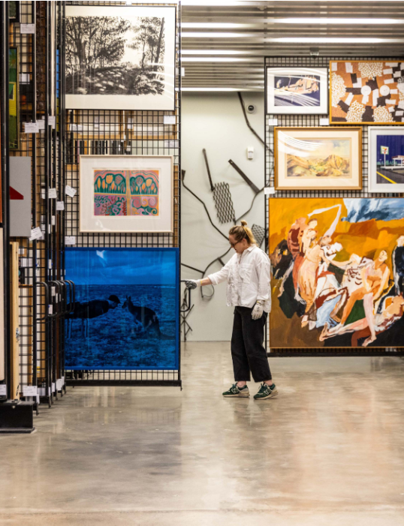
Employee opens art racks in the Artbank archives (Sydney).

Case study 6: A significance assessment informed by contextual information
Calthorpes’ House, 24 Mugga Way, Canberra, managed by ACT Historic Places, Cultural Facilities Corporation, Australian Capital Territory (ACT) Government
Contributed by: Dr Anna Wong, Director
Organisation: ACT Galleries, Museums and Heritage
Dated: 16 March 2026
Calthorpes’ House was the home of the Calthorpe family from 1927 until 1984, when the Commonwealth Government purchased the property and its contents to preserve it as a house museum.
Harry and Della Calthorpe purchased the allotment at 24 Mugga Way in Red Hill in 1924, when the first residential land releases were offered in Canberra. Harry, a partner in a successful stock and land agency, recognised the opportunities offered by the growing Federal Capital and believed Canberra would become ‘the most beautiful city in the world.’ The family commissioned the architectural firm Oakley and Parkes, the architects of the Prime Minister’s Lodge, to design their new residence. The resulting single-storey house reflected contemporary influences including Spanish Mission, Mediterranean, and Colonial Revival styles.
Completed in 1927, the modern house included electricity, piped hot and cold water and a plan typical of middle-class domestic architecture of the period. The house comprised 3 bedrooms, a breakfast room, sitting and dining rooms, bathroom, hallway and verandahs, with kitchen, pantry, maid’s room, and laundry at the rear of the house. The garden incorporated ornamental plantings, an orchard and kitchen garden. Additional structures included a cubby house for the children, and an air-raid shelter constructed by Harry Calthorpe during World War II.
The Calthorpes were meticulous record-keepers, retaining architectural plans, catalogues, receipts, photographs, ledgers, and correspondence documenting the construction and furnishing of the house. Much of the furniture was purchased specifically for the house in 1927, when Della Calthorpe travelled to Sydney and acquired furnishings from the prestigious retailer Beard Watson. The furniture, soft furnishings and tableware selected during this trip remained in place throughout the family’s occupancy, creating an unusually intact presentation of contemporary domestic taste and interior decoration of the late 1920s.
The collection also includes significant holdings of textiles, clothing and accessories and personal items reflecting domestic life, fashion and social occasions across several decades. Together with oral histories recorded with members of the Calthorpe family after the property’s acquisition, these items provide valuable insights into everyday life, community networks and social activities in Canberra from the 1920s onwards.
The primary historical and research significance of the property is increased by the exceptional survival of the house and gardens, with its intact furnishings. Many historic house museums rely on reconstructed interiors and period furnishings. By contrast, Calthorpes’ House preserves an original domestic collection assembled and used by a single family over more than 50 years. Its integrity provides a rare and representative material record of everyday domestic life in early Canberra. It was also among the first house museums in Australia established specifically to represent ordinary family life of a particular period, rather than commemorating a notable individual.
Calthorpes’ House also has artistic significance. Leading Australian architects designed it to incorporate Georgian Revival and Spanish Mission influences. It is representative of domestic architecture constructed for the newly established Federal Capital in the 1920s. The house, its contents, garden and associated structures together form a remarkably complete historic domestic environment. Their combined integrity and documentary evidence provide an exceptional resource for understanding middle-class family life in Canberra during the formative decades of the national capital. The records compiled by the Calthorpes provide detailed evidence of the provenance of the house, as well as original design choices, furnishings and decorative schemes, enhancing the interpretive capacity of the place.
Keywords:
House museum, domestic architecture (1920s), Federal Capital (early Canberra), original domestic collection, middle-class family life, social history, context.
Significance categories:
Primary criteria: Historical | Artistic | Research
Comparative criteria: Provenance | Representativeness | Condition and Completeness | Rarity | Interpretive capacity
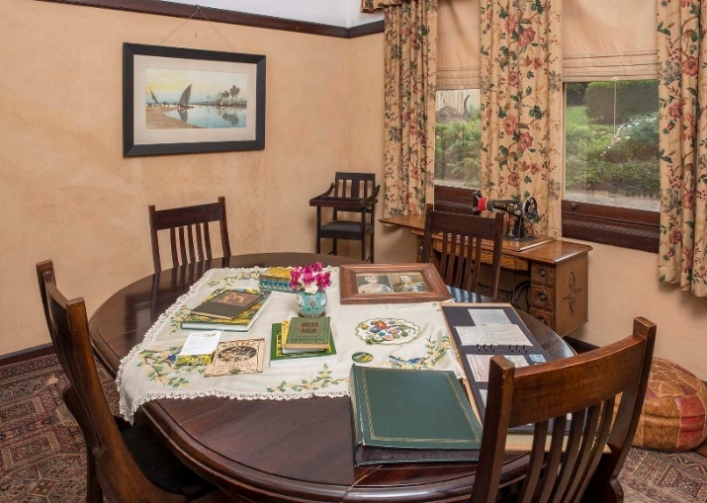
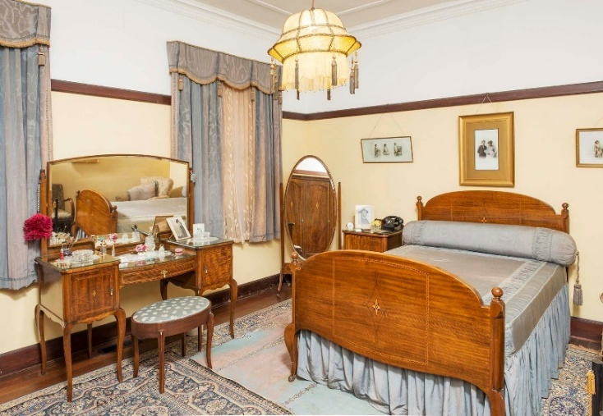
Above: Breakfast Room of Calthorpes’ House. Below: Main bedroom of Calthorpes’ House. Courtesy of ACT Historic Places, Cultural Facilities Corporation, ACT Government.

Provenance and provenance research
This section explores the role of provenance in significance assessment across all collecting domains and provides guidance on conducting provenance research. Assessing provenance is a critical aspect of the first step in assessing significance: research and information gathering. It also forms one of the comparative criteria through which to determine the degree of significance of an item or collection.

What provenance means
Provenance refers to the history and ownership of an item or collection from the time of its creation to the present. It includes information about an item’s origin, movements, chain of ownership, contexts of use, and associations with people and groups. For natural history and archaeological items, provenance will include information about when and where the item was discovered or collected. When considering the provenance of a collection, provenance covers the history and ownership of the individual items in the collection, and the collection itself, including when, where and by whom the collection was set up and developed. For First Nations material, provenance often includes histories of removal or dispossession, and an incomplete record may itself reflect that history.

Why provenance research is important for collectors
Provenance research contributes to knowledge about items, their place in the broader collection, and how to best care for, use and interpret them. It is an essential part of responsible and sustainable collection management and trade in cultural material. While the value and importance of provenance research is well recognised by institutional collectors, it can also assist private collectors to understand and make good decisions about their collections.
There is a long history of trade in cultural heritage material, and items and collections may have high monetary values. While some items were always intended to be saleable goods, there is also a market for items originally made for non-monetary social, cultural, religious or utilitarian reasons. The trade in cultural material includes legal and illegal markets, and can intersect with crimes of theft, looting, illegal export, money laundering, fencing and forgery. Items and collections can be particularly vulnerable during periods of political unrest and war, and to unethical practices including exploitation of marginalised and Indigenous creator communities. To disguise illegal or unethical associations, items are sometimes furnished with false provenance documents. Where provenance has been documented, it is important to apply a critical lens and conduct independent research to verify claims.
Determining the provenance of an item assists in confirming authenticity, cultural or monetary value, and ownership. It can also highlight legal or ethical issues that might affect the fitness of an item for a collection. These issues may be straightforward to determine if the item is recently created, excavated, or collected, or has a well-documented chain of ownership. Where more clarity is needed, provenance research can help establish legal, ethical or reputational risks. The outcomes of provenance research can inform the significance of an item or collection, and how it is used. For First Nations material, it can support return or repatriation and guide appropriate conditions for access and use.

How provenance impacts significance assessment
Provenance research is a key step in assessing significance, and in determining the degree of significance. The provenance of an item or collection can enhance or reduce performance against the assessment criteria. It can assist understanding of the cultural or historical significance of an item by confirming the community or social group it relates to, the period in which it was created and used, or its relationship to notable people. It can help explain the rarity of an item that once existed in quantity, such as a work of art produced as an edition or an everyday item that has become a design icon. Provenance information assists in determining both research significance and interpretive capacity because it can link an item or collection to a theme, story, concept, historical narrative or field of research.
Understanding the life of an item or collection provides layers and points of connection beyond its original purpose, making it emblematic of wider contexts. These may include the hands the item or collection passed through, the historical events it related to, and the individuals and communities it belongs to or holds significance for.
A provenanced item will often have more significance than an unprovenanced equivalent. However, items of limited provenance may still be significant if they meet other primary and comparative criteria. For First Nations material, a lack of documented provenance may reflect the circumstances in which an item was removed or acquired, rather than any lesser significance, which may be held separately in community knowledge and connection. Well-provenanced items are essential to building knowledge of cultural heritage as they can be used as reference points for analysing similar undocumented items. It is therefore extremely useful when collectors share the provenance information they record.

General hints when conducting and applying provenance research
Understanding provenance depends on the availability of records. Provenance research usually involves consulting primary and secondary sources, knowledgeable individuals and communities, and information from related items and collections. Sometimes provenance details may be recorded on the item itself, in marks, inscriptions, and applied bookplates, plaques, stickers, labels or tags. It is best practice to carefully document all research, including recording information sources and outcomes of consultation. Be aware of the possibility of false documentation and undertake additional research or seek expert guidance if concerns arise.
Information on provenance should be considered in relation to research into the context, including history, environment and community associations, of an item or collection. In many collecting domains, provenance may be the main reason for acquiring an item or collection. In some cases, the creator will be of primary interest, in others it will be the prior ownership or interaction with a historical event. In collecting organisations, it is important to ensure that the item or collection, not just its provenance, is relevant to the overall collecting strategy.
Ideally, provenance research should be done prior to acquisition, and embedded within other aspects of significance assessment, data collection and record creation. However, it can also be conducted retrospectively and revisited if opportunity or need arises, such as when seeking to deaccession, donate, lend, or apply for a grant or export permit. When researching the provenance of an item already in a collection, the process is the same, although the outcome will be informed by internal policies.
Before progressing to provenance data collection, clarify what information is being sought, how and where the information will be documented, and how it will be used. If the provenance is to be published, redactions may be required, or permission sought before publicly releasing information.

Process for evaluating provenance
The following information provides guidance on how to conduct provenance research, evaluate and assess provenance information obtained and use this information to support effective decision making.

Stage 1: Gather provenance information
Consult records specific to the item
Draw on primary and secondary sources, including consultation with relevant people and communities, to record what is known of the chain of ownership, from the present back to its creation or discovery. This includes details of each owner, what kind of transfer of ownership (gift, sale, bequest, or exchange), where and when that transfer took place, and what documentation exists to support that knowledge. Where the item originates with a First Nations or other community, identify that community and its connection to the item.
Relevant information sources may include:
- Records of consultation or correspondence with the current or last owner or their representative, and any known previous owners.
- Publication and exhibition records, including cataloguing records, books and articles, exhibition catalogues, newspapers, academic journals and magazines.
- Wills, invoices, auction sale notices, letters, photographs, insurance schedules, import or export documentation and permits.
- Images that document the history of the item, including published, archival and personal photos.
Information and advice provided by relevant experts, collectors and collection managers, former custodians and owners, and individuals and communities who customarily make, use or assign cultural or social significance to the item or collection, or their descendants. For First Nations cultural material, always seek information and advice from the relevant community or people who hold the cultural authority to speak for the material.
Conduct a physical inspection of the item
Examine the item to obtain evidence that supports the known provenance, or clues to help establish origins or fill in gaps in the ownership history. Assess whether the materials and techniques are consistent with related items and the time and place the item was reportedly created. Look for tags, inscriptions, markings, stickers, stamps, or labels that add to or support the chain of ownership. These may include specimen collection data, a maker’s signature or mark, a dedication by an artist to a friend, or a lot number from an auction house. Check for damage or modifications that might be indicative of the item’s history, or of forgery or wrongdoing.
Consider the broader context of the item
Draw on contextual research for further clues regarding provenance. Guiding questions include:
- Has the relevant community been identified and consulted about the item’s history and significance?
- What has the market for this type of item been? Has it been valuable to collectors and might it be traceable through sale records?
- Is a lack of market documentation reasonable, or a cause for concern?
- Has it moved around the world? If so, is there enough documentation to demonstrate that these movements have been compliant with the laws of the countries it has passed through?
- Has it been affected by historical events? Could it have been looted or unethically acquired during times of colonisation, war or hardship? Could the creator or their descendants have been exploited when it was sold or removed from its original context? Does it appear on any databases of stolen art? Is it typical of an item that is commonly subjected to theft and trafficking, as described in an International Council of Museums (ICOM) Red List (https://icom.museum/en/red-lists/)?
- Do any of the names in the chain of ownership raise concerns?

Stage 2: Evaluate provenance
It is useful to consider a simple summary of the provenance of an item or collection. The summary should name owners and custodians and include information about movement and transfer of ownership. Include reasonable assumptions but note if any details are uncertain. This enables easy identification of gaps in provenance and provides an indication of potential concerns.
Consider what can be said about the chain of ownership and what it reveals. Record whether the chain of ownership is:
- complete, with no issues associated with previous owners
- with some gaps, but no significant risks, or with gaps that are unlikely to compromise significance
- with gaps or risks that warrant further investigation or consultation.
Assess information collected against relevant frameworks
Assess whether the information establishes or supports:
- legal title (legal right to ownership of property)
- authenticity
- legal trade and movement across borders
- ethical trade and suitability for the collection, including alignment with the rights, interests and consent of the relevant First Nations communities.
Assess whether the item meets legal, ethical and policy requirements, including:
- legislation, such as the Protection of Movable Cultural Heritage Act 1986 (see Part 4 for details)
- collecting policies and organisational purpose, including mission statements and action plans
- ethical standards, including those relating to the management of First Nations cultural material.
Finally, assess any risks associated with the item. If your organisation has a risk matrix, apply this to balance the risks with the likelihood of these occurring and the impacts they will have.

Stage 3: Making decisions
Provenance information supports effective decisions on how collections should be managed, including whether items should be acquired, retained, rejected or deaccessioned. Where a decision is made or recommended, record the reasons for this and ensure that all documentation is retained according to your record-keeping policy. In some instances, you may need to conduct deeper research and consult externally with relevant stakeholders and communities, or authorities in the country of origin.

How provenance differs based on collections and collecting areas
Provenance varies in its impact on significance both across and within collecting domains and professional disciplines. It is also dependent on the nature of the collection an item is being considered for, and the type of item. Some of these differences are outlined below. Part 6 provides resources about the practices used in specific collecting areas.

Provenance and First Nations material
For First Nations cultural material, provenance carries meaning that traditional provenance research methods do not always capture. Mainstream approaches to provenance research privilege the creators and successive owners of an item. However, it is crucial to consider the originating community and its ongoing connection to the item or collections and examine the circumstances under which the item was made, used, removed or acquired.

Provenance and archives
In archives, provenance concerns the relationship between records and the organisation or individual that created, accumulated, maintained, managed or used them. This can be described as their administrative origin and history. It assists in understanding how, when, where and why the record was created. Archivists seek to organise records to ensure that those of one person or organisation are not mixed with those of another. More information on how significance operates in the archives sector is provided in Part 3.

Provenance and natural history and archaeological collections
For natural history and archaeological material, the absence of a recorded context or clear provenance may make an item or collection insignificant, or less significant. In archaeological practice, provenance refers to the documented context of excavation, ideally the precise location of the item within an archaeological site and in relation to other excavated items. This information enlarges the research potential and significance of the item and the site, enabling comparison with other items and sites. Without it, a great deal of meaning is lost. This is why the looting of archaeological sites is so damaging and has prompted legislation and international conventions that guard against the removal and sale of illicitly obtained archaeological items and antiquities.
Collectors of natural history items may express provenance and context as, or in relation to, a voucher specimen. A specimen is a sample of a natural item or organism and may include a whole or part of an animal or plant, a rock, mineral, or fossil, biological tissue or DNA. A voucher specimen is any specimen that serves as a basis of study and is retained as a reference. At a minimum, a voucher specimen is a specimen collected in the field under scientific controls that include data on the find spot, date of collection and name of collector. Any published record of a specimen that is not accompanied by a detailed description and unsupported by a voucher specimen has an element of doubt attached to it. To be optimally useful, voucher specimens should be lodged in an accessible collection, such as a museum that can properly house, care for, curate, and make them accessible for further study. Where specimens relate to First Nations people or Country, take special care and seek advice from the relevant community.

Provenance and art
When conducting provenance research on works of art, the most important factors are usually the details of creation, chains of ownership, the circumstances of ownership transfers, movements across borders, and histories of publication and exhibition. Special emphasis is placed on information that could point to the work of art’s connection with illegal or unethical activities. For example, whether it could have been among the works systematically stolen by the Nazi regime or sold under duress during World War II, removed during other conflicts, illegally or unethically excavated, illegally exported from its country of origin, or part of a theft from another collection. It is good practice to consult ICOM Red Lists https://icom.museum/en/resources/red-lists/ and databases and listings of stolen art, such as Interpol’s Stolen Works of Art Database https://www.interpol.int/en/Crimes/Cultural-heritage-crime/Stolen-Works-of-Art-Database, the Lost Art Database https://www.lostart.de/en/start, and the Commission for Looted Art in Europe https://www.lootedart.com/.

Case study 7: An assessment of provenance and significance

Provenance research – Christabel, May Prinsep (photograph), 1866, in the collection of the National Gallery of Australia
Contributed by: Dr Shaune Lakin, Senior Curator of Photography, and Anne O’Hehir, Curator of Photography
Organisation: National Gallery of Australia
Dated: July 2026

Provenance summary
- created by Julia Margaret Cameron, 1866, Freshwater, Isle of Wight
- who gave it to her nephew and godson, Valentine Cameron 'Val' Prinsep, London
- who was cousin to the subject, Mary Emily 'May' Prinsep
- by descent to one of his sons, c. 1904
- who gave it to Rev. Edwin Bean between c. 1904 and 1913
- by descent to his son Charles EW Bean, Tuggeranong, Australian Capital Territory, 1922
- by descent to his wife Ethel Clara Bean, Collaroy, New South Wales, 1968
- who sold to the National Gallery of Australia, Kamberri/Canberra, ACT, Australia, 1978

Detailed provenance story
In September 1978, the National Gallery of Australia acquired a well-travelled print of the photograph Christabel 1866 by Julia Margaret Cameron (1815–1879) that had ‘faded to a uniform brown.’ It was the first photograph by the pioneering British photographer to enter the national collection, where it was joined the following year by another 5 of her famous photographs illustrating figures drawn from British literature and fable. Despite its condition, the Gallery’s print of Christabel has both historical and artistic significance. However, its primary significance rests in its quite specific material history – its history of ownership, its movement across time and space, and the web of connections, meanings and memories carried by that provenance.
Most 19th-century photographs have become unmoored from their histories of ownership. But the story of Christabel’s ownership is virtually complete, and shows how people, families and communities can be connected through photography. It is a story that illuminates connections between families serving empire at home in Britain, in colonial India and in Australia.
Christabel depicts Cameron’s niece, Mary ‘May’ Prinsep (1853–1931), as the protagonist of Samuel Taylor Coleridge’s account of teenage desire, his poem ‘Christabel’ (1816). Cameron described it as ‘my spiritual and glorious head’ (Cox, 2003) and it quickly became one of her most famous photographs. She made at least 17 prints, with other examples held in the Metropolitan Museum in New York, the Musée d’Orsay in Paris and the Victoria & Albert Museum in London.
The photograph had been in the Bean family for at least half a century before it came to the National Gallery. It was sold to the Gallery for $850 by Ethel ‘Effie’ Bean, the widow of Charles Bean (1879–1968), one of Australia’s most distinguished journalists and historians and founder of the Australian War Memorial. Charles had inherited the photograph from his father, the Reverend Edwin Bean (1851–1922), who was born in Mumbai, India, and became a prominent schoolteacher and principal in both Australia and England. A note on the print’s backing board, in Charles Bean’s distinctive handwriting, states that it had been given to Edwin by one of the sons of the famous British painter Valentine Cameron ‘Val’ Prinsep RA (1838–1904). Prinsep’s relationship with Cameron was clearly close: as well as being her nephew, she was his godmother, and he posed for her at least 5 times.
Adopted into the Prinsep family, May was Val Prinsep’s cousin. It appears that he had a close relationship with her as he owned at least 2 prints of Christabel, and other photographs of her by Cameron. For example, the Getty Museum collection holds a print of Cameron’s May Prinsep 1870 inscribed ‘For Val’ (J. Paul Getty Museum n.d.). Val also painted May several times.
While it is unclear how Edwin Bean came to know the Prinseps, both families had close links with the town of Brentwood, Essex. Edwin Bean’s mother came from the town. Val Prinsep’s father, Henry Thoby Prinsep, was born not far from Brentwood School, where Edwin Bean was headmaster between 1891 and 1913 (Bean, 1922).
The rich complex of associations carried by Edwin Bean’s print of Christabel held particular significance for his son, Charles Bean (1879–1968). Julia Margaret Cameron was the great-aunt of Charles Bean’s best friend, Thoby Stephen. Charles and Thoby met at boarding school. Thoby’s father was the writer and social activist Sir Leslie Stephen, and his mother was Julia Stephen, Val Prinsep’s cousin and Julia Margaret Cameron’s niece and goddaughter. Along with his sisters, writer Virginia Woolf and painter Vanessa Bell, Thoby was a foundational figure in the Bloomsbury Group of writers, artists, economists and philosophers. Charles and Thoby continued their friendship through university and by correspondence during the early stages of their legal careers – Charles in Gadigal Nura/Sydney, and Thoby in Britain – before Thoby suddenly died of typhoid aged 26 (Lindsay, 2011). Cameron’s photograph of May Prinsep likely assumed even greater significance for Charles following the death of Thoby, whose DNA and family memory were deeply embedded in the print’s albumen-silver emulsion, which remains sensitised by memory. Charles kept and (based on its faded condition) displayed it until he died.
When we look at the Bean family’s print of Christabel today, it is easy to see only another faded Victorian photograph. Yet to do so misses the constellation of relationships and memories carried by its remarkable provenance. As an item that has travelled across families, continents and generations for more than 150 years, its faded surface still bears the residue of the hands that held it and the eyes that looked upon it. The poor condition of the photograph has been held in a relative state of stasis as it is housed in climate-controlled storage. It has also recently been subject to intensive attention from National Gallery paper conservators – removed from its acidic background, washed and treated to resuscitate the faint heartbeat that remains of the once beautiful print.
Keywords:
Photography, Julia Margaret Cameron, May Prinsep, Val Prinsep, Edwin Bean, Charles Bean, Thoby Stephen, Britain, India, British Empire, provenance.
Significance categories:
Primary criteria: Historical | Artistic
Comparative criteria: Provenance | Condition | Interpretive capacity

References
- Bean C (13 September 1922) ‘Edwin Bean, great headmaster’, Sunday Times, accessed July 2026.
- Cox J (2003) ‘“To startle the eye with wonder & delight”: The photographs of Julia Margaret Cameron’ in Cox J and Ford C (eds) Julia Margaret Cameron: The complete photographs, J. Paul Getty Museum, Los Angeles.
- J. Paul Getty Museum (n.d.) May Prinsep (1870), by Julia Margaret Cameron, Getty Museum website, accessed July 2026, https://www.getty.edu/art/collection/object/104G0Q
- Lindsay G SC (19 April 2011) ‘“Be substantially great in thy self”: Getting to know CEW Bean; barrister; judge’s advocate, moral philosopher’, Francis Forbes Society for Australian Legal History.

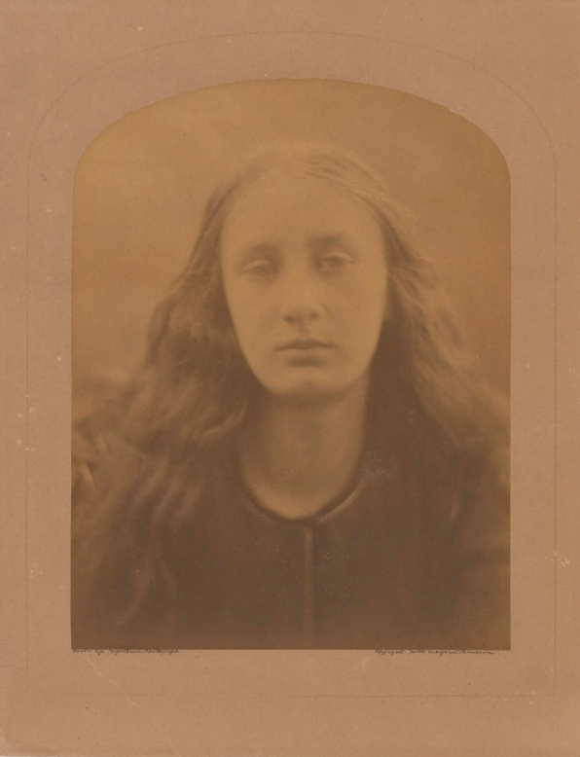
Christabel, May Prinsep, created by Julia Margaret Cameron (1815 –1879) in the United Kingdom, 1866, albumen silver photograph, 30.4 x 23.4 cm. National Gallery of Australia, Purchased 1978.

Significance across collections
Australia’s movable cultural heritage is distributed across countless private and public collections. There are nationally significant items and collections in national, state, regional and remote collecting organisations and in businesses, private homes and other settings. These repositories rarely hold a single type of cultural item and there is no sharp delineation between the material collected across the collecting domains. For example, works of art may be held in museums, archives or libraries, while art galleries may collect items of documentary heritage or social history. Significance builds awareness of this distributed national collection and encourages a consistent approach to its assessment.
Researching and assessing significance is an inherently cross-collection and cross-domain activity. Information essential to understanding a cultural item in a museum may be in a library or archive, with comparable examples in an art gallery, private collection, historical society or cultural centre. While a single cultural item or collection can hold a great deal of information and meaning, the power of cultural material to tell stories and communicate ideas is amplified when it comes into dialogue with other material. This power is clearly seen in cultural exhibitions and publications that bring together items and collections to explore a subject or theme.
For First Nations cultural material, distribution across many collections is often a consequence of colonial dispersal, which separated communities from their heritage. In this context, reconnecting distributed material with source communities and enabling its return are as important as cross-collection research and assessment. The significance assessment process can reveal challenging, contested, and previously untold histories, and the circumstances in which items were collected. In this regard, the process can facilitate truth-telling and foster shared understanding of Australian history.
The items and collections related to our national stories are often held in multiple organisations, due to their broad relevance and appeal. This is shown in the following examples of Ned Kelly and the thylacine, summarised from their publication in Significance 2.0, and recent projects that highlight how cross-collection research can assist in telling difficult stories.

The story of Ned Kelly across collections
The story of the bushranger Ned Kelly (1854–1888) and his gang has had an enormous influence on Australian culture. It has inspired visual artists, musicians, novelists, poets, film and documentary makers, game designers, historians and cultural tourists, and evoked a range of opinions. Some see the outlaws as villains, thieves and murderers, while others position them as champions of the poor and oppressed.
Material held in archives and art galleries, libraries and museums across Australia allows Kelly’s story to be researched, viewed and interpreted. Preserved at the time when the exploits of the Kelly Gang were capturing the attention of Australian colonists of the 1870s and 1880s, items and collections relating to Ned Kelly have since been used to tell his story and explain its grip on the nation’s consciousness.
These items and collections are therefore of great historical significance. They include original documents, photographs and objects. The Jerilderie letter is one of only 2 documents by Ned Kelly to have survived. Described as his manifesto, Kelly dictated the letter of around 8,000 words to Joe Byrne in February 1879. It conveys his pleas of innocence, and passionate desire for justice for his family and the poor Irish selectors of Victoria’s north-east. The Jerilderie letter brings Ned Kelly’s distinctive voice to life and offers a unique insight into the man behind the legend. The State Library of Victoria holds the original, and the National Museum of Australia has a transcription made by publican John Hanlon in 1879. For more information see: https://www.slv.vic.gov.au/search-discover/explore-collections-theme/australian-history/ned-kelly/jerilderie-letter and https://www.nma.gov.au/explore/features/ned-kelly-jerilderie-letter.
The State Library of Victoria is also the custodian of a suit of armour, fashioned from farm machinery, worn by Kelly and members of his gang at the siege of Glenrowan in 1880. In recognition of the significance of Ned Kelly in Australia, the Protection of Movable Cultural Heritage Act 1986 designates each piece of this armour as a Class A object of historical significance. For more information on the armour see: https://www.slv.vic.gov.au/search-discover/explore-collections-theme/australian-history/ned-kelly/ned-kellys-armour.
The story of Ned Kelly has also generated cultural items of significance. One example of this is the series of paintings of Kelly by Australian artist Sidney Nolan (1917–1992). Through numerous paintings of the bushranger, Nolan created an icon – a stylised black helmet that acts as a visual shorthand for Kelly’s story and evokes instant recognition among Australians, a distinction it shares with only a handful of other works of art created in this country. Nolan’s Ned Kelly paintings are of artistic significance for their evocation of the stark figure of Kelly framed in the vibrant colours of the Australian landscape, and for the pathos of his story captured in paint. The National Gallery of Australia holds 26 of the paintings from the first Ned Kelly series and the Art Gallery of New South Wales holds one. For more information see: https://nga.gov.au/exhibitions/ned-kelly/.
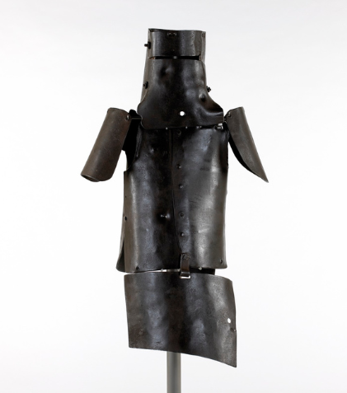
Suit of armour worn by Ned Kelly, 1880, State Library Victoria. Left shoulder plate on loan from Museums Victoria. Right shoulder plate purchased with funds from the Sundberg Bequest and the Department of Communications, Information Technology and the Arts 2001.

The Story of the Kelly Gang, directed by Charles Tait (1868–1933), was made in Australia in 1906. It has historical, artistic, creative and technical significance as the world’s first feature-length narrative film. While the original was all but lost, the National Film and Sound Archive of Australia was able to piece together and restore around a quarter of the film in 2006. The film was subsequently registered on the UNESCO Memory of the World Register in 2007. For more information, see https://www.nfsa.gov.au/stories/articles/story-kelly-gang and https://www.unesco.org/en/memory-world/story-kelly-gang-1906.
Kelly’s story is still under investigation at archaeological sites including Glenrowan, where excavated items have research significance to elucidate the Kelly Gang’s final days. The Victorian Heritage Database has a statement on the site’s significance: https://vhd.heritagecouncil.vic.gov.au/places/4073. The enduring story of Ned Kelly also has great social significance as successive generations of Australians identify with aspects of his story.
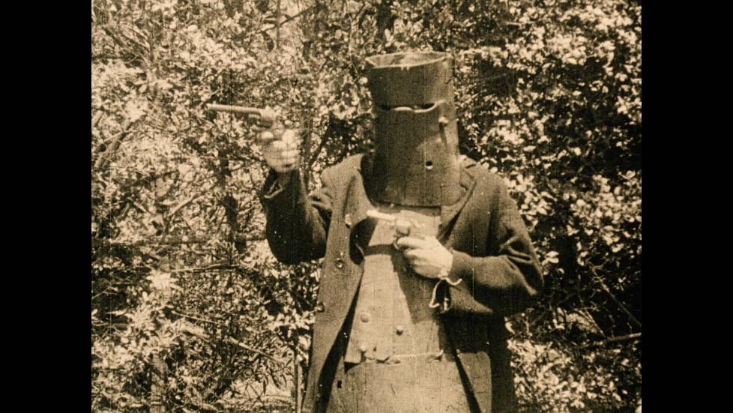
Still from The Story of the Kelly Gang, directed by Charles Tait, 1906, silent film. National Film and Sound Archive of Australia

The thylacine across collections
The thylacine (Thylacinus cynocephalus) is believed to have died out on the Australian mainland over 3,000 years ago. By the late 18th century, its populations were confined to Tasmania. Also known as the Tasmanian tiger or Tasmanian wolf, it is now Australia’s best-known example of recent species extinction, with the last known animal dying in Beaumaris Zoo, Hobart, on 7 September 1936. Since that time, the thylacine’s significance has evolved from a vilified pest, hunted to extinction, to a potent symbol of human impact on the natural environment.
The poignant reminders of the animal’s fragile existence, terminated within the living memory of many Australians, have been captured in physical specimens, photographs, film and works of art. Not confined to collections in Tasmania, or Australia, this material demonstrates the capacity of museums and art galleries, libraries and archives to hold evidence of what has existed in the past and to research its impact in the present and future.
The Tasmanian Museum and Art Gallery in Hobart, Tasmania, holds 94 thylacine specimens, as well as thylacine photographs and images and material from the various searches for a living thylacine. Australian collections that hold thylacine specimens include Queen Victoria Museum and Art Gallery in Launceston, the South Australian Museum in Adelaide, Museums Victoria in Melbourne, the National Museum of Australia in Canberra, Queensland Museum in Brisbane, the Burke Museum in Beechworth, Victoria, and the Australian Museum in Sydney. Other specimens are recorded on the International Thylacine Specimen Database: http://www.naturalworlds.org/thylacine/mrp/itsd/itsd_1.htm.
The National Film and Sound Archive of Australia holds the only known original footage of the thylacine at Beaumaris Zoo in the 1930s (https://www.nfsa.gov.au/collection/item/hobart-1932-thylacine). The Archives Office of Tasmania holds numerous records related to the thylacine, including information on vouchers for bounty claims for thylacine skins, research papers and photographs, ministerial files, and private papers such as those relating to Beaumaris Zoo.
The thylacine is part of First Nations culture, with communities of the Australian mainland and Tasmania continuing to hold intergenerational knowledge of its existence and significance. While no examples are known to have survived in Tasmania, thylacine-like animals have been identified in rock paintings in Western Australia and the Northern Territory (Branden Holmes, Gareth Linnard, The History, Ecology and Loss of the Tasmanian Tiger, CSIRO Publishing, 2023). More recent images of the animal include works of art and prints and illustrated books on natural history held in art galleries, museums and libraries around Australia. Contemporary artists have also used the thylacine as a symbol of environmental loss and damage, and as a metaphor for the experience of First Nations peoples.
Thylacine specimens, items and collections are significant across all the primary criteria. They are of immense historical significance for their ability to convey the story of this lost species. Many of the items and images associated with the thylacine story have considerable artistic significance. The many thylacine specimens housed in museums and university collections around Australia and the world are investigated for their research significance. The enduring connotations of the thylacine as a symbol of environmental harm and loss of biodiversity, particularly in Tasmania, mean the thylacine and related cultural items and collections have considerable social and spiritual significance. The thylacine may also be of cultural or spiritual significance to First Nations communities with intergenerational knowledge of, or cosmologies associated with, the thylacine.
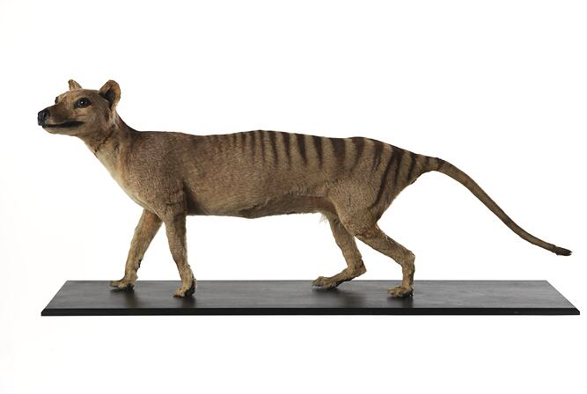
Thylacinus cynocephalus (Scientific author: Harris), 1808, dry mounted female specimen, collected in Tasmania, Australia. Museums Victoria, C 28744. Photograph: Rodney Start, Museums Victoria, CC BY 4.0.

Telling difficult stories
Identifying connections across distributed collections can be particularly important in relation to cultural items and collections that have been dispersed during traumatic historical events, such as armed conflicts, political unrest, and natural disasters, and due to patterns of discrimination, violence and displacement, including those experienced by First Nations communities. Bringing such items together through research projects, exhibitions and publications can have multiple benefits. It can reconnect people with their heritage and personal stories, promote truth-telling, assist in healing processes, and allow a deeper shared understanding of cultural and historical figures, events and themes.
There have been numerous impactful projects that demonstrate the value of this type of work. For collection managers, the most relevant will depend on the focus of their collections and the themes they are seeking to understand. Some of the many examples that may serve as useful starting points for further research include:
- The Unsettled exhibition, which was held at the Australian Museum in 2021 but can still be accessed virtually: https://australian.museum/learn/first-nations/unsettled/.
- The 2025 exhibition 65,000 Years: A Short History of Australian Art, held at the University of Melbourne's Potter Museum of Art: https://potter-museum.unimelb.edu.au/whats-on/past-exhibitions/65000-years.
- The National Picture: The Art of Tasmania's Black War exhibition held at the National Gallery of Australia in Canberra, Tasmanian Museum and Art Gallery in Hobart, Queen Victoria Museum and Art Gallery in Launceston in 2018 and 2019: https://nga.gov.au/exhibitions/the-national-picture/.
- The research, exhibitions, publication and content developed by the Australian War Memorial, and other war memorials across the country: https://www.awm.gov.au/.
- Projects by organisations that focus on traumatic events, such as museums dedicated to understanding the Holocaust, including the Melbourne Holocaust Museum https://mhm.org.au/ or those relating to more general issues that commonly have traumatic dimensions, including natural disasters, adoption and mental health.

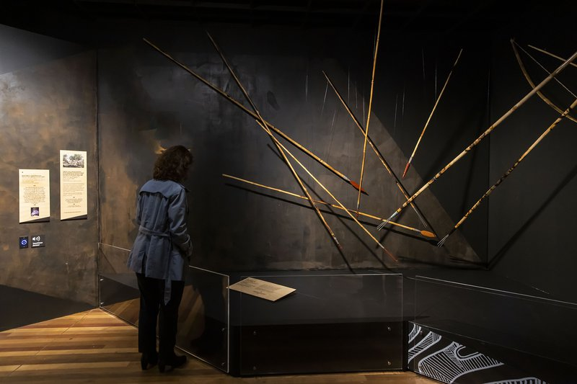
Visitors in the ‘Recognising Invasions’ section of the Unsettled exhibition. © 2021 Australian Museum. Photographer: Anna Kučera.

Significance approaches in the archives sector
Although Significance is used across the collecting sector, its application in archives is distinctive. Archives use significance assessments to understand why records exist and what functions they document, not just what they contain. They focus on collections (or series) as a whole rather than as individual items. This ensures that records are understood not just for what they contain, but for why they were created and how they relate to each other.
When used in archives, the Significance framework should not replace or override core archival principles such as provenance and original order. For records that document First Nations lives, these principles are being reconsidered to better recognise the rights and interests of the people the records are about, not only those who created them. Further guidance on these principles is available from the Australian Society of Archivists (www.archivists.org.au) and state records offices.

Government archives
In Australia, archival decision-making at the national and state levels is governed by legislation such as the Archives Act 1983 (Cth) and equivalent state records acts, which establish requirements for the creation, management, appraisal and disposal of government records. These laws mandate that records documenting government functions and accountability must be properly maintained and, where they have enduring value, transferred into archival custody. As a result, appraisal decisions are not purely discretionary but must align with legal obligations to preserve records that support transparency, accountability and the public memory.
State and national archives can use the Significance framework to strengthen appraisal and prioritisation by clearly identifying which records have enduring value for society. At these levels, archives manage very large volumes of material, much of it generated through government functions, so not everything can or should be kept permanently. Significance provides a structured way to assess which records most strongly document key aspects of governance, policy and social change. For national archives, this often means identifying records that reflect major national and global events, government authority and accountability in decision-making processes, or shifts in public life. In contrast, state and territory archives focus more on regional administration, legal systems and community development. By applying the framework’s criteria – particularly historical and research significance – archivists can justify retention decisions and ensure that the most important evidence of government activity is preserved. Government archives also identify records that document impacts of their decisions on and rights and entitlements of individuals and communities, as well as those documenting the connections of First Nations people to the land, sea and community.
In addition to appraisal, Significance can help state and national archives prioritise access, digitisation and interpretation. Even among records selected for permanent retention, institutions must decide where to invest limited resources. The framework supports this by highlighting records with high social or historical significance, such as those documenting First Nations histories, migration, or major policy impacts, which may be prioritised for digitisation or public engagement. It also encourages archives to articulate and communicate the broader importance of their collections through statements of significance, making their work more transparent and accessible to the public. In this way, Significance not only supports internal decision-making but also helps connect large institutional archives with the communities and histories they represent.
For records documenting First Nations people, significance and access are also rights-based. The individuals, families and communities these records concern have a distinct interest in accessing records about themselves. Appropriate access may mean prioritising community access and control rather than public engagement, including restricting access where records are culturally sensitive or concern living people. This is particularly relevant for records relating to the Stolen Generations and their descendants.
Many Australian Government archives are signatories to the Tandanya Declaration signed on 25 October 2019 at the first Indigenous Summit See us, Hear us, Walk with us: Challenging and Decolonising the Archive, hosted by the International Council on Archives and National Archives of Australia at Tandanya National Aboriginal Cultural Centre in Adelaide. The declaration commits signatories to the decolonisation of their archives, and to work collaboratively, respectfully and ethically with First Nations people. The Tandanya Declaration can be accessed at: https://www.naa.gov.au/about-us/partnerships/international-council-archives-ica/tandanya-declaration.

Non-government archives
For non-government archival collections, Significance is a practical framework that helps archivists understand and explain why their collections matter. Rather than simply accumulating records, it encourages organisations to think carefully about the cultural, social, historical and research significance of the material they hold. This is especially important for community archives, which often operate with limited resources and preserve stories that are not documented elsewhere.
For community archives, the framework plays a key role in appraisal, or the process of deciding what should be kept for the long term. Unlike large institutions, community collections often cannot preserve everything, so it is essential to identify what has enduring value. Significance supports this by shifting the focus from quantity to importance. For example, records documenting a local campaign, cultural practice or community organisation may have strong historical and social significance and therefore be prioritised for retention, even if they appear ordinary. By contrast, routine administrative records may have limited long-term value and can be deprioritised. It is important to note here that some community collections may also include state records, such as school records or records of births, deaths and marriages. Disposal of these records is governed by legislation, and it is important to seek advice from the respective state records or archives service before disposing of these records.
The Significance framework is also useful for prioritising work within existing collections. Even when material is kept, there are decisions to be made about what should be digitised, catalogued, conserved or shared first. Significance assessments help direct effort to where it will have the greatest impact. A collection that is highly significant to a particular community, such as oral histories or records of migration and settlement, might be prioritised for digitisation and access because of its importance to identity and collective memory.
A defining feature of Significance in the community context is its emphasis on including community perspectives. Professionals do not solely determine significance – it is shaped by the people connected to the material. This approach allows community members to articulate why records matter to them, ensuring that emotional, cultural and spiritual connections are recognised and recorded alongside historical and research significance. In this way, the framework helps to address gaps in traditional collecting practices and supports more inclusive and representative archives. For First Nations community archives and keeping places, this extends beyond including community perspectives to community control and self-determination over the material. The relevant community governs these archives in accordance with Indigenous Data Sovereignty and cultural protocols, which determine how material is held, accessed and cared for.

Case study 8: A statement of significance for an archive

Special Broadcasting Service (SBS) collection, National Archives of Australia
Contributed by: Melissa Thomas and Kirsty Johnson, Assistant Directors, Access & Public Engagement and Collection Management Branches
Organisation: National Archives of Australia
Dated: January 2026
The SBS collection comprises thousands of records in paper and audiovisual formats. It includes SBS board meeting minutes, program files, publicity material, video and film recordings, and programs produced or commissioned and broadcast by SBS.
SBS was established in January 1978 under the Broadcasting and Television Act 1942 (Cth) to provide multilingual broadcasting and television services to all Australians. The first multicultural radio stations, 2EA and 3EA, began as a broadcasting experiment in June 1975, and SBS assumed responsibility for both stations once it was established. SBS Television channels commenced full-time transmission in October 1980 and in 2012 the National Indigenous Television (NITV) channel was also included as part of SBS service delivery.
The SBS Charter identifies the principal role of SBS as providing multilingual and multicultural radio and television services that inform, educate and entertain all Australians and, in doing so, reflect Australia’s multicultural society. The collection reflects the activities undertaken by SBS in the fulfilment of its Charter. The material highlights the unique role SBS occupies and contributes to Australian society as a national broadcaster with a legislative mandate to present Australia’s multiculturalism and depict the cultural, linguistic and ethnic diversity of the Australian people.
Within this context, the SBS collection is of historical significance as a comprehensive record of the work of this national broadcast service. Through its depiction and reflection of cultural diversity and multiculturalism in Australia, including First Nations culture, the collection has evident cultural and social significance, telling specific stories and experiences of multicultural and migrant communities in programs and recordings. The collection’s research significance is substantial. It provides researchers with opportunities to interrogate and compare the media’s representation of and engagement with multicultural and First Nations communities.
The provenance of the SBS collection and its relationship to other collections is well understood and documented within collection management systems. The collection is preserved to the highest preservation standards by the National Archives and available to all Australians for public access. The collection is the only one of its kind in Australia, and it has substantial interpretive capacity to enrich knowledge and understanding of Australia’s history, society, culture, economy and the experiences of its people over time.
Notable examples demonstrating the primary historical, cultural and social, research significance and interpretive capacity of the collection include Significant Community Observations of People (SCOOP) film reels produced by SBS, which debuted in 1980 and were broadcast until 1983. The program depicts a range of community activities and the interaction of a cross-section of people from across Australia. The program was designed to be an Australian magazine-style television program focused on the cultural activities of cultural groups across Australia who were not particularly visible in mainstream media at that time. Episodes gave voice to the challenges and experiences of a broad range of people. Examples include documenting First Nations Australian Football League (AFL) players visiting the former Coranderrk Aboriginal Mission, prominent Melbourne business personality and furniture retailer Franco Cozzo, and the experiences of 2 migrants – French artist, Frederic Chapeaux, and Vietnamese politician, academic and writer, Nguyen Thanh Vinh – adjusting to life with their families in Sydney.
The collection’s NITV Tape Moving Images provides another notable example of the primary historical, cultural and social, research significance and comparative interpretive capacity of the collection. The images are captured on master Betacam tapes and were broadcast by NITV between 2007 and 2012. The tapes exemplify the flagship programming and storytelling of the first dedicated First Nations television broadcaster prior to its incorporation within SBS in late 2012. With over 100 individual titles, the tapes contain a wide variety of Indigenous content, including history programs, children’s programs, sport programs, and music productions. They include Chocolate Martini, a musical concert series showcasing performances and interviews with First Nations performers and musicians including Archie Roach and Ruby Hunter, the Joe Geia Band, the Stiff Gins and others. Also included is the Marngrook Footy Show, a weekly program from 2007 broadcasting AFL information from a First Nations perspective and with an emphasis on First Nations footballers. The program included analysis of AFL issues and detailed match previews, and regularly paid tribute to First Nations pioneers of the game with feature stories outlining their contributions.
As well as offering insight into the experiences of individual Australians and being a source of entertainment, the SBS collection includes videocassette recordings of SBS Television programs. A notable example is Dateline, an award-winning international current affairs documentary series which debuted in 1984 and is still broadcast today as Australia's longest-running international current affairs program.
Keywords:
SBS, archives, archival collections, multiculturalism, First Nations perspectives, National Indigenous Television (NITV), community life, social history, storytelling, migrant communities, audiovisual.
Significance categories:
Primary criteria: Historical | Cultural and Social | Research
Comparative criteria: Provenance | Condition and Completeness | Interpretive capacity | Rarity
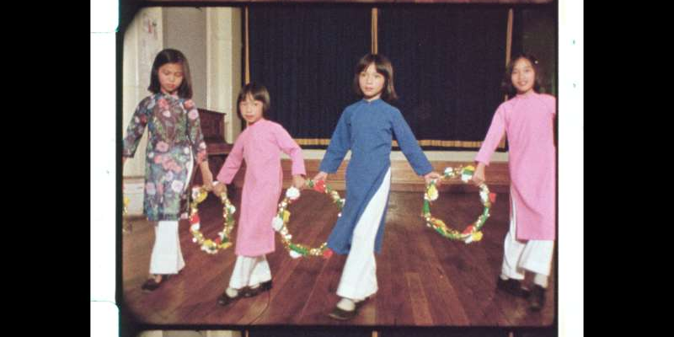
Still from SCOOP [Significant Community Observations of People] 1981 – Faces (Primary Version 1052115), 1 November 1981. National Archives of Australia (C5206_F 0661-81_113948_17719).
This episode documents the challenges and experiences of 2 migrants and their families. It focuses on French artist Frederic Chapeaux, and Vietnamese politician, academic, and writer Nguyen Thanh Vinh and his family. This still depicts Vietnamese girls celebrating the Moon Festival.

Significance approaches for operating heritage
Operating heritage refers to cultural heritage items and collections that are used regularly to demonstrate their original form and function. It is a key area in the significance landscape that offers an especially rich exemplar of the primary significance criterion of cultural, social, or spiritual significance. Operating heritage items often also have a high degree of interpretive capacity.
Items of applied science and technology have a very specific attraction for both volunteers and visitors alike. They include transport items such as animal-drawn vehicles and implements, trains, trams, motor vehicles, vessels and aircraft, agricultural items such as tractors and harvesters, and infrastructure items such as steam engines that can power a range of facilities, including waterworks, electricity supply and machinery.
Operating heritage also includes playable musical instruments (traditional and electronic), playable games such as pinball machines and cameras, sewing machines, tools, and electronic items such as radios and computers that remain in active use. Some traditional First Nations items could also come under the definition of operating heritage if they continue to be used for their intended purpose.

Operating heritage and social significance
While an item of operating heritage could potentially be significant under any of the primary criteria, it is often not difficult to demonstrate contemporary attachment to these items to validate a claim for social significance. The capacity of operating heritage to generate enthusiasm and commitment in volunteers is expressed in the Transport Heritage NSW Culture Framework, developed by Henry Reed Pty Ltd:
For some, their passion for transport heritage is based on the nostalgia of lived experiences and desire to share this with others. For many, it is the joy of sharing new experiences with younger generations and being part of providing a fun and engaging way to educate them about the past (Transport Heritage NSW 2025).
Volunteers in the operating heritage sector may have had a relationship with these items in their working lives and, in their spare time and retirement, give their services to maintain historical technology, bringing to the task their years of experience and sharing specialist knowledge of how things work. In some cases, the work they carry out involves rare and often vital trades, a form of intangible cultural heritage. In the process, volunteers and specialists expend an enormous amount of collective time caring for and sharing these items and associated knowledge.
Their commitment can be quantified to demonstrate the social significance of the items on which they work. In many instances, enthusiasts form clubs and associations and hold events such as open days and festivals that celebrate and share the operating heritage to which they are committed. These events can build new connections between people and operating heritage items, further enhancing their social significance. For example, the Good Old Days Festival is an annual display of privately-owned animal-drawn items held in Barellan, New South Wales (population 300). In 2025, the festival attracted 10,000 people (https://barellanclydesdales.com.au/records-spill-for-horses-bullocks-and-crowd-at-godf/).
The Paddle Steamer (PS) Enterprise is the National Museum of Australia’s largest working exhibit, and has been a cargo ship, floating store, fishing vessel, houseboat and showboat. Launched in 1878, it was acquired by the Museum in 1984 and restored in Echuca, Victoria, before being moored in its new home on Lake Burley Griffin, Canberra. A committed team of volunteers, including skippers, engineers and deckhands, look after the PS Enterprise and dedicate more than 1,660 hours per year to operate the vessel, which is maintained by Museum staff and specialist heritage shipwrights (https://www.nma.gov.au/explore/collection/highlights/paddle-steamer-enterprise).
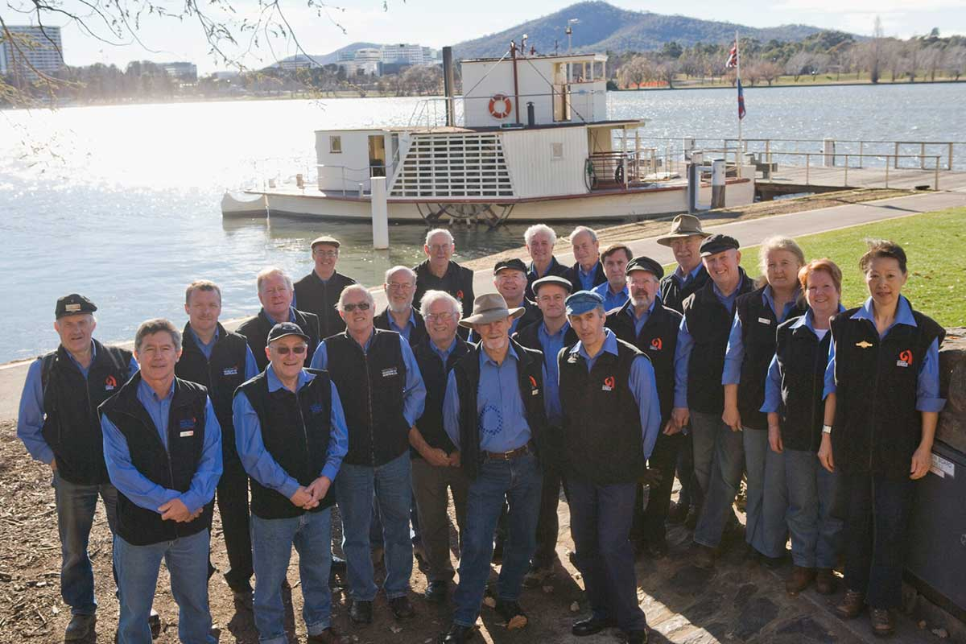
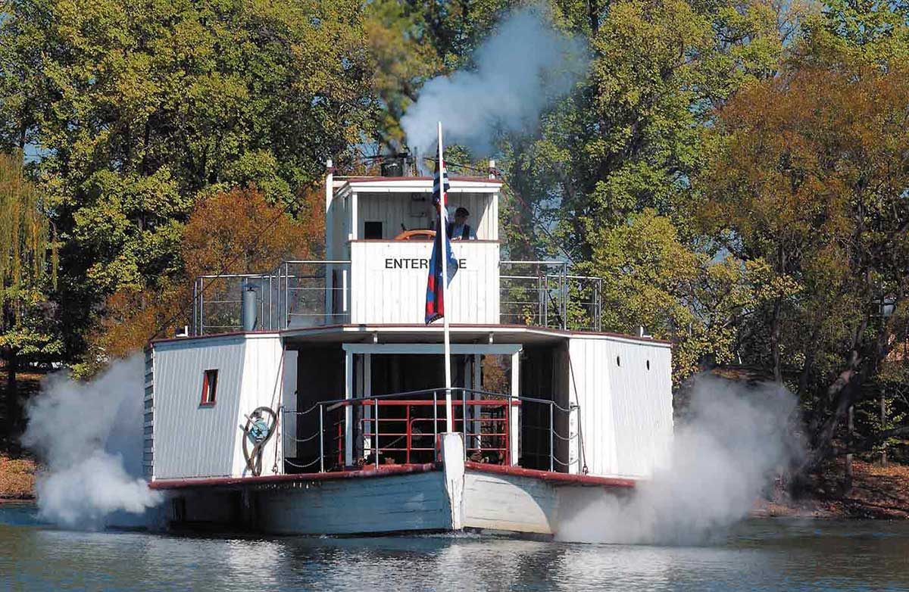
Above: Crew of the PS Enterprise. Below: PS Enterprise at full steam on Lake Burley Griffin in Canberra

Examples of operating heritage
The PS Adelaide (see case study 27), another paddle steamer, has operated since 1960 due to community interest and involvement with the vessel, which began in that year when local Echuca organisations decided to rescue the Adelaide, restore and operate it. The PS Adelaide is now significant to steam, maritime and engineering heritage communities around Australia, and to people who want to experience the movement, sound, smell and feel of an operating 19th-century paddle boat. This sensory experience, made possible by operating heritage, often has the potential to enhance the interpretive capacity of the item.
Readily movable operating heritage is not the only historical operating technology that inspires passion and commitment, thus demonstrating its social significance. Large engines that powered municipal facilities, such as water supply and street lighting, also attract a similar level of engagement from both volunteers and the public.
Goulburn’s Historic Waterworks, on the banks of the Wollondilly River in New South Wales, was built between 1883 and 1885 and is of historical significance. This steam-operated pumping facility provided Goulburn’s first reticulated water supply, and the pumphouse still contains the original Appleby Bros beam engine pump and Galloway boilers. The Waterworks is rare as the only complete, steam-powered municipal water supply in the southern hemisphere still in its original location. The Waterworks also displays a horizontal engine built by Hick, Hargreaves & Co, England, in 1866. Although this engine is not original to the site, it represents an earlier type and different style of a stationary steam engine.
The Goulburn Historic Waterworks Museum’s machinery can be viewed in operation on specific dates throughout the year. The facility also hosts the Steampunk Victoriana Fair on the third weekend of October every year, reinforcing the social significance of the site for a contemporary audience. Goulburn Historic Waterworks Museum website can be accessed at https://www.goulburnwaterworks.com.au/).
Tamworth, also in New South Wales, pioneered municipal street lighting in the southern hemisphere, when on 9 November 1888 the town’s streetlights – powered by electricity – lit up, bestowing on Tamworth the title of ‘City of Light’. This path-breaking municipal development was achieved with 2 locomotive-style fire tube boilers that each supplied steam to a 34-kW Fowler under-type steam engine that in turn drove a Crompton No 15 Dynamo, generating 230 volts of direct current to supply a street lighting system extending over most of the town (Tamworth Power Station Museum Volunteer Information Document October 2021). This array of technology is of historical significance for its role in this municipal initiative in regional New South Wales. The Fowler under-type steam engine has also been recognised as rare. It is one of only 2 examples of this model extant in the world. As a working engine it provides powerful evidence of the development and use of steam power in Australia from 1880 to 1900.
The Tamworth Powerstation Museum now holds this significant operating heritage, which has a high degree of social significance for the Tamworth community. This manifests itself in the support given to the Powerstation Museum by the community, especially on open days when the boilers are fired up and the engine is running, a process made possible by a team of dedicated volunteers.
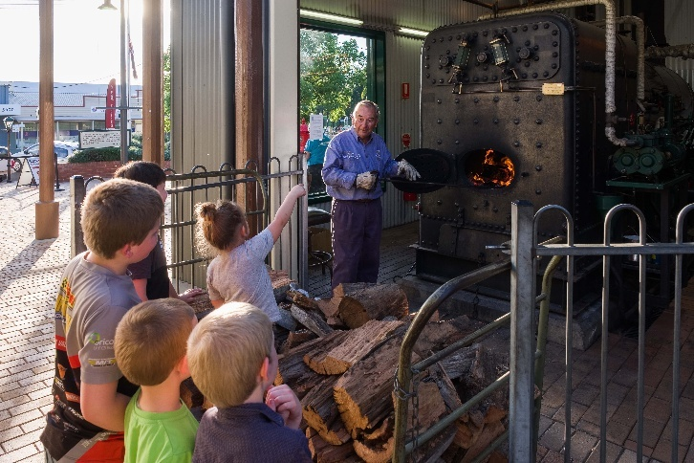
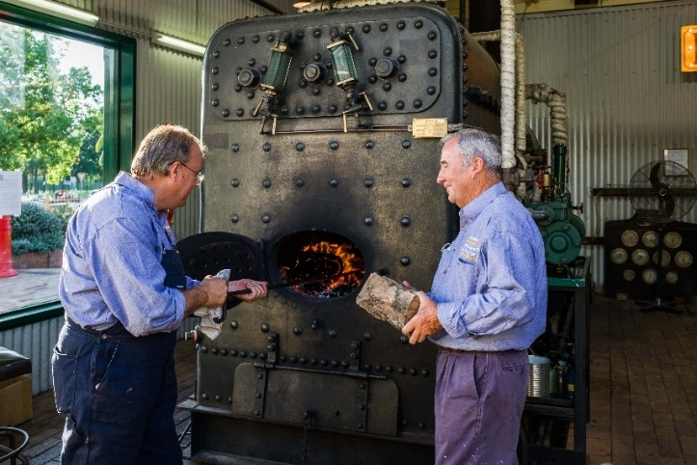
Tamworth Powerstation Museum volunteers demonstrate the operation of a fire tube boiler that once powered street lighting in Tamworth.

Balancing social significance with conservation requirements
Operationality is integral to the meaning and significance of many items. For example, a piece of electronic music equipment may make a specific sound that is impossible or difficult to replicate in other formats. If it is not played, it effectively loses that aspect of its significance.
There are also instances when operating an item helps to conserve it. One example of this is the quartet of stringed instruments – a cello, viola and two violins – made by AE Smith, Australia’s most important and influential violin maker, which is held by the National Museum of Australia (NMA). The instruments were made during Smith’s ‘golden period’, from the 1940s to the mid-1950s.
Recognising that being played can contribute to the continuation of an instrument's cultural and intangible significance, the NMA considers requests for the instruments to be used in performance as part of their ongoing stewardship and interpretation. In advance of a performance, the quartet needs to be 'woken up.' Conservation and Registration teams work closely with specialist luthiers to ready the instruments for the rigours of being played, including checking structural elements, cleaning and renewing varnish, and restringing. Considering the importance of their tonal and playing characteristics, material selections and treatment approaches may differ from standard museum practice to achieve an appropriate balance between conservation objectives, acoustic and musical requirements, documentation needs and risk management.
Prior to performance, musicians then 'play them in' over several months, allowing them to become familiar with their unique playing qualities. On the night of the performance, audiences can hear the quartet as their maker intended, and glimpse how they might have been experienced by audiences in the past. Documenting each cycle of use generates an archive of care, practice and performance, and a record of the active life and evolving sound of these historical instruments.

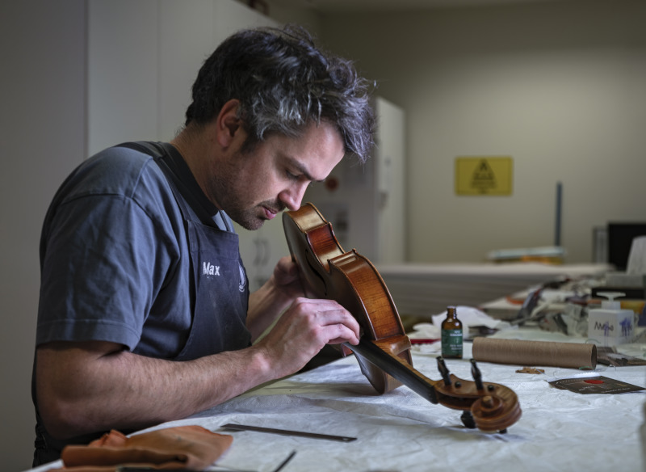
Luthier Max Glanville inspects and conducts maintenance to the AE Smith instruments prior to the performance by the Canberra Symphony Orchestra quartet (MA554381105).
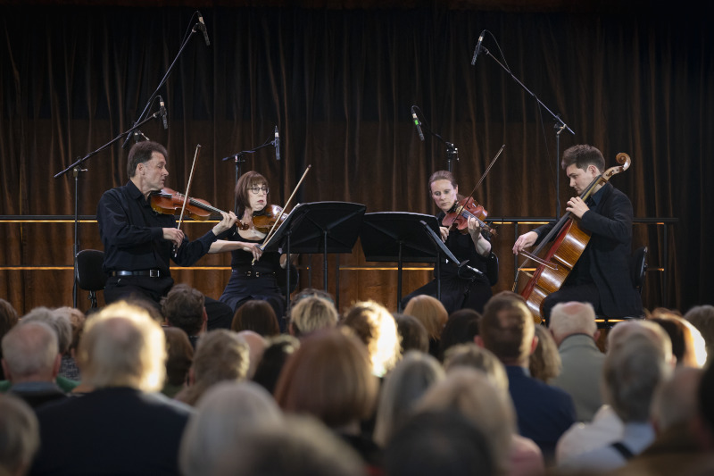
Resonances: Performing the AE Smith Collection, Canberra Symphony Orchestra quartet Douglas Macnicol, Pip Thompson, Lucy Carrigy-Ryan and Samuel Payne perform with the AE Smith instruments for the Resonances event, Gandel Atrium, Acton (MA558887347). Photographs by Jason McCarthy. National Museum of Australia.

Balancing the care of collection items with this type of intrinsic significance, as well as the desire to have them operating to engage audiences (and thus enhance their social significance), is a major challenge facing custodians of operating heritage. Items of operating heritage, by their nature, have been subject throughout their working lives to repairs and replacement of no longer usable parts. Making operating heritage items work again – or continue to work as they have done until they came into a collection – can be seen as a continuation of a familiar pattern of care.
Nevertheless, conservation standards commonly recommend that an item in a collection should retain its original or current condition where possible, especially when this is a key aspect of the item’s integrity and authenticity. To make an item operational again may require replacement parts and other modifications, so collection custodians must balance the benefits related to experiencing operating heritage with the need to preserve the item’s integrity. Any repairs should be carefully documented and, where appropriate, reversible, with all original components retained so that they can be restored in the future if the item is no longer required to operate. Adhering to strategic documentation, such as vessel management plans, can help guide decision-making, identify required resources and ensure regulatory compliance.
There are, however, differences of opinion on operability. Conservation decisions may change depending on the collector or collecting organisation, and their perceptions of the role of operability in the significance of the item. The collector or collecting organisation may also determine that an item needs to be in working order to maintain or enhance its condition and assert its integrity. Some items may also be determined to not only be more significant, but to be inherently significant because of their operability. Significance assessment can help the custodians of operating heritage items decide the appropriate balance to strike between the use of an item and its conservation.
When considering the condition of an operating heritage item, it is important to note that its restoration may relate to a certain point in time or historical context in which the item was used. For example, a vessel originally used for defence purposes that was later converted to a commercial training vessel could be restored to working order in either of those contexts. The significance of those contexts in relation to the item may differ. Significance assessment is a useful tool for informing decisions about the restoration of an item, and what state to restore it to in order to best retain its significance. It may also aid in identifying associated objects required for the continued operation of the item, such as specialised tools, materials and documentation, which can also provide context for the item.
Another issue associated with balancing conservation of operating heritage with the desire of audiences to see it working is the security of an item in a public context, such as a street parade of historic vehicles. When large crowds gather to view motorcades of vintage cars there are enhanced risks to the vehicles through interaction with members of the public. The benefits of social engagement with an operating heritage item must be weighed against any potential damage that it may incur. Other considerations include regulatory compliance and safety, maintaining historical fuel systems, the availability of materials and components, and accessibility to rare and endangered trade skills to support continued operation.

An integrated approach to preserving operating heritage
Transport Heritage NSW, in its vision statement, promotes an integrated strategy to ensure that operating heritage items continue to engage coming generations and maintain their social significance:
To preserve transport heritage, it is important to take a holistic approach and embrace the experiences and stories of other forms of transport including trams, buses, and ferries … The future of the transport heritage sector will rely on collaboration and partnership. Successful past collaborations have shown that working together engages diverse audiences, enables the delivery of unique experiences, and provides opportunities to effectively share resources (Transport Heritage NSW 2025).
A similar approach could include other forms of operating heritage and ensure that their social and historical significance is ‘understood, celebrated and preserved for future generations’ (Transport Heritage NSW 2025).

Case study 9: A statement of significance for a large operating technology item

Hartnett Estate ‘Woody’ wagon motor car in the collection of the Trafalgar Holden Museum
Contributed by: Mick Bourke OAM
Organisation: Trafalgar Holden Museum
Dated: April 2026
The Hartnett Estate ‘Woody’ wagon motor car in the collection of the Trafalgar Holden Museum was designed and built c. 1952–53 by Hartnett Motor Company Ltd. Hartnett was an Australian company established by Sir Laurence Hartnett (1898–1986) after he left General Motors Holden (GMH). Sir Laurence Hartnett is often referred to as the 'father of the Holden' because he oversaw the development of Australia’s first mass-produced car, the Holden 48-215 (also known as the Holden FX).
This 4-seat Estate 'Woody' wagon, in its original colour scheme of light green with cream interior, is believed to be the only Estate wagon in existence. It is thought that there are fewer than a handful of Hartnett motor cars of any model type currently in existence. ‘Woody’ was acquired with the support of the National Cultural Heritage Account, which confirms its historical significance under the Protection of Movable Cultural Heritage Act 1986.
This motor car is of historical significance, due to its connections with Sir Laurence, who came from Britain to Australia in 1934 to become GMH’s general manager between 1934 and1947. Sir Laurence is regarded by many as the elder statesman of the Australian automotive industry. After leaving GMH due to a dispute, Hartnett established his own company, Hartnett Motor Company Ltd, in 1949. ‘Woody’ is also historically significant as a symbol of Australian post-war optimism and the challenges faced when Australia pursued industrial self-sufficiency, and as a working example of historical Australian-led motor vehicle design and manufacturing. The vehicle is also of social significance to Australia’s motoring enthusiast community, particularly those with an affinity for cars related to Hartnett and the Holden story.
Originally intending to manufacture 5,000 vehicles in the first year, then 10,000 annually thereafter, the company advised in September 1952 that it only had orders for 341 vehicles (The Sydney Morning Herald, 11 September 1952). There is uncertainty about the total number of cars manufactured by Hartnett and the duration of the company’s operations. The website of Museums Victoria states that 135 Hartnett motor cars were produced between 1950 and 1954. However, during a court settlement process, Melbourne's The Argus newspaper reported on 10 December 1955 that production of the Hartnett motor car ceased in 1952 with only 80 vehicles manufactured. In fact, it appears that production only occurred in 1952, ceasing in September of that year, although this is disputed by the previous owner of the car who claimed production occurred between 1952 and 1956.
The provenance of the car is excellent. It has its original serial numberplate (1068) attached to it, demonstrating that it was built by the Hartnett Motor Company Ltd. The website of Motor Classica, which was an annual exhibition of vintage, veteran and classic vehicles, displayed the vehicle as a 1953 Hartnett Estate car, based on information provided by the car’s previous owner.
‘Woody’ is an extremely rare example of its type for 2 main reasons. First, it is believed to be the only one in existence of the no more than 16 of this model of the Hartnett motor car that were manufactured. There appears to be no definitive known number of Hartnett cars built, with articles providing quantities between 75 and 135. It is believed to be the last Estate wagon type in the world. Second, it is a rare example of a car that is part of the history of both Holden/GMH and Australia’s broader motoring history. The motor car was built by the company (Hartnett Motor Company Ltd) established by Sir Laurence Hartnett, who had previously been GMH's managing director.
The Trafalgar Holden Museum celebrates Australia’s motor manufacturing heritage. ‘Woody’ has great interpretive capacity as an operating vehicle in this context, providing insight into a short-lived and commercially unsuccessful phase in the career of Sir Laurence Hartnett, a central figure in the Holden story.
Keywords:
Sir Laurence Hartnett, Hartnett Motor Company Ltd, Australian automotive industry, cars, vehicles, Holden, motoring history, mechanical engineering.
Significance categories:
Primary criteria: Historical | Social
Comparative criteria: Provenance | Rarity | Interpretive capacity
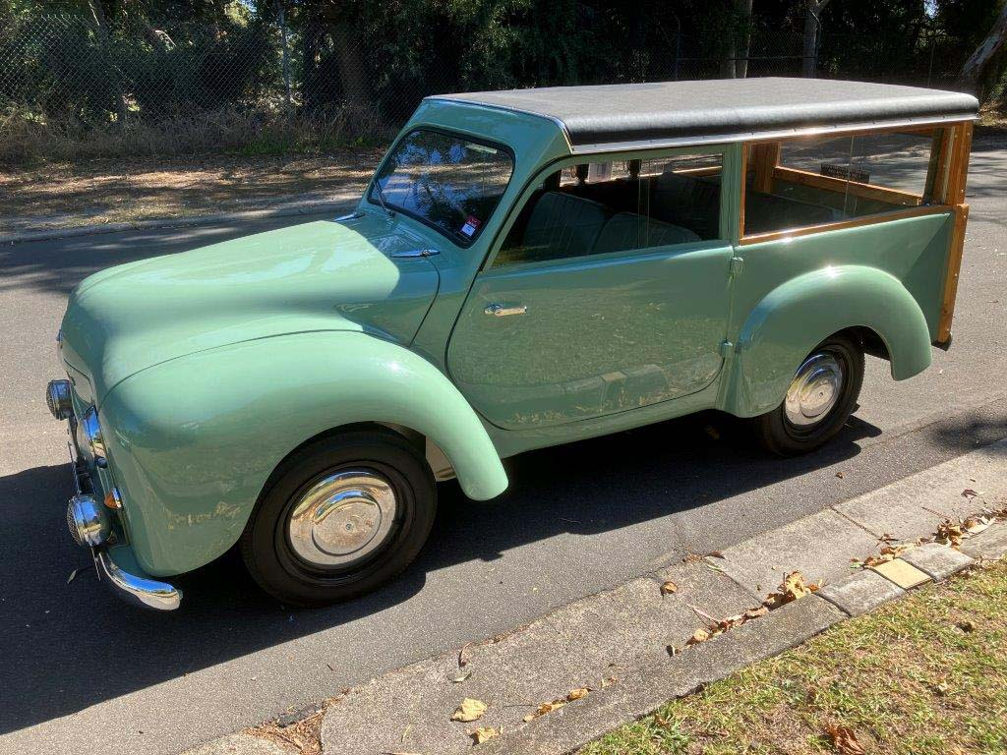
Hartnett Estate ‘Woody’ wagon motor car built circa 1952-53 by Hartnett Motor Company Ltd. Trafalgar Holden Museum.

Case study 10: A statement of significance for a playable musical instrument

Keith Humble Optronics Workstation (c. 1969–1970) in the collection of Melbourne Electronic Sound Studio (MESS)
Contributed by: Robin Fox, Co-founder and Artistic Director, MESS, and Byron Scullin
Organisation: MESS
Dated: July 2026
The Melbourne Electronic Sound Studio (MESS) is a living museum of electronic sound and music founded by Robin Fox and Byron J Scullin. Its collection spans the entire history of electronic music. Preservation through use is at the heart of the MESS philosophy and everything in MESS is playable.
The Keith Humble Optronics Workstation is an important instrument in the MESS collection primarily due to its historical significance and rarity. The workstation represents the beginnings of electronic music exploration in Australia. It also holds the Australian origin story of the emergence and development of the Electronic Music Studios Limited (EMS) in London, which was one of the first companies in the world to produce and sell electronic musical instruments that were affordable and accessible to the public.
The workstation contains a synthesiser that was commissioned by Australian composer and educator Keith Humble AM (1927–1995). Born in Geelong, Humble was an incredibly important artist in the development of electronic music in Australia. A renowned performer, composer and educator, Humble’s passion for contemporary music saw him found the Electronic Music Studio at the University of Melbourne in 1966. He was also Foundation Professor of the influential music school at La Trobe University in Melbourne from 1975 to 1989. Many seminal contemporary composers, performers and sound artists attended this innovative course which directly influenced an entire generation of Australian electronic music creation.
The workstation comprises a mixing section, patch panel, OmniVoila brainwave reader (which takes brainwave impulses from an electrode attached to the user’s temple and turns these signals into voltages that can control a synthesiser) and, most remarkably, a VCS-1 synthesiser. Only 3 VCS-1s were ever built and they constitute the spark that resulted in a revolution in the accessibility of electronic musical instruments that still reverberates today. The VCS-1 was originally built to stand alone but was integrated into this workstation by Humble and Graham Thirkell. It is believed to be the only one of the 3 in the world that is still fully functional, demonstrating its technical significance and rarity.
The workstation’s provenance is well-documented. After a concert of electronic music in London in c. 1968–1969, Australian composer and performer Don Banks convinced British composer Peter Zinovieff and English-Australian composer Tristram Cary OAM to accept a £50 commission (the equivalent of £700 in early 2021) to build him a portable synthesiser he could fit in a suitcase to take home to Australia. They, along with electronics engineer and designer David Cockerell, designed and built the Don Banks Music Box, later called the VCS-1 (or Voltage Controlled Studio 1), which is now housed at the Powerhouse Museum in Sydney. Keith Humble got wind of this, and he too commissioned an instrument. Humble’s VCS-1 wound up being folded into this Optronics workstation. The workstation itself was hand-built c. 1969-1970 by another Australian electronics pioneer, Graham Thirkell, who founded the Optronics company and built world-class multi-track tape machines and mixing consoles that were the foundation of many Australian radio station studios. It came into the MESS collection via MESS co-founder and director Robin Fox, who received it as a gift from engineer Jim Sosin. Sosin was Keith Humble’s friend and technician and had worked alongside him for many years. With Humble’s passing in 1995, Sosin inherited many of his instruments.
The prompt to construct the VCS-1 inspired Zinovieff, who founded EMS Ltd, to go into partnership with Tristram Cary and David Cockerell to focus EMS on the production of portable and affordable electronic musical instruments – and all with an Australian origin story. This instrument therefore has major historical significance and strong interpretive capacity as an authentic instrument in good functional condition that is available for the public to play through MESS.
Keywords:
Electronic music, technical innovation, Keith Humble, musical instrument, operating heritage, synthesiser, Melbourne, Australia, Graham Thirkell, Peter Zinovieff, Tristram Cary.
Significance categories:
Primary criteria: Historical | Technical
Comparative criteria: Provenance | Rarity | Condition | Interpretive capacity
References
- Australian Music Centre (n.d.) ‘Keith Humble (1927–1995)’, Australian Music Centre, accessed July 2026, https://www.australianmusiccentre.com.au/artist/humble-keith.
- Powerhouse Museum (n.d.) '“Don Banks Box” electronic music synthesiser, 1968’, accessed July 2026, https://collection.powerhouse.com.au/object/259174.
- Stitsky L (1993) ‘Banks, Donald Oscar (Don) (1923–1980)’, Australian Dictionary of Biography, Australian National University, accessed July 2026, https://adb.anu.edu.au/biography/banks-donald-oscar-don-9418.
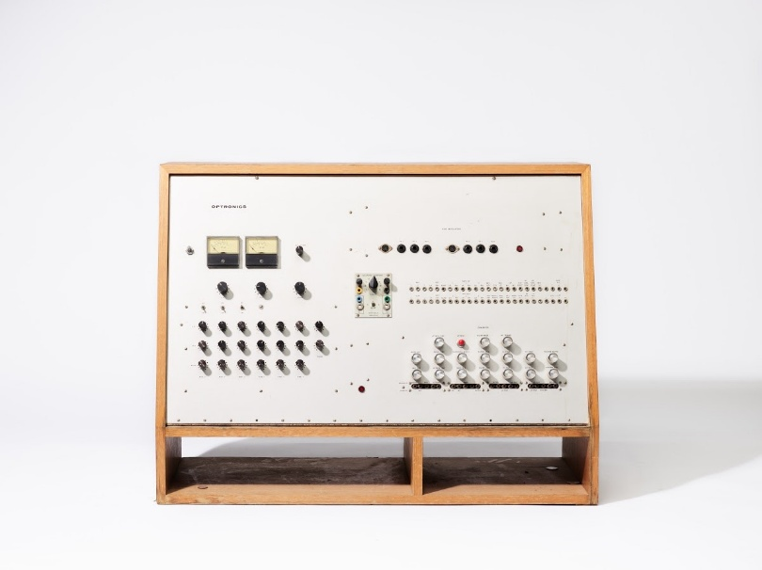
Keith Humble Optronics Workstation, c. 1969–1970, created by David Cockerell, Tristram Cary, Peter Zinovieff and Graham Thirkell (Electronic Music Studios Ltd), Melbourne Electronic Sound Studio, photograph by Kristoffer Paulsen.

Part 4: Significance in action
Significance assessment is not an end in itself but a process to aid good management of items and collections. It has many practical applications and has helped shape broader processes across the collecting sector and in cultural heritage conservation, management and protection. The following information is not intended as an exhaustive guide to collecting practices but explore the applications and interactions of Significance in strategic collection management, funding programs and legislation.

Strategic collection management
The Significance framework can be usefully integrated into collection management plans and policies prior to and when assessing the significance of items and collections. For individual and family custodians, this may take the form of an intention to collect material that has significance in a particular way, or to systematically assess significance. For collecting organisations, the framework can be integrated into strategic plans and policies, including mission statements, collecting strategies, and policies, actions and recommendations about collection care, management and access. These strategies should be reviewed as significance assessment processes progress because priorities may change with new assessments, and as previous ones are reviewed. Ideally, significance assessment should be part of collection audit and review processes.
For collections that include First Nations material, strategic review should also consider the community's rights and interests in that material, including consultation on the scope of collecting and access, and the possibility that the appropriate strategic direction is return or repatriation rather than continued collecting or retention. Decisions about how items are held, cared for, accessed, shared or returned should be made with the relevant community, in accordance with cultural protocols and Indigenous Cultural and Intellectual Property rights. For First Nations community archives and keeping places, these decisions rest with the community itself.

Prioritisation and resource allocation
Anyone can use Significance to inform decisions about appropriately allocating resources to the items and collections they hold. Understanding the significance of an item or collection should inform decisions about insurance, storage, security, conservation treatments, display, and purchase or sale arrangements. The assessment process encourages deep engagement with items and collections and supports the development of strategies grounded in a clear understanding of their significance. It enables custodians to articulate the need for specific types of support, make internal decisions on priorities for investment and promotion, and interpret and share their collections more effectively.
Collection development and interpretation
Significance is particularly useful in informing collection development policies. Custodians that hold and publicly display cultural material should have a written statement that defines and describes their collections and outlines the principles and processes they use to acquire and accession (register and add to the collection) or deaccession (deregister and remove from the collection) items. If they do not, the Significance framework can assist in developing one.
Effective collection development policies integrate information about how and why an organisation’s collection is significant, and what actions can be taken to ensure it remains significant. This will usually be through guidance on what to acquire, and how to prioritise funding and secure philanthropic support. Some policies will include desiderata (Latin for ‘things desired’ – a wish list) stating the items that will be sought through purchases, gifts or commissions.
Private collectors will often have a special interest area and a strong sense of the types of items that suit their collections. However, it can be helpful to set out collecting intentions in writing. Statements of significance can serve as a practical tool to guide decisions about what to collect. They can also be useful when seeking to sell or donate items to a collecting organisation, providing them with a better understanding of the context of the collection and its significance.
The overall significance of a collection can be enhanced through deaccessioning, and it is beneficial to ensure that both acquisition and deaccession are covered in collecting policies. By reducing the number of items held, especially those with limited significance, an organisation can concentrate on its strengths. This is also a good way to redistribute items to where they are most significant, or where they better belong. There are also instances when research and significance assessment will reveal that it is not appropriate to hold an item or collection. For example, research might demonstrate that an item was stolen, illegally imported, or misappropriated from a First Nations community, and should be returned to its rightful owner or repatriated to its country or community of origin. Good deaccession policies will include a clear pathway for return, restitution and repatriation based on assessment of legal and ethical information.
Significance assessment can influence collection interpretation plans or policies, which support strategic curatorial decision-making and audience engagement strategies. Significance assessment lays the groundwork for this by providing a process through which to clearly articulate the stories and meanings of items and collections and the people they have relevance to. The comparative criterion of interpretive capacity is particularly important here as it helps to identify items likely to be useful for storytelling and engagement. Interpretation plans often also consider factors such as the condition and conservation requirements of certain items, which are embedded within significance assessment.

Caring for collections
Responsibly caring for collections entails more than physical care to conserve material for its own sake. It is an ongoing process of documenting, understanding, and conserving items and collections to enable important material to be retained, protected and put to appropriate use. This requires collaboration across governments, collectors and collecting organisations, cultural heritage professionals and communities, including the First Nations communities who hold authority over their cultural heritage.
Integrating significance assessment into collection care strategies makes them more effective. The care of collections should be founded on the principle of stewardship: the responsibility to conserve, document, protect and provide appropriate access to cultural material for present and future generations. Custodians must actively engage with risks that can adversely impact the significance, accessibility and interpretation of material. Physical risks include rare or catastrophic environmental events like floods, fires and earthquakes, as well as theft and vandalism. Collections can also be affected by slow and cumulative deterioration caused by inappropriate climate conditions, poor storage, handling and display and biological factors. The likelihood and severity of these risks will depend on factors including the type of material, storage conditions, and the knowledge and skill of custodians.
Dissociation is another risk that can occur when items are separated from the information needed to identify, locate or understand them due to inappropriate storage, handling and interpretation. Dissociation can impact knowledge of an item's meaning, as well as its intrinsic significance. Closely related to this is the risk of cultural harm, including breaches of cultural protocol, inappropriate access or display and the continued separation of material from the community it belongs to. Risks of dissociation and cultural harm are often heightened for items that are culturally sensitive or hold significance for a marginalised sector of society, including First Nations peoples and communities. Undertaking significance assessment is an effective means of mitigating these risks, especially when the assessment process involves appropriate consultation.
Custodians should develop integrated collection management practices that combine significance assessment with strategies for active and preventive conservation measures. This will typically involve:
- day-to-day practices of maintaining appropriate storage, handling and display environments, tracking and documenting item movements, and controlling pest and security risks
- seeking external advice when possible and as needed
- preventive measures like disaster preparedness and sustainability planning
- systems for routine monitoring of collections to support their long-term conservation
- an ongoing commitment to significance assessment
Collection digitisation activities have become an increasingly important part of caring for and preserving items and collections. Digitisation includes the creation of digital records of physical or analogue items as well as creating derivatives of born-digital collection items. It can help protect significant items and collections from physical deterioration and technological obsolescence, while enabling broad accessibility, supporting research and education, strengthening cultural connections and ensuring cultural heritage remains accessible for future generations.
For First Nations material, it is good practice for digitisation to be undertaken with the consent of the relevant community and in accordance with Indigenous Cultural and Intellectual Property rights and Indigenous Data Sovereignty. While digitisation can reconnect communities with their heritage, broad public accessibility is not always appropriate, as some material is culturally restricted, and access to the digital record should be determined by the community.
Where resources are particularly limited, custodians of collections may need to make difficult decisions regarding prioritisation of collection care. Significance assessment supports these decisions by helping custodians understand the nature and condition of items, their significance and the risks associated with management and conservation. This also supports custodians to balance conservation and access.

Resources to guide your approach
There are many publications and guides available to help individuals and organisations to plan and implement achievable and sustainable collection management strategies and processes for collection care. Many of these resources are listed in Part 6. National and state and territory peak bodies and member associations publish additional resources to assist with strategic collection management. It is recommended you consult these resources where available.
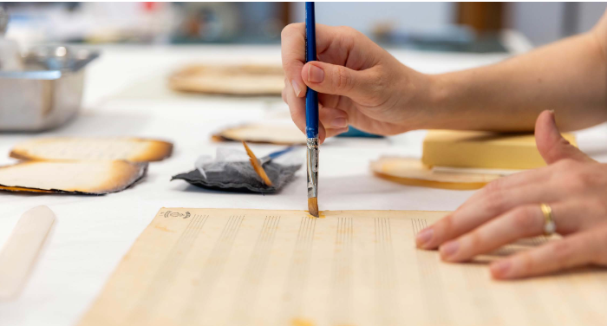

Case study 11: Significance and strategic collection management at the regional level
In the following case study, Bridget Guthrie, Director of the Tamworth Regional Gallery and Museums, shares recent approaches taken by the Tamworth Regional Council to address sustainability issues and rationalise collections in line with significance assessment. This demonstrates how Significance-informed strategic collection management can be implemented by local governments and provides examples that can be applied at the organisational level.

Deaccession, disposal and reinvention: strategic responses to resource constraints for regional museum collections
Contributed by: Bridget Guthrie, Director
Organisation: Tamworth Regional Gallery and Museums
Dated: July 2026
Regional museums operate within increasingly constrained resource environments, requiring strategic approaches to collection management and sustainability. They generally rely heavily on local government support and may be owned or operated by councils, municipalities or shires. Drawing on recent actions and strategic documents of the Tamworth Regional Council, this case study discusses how local governments can address some of their collection management challenges through active deaccessioning, systematic disposal practices, and the planned closure or rationalisation of select volunteer-run museums, which can sometimes be necessary. These approaches, underpinned by significance assessment frameworks, enable the sustainable stewardship of cultural heritage in the face of finite resources.

Deaccessioning and disposal
A central tenet of contemporary museum collection management practice is the need for active, ongoing deaccessioning. The Tamworth Regional Council (TRC) Museum Collection Policy explicitly embeds deaccessioning as a deliberate and essential mechanism to ensure that collections remain aligned with the organisation’s purpose and capacity. It defines deaccessioning as the removal of items that lack relevance, significance, provenance, or appropriate storage capacity, with the aim of ensuring that only materials relevant and appropriate to the museums’ future directions are retained. This reflects a critical shift in museum thinking: objects may be inherently significant but not necessarily significant to a particular collection. Such a distinction acknowledges that significance is relational and contextual rather than absolute. In practice, ongoing deaccessioning enables collections to be refined, better documented, and more effectively interpreted, particularly in the context of the TRC, where regional collections are estimated to collectively hold approximately 85,000 objects and continue to grow.
Closely connected to deaccessioning is the necessity of systematic disposal, particularly in relation to museum objects that are not yet accessioned or poorly documented. Disposal processes, as outlined in both the TRC Policy and broader collection management procedures, must be ethical, transparent and structured, prioritising disposal through return to donors (note that this is not available for items acquired under the Cultural Gifts Program), transfer to other organisations, or reuse where possible. Only when these avenues are exhausted will consideration be given to destroying the item.
An example of the benefits of managing this challenge is the successful relocation of the Tamworth Regional Film and Sound Archive in 2025. The Archive was previously located at Council’s Ray Walsh House building and managed by a team of dedicated volunteers. In 2022, this facility was closed because the building was found to have asbestos contamination. The Archive was subsequently housed across 3 separate locations. The relocation to the Archive’s permanent home was managed in line with the Tamworth Region Museum and Archive Strategy 2024–25 to 2029–30 (TRC Strategy), and involved a review of the Archive’s collections, including material stored at offsite locations.
Legacy accumulation, inconsistent or lack of documentation, and storage limitations required proactive intervention, including disposal of select items. The volunteers at the Archive understood the pressures and space restrictions as well as the opportunity the move offered to refine the Archive’s holdings. Disposal in these contexts is not a failure but an exercise in sound management, addressing risk, improving storage conditions, and ensuring that resources are directed toward collections of demonstrable relevance. Without such action, museums risk becoming custodians of unmanaged accumulation rather than curated collections.

Rationalisation of collections
Beyond collection management, the sustainability of museum operations themselves must be addressed, particularly in volunteer-dependent institutions. The TRC Strategy highlights that the region has more than 200 volunteers contributing over 21,000 hours annually. However, it also identifies significant challenges in volunteer recruitment and succession planning. While efforts to support and retain these volunteers and attract new volunteers are critical, in instances where volunteer capacity continues to decline, some museums will inevitably face closure.
This then presents the opportunity of reframing such closures as a managed, consultative process that acknowledges community attachment while recognising operational realities. Some may reach a point where continuation is no longer viable. In these cases, proactive planning is essential. Collections should be assessed, rationalised, and redistributed where appropriate. Stakeholders should be engaged in a transparent dialogue, and emotional responses, including grief, blame or resentment, should be anticipated and supported.
This approach reflects broader constraints on local governments in recent years, which impact their capacity to support volunteer-run museums due to rising costs, competing priorities and limited resources. While the triple bottom line, including social, cultural and economic value remains a guiding principle, it must be balanced against feasibility and risk. Allowing museums to decline unmanaged poses greater risks than planning for closure, including the risks of loss of collections, reputational damage and community dissatisfaction.
A positive and practical model for sustainable museum practice is demonstrated through the co-location of collections within existing civic infrastructure such as libraries and Visitor Information Centres (VICs). The relocation of the Gil Bennet Rocks, Gems and Minerals Collection in Nundle, New South Wales, provides a clear example of how this approach can enhance access and address the planned closure and relocation of a collection. Access to this collection had been dependent solely on volunteer availability. By integrating the collection within the Nundle Regional Library, the collection is now available to the public on a consistent, reliable basis, extending access to 6 or 7 days per week. This model not only improves visibility and engagement but also captures new audiences, who may not intentionally visit a standalone museum, by embedding heritage experiences within everyday community spaces.
Importantly, co-location also represents effective resource allocation and asset optimisation, addressing both operational and built environment challenges. The transition from a small, volunteer-operated demountable facility to a professionally staffed, centrally located library ensures improved environmental conditions, security and exhibition standards for the collection. It reduces duplication of infrastructure and enables shared staffing, utilities and maintenance costs, thereby strengthening long-term sustainability. Furthermore, situating collections within an active community hub contributes to place-making and cultural tourism, positioning heritage assets as integral to regional identity and economic development. In this way, co-location provides a scalable and strategic response to limited resources, ensuring that collections remain both well-managed and meaningfully accessible to the communities they serve.
The effective asset management of cultural collections, particularly the interrelationship between collections and the built environments that house them, should also be considered. Museum collections are not independent assets – their preservation is intrinsically tied to the quality, capacity and environmental performance of storage and display facilities. The TRC Strategy highlights that many collections contain fragile materials, such as textiles, paper and film, and are frequently housed in unsuitable or non-climate-controlled environments, creating significant preservation risks. Maintaining appropriate environmental controls (including temperature, humidity, lighting and pest management) is essential to prevent deterioration, yet these systems are costly to install, operate and maintain, particularly across a geographically dispersed network of small museums. As such, the cost of sustaining multiple underutilised or substandard facilities must be critically weighed against the value of the collections they house.
Strategic asset management therefore requires an integrated approach that considers both collection significance and infrastructure capability, including the consolidation of storage, investment in fit-for-purpose facilities and the relocation of collections to environments where long-term preservation can be provided. Considered in this context, decisions regarding deaccessioning, disposal, or even museum closure are not solely curatorial. They are also asset-based, aiming to ensure that limited resources are directed toward maintaining appropriate standards of care for collections that justify the ongoing investment.

Recognising the value of collections
Communities grappling with these decisions need to also consider the triple bottom line. Museums deliver significant social, economic and environmental benefits that extend well beyond their core role of preserving local history and culture. In many communities, museums serve as important social hubs, fostering community pride, volunteer participation, intergenerational learning and social cohesion. They often represent a region’s primary cultural tourism attraction, providing opportunities for residents and visitors to connect with local stories, heritage and identity. Local government support of these facilities helps strengthen community wellbeing, build social capital and ensure the long-term sustainability of valued cultural assets.
From an economic and environmental perspective, relatively modest local government investment can generate substantial returns. Museums contribute to local visitation, increased overnight stays and visitor spending, supporting local businesses and regional economic development. At the same time, they play a vital role in the preservation, adaptive reuse, and enhancement of heritage buildings and community assets, reducing the loss of important cultural infrastructure. By supporting both volunteer-run and staff-operated museums, local governments can achieve strong triple bottom line outcomes, delivering social value, economic growth and sustainable stewardship of community assets for the benefit of current and future generations.

Applying the Significance framework
For the TRC, a critical tool in navigating these decisions has been the application of the Significance framework, already referenced within TRC Museum Collection policy and procedures. Significance assessment provides a structured framework for evaluating historical, aesthetic, social and research significance, enabling informed prioritisation. The next iteration of significance assessments across the Tamworth network offers an opportunity to align collecting, deaccessioning, resourcing and potential closure decisions. By identifying which museum objects and themes contribute most strongly to regional narratives – such as Tamworth as the ‘City of Music’ or ‘City of Light’ and part of the ‘Fossickers Way’ – resources can be directed toward collections of highest strategic value. Conversely, collections with predominantly localised or redundant content may be candidates for rationalisation, transfer or, in some cases, planned closure.
The challenges facing regional museums necessitate difficult decisions. Active deaccessioning ensures collections remain relevant and manageable. Systematic disposal addresses legacy accumulation and risk. The respectful closure of unsustainable museums acknowledges both community values and operational realities. Underpinning these processes, significance assessment offers a robust framework for prioritisation. Together, these strategies support a sustainable, ethical, and future-focused museum sector, ensuring that limited resources are invested where they can deliver the greatest cultural impact.
References
- Australian Country Music Hall of Fame (2020) Australian Country Museum Hall of Fame Strategic Plan 2020–2025.
- NSW Department of Climate Change, Energy, the Environment and Water (2024) Heritage asset management guidelines: Heritage Council of NSW guidelines for state agencies, NSW Government, https://www.environment.nsw.gov.au/publications/heritage-asset-management-guidelines.
- Tamworth Powerstation Museum (2016) Tamworth Powerstation Strategic Plan 2016–2020, Tamworth Regional Council.
- Tamworth Regional Council (11 February 2025a and 2025b) ‘Permanent home for the Tamworth Regional Film and Sound Archive’ and ‘Moonbi Museum S355 Committee Transfer to Incorporated Body’, Business Paper: Ordinary Council Meeting, Tamworth Regional Council.
- Tamworth Regional Council (2024) Tamworth Region Museum and Archive Strategy 2024/25–2029/30, https://www.tamworth.nsw.gov.au/live/arts-and-culture/tamworth-regional-museums.
- Tamworth Regional Council (2025), Cultural Collections Asset Management Plan.
- Tamworth Regional Council (8 August 2022) Creative Capital Minor Works and Equipment Round two application: Nundle’s Precious Gems and the Fossickers Way – Relocation of the Gil Bennet Rocks, Gems and Minerals Collection, Tamworth Regional Council.
- Tamworth Regional Council (n.d.) Tamworth Regional Museums Collection Policy, Tamworth Regional Council General Policy Register, https://www.tamworth.nsw.gov.au/about/policies-plans-and-regulations/general-policy-register.
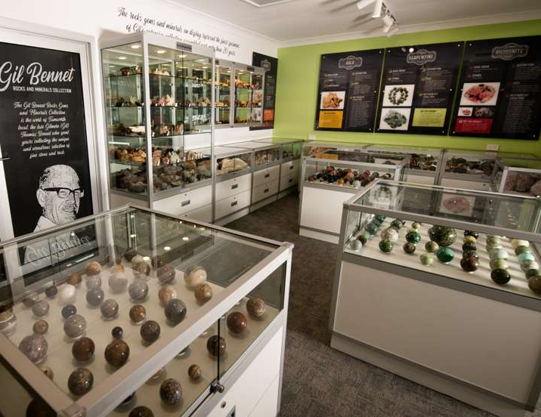
Items within the Gil Bennet Rocks, Gems and Minerals Collection, Nundle Regional Library, Tamworth Regional Council.

Case study 12: A Significance-informed collecting strategy

Developing collections through comparative significance assessment – Maitland Regional Art Gallery’s Les Darcy Collection
Contributed by: Dr Gerry Bobsien, Director
Organisation: Maitland Regional Art Gallery
Dated: November 2025

Collection context
Australian boxing champion Les Darcy (1895–1917) was born and raised in East Maitland in New South Wales. Known as the ‘Maitland Wonder,’ Darcy achieved international recognition as a boxer before he controversially left Australia for the United States of America in 1916 to avoid being conscripted to fight in World War I (1914–1918). Tragically, he died from an infection in Memphis, Tennessee, the following year at the age of 21. Today, Darcy’s legacy remains central to Maitland’s regional identity and contributes to the national history of sport.
Maitland Regional Art Gallery (MRAG) holds an extensive collection relating to Les Darcy, including personal belongings, handwritten letters, photographs, newspapers, magazines and ephemera. This material was embedded in the collection from various means including donation by members of Darcy’s family and through acquisition.
The Les Darcy Collection has cultural, historical and research significance, is in good condition and has well-documented provenance, representativeness and interpretive capacity. It supports understanding and appreciation of the life and career of one of Australia’s most prominent early 20th-century sporting figures. The collection also provides insight into a golden age of Australian boxing, its cultural importance and the broader social and cultural context of Australia during the early 20th century. The Les Darcy material also has cultural and social significance due to its strong regional connection, reflecting Darcy’s origins and ongoing importance to the Maitland community.
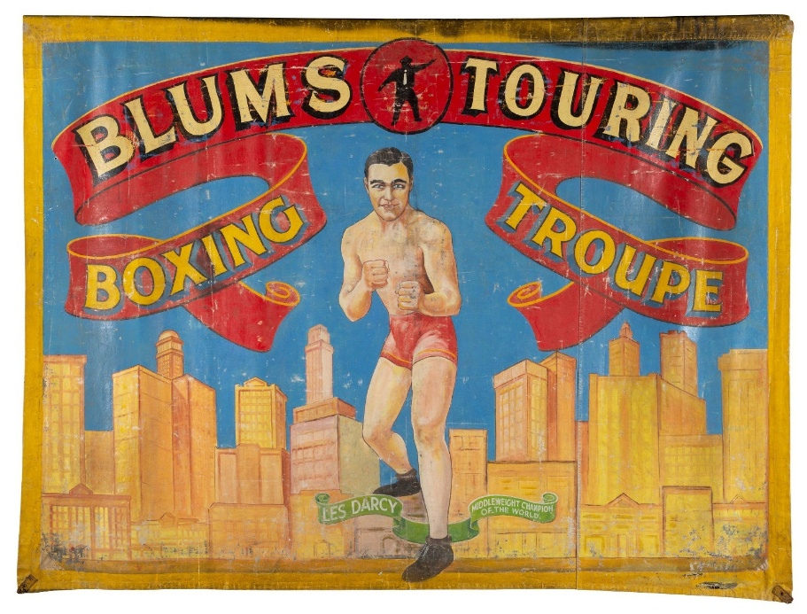
Blums Touring Boxing Troupe, unknown artist, c. 1950s, boxing tent wall (mixed media), 175 x 233 cm, Purchased by Maitland Regional Art Gallery, 2004.015.

Building on collection strengths
MRAG has applied the Significance framework to guide strategic acquisitions that extend and deepen the significance and interpretive capacity of the Les Darcy Collection. Three key acquisitions include a mid-20th-century boxing troupe canvas featuring Darcy, Nigel Milsom’s portrait of Darcy titled Judo-House part 9 (birdland) (2021), and Karla Dickens’ sculpture Pound for Pound #3 (2019). These works strengthen the collection by adding to MRAG’s ability to tell Darcy’s story and providing both historical continuity and contemporary perspectives on boxing and its cultural meanings. The significance of these acquisitions and their relationships to the Les Darcy collection are described below.
The Blum’s Touring Boxing Troupe canvas is a wall from a boxing tent from the 1950s that depicts a painted image of Darcy in boxing stance against a cityscape. Arthur Blum managed a boxing troupe that regularly travelled to Western Australian agricultural shows and mining towns. The canvas has historical significance because it demonstrates the continuing cultural presence of Darcy’s image in mid-20th-century popular entertainment. It provides evidence of how boxing troupes contributed to the circulation of sporting figures and narratives, particularly in regional and remote communities.
The 2021 portrait of Les Darcy by Newcastle artist Nigel Milsom (born 1975) provides a contemporary reinterpretation of the historical figure and demonstrates strong artistic significance. Developed through Milsom’s research into the Les Darcy collection, the work illustrates how historical collections can inform new artistic production and underscores the research significance of the material held by MRAG.
MRAG’s acquisition of the sculpture Pound for Pound #3 by Wiradjuri (First Nations) artist Karla Dickens (born 1967) extends the Les Darcy story to explore the broader history of boxing in Australia. The sculpture has artistic significance through its conceptual and material exploration of boxing, identity and cultural memory. It also introduces an important contemporary First Nations perspective by recognising the contributions and experiences of First Nations boxers who participated in travelling tent boxing troupes. The work contributes to a broader and more inclusive understanding of Australian boxing history. The work acknowledges both the pride and championship of these athletes and the exploitation many experienced, prompting critical conversations about race, representation and labour within Australian sporting history.
Wesley Enoch elaborates on this context in his essay for MRAG’s exhibition, Shadow Boxer:
When I was growing up my Aboriginal father would talk of Dave Sands as if he lived around the corner, that Elley Bennett was a dear old friend and Lionel Rose was best man at his wedding. None of these things were true but it spoke of an affection and pride that went beyond the sport of boxing and dug deep into a fighting spirit needed to empower First Nations people during a time of great struggle. – Wesley Enoch, Shadow Boxer, Maitland Regional Art Gallery, 2021
All 3 works have clear and well-documented provenance and are in stable condition, retaining their physical integrity.
Comparative significance assessment demonstrates that the inclusion of the 3 works in the MRAG collection enhances its overall cultural, historical, artistic and research significance by connecting material directly related to Les Darcy with historical items and contemporary art that responds to his story. Together, the works strengthen the interpretive capacity of the Les Darcy collection by representing multiple historical perspectives and deepening understanding of boxing as an important aspect of Australian social history, including by highlighting the role of sport and art as vehicles through which First Nations people have historically gained public visibility and recognition (Enoch 2021). The Dickens and Milsom works further extend this interpretive scope by introducing contemporary perspectives and enabling new narratives to be explored. This strengthens the collection’s capacity to support research, exhibition and public engagement.
This case study demonstrates how the Significance framework can inform strategic acquisition and collection development. The application of primary and comparative criteria has ensured that new acquisitions enhance the collection’s interpretive capacity and long-term significance. This approach supports the ongoing relevance of the collection and enables broader and more inclusive interpretation of Australian sporting and cultural history.
Keywords:
Les Darcy Collection, Australian boxing history, regional identity, sport and society, public engagement, boxing ephemera, Indigenous sporting histories, First Nations representation, social history of sport.
Significance categories:
Primary criteria: Historical | Artistic or Aesthetic
Comparative criteria: Provenance | Condition | Interpretive capacity
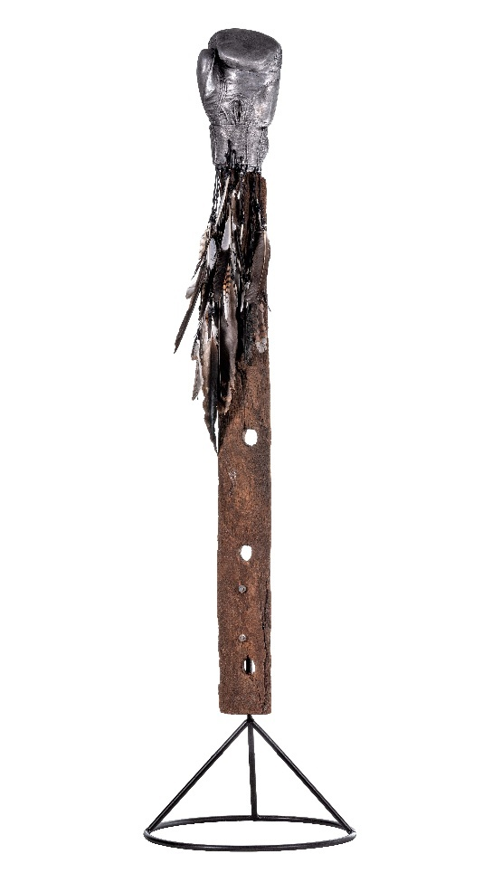
Left: Pound-for-pound #3 (from the series Pound-for-pound), created by Karla Dickens, 2019, mixed media, 161 x 41 x 41 cm, purchased by Maitland Regional Art Gallery 2020, 2020.153.
Right: Judo-House part 9 (birdland), created by Nigel Milsom, 2021, oil on linen, 180 x 125 cm, purchased by Maitland Regional Art Gallery 2021, 2021.054.

Case study 13: A statement of significance for an exhibition project

The Hidden Line: Art of the Boyd Women exhibition, a Significance-informed cross-collection project by Bundanon
Contributed by: Sophie O’Brien, Head of Curatorial and Learning
Organisation: Bundanon Trust
Dated: January 2026
Bundanon is an expansive property on the Shoalhaven River near Nowra in New South Wales that was once the home of the Boyd family, one of Australia’s most influential artistic dynasties. In 1993, artists Arthur and Yvonne Boyd donated Bundanon to the Australian public, along with an extensive collection of art. The collection included works created by their own hands, those of their peers and members of their extended family. The Boyds’ unprecedented act of generosity was accompanied by an organisational remit to focus on representing the work of living artists and creative practices across disciplines.
The Bundanon Collection includes works of art and many items of significance to the Boyd family and the history of Australian art, including over 3,900 works by the many women artists of the Boyd family. These works of art are of historical, artistic and research significance. They represent both the creative legacy of the Boyd family, and contribution to the story of Australia’s women artists, whose work has historically been less celebrated than their male peers. Recognising the significance and strong interpretive capacity of these works, Bundanon engaged in a project to extend the impact of its collection through an exhibition that brought together the dispersed works of the Boyd women from multiple collections across the country.

Exhibition summary
The Hidden Line: Art of the Boyd Women exhibition was held at Bundanon from 22 November 2025 to 15 February 2026. It brought into focus the creative force of the women of the extended Boyd family, artists whose work helped shape and sustain one of Australia's most influential artistic dynasties. Spanning 5 generations, the exhibition traced a succession of artists whose contributions have remained largely unrecognised, despite their creative lives being central to the family’s enduring legacy. It included works from Bundanon and loans from the National Gallery of Australia, National Gallery of Victoria, Heide Museum of Modern Art and private collections, to create a new lens through which to view Australian art history.
Featuring more than 300 works by over 23 artists, The Hidden Line revealed a deep and diverse tradition of artmaking through painting, ceramics, drawing, printmaking and photography. It celebrated multiplicity of medium, vision and experience, embodying a shared family ethos that placed the highest value on a life of creativity. In addition to the works of the Boyd women, the exhibition featured new responsive commissions by leading contemporary artists. The dialogue created between these works allowed a deep exploration of themes of gender, family, art history and creative inheritance. These new works demonstrated how women artists have continued to shape the national cultural narrative and helped to realise the Boyd vision for Bundanon to be a working arts centre.
The Hidden Line refers not only to a powerful, shared creative lineage. It also reflects the subtle, often invisible, threads of influence, mentorship and memory connecting these artists. While the women of the Boyd family have previously been positioned at the periphery, The Hidden Line demonstrates that they were central to the artistic dynasty. The exhibition design focused on bringing material together in familial groupings, not chronological order. The selection of items ensured that the meaning of the ‘collections in conversation’ were communicated in both exhibition design and in the publication.
Examining the creativity of generations of overlooked women artists from the Boyd family presented many challenges and invited a fresh curatorial approach. The relevant art historical information was difficult to find because traditional art histories recorded few details about the artists. As art created by women has historically been under-valued in Australia and other parts of the world, the works were widely dispersed and highly under-represented in major Australian collections. Research in national and state collecting institutions uncovered limited support material, with the primary information located predominantly with the artists themselves. Most works held by the institutions were traditional representational paintings or works created in partnership with a male (and better-known) collaborator.
Uniting these works with the more innovative examples held by Bundanon and in private collections resulted in a new line of art historical thinking, better illustrating the originality and skills of the artists. The conversations between public and private collections reflected aspects of Australian cultural life and artistic preferences from 1860 until today. Assessed through a contemporary curatorial lens, the different collections revealed the biases inherent in the collecting practices of the contexts and periods in which they were acquired.
This cross-collection project successfully built a broader understanding of the women of the Boyd family, laying the foundations for strategic collecting in the Bundanon Collection and other institutions. The conversation between collections amplified the historical and artistic significance of the works and the material held by Bundanon. The exhibition was notable for its rarity and the detailed provenance information that was uncovered. The Hidden Line served as a catalyst for deep inquiry into the artists and art history that resulted in a substantial full-colour publication of 200 pages. This publication captures the ongoing research significance of the project, providing the starting point for future researchers who will work towards revising and expanding the art history of Australia. The exhibition and catalogue hold exceptional interpretive capacity, enabling Bundanon to share the story of the extraordinary Boyd women. It was also deeply generative for a new generation of women artists.

Artists in the exhibition
Boyd family artists: Helen a’Beckett Read (1903–1999), Margot Beck (born 1948), Amanda Boyd (1948–1998), Cassandra Boyd (born 1956), Charlotte Boyd (1968–2021), Doris Boyd (1888–1960), Emma Minnie Boyd (1858–1936), Hermia Boyd (1931–2000), Jessica Boyd (born 1978), Lenore Boyd (born 1953), Lucinda Boyd (born 1954), Lucy Boyd (born 1958), Polly Boyd (born 1946), Yvonne Boyd (1920–2013), Lucy Boyd Beck (1916–2009), Ellen Boyd Green (born 1986), Florence Boyd Williams (born 1983), Mary Nolan (1926–2016), Alice Perceval (born 1957), Celia Perceval (born 1949), Kitty Perceval (born 1996), Tessa Perceval (born 1947), Pip Ryan (born 1984).
Contemporary new commissions: Pat Brassington (born 1942), Elizabeth Dunn (born 1973), Diena Georgetti (born 1966), Helen Johnson (born 1979), Narelle Jubelin (born 1960), Camille Laddawan (born 1990), Tjunkaya Tapaya OAM (born 1947), Timna Taylor (born 1953).

Keywords:
Exhibition, cross-collection research, women artists, Australian art history, feminist perspectives, inclusivity, Boyd family, Bundanon Collection, dispersed collections
Significance categories:
Primary criteria: Historical | Artistic | Research
Comparative criteria: Provenance | Rarity | Interpretive capacity

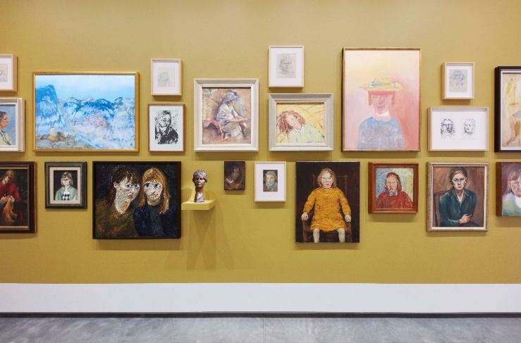
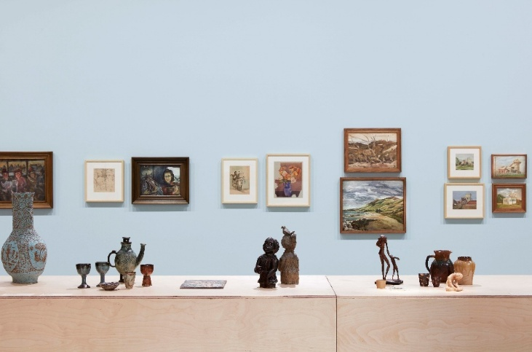
The Hidden Line: Art of the Boyd Women (installation view, includes art works which are on long term loan from the National Gallery of Australia with support from the Australian Government as part of Sharing the National Collection), Bundanon, 2025, Photo: Zan Wimberley.

Case study 14: A Significance-informed approach to digitisation

The Central Australian Aboriginal Digitisation Project of the Strehlow Research Centre and the National Film and Sound Archive of Australia
Contributed by: First Nations Engagement Team
Organisation: National Film and Sound Archive of Australia
Dated: July 2026
The National Film and Sound Archive of Australia (NFSA) has partnered with the Strehlow Research Centre, part of the Museum and Art Gallery of the Northern Territory (MAGNT), to successfully deliver a co-designed project to digitise and provide on-Country access to films and audio recordings from the Strehlow Collection, one of the most culturally and historically significant collections relating to Indigenous ceremonial life in the world.
The Strehlow Collection is based on the fieldwork of Professor Theodor (Ted) George Henry Strehlow (1908–1978). Born in Hermannsburg in Central Australia to German-born parents, Strehlow was an Australian anthropologist, linguist and ethnographer who spent more than 4 decades working with Aboriginal communities across Central Australia, recording their ceremonies, languages and songs from 1932 to the mid-1970s. This unique collection includes films, audio recordings, maps, photographs, genealogies, diaries and sacred objects, with much of it relating to 'men's-only' sacred and secret ceremonies.
The Northern Territory Government purchased the Strehlow Collection and subsequently established the Strehlow Research Centre within MAGNT’s Museum of Central Australia in Mparntwe (Alice Springs). The Centre manages the Strehlow Collection by working closely with Traditional Owners and providing them with access to its material. The Strehlow Research Centre Board deposited the films and audio recordings from the collection with the NFSA in 1990 for safekeeping. This material is now kept in restricted, environmentally controlled vaults in Canberra to limit deterioration.
The audiovisual material from the Strehlow Collection consists of 400 reels of 16-mm film and over 1,000 audio recordings representing more than 800 ceremonial acts and 150 hours of language, stories and songs, which are of immense historical, social, cultural and spiritual significance to Central Australian Aboriginal communities. However, these items are vulnerable to degradation and in obsolete formats. Without digitisation, Traditional Owners risked losing access to the ceremonies, songs and cultural practices that their Elders had worked with Strehlow to record. The Strehlow Collection also has research significance and interpretive capacity as a resource relating to Central Australian Aboriginal language, ceremonial life and culture, and genealogy. Access to its audiovisual material is vital for ongoing cultural maintenance, revitalisation of traditional language and intergenerational knowledge transfer within Central Australian Aboriginal communities. NFSA maintains a strong connection to the Strehlow Centre so that when the Centre finds new items, they are also added to the NFSA collection.
Recognising the significance of the Strehlow Collection, the NFSA and the Strehlow Research Centre at MAGNT entered a partnership to undertake the Central Australian Aboriginal Digitisation Project. The project involved digitising and preserving the at-risk film and audiovisual material and enabling ongoing access by Traditional Owners on Country. Under guidance from senior First Nations men and through tailored technical and cultural co-design, the NFSA developed cultural safety protocols so it could undertake digitisation of the at-risk material over a 4-year period at its preservation facilities in Canberra. The NFSA dedicated 2preservation areas to be temporary restricted spaces and, while digitising the content, limited access to male staff who had community approval to view and handle the content. The original material is held by NFSA for preservation in a restricted space with clear signage advising that any movement of materials should include consultation with the NFSA First Nations Engagement Team’s men’s group.
The NFSA also purpose-built a digital access studio and transported it to Mparntwe (Alice Springs) in 2023. The studio creates a culturally safe place on Country at the Strehlow Research Centre, providing unprecedented access to the newly digitised collection for Aboriginal communities. The NFSA also provided Aboriginal Heritage Officers from the Strehlow Research Centre with training in audiovisual archiving and digital access, empowering them to manage their collection on Country.
‘We have been working with Senior Men and the NFSA to give access to this living collection and bridge knowledge with future generations.’
Winston Green, Pintupi Luritja man and Aboriginal Heritage Officer, Strehlow Research Centre
The Central Australian Aboriginal Digitisation Project serves as a strong case study in the application of significance assessment to both collection acquisition and preservation processes. It demonstrates how significance can extend beyond collections themselves to encompass project methodologies and contemporary understandings of cultural value. Through the project, content, individuals, places and cultural knowledge have been newly identified and contextualised by Aboriginal communities, including the stories surrounding the creation of the recordings. This process deepens and strengthens the collection’s provenance by embedding community-held knowledge and perspectives directly into the collection record.
This project was supported through the Australian Government's Indigenous Languages and Arts program.
Keywords:
Professor Theodor (Ted) George Henry Strehlow, digital archives, digitisation, digital preservation, First Nations, Indigenous ceremonial life, Central Australia, provenance.
Significance criteria:
Primary criteria: Historical | Social, cultural and spiritual | Research
Comparative criteria: Provenance | Interpretive capacity
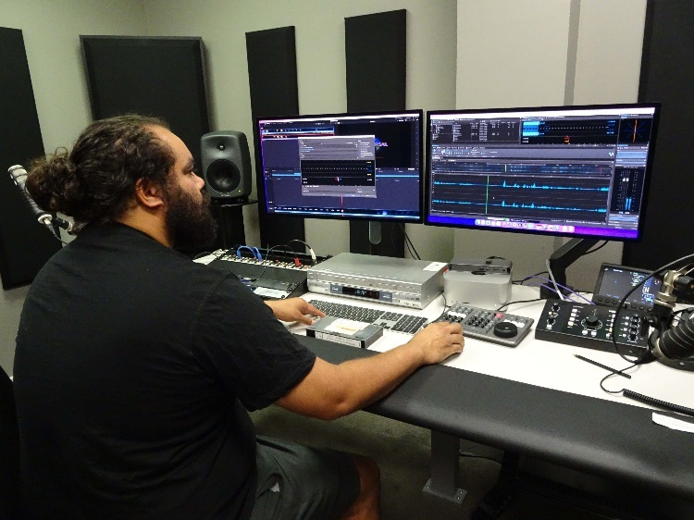
Aboriginal Heritage Officer Franky Gorey in the digital access studio at the Strehlow Research Centre.

Cultural heritage funding programs in Australia
This section discusses how the processes outlined in Significance can be applied to assist in securing and prioritising funding, with particular emphasis on the Australian Government Community Heritage Grants program. In this context, Significance is a practical tool underpinning the sustainability of cultural heritage collections and the funding programs that support them.
Across Australia, collections and cultural heritage funding programs are often grounded explicitly or implicitly in the principles outlined in Significance. While many of these programs are targeted at organisations that make collections accessible to the public, some enable individual and family collectors to apply for support to properly care for the significant items or collections they own. These programs typically require applicants to demonstrate why their collections matter, how they contribute to broader narratives, and how limited resources can be directed to achieve the greatest cultural benefit.
Integrating the Significance framework into funding programs helps ensure that resources are directed where they will have the greatest impact. It also provides a shared language that enables applicants to articulate the importance of their collections and funding bodies to make fair decisions. This is particularly important when resources are limited and demand is high. While Significance brings a level of consistency, each program has its own purposes and objectives. Applicants should always consult grant guidelines to understand eligibility and assessment criteria.
Key funding programs that intersect with the Significance framework are outlined below.

Community Heritage Grants
Website: www.library.gov.au/services/grants/community-heritage-grants
Supported by the Australian Government, the Community Heritage Grants (CHG) program provides one of the clearest examples of how Significance operates as a conceptual framework and a practical tool. CHG is administered by the National Library of Australia in partnership with the Office for the Arts, National Archives of Australia, National Film and Sound Archive of Australia and National Museum of Australia. Since its establishment in 1994, CHG has supported over 950 community heritage organisations across Australia to better understand, care for and share their collections.
Within CHG, supporting collections of national significance is a core eligibility requirement that defines the program. CHG is designed for small, often volunteer-run, organisations that hold collections of national significance but have limited funding and resources and would benefit from professional cultural heritage expertise. These include local historical societies and community museums, archives and cultural organisations. While such collections are often highly valued and much-loved within their communities, they may be at risk due to inadequate storage, limited documentation, and gaps in conservation and collection management knowledge. In this context, Significance provides a critical framework for identifying priorities and guiding action and, to be competitive, applicants must demonstrate strong claims against the primary and comparative criteria.
The CHG program has a staged structure aligned with the Significance framework. Applicants can apply for funding up to $20,000 per year (current rate, subject to change) in the following stages:

Stage 1: Significance assessment
The recommended first stage in CHG is to apply for funding to obtain a significance assessment report, which serves as a foundational document for the organisation and the program. The level of significance of a collection will not be known with certainty at this stage, but applicants must present a strong case that it is likely to have national significance. CHG funds independent qualified heritage professionals – historians, archivists and museum consultants – to produce significance assessment reports. Assessors undertake research and analysis and apply the Significance assessment criteria to formalise, test and strengthen the argument begun in the application. This strengthens an organisation’s understanding of its collection, often revealing previously undocumented connections and narratives. It also provides a foundation for informed decision-making.
Assessors are engaged to produce an extended report that addresses defined headings and includes a statement of significance that clearly articulates why the collection is significant. The report also provides a history of the organisation and collection, detailed assessment of the most significant items, and prioritised recommendations on collection management. The report is not a financial valuation, but an evidence-based assessment of significance that situates the collection within local, state and national contexts. In line with the program criteria, the assessor should provide a clear statement about the level of significance.
While the assessment may result in a finding of local or state significance, collections must be confirmed as nationally significant to be eligible for funding beyond Stage 1. As the report provides an evaluative framework, organisations with collections that are not assessed as nationally significant can still benefit from the process. Assessments may support applications for state or local funding and strengthen advocacy to philanthropic organisations. They often include practical recommendations that can be implemented without external funding, enabling organisations to act or plan future work.

Stage 2: Preservation needs assessment
For organisations with collections that are assessed as nationally significant, the second stage of CHG is a preservation needs assessment that builds on Stage 1. Conducted by a qualified conservator, this focuses on the physical condition of the collection and the environments in which it is stored and managed. It identifies risks to the collection and provides practical recommendations to mitigate them. This stage also supports prioritisation, enabling organisations to identify items requiring immediate or specialised care and appropriately direct conservation efforts.

Stage 3: Conservation and collection management activities
The third stage provides funding to implement the recommendations arising from the preservation needs assessment. This may include conservation treatment, improved storage, environmental controls, or digitisation. Resources are directed toward actions that will have the greatest impact on preserving and enhancing access to the nationally significant aspects of a collection
In addition, CHG supports collection management projects such as cataloguing, digitisation and training. While these activities may be undertaken independently of significance assessment, they are strengthened by a clear understanding of significance.

The integration of Significance into all stages of CHG distinguishes it from many funding programs. Rather than simply requiring applicants to demonstrate significance, CHG supports organisations in developing this understanding through professional assessment and ongoing engagement. This strengthens funding outcomes while building capacity within organisations, equipping staff and volunteers with the knowledge and skills required for long-term collection management. The 3 stages of CHG support ongoing engagement with collections and encourage organisations to revisit and refine their assessments over time. It helps connect collections to people, places and stories, ensuring that decisions about their care and use are grounded in a clear understanding of value. By embedding Significance within its structure, CHG demonstrates how understanding can lead directly to improved care, increased access and stronger community engagement.

Other grant programs
While CHG is explicitly based on Significance, the framework extends across the funding landscape. Many national, state and local government programs require applicants to argue for the value of their collections or projects in ways that align with Significance. Similarly, state and territory arts and heritage agencies and philanthropic organisations will base support on a demonstration of cultural significance. National Collecting Institutions sometimes incorporate these principles into funding and partnership programs. Although less formal in their requirements, the underlying expectations are consistent: funding should support activities that deliver clear cultural value and public benefit. In this context, it is essential to articulate significance clearly and persuasively.
Examples of Australian Government funding programs that relate to the Significance framework and may be relevant to cultural heritage organisations include:
- Indigenous Languages and Arts program – supports Aboriginal and Torres Strait Islander peoples to express, conserve, and sustain their cultures through language and arts activities across Australia. Website: www.arts.gov.au/funding-and-support/indigenous-languages-and-arts-program.
- National Cultural Heritage Account – supports Australian cultural organisations and groups to acquire significant cultural objects. This program requires assessments of significance that align with the Protection of Movable Cultural Heritage Act 1986 (for details, refer to the next sections in Part 4). Website: www.arts.gov.au/funding-and-support/national-cultural-heritage-account.
- Cultural Gifts Program – offers tax incentives to encourage donations of culturally significant items to public art galleries, museums, libraries and archives in Australia. Website: www.arts.gov.au/what-we-do/cultural-heritage/cultural-gifts-program.
- First Nations Heritage Grants – provides funding to help identify and protect First Nations heritage in existing World and National Heritage-listed places. Website: www.dcceew.gov.au/parks-heritage/heritage/grants-and-funding/fnhg.
- Australian Heritage Grants – provide funding to conserve, protect, and promote places on the National Heritage List, including support for conservation work, heritage planning, and public engagement activities. Website: www.dcceew.gov.au/parks-heritage/heritage/grants-and-funding/australian-heritage-grants.
- Maritime Museums of Australia Project Support Scheme (MMAPSS) – administered by the Australian National Maritime Museum, supports museums and other organisations to identify, conserve, maintain and display items of maritime significance. Website: https://www.sea.museum/en/about/grants-and-awards/mmapss.

Where to find funding information
All Australian Government grant opportunities are published on GrantConnect at www.grants.gov.au. National cultural heritage support programs are generally aimed at cultural organisations rather than individuals and groups. The Australian Government Department of Climate Change, Energy, the Environment and Water provides a list of grant funding across Australia, including state-specific opportunities at www.dcceew.gov.au/parks-heritage/heritage/grants-and-funding. Opportunities in the arts sector are published by the Department of Infrastructure, Transport, Regional Development, Communications, Sport and the Arts at www.arts.gov.au/funding-and-support or through Creative Australia at www.creative.gov.au/investments-opportunities.
For state and local government opportunities, including those available to individuals and community groups, check the websites of the relevant state, territory or local government.

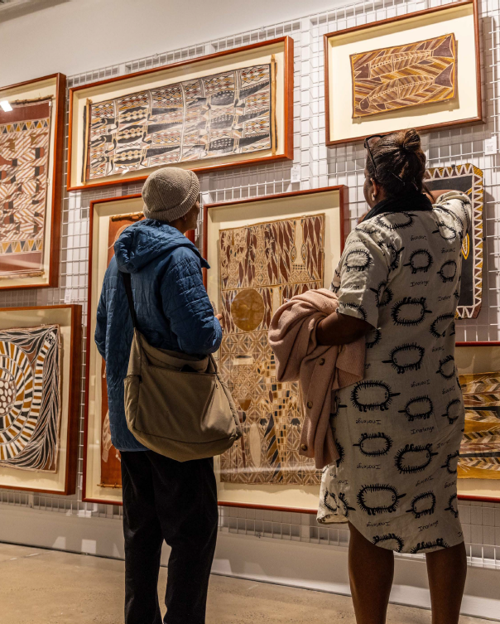
Above: First Voices: Indigenous Artworks from the Artbank Collection exhibition, Artbank Sydney 2024. Photo by Declan Shrubb.

Case study 15: A statement of significance on items from a Community Heritage Grants recipient

Colonel Light – The Founder, 1936 souvenir programme and poster in the collection of the Adelaide Repertory Theatre Company
Contributed by: Lise Windsor, assisted by Susan Marsden
Organisation: Adelaide Repertory Theatre Company
Dated: August 2026
The Adelaide Repertory Theatre Company (the Rep) holds an original theatre programme and accompanying poster for the 1936 play Colonel Light – The Founder. Both items are important within the collection of theatre ephemera that has been kept by the Rep since its formation at the University of Adelaide in 1908. In 2025, the Community Heritage Grants program supported a significance assessment of the Rep’s collection. The assessors found that the collection has historical and research significance within a national context. The collection constitutes a documentary history of the oldest repertory theatre company in Australia and one of the longest surviving amateur non-commercial theatre companies in the world. The material forms a valued resource for researchers as part of a broader dispersed national collection of theatre memorabilia that traces the history of Australia’s performing arts. Assessors also noted the collection’s social significance for the Rep community and wider public and the aesthetic significance of some items within the collection.
The theatre programme and poster for Colonel Light – The Founder are of national significance due to their association with the celebrations marking the centenary of European settlement in South Australia in 1936 and the beginnings of a ‘national theatre’ (McCredie 1988: 43). In the lead-up to the centenary, The Advertiser newspaper launched an Australia-wide competition for a 3-act stage play with a South Australian theme (Afford 2004: 32). First prize of £100 was awarded to Max Afford (1906–1954), a young South Australian journalist and radio playwright, for Colonel Light – The Founder. According to the souvenir programme, this play depicted ‘some of the dramatic moments in the eventful life of Adelaide’s founder Colonel William Light, over a period of 3 years, from 1837 to 1839, in the newly settled colony of South Australia’.
The play was performed by the Rep over 7 nights at the Tivoli Theatre in November 1936, with proceeds going to local charities. It received enthusiastic reviews from critics, with David Dawson earning praise for his portrayal of Colonel Light (Afford 2004: 34). At the time, the Rep was already 28 years old and held pride of place in Adelaide’s thriving independent theatre scene (Afford 2004: 3). Muriel Craigie, a member of the Rep from 1909 and its secretary for 24 years, performed the part of Mrs Mannheim, alongside other long-term members including Iris Hart, Jack Ham and Frank Johnston. In the souvenir programme, Craigie comments that the play ‘is the consummation of an ideal of the … Company – the oldest organisation of its kind in Australia … it actually marks the beginning of the National Theatre planned so many years ago.’
Thelma Thomas, Afford’s future wife, designed the play’s elaborate costumes. Thomas was also responsible for other centenary costume designs, including Heather Gell’s production of Heritage and the official centenary outdoor pageants. The State Libraries of South Australia and New South Wales have extensive collections of these designs.
The Rep is still producing plays and remains the oldest continuous surviving amateur theatre company in the southern hemisphere (Worby 2024: 681). In 1986, it again presented Colonel Light – The Founder as part of the State’s sesquicentenary celebrations.

Statement of significance
The theatre programme and poster for Colonel Light – The Founder have historical and research significance as primary documents of Afford’s play, the 1936 centenary of European settlement in South Australia and a period in the broader history of theatre in Australia. The 2 items have well-documented provenance and are in excellent condition, adding to their significance. Importantly, in the context of the Rep’s broader archival collection, they also have strong interpretive capacity, providing a basis from which to understand and explain artistic, social, cultural and economic trends in Australia.
Keywords:
Adelaide, South Australia, commemorative celebrations, theatre, ephemera, memorabilia, archival collection, performing arts, national significance, Community Heritage Grants.
Significance categories:
Primary criteria: Historical | Research
Comparative criteria: Provenance | Condition | Interpretive capacity

References
- Afford T (2004) Dreamers and Visionaries: Adelaide’s Little Theatres from the 1920s to the early 1940s, Currency Press, Sydney.
- McCredie A (1988) From Colonel Light to the footlights: The performing arts in South Australia from 1836 to the present, Pagel, South Australia.
- Worby G (2024) ‘Theatre’, in Prest W, Round K, Kearney S and O’Neil B (eds), The Wakefield Companion to South Australian History, Wakefield Press, Mile End.
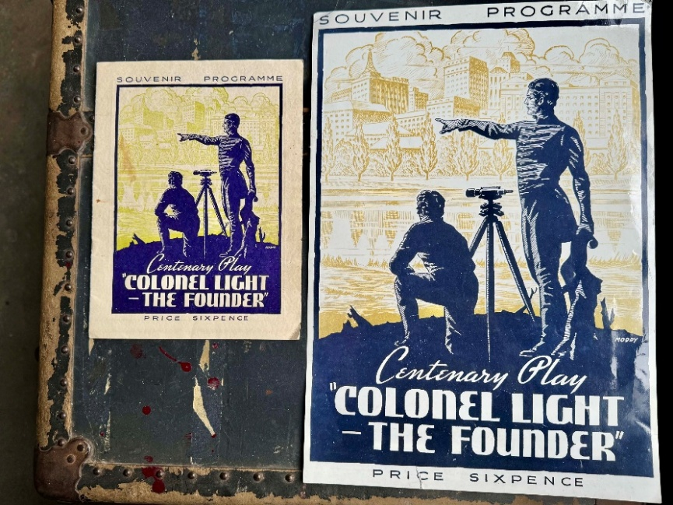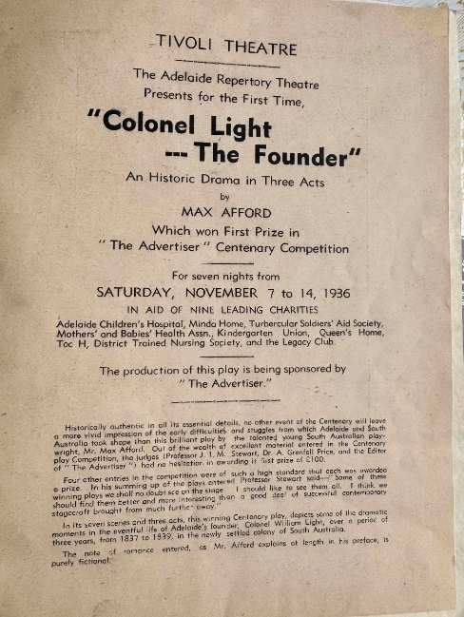
Left: Original souvenir programme and poster from the 1936 South Australian Centenary production of Colonel Light – The Founder, written by Max Afford.
Right: Original souvenir programme showing performance details from the 1936 South Australian Centenary production of Colonel Light – The Founder. These items are from the Adelaide Repertory Theatre Company’s archival collection. Photos courtesy of Susan Marsden.

Case study 16: A statement of significance on a single item from a Community Heritage Grants recipient

Cheynes IV – Australia’s last whaling vessel, held at Albany’s Historic Whaling Station
Contributed by: Denyse MacNish, Curator, Collections and Projects
Organisation: Albany’s Historic Whaling Station
Dated: March 2026
The following case study is based on a significance assessment of the wider collection undertaken in 2025, which was supported by a Community Heritage Grant.
Cheynes IV is Australia’s only intact modern whaling vessel and represents the final chapter of the nation’s commercial whaling industry. Preserved at Albany’s Historic Whaling Station in Western Australia, the vessel’s strong provenance, intact engineering and enduring connections to the Albany community make it a powerful object for understanding the technological, economic and social history of 20th-century whaling.
The acquisition and continued stewardship of Cheynes IV were assessed using the framework provided in Significance. Applying the guide enabled the museum to clearly articulate the vessel’s historical, aesthetic, scientific and social significance, supporting its place as a central object within the collection.

Historical significance
Cheynes IV is a 45.44-metre steam-powered whale chaser built in 1948 at the Framnes Mekaniske Værksted shipyard in Sandefjord, Norway. Previously named W. Fearnhead, and then Wilfrid Fearnhead, the vessel was sold to, and operated by, the Union Whaling Company in Durban, South Africa, before being purchased by the Cheynes Beach Whaling Company in 1969. After sailing from Durban to Fremantle in Western Australia, the vessel was renamed Cheynes IV and commenced service in Albany in 1970. Cheynes IV remained active until the closure of the station in 1978, which marked the end of commercial whaling in Australia. The vessel was preserved and in 1981 towed to its current location and dry-docked at Albany’s Historic Whaling Station. The museum’s archive holds extensive supporting documentation including logbooks, photographs, film footage and operational records and the provenance of the vessel is well-established through this documentation.

Rarity and representativeness
Cheynes IV is both rare and representative as the only intact whaling vessel from the modern whaling era in Australia and one of only 2 known surviving vessels of this type internationally. A comparable vessel is the Southern Actor, located at the Sandefjord Whaling Museum in Norway.

Scientific and research significance
The vessel is in good condition and retains its original propulsion system: a 4-cylinder compound steam engine producing approximately 1,750 horsepower and powered by 2 Foster Wheeler oil-fired boilers. The vessel is part riveted and part welded steel. This machinery is of research significance, providing opportunities for research into mid-20th-century marine engineering and industrial whaling technologies.

Aesthetic and technical significance
This criterion is demonstrated through the vessel’s distinctive industrial design. Its streamlined form and functional configuration reflect the minimalist engineering typical of steam-powered whale chasers built for speed and manoeuvrability.

Social significance
Whaling shaped the economic and social life of Albany for decades. Many former whalers and their families live locally and others who have moved away still visit, or their descendants visit to see where their family member worked. The vessel is frequently referenced in memoirs, newspaper articles, social media posts, community discussions and oral histories, demonstrating its enduring place in local memory. Cheynes IV acts as a tangible representative of the industry and the people who worked in it.
The vessel’s high level of significance to the museum’s collection has been supported in the publication Albany’s Historic Whaling Station Conservation Management Plan 2025 which identifies Cheynes IV as being an object of ‘considerable significance.’
Keywords:
Modern whaling era, maritime heritage, marine engineering, industrial design, community memory, ship, Community Heritage Grants.
Significance categories:
Primary criteria: Historical | Cultural and Social | Aesthetic and Technical
Comparative criteria: Provenance | Rarity | Representativeness | Condition
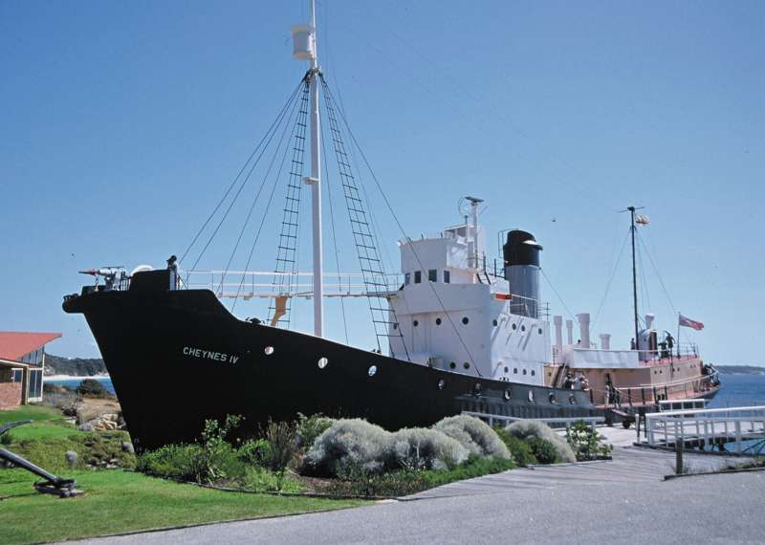
Cheynes IV, Albany’s Historic Whaling Station. All rights reserved. OBJ.2026.1.

Case study 17: A statement of significance on a single item supported by the National Cultural Heritage Account

The Center Pipes, held by Mackay RSL
Contributed by: Mackay Sub Branch, Central Queensland District, RSL Queensland with information supplied through an independent significance assessment of a grant application to the National Cultural Heritage Account
Organisation: Mackay Sub Branch, Central Queensland District, RSL Queensland
Dated: July 2026
The story of the Center Pipes, owned by the Mackay Sub Branch of the Returned and Services League (RSL) of Queensland, demonstrates how the Australian Government’s National Cultural Heritage Account can enable cultural items to be returned to the communities where they mean the most.
The Center Pipes are a single set of bagpipes made from African Blackwood and mounted in ivory. Their maker is recorded on a metal stamp engraved on the bagpipes’ chanter (melody-producing pipe) with the words John Center & Sons Melbourne. The bagpipes also have a silver plaque affixed to the bass drone stock (the socket connecting the pipe that produces a continuous sound) that reads: Pres-td to the 42nd Battn A.I.F by the People of Mackay May 1916.
Research shows that the bagpipes have a strong connection to Mackay that was interrupted for close to a century by the events of World War I. This connection began in May 1916, when Captain Colin Ralph Cameron of the 42nd Battalion of the Australian Imperial Force (AIF) informed the Mackay Caledonian Society committee that the Battalion’s pipe band was short 2 sets of bagpipes, which the Australian Army refused to supply. The committee responded to this news as many of the soldiers in the 42nd Battalion were from the Mackay region, and the Society was dedicated to preserving Scottish heritage. Society Secretary, Mr A. Clarke, set about canvassing donations. Within a single afternoon, Clarke had raised thirty pounds and 7 shillings from members of the Caledonian Society and the community of Mackay. This was enough to purchase 2 sets of bagpipes manufactured by leading bagpipe maker John Center of John Center & Sons in Melbourne (Daily Mercury 3 June 1916). Center was a bagpipe-maker from Edinburgh, Scotland, who continued his bagpipe-making practice when he moved to Melbourne with his family in 1908 (Campbell 2001). Later that month, Cameron presented the 2 sets of bagpipes to the Battalion on behalf of Mackay. The donation meant that the Battalion had a full band of pipers.
The 42nd Battalion was formed at Enoggera, Brisbane, in December 1915. It deployed to France on 26 November 1916 and entered the front line on 23 December 1916. Throughout 1917, the 42nd Battalion served in Belgium, fighting in several battles. These included Passchendaele, which was part of the Third Battle of Ypres, one of the key battles of the First World War, where the Battalion lost over a third of its strength. In March 1918, the Battalion defended the railway junction of Amiens in France. It continued to serve in France until 20 September 1918, when it was ordered to disband and join other battalions. The men felt so connected that they initially refused to separate, fighting one last battle at St Quentin Canal before folding to pressure and disbanding on 22 October 1918 (https://www.awm.gov.au/collection/U51482).
A photograph of the Battalion pipe band prior to its departure from Brisbane indicates that the 2 sets of bagpipes donated by the Mackay community left Australia with the Battalion, and it is likely that they were played on the battlefield (https://www.awm.gov.au/collection/C1218522?image=1). However, the details of the next phase in their provenance have been obscured by war and the difficulties and disruptions of the post-war period. There is no further information about one of the sets of bagpipes. The known chain of ownership for the set now owned by the Mackay RSL resumes in October 2021, when a professional bagpiper from Chino Hills in southern California purchased the bagpipes at a private sale in Newport Beach, California. Seeing the plaque, he contacted Ian Dean, a piper in Mackay. This eventually led to the Mackay RSL learning of the bagpipes’ existence and purchasing them with the support of the National Cultural Heritage Account in 2024. (For more information, see https://www.arts.gov.au/news/heritage-bagpipes-marching-mackay)
The Center Pipes have historical, aesthetic and technical, and social significance, enhanced by their provenance, representativeness, good condition and interpretive capacity. The historical significance of the bagpipes is due to their connection with the 42nd Battalion AIF. While particularly relevant to Mackay, the story of this Battalion is also part of Australia’s broader military history, reflecting the historical and cultural ties between Australia and the British Empire. The bagpipes are an excellent representative example of the type of Highland bagpipes that were employed as a tactical and psychological device on the Western Front throughout World War I, and form part of the continued tradition of military bands in Australia’s armed forces. Although incomplete, the provenance of the Center Pipes is supported by compelling physical and documentary evidence that demonstrates the bagpipes’ origin, association with Mackay and presence in Europe during World War I.
The bagpipes are complete and in very good condition, which adds to their aesthetic and technical significance as a high-quality musical instrument. Of the more than 50 sets of pipes handcrafted by John Center, each was given a distinctive appearance, and the Center Pipes are an excellent example of his skilled artisanship and attention to detail. The bagpipes also demonstrate the presence of Scottish music and crafts in Australia in the early 20th century and encapsulate the importance of cultural connections for migrant communities, as well as the transfer of creative skills to Australia.
The Center Pipes continue to hold social significance for Scottish-Australians, the Mackay community, and the descendants of soldiers who served in the 42nd Battalion AIF. The story of the bagpipes has strong interpretive capacity, allowing an exploration of themes of life at war, loss, connections with home, and the reputation for resilience, bravery and camaraderie among Australian troops. In the collection of the Mackay RSL, the Center Pipes serve as an important item of remembrance and are displayed to honour the sacrifices made by Australian soldiers and to help preserve the Anzac legacy, which continues to shape Australian society and identity. This ongoing social significance was most poignantly realised on 11 November 2024, when Ian Dean played Flowers of the Forest on the Center Pipes during the Memorial Day wreath-laying ceremony (Daily Mercury 12 November 2024).
Keywords:
Australian military history, RSL, World War I, musical instrument, bagpipes, military bands, National Cultural Heritage Account, Scottish heritage.
Significance categories
Primary criteria: Historical | Social |Aesthetic and Technical
Comparative criteria: Provenance | Representativeness | Condition | Interpretive capacity

References
- Australian War Memorial (n.d.) ‘42nd Australian Infantry Battalion’, Australian War Memorial website, accessed July 2026, https://www.awm.gov.au/collection/U51482.
- Campbell J (2001) Highland bagpipe makers, Magnus Orr.
- Daily Mercury (12 November 2024) ‘Mackay commemorates fallen at Remembrance Day ceremony’, Daily Mercury, accessed July 2026, https://www.couriermail.com.au/news/queensland/mackay/mackay-commemorates-fallen-at-remembrance-day-ceremony/news-story/70cc42febd844c00ad7fe5578b9ebc53.
- Daily Mercury (3 June 1916) ‘The 42nd Battalion Pipe Band’, Daily Mercury, accessed July 2026, http://nla.gov.au/nla.news-article188683614.

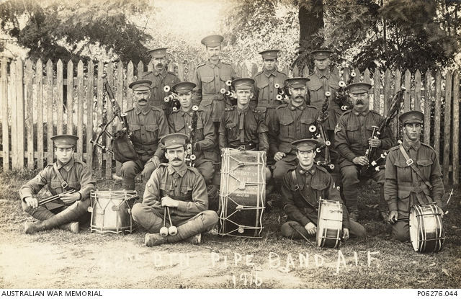
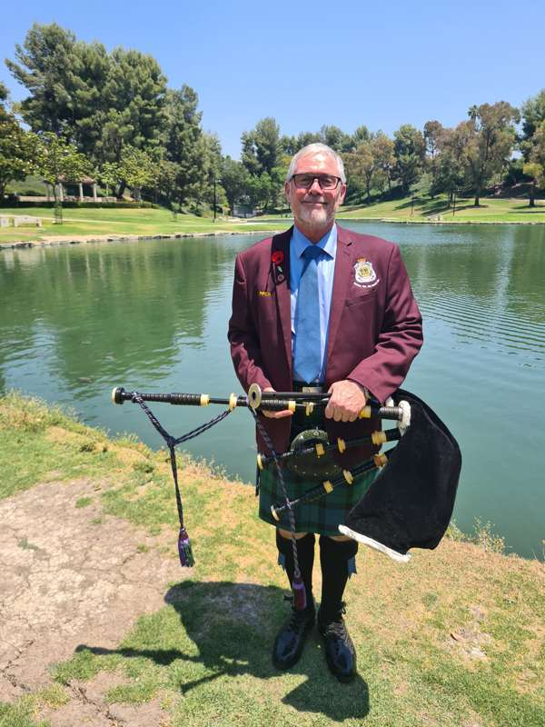
Above: 42nd Battalion, Pipe band, A.I.F. Group portrait of thirteen men in universal training uniform, Kitchener Studio, 1916, Photograph (black & white – print silver gelatin), Australian War Memorial, P06276.044. Below: Mr Ian Dean, Mackay RSL piper, receiving the Center pipes in 2024.

Relevant legislation
There are laws relating to many types of items and collections, including those that prohibit or restrict certain actions involving those items and collections. Some are designed to protect significant movable cultural heritage, while others are more general, such as the laws that govern property ownership and prohibit theft. People who collect or trade in cultural heritage material are responsible for understanding and complying with these laws.
For most collectors in Australia, Australian legislation will be most applicable. However, it is important to be aware of international laws when importing international items or when taking Australian items overseas. Collectors should also check state and territory laws and seek to abide by international conventions relating to the material they collect, as well as relevant ethical codes.
The section below explains the function of the Protection of Movable Cultural Heritage Act 1986, which has both Australian and international dimensions, and how it intersects with Significance. It is followed by a list of some of the other legislation and ethical codes that are relevant to the collections sector.

Protection of Movable Cultural Heritage Act 1986
The Protection of Movable Cultural Heritage Act 1986 (the Act) provides the legislative framework through which Australia protects its movable cultural heritage and regulates the import and export of protected objects. It is also the mechanism through which Australia meets its international responsibilities to prevent illicit trade in cultural heritage items.
The Act applies to a wide range of Australian and international items and collections. It establishes controls over the export of certain classes of objects identified as culturally significant to Australia. It also gives effect to Australia’s obligations under the UNESCO 1970 Convention on the Means of Prohibiting and Preventing the Illicit Import, Export and Transfer of Ownership of Cultural Property (UNESCO 1970 Convention) by providing a mechanism for the return of illegally exported foreign protected objects that are imported into Australia.

Export provisions
The Act seeks to balance lawful movement and trade in cultural objects with the protection of items that are of importance to Australia, or a particular part of Australia. It primarily does so by regulating the export of certain items of movable cultural heritage. The Protection of Movable Cultural Heritage Regulations 2018 (the Regulations) support the Act. The Regulations include a definition of ‘significance to Australia’ as an object that is of Australian origin, has substantial Australian content, or has been used in Australia, and meets at least one of the following:
- is associated with a person, activity, event, place or business enterprise, notable in history;
- has received a national or international award or has a significant association with an international event;
- represents significant technological or social progress for its time; or
- is an object of scientific or archaeological interest.
The Regulations set out the National Cultural Heritage Control List (Control List). The Control List specifies the categories of items and collections that are Australian protected objects under the Act and therefore subject to export regulations, if they meet defined monetary, age and representativeness thresholds. Australian protected objects have significance to Australia. The items and collections are listed by media and significance type, and include First Nations heritage, archaeological objects, natural science objects, applied science and technology objects, fine and decorative art, documentary heritage, coins and medals, stamps and objects of historical significance (see the list at the end of this section for more details).
Under the Act, Australian protected objects require an export permit before they can be legally exported. Anyone who wishes to permanently or temporarily export an Australian protected object must submit a permit application, which will be assessed by at least one expert examiner. The National Cultural Heritage Committee, established under the Act, will then consider the information provided by the applicant and expert examiners and advise the Minister for the Arts (or their delegate) on the significance of objects and whether export permits should be granted or refused. Objects refused an export permit are listed on the Movable Cultural Heritage Prohibited Exports Register. More details on this process are available at: www.arts.gov.au/what-we-do/cultural-heritage/movable-cultural-heritage.
The Control List describes 2 classes of Australian protected objects:
- Class A objects, which cannot be exported from Australia
- Class B objects, which can only be exported from Australia following a successful application for an export permit granted under the Act.
Class A objects include:
- Aboriginal and Torres Strait Islander cultural material including sacred and secret ritual objects, bark and log coffins used as traditional burial objects, human remains, rock art, dendroglyphs (carved trees), and certain Aboriginal or Torres Strait Islander works of art.
- Victoria Cross medals awarded to named Australian service personnel (unless they are owned, or held on loan, by the Commonwealth or a principal collecting institution).
- Each piece of the suit of metal armour worn by Ned Kelly at the siege of Glenrowan in 1880.
Class B objects include objects other than Class A objects that meet the specific thresholds for Australian protected objects detailed in the relevant Part of the Control List.

Import provisions
The Act also regulates imports, providing for the seizure, forfeiture and return of objects that have been unlawfully exported from foreign countries and subsequently imported into Australia, provided certain conditions are met and a formal request has been made for the objects’ return. This aspect of the Act covers any protected object of a foreign country that has been:
- exported in contravention of a cultural property law of that country at any time and
- imported into Australia on or after 1 July 1987, the date the Act came into force.

Interactions with Significance
The Regulations and Control List ensure that applications for export permits are considered in accordance with a consistent articulated set of criteria. The Significance framework informs these considerations but does not precisely align with the Act and the Regulations. Instead, it provides an interpretive and assessment tool for expert examiners, the National Cultural Heritage Committee, and the final decision-maker to assist them to understand and articulate the importance of items and collections and make recommendations or decisions under the Act.
For decisions regarding the export and return of objects, the Significance framework plays a critical role in the operation of the Act by informing how the significance of objects or collections is identified and considered. The primary and comparative criteria align closely with the values the Act is designed to protect, providing a shared professional language for assessment. They support robust, evidence-based advice to the National Cultural Heritage Committee and the Minister for the Arts, helping to ensure understanding of why an object matters, to whom, and in what context.
Significance complements the statutory tests set out in the Act and Regulations by strengthening the quality and consistency of assessments. Applying the principles of the Significance framework supports transparency, especially where decisions are contested or subject to review. In this way, the Act, Regulations and Significance form an integrated system for the protection of movable cultural heritage. The Act establishes the legal authority, the Regulations provide administrative clarity, and Significance supplies the professional methodology needed to interpret and apply the concept of significance. This combination ensures that decisions about export, retention and return are grounded in an understanding of cultural value in all its forms.

Resources
- The website of the Office for the Arts includes information on the Act and Regulations: www.arts.gov.au/what-we-do/cultural-heritage/movable-cultural-heritage.
- The full text of the Protection of Movable Cultural Heritage Act 1986 and Protection of Movable Cultural Heritage Regulations 2018 is online at: www.legislation.gov.au/C2004A03252/latest/text and www.legislation.gov.au/F2018L01710/latest/text.
- Read about the UNESCO 1970 Convention: www.unesco.org/en/legal-affairs/convention-means-prohibiting-and-preventing-illicit-import-export-and-transfer-ownership-cultural.

Categories of Australian protected objects
The following list provides examples of the types of objects reflected in the Control List. It is not a comprehensive or exhaustive list of criteria, and the Act and Regulations should be consulted in full by anyone considering the export of Australian movable heritage to ensure that any potential export is legal.
- Objects of Australian Aboriginal and Torres Strait Islander heritage, including items and collections of cultural significance to First Nations people, or made by First Nations people, that are at least 30 years old.
- Archaeological objects of significance to Australia that have remained in place for at least 50 years.
- Natural science objects, including palaeontological objects and meteorites, specimens of flora or fauna, and any mineral, gold nugget, diamond, sapphire, opal or other gemstone over specified market values.
- Objects of applied science or technology, including tools, weapons, implements, machines, prototypes, models, patents and equipment relating to activities such as agriculture, engineering, air transport, rail transport, road transport and water transport, and objects of scientific interest that are at least 30 years old.
- Objects of fine or decorative art, in a broad range of media, that are at least 30 years old, and over specified market values.
- Objects of documentary heritage that are at least 30 years old, including books, letters, ledgers, registers, pamphlets, sound and moving image recordings, maps, plans, photographs, drawings or other graphics, and government records.
- Numismatic objects over a specified market value, including civil or military medals or decorations and associated documents or insignia, badges, tokens, charms, coins or paper money, and a pattern, proof or specimen striking for coin production.
- Philatelic objects, being stamps, postal markings and stamp collections.
- Objects of historical significance that are at least 30 years old, including items and collections relating to heraldry, Australian military history, domestic life, work life, courts, tribunals and law enforcement, education, health and medicine, arts and crafts, leisure and recreation (including sport, entertainment and tourism), politics, exploration, migration, community activities and religion.

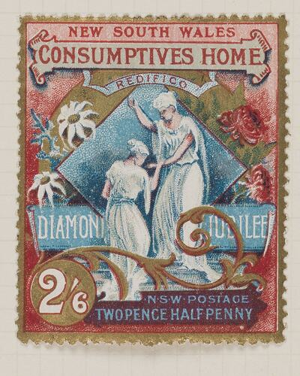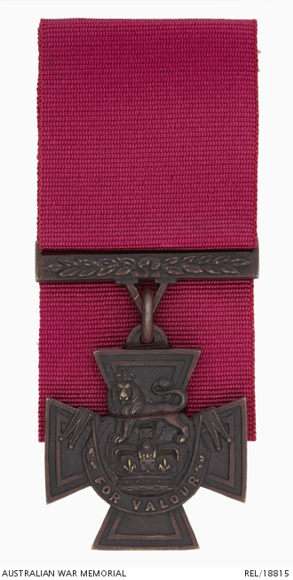

Examples of types of objects that may be Australian protected objects under the Protection of Movable Cultural Heritage Act 1986. Above left: Stamp – Diamond Jubilee Charity Issue, 2½ Pence, New South Wales, 1897, 5.2 x 4 cm. Collection of Museums Victoria, item PH 8528. Above right: Victoria Cross awarded to Corporal Alexander Henry Buckley, 54th Battalion, Australian Imperial Force, c. 1918. Collection: Australian War Memorial, REL/18815.

Other legislation, codes, best practices and conventions
- Environment Protection and Biodiversity Conservation Act 1999
Some items and collections, and their uses, are subject to the Environment Protection and Biodiversity Conservation Act 1999 (EPBC Act). The EPBC Act and its accompanying regulations form Australia's main national environmental legislation, providing a way to protect and manage nationally and internationally important plants, animals, habitats and places. They also enable Australia to meet its obligations under the Convention on International Trade in Endangered Species of Wild Fauna and Flora 1975 (CITES Convention). The CITES Convention is an international agreement that controls imports, exports and re-exports of wildlife endangered due to trade. Australia ratified CITES and implemented the Convention through national legislation in 1976. The full text of the legislation is available via: www.legislation.gov.au/C2004A00485/latest/text. Information on the CITES Convention is available at: https://cites.org/.
- Aboriginal and Torres Strait Islander Heritage Protection Act 1984
The Aboriginal and Torres Strait Islander Heritage Protection Act 1984 (ATSIHP Act) can protect areas and objects that are of particular significance to Aboriginal and Torres Strait Islander people. It allows the Minister for the Environment and Water to make a declaration to protect an area, object or class of objects from a threat of injury or desecration. Aboriginal and Torres Strait Islander people or their representatives can apply to protect a specified area or objects under the ATSIHP Act. The full text of the legislation is available via: www.legislation.gov.au/C2004A02943/latest/text.
- Protection of Cultural Objects on Loan Act 2013
The Protection of Cultural Objects on Loan Act 2013 and the Protection of Cultural Objects on Loan Regulations 2024 protect cultural objects relating to Australia and other countries from seizure when on loan to an approved Australian collecting institution from an overseas collection. The full text of the legislation is available via: www.legislation.gov.au/C2013A00012/latest/text.
- Underwater Cultural Heritage Act 2018
The Underwater Cultural Heritage Act 2018 protects Australia’s underwater cultural heritage, including historic shipwrecks, sunken aircraft and other underwater cultural heritage sites in Australian waters. The full text of the legislation is available via: www.legislation.gov.au/C2018A00085/latest/text.
- Codes of ethics and codes of practice
Collectors and collecting organisations should ensure that they are aware of relevant codes of ethics and guidelines regarding items and collections and collecting practices. Examples include:
    - The Indigenous Art Code: www.indigenousartcode.org/.
    - The Australian Institute for Conservation of Cultural Material’s Code of Ethics and Code of Practice: https://aiccm.org.au/wp-content/uploads/2024/01/CODE-OF-ETHICS-AND-CODE-OF-PRACTICE.pdf.
    - The International Council of Museums Code of Ethics: https://icom.museum/en/resources/standards-guidelines/code-of-ethics/.
    - Australian Best Practice Guide to Collecting Cultural Material: www.arts.gov.au/publications/australian-best-practice-guide-collecting-cultural-material.
    - The publication Collections Law & Ethics by Shane Simpson and Ian McDonald, published by The Federation Press: https://federationpress.com.au/.
- The Washington Conference Principles on Nazi-Confiscated Art (1998), and Best Practices for the implementation of the Washington Principles (2024): Australia endorsed the 1998 Washington Principles at their inception, and the Best Practices in December 2025. These are non-binding, civil restitution guidelines which collecting institutions are encouraged to take into account when acquiring art or reviewing their collections: https://www.state.gov/washington-conference-principles-on-nazi-confiscated-art.There are also international conventions that establish ethics and standards relating to collections and collecting practices. These include:
    - UN Declaration on the Rights of Indigenous Peoples, 2007
    - UNESCO Convention on the Protection and Promotion of the Diversity of Cultural Expressions, 2005
    - UNESCO Convention for the Safeguarding of the Intangible Cultural Heritage, 2003
    - UNESCO Convention on the Protection of the Underwater Cultural Heritage, 2001
    - UNESCO Convention for the Protection of Cultural Property in the Event of Armed Conflict with Regulations for the Execution of the Convention 1954 (The 1954 Hague Convention, First Protocol (1954) and Second Protocol (1999))
    - UNESCO Convention concerning the Protection of the World Cultural and Natural Heritage, 1972
    - UNESCO Convention on the Means of Prohibiting and Preventing the Illicit Import, Export and Transfer of Ownership of Cultural Property, 1970

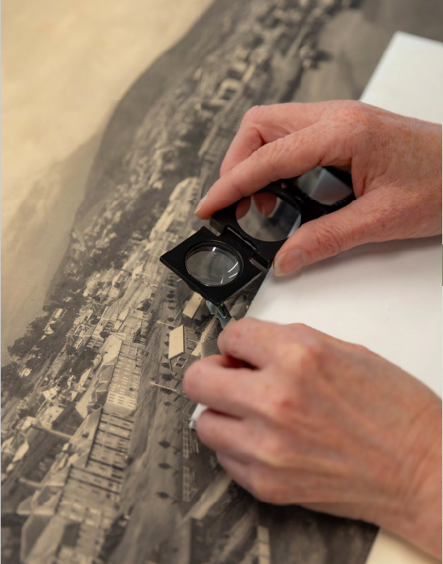

Part 5: Further case studies

Case studies 18–32: Statements of significance on cultural items

Case study 18: Fred Embrey Djan’djari figure, Queensland Art Gallery | Gallery of Modern Art
Contributed by: Simon Elliott, Deputy Director, Collection and Exhibitions
Organisation: Queensland Art Gallery | Gallery of Modern Art (QAGOMA)
Dated: July 2026, drawing on a February 2024 report by Michael Aird, Lindy Allen and Paul Memmott
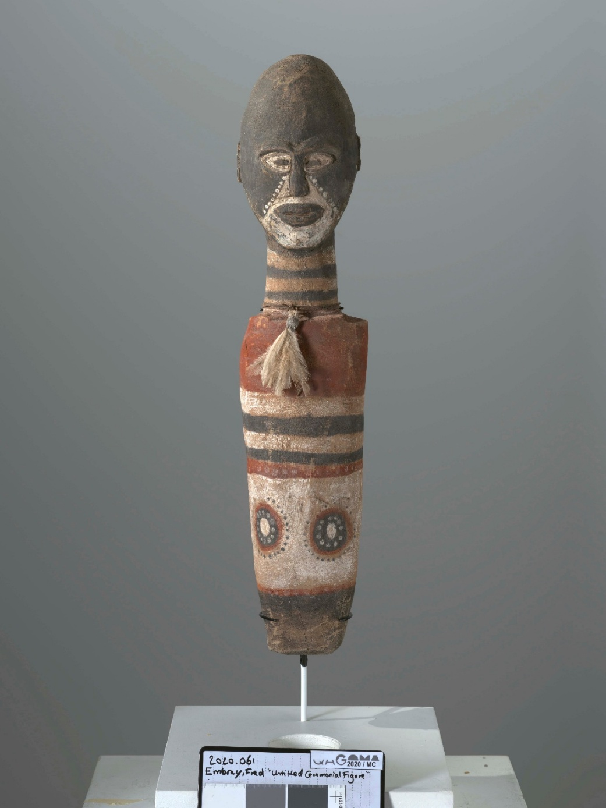
Djan’djari figure, created by Fred Embrey (c.1880–1939), Kabi Kabi people, Queensland, Australia, 1930s, carved softwood with natural pigments, emu feathers bound with bush string and resin, 65.5 x 14 x 14 cm. Collection: Queensland Art Gallery | Gallery of Modern Art. Purchased 2020 with funds from the Mather Foundation through the Queensland Art Gallery | Gallery of Modern Art Foundation.
Djan’djari figure is a solemn sculpture that has cultural, historical, aesthetic and research significance at the national level. It is in excellent condition and a rare example of a Queensland Kabi Kabi figure produced for use in First Peoples’ ceremony in a Government mission setting. It was created in the 1930s by Fred Embrey (c.1880–1939) of the Burnett and Mary Rivers region of Queensland. Embrey had a connection with Mount Mia Station in Kilkivan near Barambah. Later known as Cherbourg, Mount Mia Station was the receiving place for Aboriginal people from the South Burnett region and elsewhere who, under Queensland government policies implemented from the late 1800s to the 1970s, were forcibly removed from their traditional lands and communities and relocated to government-run reserves, often without their consent. In 1935, it was estimated that there were 28 groups at the mission, living in conditions described as poor and challenging. As a holder of Indigenous knowledge and culture, Fred Embrey was a leader in this community.
A few years before creating Djan’djari figure, Embrey was presented with a breastplate and given the title ‘King of Mount Mia Station.’ King breastplates were issued by authorities in the 19th century to prominent First Australian men and women influential in their tribe or kinship group. Embrey was a long-term Cherbourg resident who preserved the spirit of First Peoples’ culture and provided cultural guidance throughout his lifetime, despite the mission’s prevailing Christian belief system.
Carved figures such as Djan’djari figure are notable objects of ceremony. Embrey’s great-grandson, Alex Bond, describes the carving as:
Important cultural art that comes from Kabi Kabi mob, Kabi Kabi community, Kabi Kabi culture. These are Djan’djari . . . little hairy men. Djan is man, djari is little. Little man. (Alex Bond and Paul Memmott, interview with Peter McKay, Brisbane, 24 February 2020)
Embrey is credited as rejuvenating ceremony with these Djan’djari, which remind Kabi Kabi people to be mindful of others. His depiction of the Djan’djari is thought to be influenced by a personal encounter with them while collecting bunya nuts. Bunya forests were important gathering places and central to Kabi Kabi social and ceremonial life. Motifs of bunya trees appear repeatedly on body painting from this culture and were replicated by Embrey in his carvings. However, it is not known whether the markings on this Djan’djari figure relate to the same bunya motifs.
This sculpture has enhanced QAGOMA’s ability to represent uniquely Queensland stories of cultural revival and resilience in response to colonial expansion and government control of Aboriginal people. Its inclusion in the Gallery’s collection positions the artefact as significant material belonging to ongoing cultural traditions. The work is an important example of how QAGOMA is preserving First Australians’ cultural legacy for visitors to appreciate and learn from.
QAGOMA has collaborated with Michael Aird, Director of the Anthropology Museum at the University of Queensland, Kabi Kabi Traditional Owner Alex Bond, and Professor Paul Memmott AO, with assistance from Lindy Allen and Dr Diana Romano, to complete the Fred Embrey Sculpture Research Project. This project supported important Indigenous-centred research to share knowledge about, and digitally preserve, culturally significant works such as Embrey’s Djan’djari figure. Alongside deep consultation with the artist’s family, the project employed digital photogrammetry to create a 3D model of this rare work, shared personal, community-based stories that link the object’s significance to its place, maker and people, and produced a research report examining the sculpture within Aboriginal art traditions. This report formed the basis for this statement of significance and is available online at: https://collection.qagoma.qld.gov.au/page/fred-embrey.

Case study 19: Angela Tiatia’s The Matildas 2025, commissioned by the National Portrait Gallery of Australia
Contributed by: Dr Emma Kindred, Curator
Organisation: National Portrait Gallery of Australia
Dated: June 2026

Still from The Matildas created by Angela Tiatia, 2025, single channel 8K video, 16:9, colour, sound, 22 minutes 47 seconds. National Portrait Gallery. Commissioned with funds provided by Tim Fairfax AC and the Commonwealth Bank of Australia 2025.

Angela Tiatia’s The Matildas 2025 is a major moving-image portrait commissioned by the National Portrait Gallery of Australia that documents a nationally significant moment in contemporary Australian sporting and cultural history. The work portrays the 23 players of the CommBank Matildas squad that competed at the 2023 FIFA Women’s World Cup, which was jointly hosted by Australia and Aotearoa New Zealand. The Matildas’ fourth-place finish was the most successful World Cup campaign by an Australian soccer team and became a unifying cultural experience, marked by unprecedented public attention and engagement. The semi-final match against England, watched by 11.15 million Australians, underscored the extent to which the Matildas’ campaign entered the national narrative and contributed to a sense of collective identity and pride.
The Matildas is an immersive digital portrait of the team and a testament to this cultural moment. Angela Tiatia (born 1973) is an acclaimed Sāmoan/Australian artist known for large-scale moving-image works that alternate between dynamic group portraits and intimate, individual encounters. Working across video, photography and performance, the Newcastle-based artist creates work that explores structures of power, particularly in relation to gender, representation and the female body. Rather than depicting the players in a stadium environment, Tiatia staged the work in a controlled studio setting against a black backdrop. Accompanied by an evocative instrumental soundscape, her use of intense close-up cinematography draws viewers into the players’ physical and emotional space, heightening the intimacy of quiet gestures and exchanges while amplifying the atmosphere of anticipation and collective resolve.
The work captures moments of focus and game preparation such as strapping boots, fastening armbands and tying ribbons, alongside candid exchanges that reveal humour, camaraderie and reflection. Through this carefully choreographed approach, Tiatia foregrounds the players’ physicality, ritualised gestures and interpersonal dynamics, balancing individual identity with team cohesion, while exploring the relationship between public image and private experience.
The portrait is significant for its capacity to represent the Matildas’ cultural and social impact beyond elite sport, reflecting broader shifts in the visibility and recognition of women athletes in Australian public life. Their influence, particularly for women and girls, continues to be reflected across media, popular culture and public discourse. In addition to this cultural significance, The Matildas is of enduring artistic and aesthetic significance as an interpretation of a pivotal event in Australia’s social and cultural history. It is also an accessible resource that has research significance for investigating national identity, gender representation and the cultural history of sport. The moving-image format offers strong interpretive capacity through exhibition, education and public programming that transcend art-focused storytelling.
Reassembling the 2023 Matildas squad, who play for clubs all over the world, was a significant undertaking, enabled through the support of Football Australia. The logistics of the project are irreplicable due to the complexity of production and the availability of the subjects. The portrait was realised through 7 shoots across 3 countries, including filming in Texas to coincide with a training camp and a tightly scheduled session in London to film Matildas captain Sam Kerr.
The Matildas not only makes a major contribution to the development of contemporary Australian art but also expands audience understanding of the genre of portraiture, which enhances its artistic significance. The work takes the idea of portraiture beyond the conventions of static representation that highlights status or achievement to instead foreground movement, emotion, collective identity and interpersonal relationships. This contributes to the cultural and social significance of the work. It re-imagines the genre as dynamic, socially engaged, and capable of representing both individuals and communities. The portrait is significant as a rare and exemplary expression of the increasing importance of contemporary Australian moving-image practice in the distributed national collections and is the first portrait commission of an entire sporting team to enter the National Portrait Collection.

Case study 20: Fruit Ninja, in the collection of the National Film and Sound Archive of Australia
Contributed by: Chris Arneil, Digital Games Curator
Organisation: National Film and Sound Archive of Australia
Dated: August 2024

Fruit Ninja by Halfbrick Studios on smartphone, 2010. Collection of the National Film and Sound Archive of Australia. Kindly donated by Halfbrick Studios Pty Ltd. Photographer: Sian Fay Kerr.

Fruit Ninja is a mobile video game created by Brisbane-based developer Halfbrick Studios under lead designer Luke Muscat that was initially released for the Apple iPhone and iPod Touch in 2010. The game features simple touchscreen gameplay in which the player controls a blade with their finger to slice fruit as it appears on the screen, earning points for each successful cut. Given the inherent challenges of preserving iPhone titles due to Apple’s ‘walled garden’ architecture, Fruit Ninja is represented in the collection of the National Film and Sound Archive of Australia (NFSA) through Android application package (APK) files from 2024 updates to the game. These encompass both Fruit Ninja and Fruit Ninja Classic, two distinct titles that Halfbrick has branched the franchise into, offering both a live, continuously evolving game and a streamlined experience aimed at preserving the mechanics of the 2010 original. While the ‘Classic’ version provides an experience reminiscent of the original, it is not a 1:1 replica, featuring updated graphics, game modes and gameplay mechanics.
The acquisition of these modern versions in lieu of the obsolete iPhone launch version is emblematic of a defining challenge in born-digital preservation: the tension between maintaining operability and retaining authenticity. While a 2010 iPhone IPA (iOS App Store Package) file of Fruit Ninja represents the game in a more original condition, it would have little to no interpretive capacity without the labour-intensive, ongoing maintenance of obsolete hardware, or relying on the development of community-made emulators that may lack complete, accurate compatibility. Although the modern Android APK mitigates immediate obsolescence, it too will inevitably require similar legacy environment maintenance to remain functional, albeit in a less closed-source environment.
The provenance of the object is established. The playable builds, recorded gameplay footage, screenshots, trailers and key art were donated to the NFSA by Halfbrick Studios through the Australian Government’s Digital Games Tax Offset program in 2024 (https://www.arts.gov.au/what-we-do/screen/digital-games). The Fruit Ninja core collection has subsequently been enhanced with the acquisition of related franchise merchandise (outlined below).
Fruit Ninja is of historical and social significance. Released during the rapid expansion of smartphone ownership in the early 2010s, Fruit Ninja emerged as a defining cultural product of the early mobile gaming era. Two years after release, it was installed on approximately one-third of all iPhones in the United States of America. By 2015 it had surpassed 1 billion downloads globally, the most downloaded mobile game developed by an Australian studio. As an Australian-developed title, Fruit Ninja holds particular historical significance within the context of Australia’s digital and creative industries. Its success marked a pivotal moment in the international visibility of Australian video game development and contributed to the global recognition of Australia as a producer of innovative, commercially viable digital media.
Within the NFSA’s remit to collect and preserve audiovisual works of national significance, Fruit Ninja is representative as an important example of early 21st-century screen culture, reflecting shifts in technology, consumption and modes of play. Its cultural and social significance lies in its widespread adoption across age groups and geographies, embedding itself as entertainment in everyday digital life, and contributing to shared cultural experience during a formative period in mobile media history and culture. The game’s commercial and cultural impact led to its expansion into a broader franchise, including sequels, an animated series, comic books, tabletop games and toys. This demonstrates its cultural reach and longevity, strengthening its interpretive capacity within the NFSA’s remit, engaging audiences now and into the future.
Fruit Ninja is also representative of the early years of mobile app distribution, when independent developers could publish their own titles on platforms such as Apple’s App Store and release games cheaply and directly to consumers without the need for a publisher or distributor. This model marked a significant shift in how games were produced and distributed. The NFSA’s holdings also have research significance: the game has been examined in scholarship across games studies, media and communication studies, design studies, platform studies, computer science, and sports and health sciences, including rehabilitation research in which the game has been used as a therapeutic tool for stroke patients. Fruit Ninja’s game design also holds creative and technical significance as one of the first mainstream games to leverage the iPhone’s capacitive touchscreen. The movements of the player’s finger were quickly and accurately mirrored to the actions onscreen, as opposed to earlier smartphone games that relied on less intuitive virtual control pads and on-screen buttons.
In addition to later releases for home consoles, virtual reality platforms and a 2020 sequel, Halfbrick Studios has continued to update the original smartphone version of Fruit Ninja to take advantage of new technical capabilities in modern devices. The game’s revenue model has also changed over time – initially sold for 99 cents, it later incorporated in-app purchases and now features a subscription model, reflecting broader shifts in the video game industry since 2010.

Case study 21: A series of paintings by Marlene Gilson at the Art Gallery of Ballarat
Contributed by: Emily Wakeling, Curator
Organisation: Art Gallery of Ballarat
Dated: April 2026
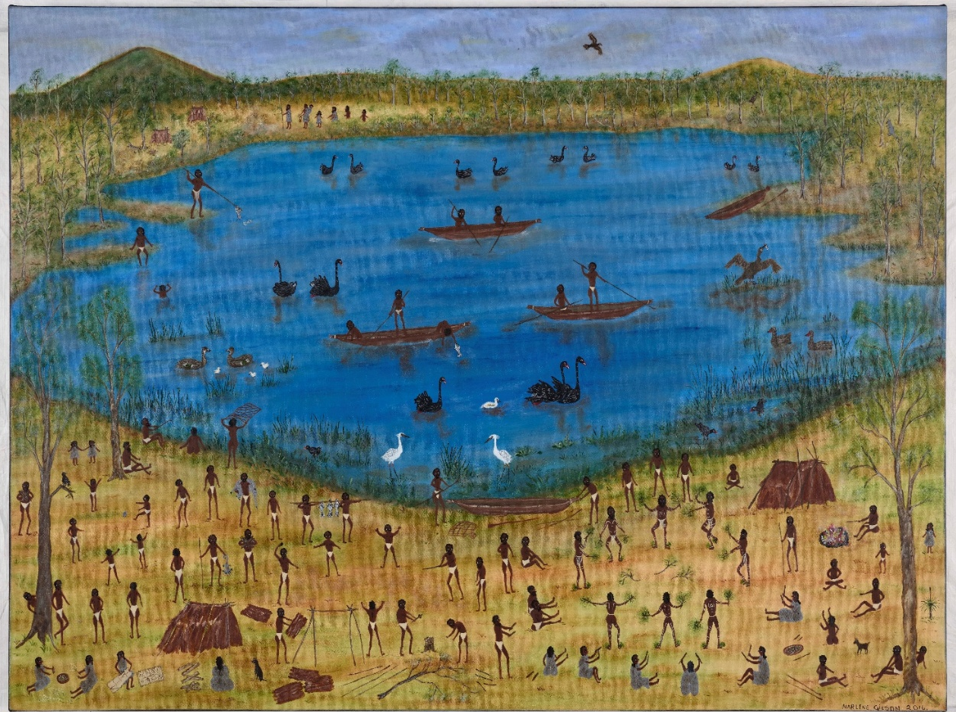
Black Swamp – Lake Wendouree, by Marlene Gilson, Wadawurrung, (born 1944), 2018, synthetic polymer paint on linen, 76.8 x 101.7 cm. Purchased with funds from the Art Gallery of Ballarat Association, 2018. Image courtesy of the Art Gallery of Ballarat.

Aunty Marlene Gilson (born 1944) is a Wadawurrung (Wathaurung) Elder who lives on Country near Ballarat in Victoria. After discovering painting later in life, Gilson is now a respected visual artist and cultural leader. Her narrative landscapes depict life as it was for her ancestors, Mullawallah (also known as King Billy) and Catobeen (or Queen Mary), during the early years of colonisation and the Gold Rush. The Art Gallery of Ballarat holds 6 significant paintings by Marlene Gilson, acquired over a number of years since the artist started painting in 2012. The largest selection of the artist’s work in any public collection, these paintings have cultural, historical and artistic significance, enhanced by their clear provenance and interpretive capacity.
Gilson’s painted scenes are remarkable reworkings of the history painting genre that retell some of Australia’s pivotal historical moments from the perspective of the colonised rather than the coloniser. These works engage with a national history. Many are of specific importance to the Art Gallery of Ballarat collection for the stories they tell of the lands on which the Gallery was established. Gilson’s style and subject matter have also been influenced by other paintings in the Gallery’s collection, particularly by Eugene von Guérard (1811–1901) and Charles Doudiet (1832–1913), who created first-hand images of significant events of the Gold Rush era in Central Victoria, Australia.
Gilson’s 2013 painting Mount Warrenheip and Eureka Stockade depicts an often-told Ballarat story, the Eureka Uprising, but from a Traditional Owner’s perspective. The artist’s gaze from an elevated view captures not only the violent conflict between the miners and the soldiers but also life in the Wadawurrung campsite adjacent to the action. On the left side of the Yarrowee River, below Mount Warrenheip, is an Aboriginal campsite where Mullawallah and Catobeen look on at the distant fighting. Among the possum-skin clad group are some non-Indigenous children, distinguished by their clothing. According to Gilson’s inherited oral histories, immigrant children fled to the Aboriginal camp during the siege to seek safety (Gilson, ABC, 2022). Gilson also draws attention to the environmental costs of the Gold Rush through a grouping of tree stumps and a dried-up riverbed.
Gilson’s series of miniature paintings from 2018 are features of her larger narratives, in which single figures or acts are in focus including an Aboriginal police officer in Trooper, a double portrait of King Billy and Queen Mary campsite and Eel trapping.
Gilson’s paintings also hold ancient Wadawurrung creation stories, as seen in Mt Warrenheip, Bunjil and his creations circa 2012 and Black Swamp – Lake Wendouree 2018 (pictured), where the creator spirit Bunjil takes the form of an eagle in flight. The latter painting is also a reminder of what Ballarat looked like before colonisation. In Gilson’s landscape, the landmark now known as Lake Wendouree was a wetland abundant in fish, eel and waterfowl. Dozens of human figures engage in canoeing, spearing and a corroboree takes place in the lower right. Through this wide view, Gilson re-inserts Wadawurrung people into the landscapes that were declared terra nullius (not peopled) by English colonisers.
References
- ABC interview with Marlene Gilson (8 June 2022) ‘Eureka!: Eureka Art’ [video], ABC Education, ABC website, https://www.abc.net.au/education/eureka-eureka-art/13918382, accessed April 2026.

Case study 22: Bikpela Siliceous Chimney, in the collection of the Australian National Maritime Museum
Contributed by: Dr Kimberley Webber and Emily Jateff
Organisation: Australian National Maritime Museum
Dated: July 2026
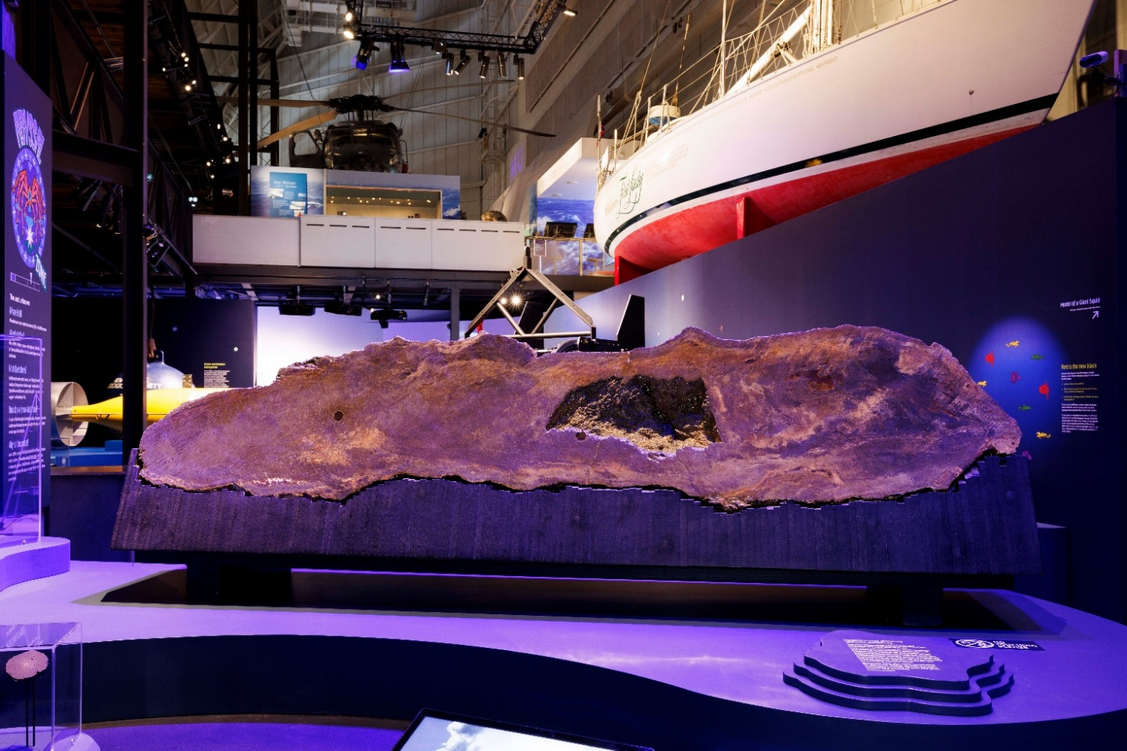
Bikpela siliceous chimney from the PACMANUS Hydrothermal Field, Manus Basin, Papua New Guinea. Recovered April 2000, opaline silica and barite with some zinc, iron, lead and copper sulphides and significant trace amounts of gold and silver, 80 x 270 cm, 970 kilograms. Australian National Maritime Collection. Gift of CSIRO Mineral Resources, 2024.

The Bikpela mineral spire is a rare example of a siliceous chimney from the deep oceans off Papua New Guinea. Such chimneys are formed in active hydrothermal vents (the hot springs of the ocean floor) across the Pacific and Atlantic Oceans, usually along the Earth’s tectonic plate boundaries or at sites of volcanic activity. Found only at great depth, the existence of these hydrothermal vents was not known until 1977, when one was discovered off the Galapagos Islands in the Pacific Ocean off the coast of Ecuador. Since then, 2 major forms of chimneys have been identified based on the colour of their emissions: black smokers and white smokers.
Chimneys are formed when metal-rich superheated fluids, which can reach temperatures as high as 464 degrees Celsius, burst through the ocean floor and mix with seawater. This causes the metals to precipitate to form chimney-like structures around the hydrothermal vent. Often structurally unstable, these chimneys can reach up to 60 metres in height. Most last only a few decades, although some have been found in the Manus Basin in the Bismarck Sea northeast of Papua New Guinea that are over 4,000 years old at their base.
Despite existing in a harsh environment, with high water temperatures and the complete absence of light, these chimneys support communities of organisms. As a result, the areas around hydrothermal vents are more biologically complex than much of the deep sea. As these fields date from the very early history of the planet, some scientists have speculated that places such as this could be where life on Earth began.
This chimney was recovered accidentally in April 2000. A team of Australian and Papua New Guinean researchers, led by Chief Scientist Dr Ray Binn, was on board the Commonwealth Scientific and Industrial Research Organisation (CSIRO) Marine National Facility ORV Franklin, investigating the ‘Satanic Mill’ hydrothermal field in the eastern Manus Basin. Seafloor dredge MD-133 was deployed to gather samples of microbial life. It accidentally snagged and brought to the surface a largely intact 2.7 metre chimney. Named ‘Bikpela Binatang’ (meaning Big Bug in Tok Pisin, the language spoken throughout Papua New Guinea) and subsequently just called Bikpela, it was transported to Perth, Australia. In Australia, it was sliced in half to reveal a complex internal structure that is distinctly different from the sulphide-rich chimneys typical of the Manus Basin. Although similar in external appearance, Bikpela’s vibrant core was layered with deposits of opaline silica, barite, zinc, iron, lead and copper sulphides, as well as trace amounts of silver and gold. Researchers found 3 distinct layers of deposits and a large internal collapsed cavity.
The smaller section of Bikpela was donated to Museums Victoria, while this larger section was a popular feature in the foyer of CSIRO Mineral Resources Kensington Office in Perth until its donation to the Australian National Maritime Museum in 2024. Bikpela is a significant addition to the ANMM collection, providing a rare opportunity for the public to see an example of a structure that supports deep-sea biodiversity. It has scientific and research significance, with capacity to expand our knowledge of marine geology. Its relative significance is increased by its representativeness, known provenance and rarity. Bikpela also has strong interpretive capacity, enabling researchers and museum visitors to observe an item usually inaccessible to humans that demonstrates the results of deep-sea hydrothermal activity.
References
- Binns RA (2014) ‘Bikpela: A large siliceous chimney from the PACMANUS hydrothermal field, Manus Basin, Papua New Guinea’, Economic Geology, 109 (8): 2243–2259, doi:10.2113/econgeo.109.8.2243
- Osterloff E (n.d.) ‘Hydrothermal vents: survival at the ocean's hot springs’, Natural History Museum, https://www.nhm.ac.uk/discover/survival-at-hydrothermal-vents.html, accessed July 2026.
- Johns S, Ditchburn R, Barry B and Yeats C (2014) ‘Episodic subfloor hydrothermal activity within the Eastern Manus Back-Arc Basin determined by uranium-series disequilibrium in barite’, Economic Geology, 109 (8):2227–2241, doi:10.2113/econgeo.109.8.2227.
- Daniel S (20 December 2024) ‘From the ocean’s depths to the public eye: Bikpela’s amazing journey’, CSIRO: https://www.csiro.au/en/news/all/articles/2024/december/bikpela-hydrothermal-spire, accessed July 2026.

Case study 23: Hung out to Dry by Madi Mercer, in the collection of the Koorie Heritage Trust
Contributed by: Katherine Giesen-White
Organisation: Koorie Heritage Trust
Dated: April 2026
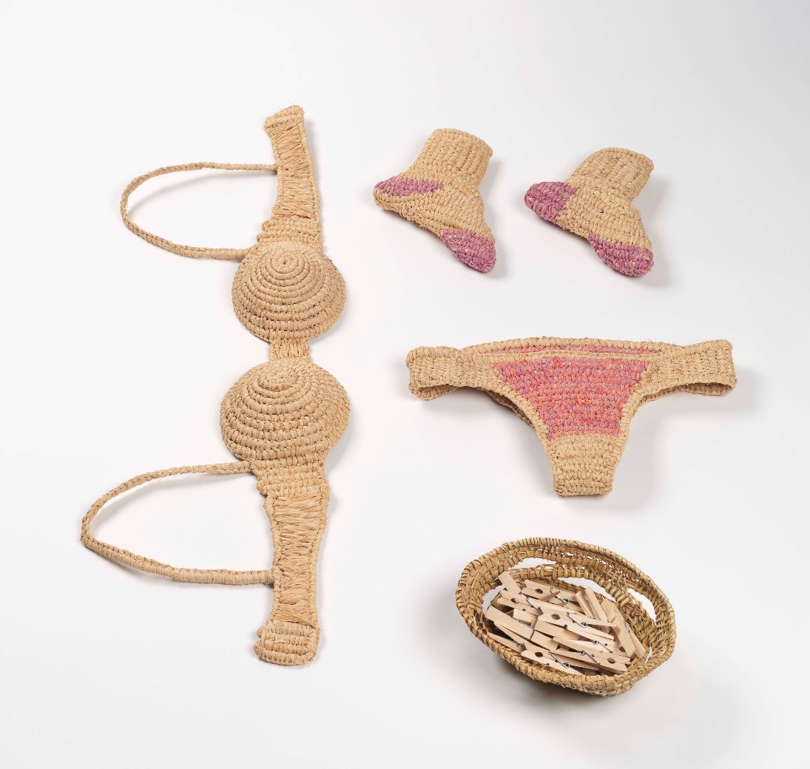
Madi Mercer (Wadawurrung), Hung out to Dry, 2022, raffia, 5 parts, 1000 x 1400 x 300 mm (overall). Collection of Koorie Heritage Trust, Narrm (Melbourne). Purchased 2023, AH 04035. Courtesy of Koorie Heritage Trust. Photo: Christian Capurro.
Hung out to Dry by young living artist Madi Mercer was a significant acquisition for the Koorie Heritage Trust (KHT) Collection. When displayed, the work features woven clothing – socks, a bra and underwear – suspended from a clothesline with clothes pegs.
In terms of the primary significance criteria, the work’s cultural significance is demonstrated by its strong links to the continuous cultural practice of weaving, providing a contemporary insight into the experiences and perspectives of Blak women in relation to the ongoing legacies of colonisation. Its social significance is demonstrated as Hung out to Dry embodies the feminist values, strength and resilience of strong Blak women, bringing new energy and perspectives of younger-generation First Peoples artists. An original work by Madi Mercer, the work has artistic significance as an important document of her art practice. It also showcases artistic innovation within the cultural practice of weaving, presenting a new take on familiar, everyday objects through a range of techniques.
The installation of the work is critically engaged with subject matter relating to Blak feminism, empowerment, resilience, the systematic oppression of First Peoples and the ongoing impacts of colonisation. The multipart format allows for flexible display across various contexts. The work holds research significance for studies concerning continuity and change in south-east Australian weaving practices, the role of weaving within the KHT Collection, Blak feminism, colonisation and art as activism.
The significance of Hung out to Dry is amplified under the comparative criteria. The work has clear provenance as documented by the artist. Prior to acquisition, it was exhibited in the Vitrine Gallery at Craft Victoria in Narrm (Melbourne) from 17 May to 18 June 2022 and in the 10th Koorie Art Show at the KHT in Narrm (Melbourne) from 3 December 2022 to 19 February 2023. Its rarity and representativeness are confirmed as it is a unique, original and innovative application within a well-documented cultural form. The condition of the work is excellent. It is in its original condition and is intact and complete, ensuring its longevity within the KHT Collection.
Finally, the work’s interpretive capacity is high. The work highlights the ongoing impacts of colonisation alongside the strength and resilience of First Peoples in south-east Australia. It significantly enhances KHT programming by ensuring the representation of weaving as a continuous cultural practice. The acquisition of Hung out to Dry ultimately aligns with the KHT’s purpose to collect and interpret Cultural Belongings and contemporary art so that the continuous traditions and critical current dialogues of First Peoples in south-east Australia are preserved and celebrated.
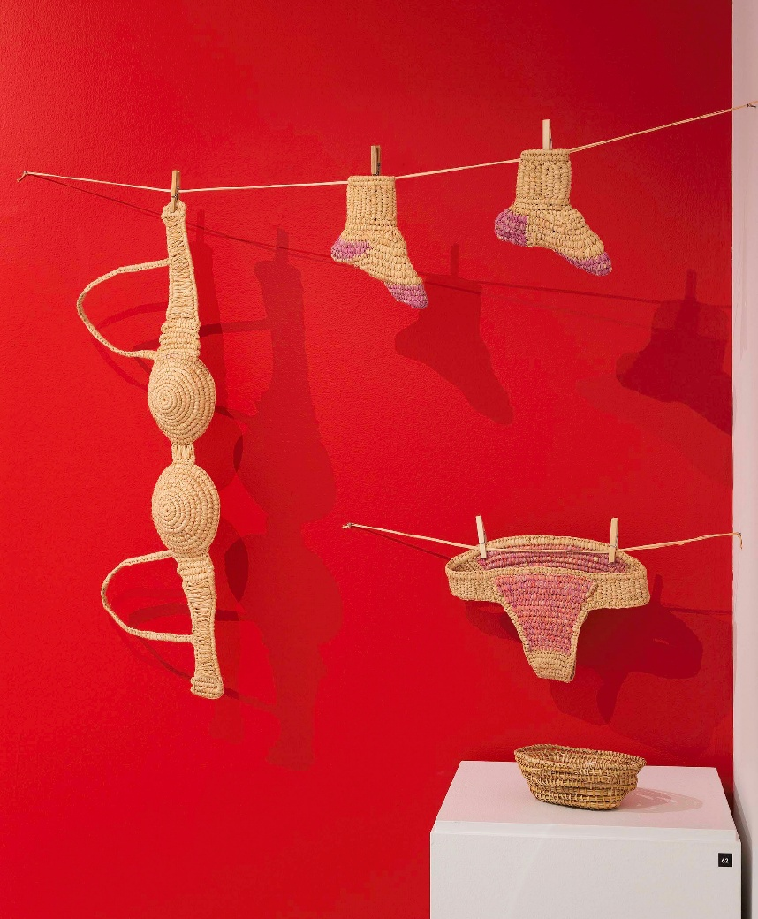
Madi Mercer (Wadawurrung), Hung out to Dry, 2022, raffia, 5 parts, 1000 x 1400 x 300 mm (overall). Collection of Koorie Heritage Trust, Narrm (Melbourne). Purchased 2023, AH 04035. Courtesy of Koorie Heritage Trust. Photo: Christian Capurro.

Case study 24: Cochlear implant, in the collection of the Powerhouse
Contributed by: Nina Earl, Collection Curator
Organisation: Powerhouse
Dated: July 2026
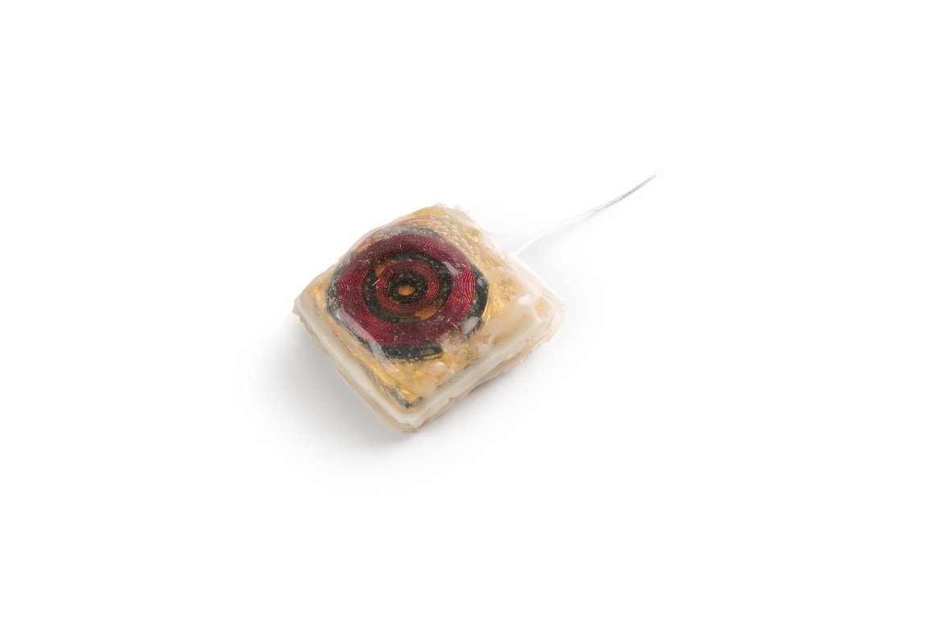
Prototype 'gold box' cochlear implant, designed and made at the University of Melbourne Department of Ear, Nose and Throat Surgery, 1979, mixed materials, 7.5 x 3.2 x 1.0 cm. Powerhouse Collection. Gift of Professor Graeme Clark and the University of Melbourne.

The ‘gold box’ cochlear implant was the second prototype developed by Professor Graeme Clark (born 1935) and his team in 1979 at the Department of Ear, Nose and Throat Surgery at the University of Melbourne. It is one of several identical prototypes made while testing wireless connectivity between an implant and external processor. Cochlear implants overcome hearing loss by bypassing the damaged hair cells in the inner ear and using electricity to directly stimulate the auditory nerve. The pioneering surgeries conducted by Professor Clark and his team proved that hearing could be restored, even in extreme cases. This research formed the basis of Cochlear Limited, an Australian company which became an international leader in the manufacture and sale of cochlear implant systems. By 2010, over 200,000 people in more than 100 countries had received the implant and today implantable hearing aids are used around the world.
Professor Clark, who had training as a surgeon, auditory neurophysiologist and speech therapist, was inspired to research ways that electrical stimulation of the cochlear might help with reducing hearing loss after watching his father, a pharmacist, struggle with hearing loss while at work for many years (Australian Academy of Science n.d.). Initially, funding for the research was limited as it conflicted with the dominant scientific view of the time. However, the first prototype, implanted in test patient Rod Saunders in 1978, proved that internal stimulation of the cochlear was possible. While the first cochlear implant prototype required a room full of equipment, this second version, designed for test patient George Watson in 1979, was smaller and paired with a portable speech processor. It worked successfully for around half a year before it began to fail. This device held by the Powerhouse was one of several prototypes of the same design, other examples of which are held in the collections of the National Museum of Australia and Museums Victoria.
Mr Watson’s implant does not survive today, but the initial success of the ‘gold box’ prototype demonstrated that Professor Clark's idea for a multiple electrode implant with aerials or inductive coupling of coils across the skin and the associated speech processing strategy worked. It provided enough evidence for Professor Clark and his team to gain support for further development and a clinical trial subsequently commenced in 1982. After the implant failed, its removal and analysis revealed a flaw in the design – small movements caused the wires to fracture where they emerged from the ‘gold box.’ This knowledge informed Professor Clark’s selection of Nucleus (Telectronics), with their expertise in sealing electronics for pacemakers, as an industry partner to undertake further development of the implant for clinical trial.
Visible on top of the ‘box’ is a red enamel-coated copper coil that forms the receiver. The inclusion of this receiver allowed this prototype to be fully embedded under the skin, an important design feature that has contributed to the success of the device. This wireless design allowed Cochlear Limited to make improvements to the external units compatible with all previous implant designs. This enabled users to access contemporary improvements such as improved sound interpretation, waterproofing, or to own multiple processors in different colours and designs. Since the development of this prototype, Cochlear Limited has continued to lead the world in the development of implants and speech processors with a commitment to technological improvement and hearing for all.
The Powerhouse has a rich collection of material related to the development of the Cochlear Hearing Aid, donated by both Professor Graeme Clark and Cochlear Limited. The collection includes this early prototype ‘gold box’ implant and its associated prototype speech processor (Powerhouse Museum 2011a), alongside numerous later models that track the evolution of this technology from the first commercial model (Powerhouse Museum 2015) through to hybrid systems (Powerhouse Museum 2011b) that combine implant technology with a traditional hearing aid.
References
- Australian Academy of Science (n.d.) Professor Graeme Clark, otolaryngologist, Australian Academy of Science, https://science.org.au/our-focus/history-australian-science/conversations-australian-scientists/professor-graeme-clark-otolaryngologist, accessed July 2026
- Powerhouse Museum (2011a) ‘Prototype wearable speech processor for cochlear implant system’, Powerhouse Collection, Object No. 2011/10/2, https://collection.powerhouse.com.au/object/414321
- Powerhouse Museum (2011b) ‘Cochlear Hybrid hearing system, 2008’, Powerhouse Collection, Object No. 2011/22/1, https://collection.powerhouse.com.au/object/415633
- Powerhouse Museum (2015) ‘Prototype wearable speech processor for cochlear implant system’, Powerhouse Collection, Object No. 2011/10/2, https://collection.powerhouse.com.au/object/55249

Case study 25: Ngabu installation by Aunty Lola Ryan, 2025, in the collection of the Powerhouse
Contributed by: Tammi Gissell, Collections Coordinator, First Nations
Organisation: Powerhouse
Dated: May 2026

Ngabu by Aunty Lola Ryan, 2025, installation, 420 x 569 cm. Co-Creative Team: City People, Dr Michael Cohen (Curators and Producers), Joey Ruigrok van der Werven (Construction designer), Pink Cactus (Fabricator), Eyejack (AR designer for Ngabu Djal Yanda). Powerhouse Australian First Nations Collection. Originally Funded and Presented by Transport for NSW (TfNSW), NSW Office of the 24-hour Economy Commissioner, Walsh Bay Arts Precinct & Precinct Association and Sydney Festival.

Ngabu (meaning ‘Nan’ or ‘Grandmother’) is an installation conceived by Dharawal artist Aunty Lola Ryan. Originally commissioned by the Walsh Bay Arts Precinct and donated to Powerhouse after its premiere season, Ngabu pays homage to Aunty Lola’s esteemed lineage of shell artists from the La Perouse Aboriginal community in the eastern suburbs of Sydney. The artist’s grandmother, known fondly as Ma Page (Elizabeth Jane Page, 1886–1962), mother, Lola Delia Ryan (1925–2003), and aunt, Mavis Longbottom (1917–2003), were all master shell artists and passed knowledge of the craft down to Lola, her siblings and cousins.
The overall design of Ngabu is a shell-decorated model (5.69 metres wide and 4.2 metres high) of the iconic Sydney Harbour Bridge. The large scale installation is fully interactive, allowing it to be climbed across, and includes an augmented reality ‘treasure hunt’ of Ancestral sites and their stories. Ngabu reimagines the intricately crafted miniature models of the Sydney Harbour Bridge made famous by her mothers and grandmothers, which remain much desired by collectors and institutions today. Women from La Perouse have made shellwork for sale to Europeans for many generations. The craft, first introduced to the community by missionaries, centred on the women’s deep understanding of Country, waterways and seasons, which allowed them to procure the finest shells. Records show that by the 1880s Aboriginal women were selling shell baskets at Circular Quay and La Perouse. Although not a traditional Aboriginal art form, the skill of shell working has been handed down from mother to daughter to granddaughter in the same way that traditional technologies pass down the generations.
Aunty Lola acknowledges, ‘I always felt mum’s shellworks were so perfect that I would never attempt to try and replicate them exactly.’ Instead, Aunty Lola has featured shells and incorporated shelling techniques into her paintings and other variable media works of art. Aunty Lola’s capacity to express admiration for her mother’s techniques and established aesthetic while not imitating her is beautifully highlighted in Ngabu. In contrast to the handheld, delicate and ornamental pieces created by her matriarchs, Ngabu is a monumental site installation which encourages interaction and immersion in stories of place. In the installation’s augmented reality (AR) treasure hunt, Ngabu Djal Yanda, Aunty Lola speaks to the Dreaming story of Buri-buri the whale, shell middens, the first contact between Cammeraygal (also spelled Gamaraigal) woman Patyegarang and British astronomer William Dawes in 1788, and shell art from the 19th century.
With its monumental size, unrestricted accessibility and inclusion of contemporary technologies, Ngabu honours the artistic legacy of those who came before Aunty Lola and points to the future of Indigenous artistic forms. Ngabu takes La Perouse shell art beyond producing objects to providing an experience for audiences. By collaborating with non-Indigenous makers and modern technologies to create Ngabu, Aunty Lola encourages more intimate engagement with Indigenous heritage expressions, and a movement toward the shared contemplation of place as an experience of history and memory, lived and relived.
The acquisition of Ngabu is a significant addition to the shell artworks made across generations of La Perouse Aboriginal artists in the Powerhouse collection. Its radical reimagination of scale and interactivity provides considerable testimony to the enduring artistic and technical knowledge of producing shell art, transmitted from grandmother to mother and from mother to daughter, in the La Perouse Aboriginal community for at least 140 years.
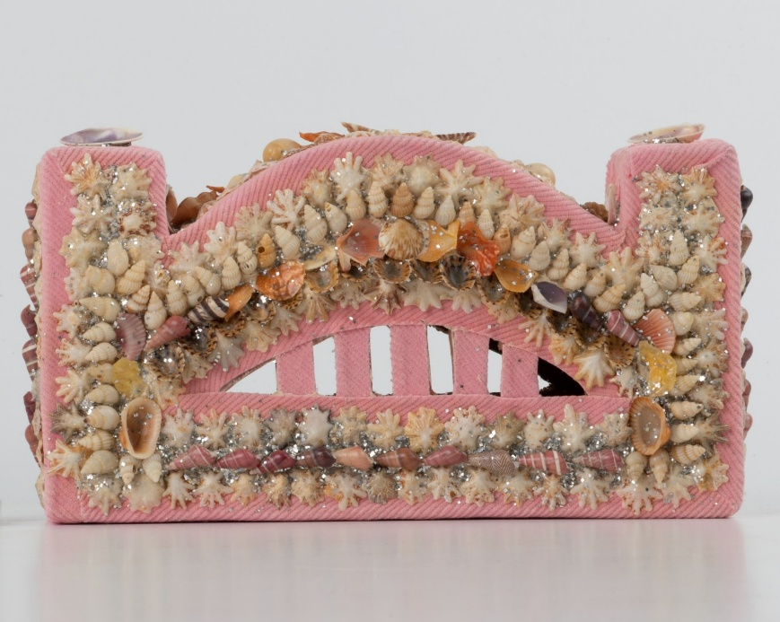
Shellwork Sydney Harbour Bridge, made by Mavis Longbottom and Lola Delia Ryan in La Perouse, New South Wales, Australia, 1986, fabric model made of stiff cardboard and covered in pink corduroy and decorated with shells arranged in different patterns around the image of the bridge, 4.8 x 12 cm. Powerhouse Collection.

Case study 26: Adelaide Armpits T-shirt, in the collection of the Migration Museum, History Trust of South Australia
Contributed by: Corinne Ball, Senior Curator, Collections
Organisation: Migration Museum, History Trust of South Australia
Dated: April 2026
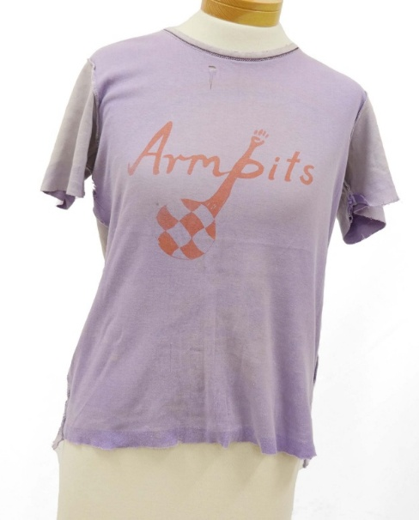
Armpits T-shirt, 1982, textile, cotton, dye, paint, 55 x 45 cm. Armpits Collection, State History Collection (HT 2019.0921), History Trust of South Australia.

This soccer (football) shirt is part of the History Trust of South Australia’s Armpits Collection, donated by Truffy Maginnis. The Armpits Collection comprises material associated with the Adelaide Armpits lesbian soccer team, including this shirt and another later team shirt, a ‘golden boot’ trophy, team lists and notebooks, letters, and other items and documentation.
The Armpits team, which played for nearly 3 decades from 1982, began when a group of radical activist lesbian women, mostly students, on low incomes or unemployed, sought to join the South Australian Women’s Soccer Association. The first team had no home ground and little training but aspired to operate on feminist, non-hierarchical principles, with no official coach or captain, to encourage women of all ages and abilities to join in. Later success brought increased structure and a broadening of the team base, as members fought prejudice and stereotyping from other players, teams and the Association.
The 1960s and 1970s were decades of immense social change in Australia, as previously marginalised or under-represented groups increasingly sought rights and recognition. In 1975, South Australia was the first state in Australia to decriminalise male homosexual activity, under the premiership of Don Dunstan (1926–1999). While female homosexuality was not a crime, many women did not feel safe to be open about their sexuality and identity. The Armpits soccer team became an effective way for lesbians in Adelaide to express themselves and create a safe space for women to be ‘out and proud’.
The donor of the Armpits Collection, Truffy Maginnis, was a recent migrant to South Australia when she became a founding member of the Armpits team in 1982. Born in Northern Ireland, she moved as a teenager, first to London and later to Australia, to find a place where she could be herself as a young lesbian woman. Maginnis played for the Armpits every soccer season until 2000 and was part of a team fielded for the 2002 Sydney Gay Games. This major event featured over 14,000 athletes from 77 countries and signalled the increased visibility, acceptance and progress made over the previous 20 years. Maginnis’ 2002 shirt is also part of the History Trust’s Armpits Collection.
To save costs, the Armpits produced their team strip as a group, batch dyeing, painting and printing a design created by an anarchist friend onto cheap shirts. The purple number 6 shirt, which was made by recycling an inside-out souvenir cotton t-shirt, reflects the rough-and-ready nature of the first season Armpits team and the sport they played in the early 1980s. This contrasts with Maginnis’ Sydney 2002 shirt, which was commercially produced and featured a rainbow motif and visible corporate sponsorship from a local gay and lesbian-friendly pub.
Both shirts have historical significance as well-provenanced examples of amateur sports uniforms that indicate some of the changes in practice and social life between the 1980s and early 2000s. They also have high social significance and interpretive capacity as representations of LGBTIQA+ people’s histories and contributions in South Australia. The Armpits Collection has broader historical and social significance as material relating to women's sport, the activities of South Australian community organisations and migrants to the state.
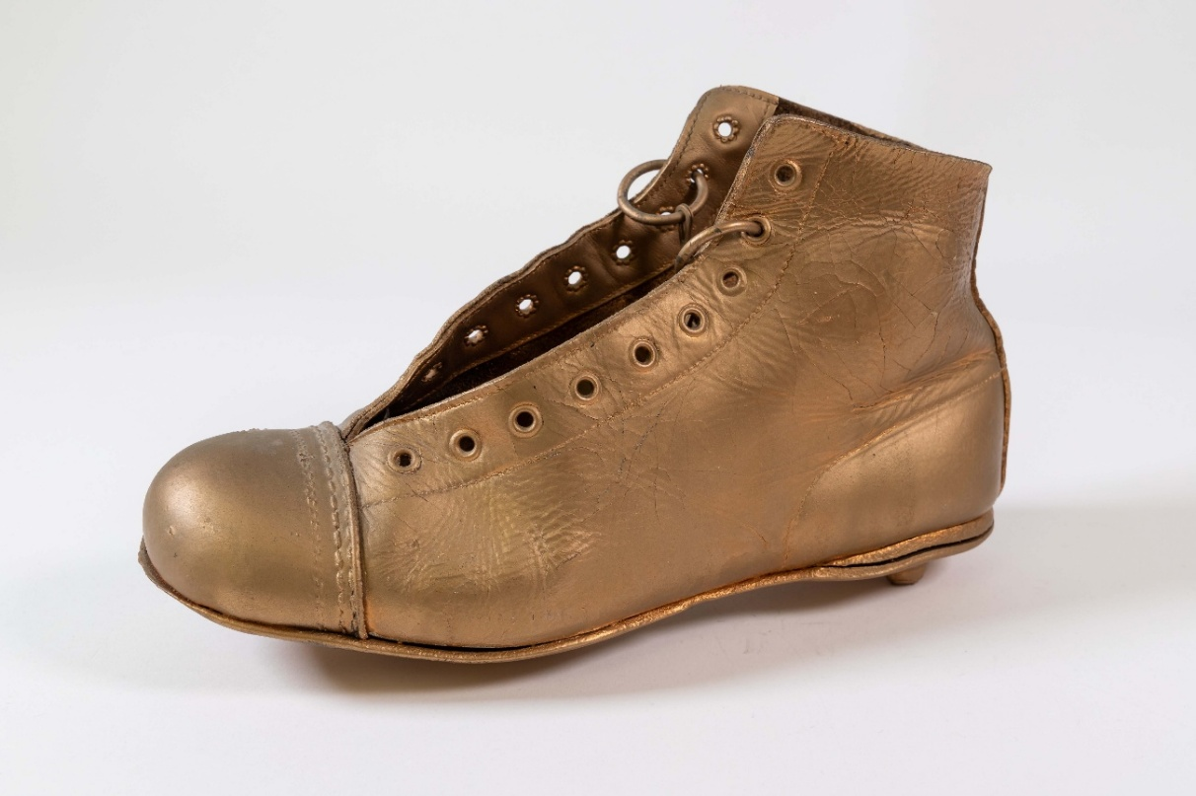
Armpits gold boot, created between 1982 and 2000, textile, metal, leather, paint. Armpits Collection, State History Trust Collection (HT 2019.0927), History Trust of South Australia. Photograph by Stephen Dean. Licensed under CC BY 3.0 AU.

Case study 27: Paddle Steamer Adelaide
Contributed by: Neil Hogg and Neil Meyers, Convenors: Operating Heritage Australia
Organisation: Port of Echuca
Dated: August 2025
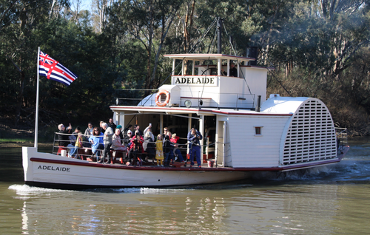
PS Adelaide cruising (one of 4 daily cruises) from her home port of Echuca in July 2021, Photograph: Thom Devereux, via Wikimedia Commons, licensed under CC BY-SA 4.0.

The Paddle Steamer Adelaide (PS Adelaide) was built at Echuca in Victoria, Australia, in 1866 by George Linklater (1829–1886). It is now the oldest remaining Murray River paddle steamer and is of historical significance as the oldest wooden-hulled operating paddle steamer in the world. The PS Adelaide is typical of a period when river transport was the only reliable option. During the vessel’s long career, it performed many and varied roles. PS Adelaide transported wool in its very early days in the lower Murray. It returned to Echuca in 1873 and towed barges of red gum timber, people and general cargo between agricultural and trading centres until 1958. Along with the other river steamers that appeared over time, PS Adelaide was essential to the economic and social development of the communities in and around the Murray.
The PS Adelaide has clear social and cultural significance, as shown by community interest and involvement with the vessel. In 1960, local Echuca organisations decided to rescue the Adelaide and, subsequently, to restore it to a state representing its early days. It returned to operation in 1985. Since then, it has become a major attraction at the Port of Echuca heritage site where it is steamed regularly along the Murray. The Adelaide is also highly significant to steam, boating and engineering heritage communities around Australia. This wide involvement has resulted in a more comprehensive significance assessment, as well as continuing interest from people wanting to experience the movement, sound, smell and feel of an operating 19th-century paddle boat, all of which enhance its interpretive capacity.
The PS Adelaide is significant as a representative example of its type, within the historical themes of transport, communication, infrastructure and developing a national economy. The boat itself is typical of an early Australian river paddle boat. It has a round bilge, counter stern and a shallow draught of 3 feet, with 2 side paddle wheels allowing it to navigate at low river levels and around the many and changing snags in the rivers. The Adelaide is rare as one of 7 remaining operating paddle steamers and one of the few retaining its original form and original steam engine, which was manufactured by Fulton & Shaw in Melbourne. PS Oscar (1908) at Goolwa in South Australia and PS Enterprise (1878) at the National Museum of Australia in Canberra demonstrate the continued suitability of the design over time. The Adelaide is a good example of historical artisanship and skills, giving it creative and technical significance. It also has research significance, serving as a primary source of information to future researchers.
Its provenance, including creation, ownership, use and context, is well known and much historical and current material relating to the vessel and its use is readily available. Although it has been repaired and modified throughout its life – demonstrating its adaptability to changing conditions, economic needs and ways of life along the river – thorough research and significance assessments have allowed the Adelaide to be conserved to a known former condition.
As well as understanding the significance of the boat as a whole, assessments enabled identification of the relative significance of its components. For example, the engine is very significant, while the paintwork is not. This allowed a comprehensive conservation management plan to be developed and followed, resulting in an authentic restoration. The assessments also enable the development of appropriate operating and maintenance plans to ensure the long-term conservation of the boat.
Although the PS Adelaide is a magnificent sight when steaming in its element along the river, its significance is enhanced when it is in its home at the Port of Echuca. With its fleet of restored paddle steamers and barges, railway and colonial heritage buildings and heritage-listed wharf, the Port provides good context and forms a critical part of Echuca’s heritage. It is important also to recognise other, less obvious heritage associated with the PS Adelaide. An operating machine of any kind needs associated objects such as fuel, specialised tools, special equipment and related machinery, spare parts and operating and maintenance manuals. Most critically, an operating machine needs people with specialised skills to operate and maintain it. Specifically, the PS Adelaide requires a Master, steam engineer, shipwrights, boiler operators and inspectors, and many others to create a viable future as an operating vessel.
The PS Adelaide is an important example of a former way of life and a flourishing economy in the late 1800s and early 1900s. A thorough cultural significance assessment process has been followed, and appropriate conservation, operation and maintenance plans developed to ensure the long-term conservation of the boat. This gives the vessel great interpretive capacity, because it allows current and future generations to experience something of the life of former generations.

Case study 28: The flag of the Southern Cross (Eureka Flag) at Art Gallery of Ballarat
Contributed by: Emily Wakeling, Curator
Organisation: Art Gallery of Ballarat
Dated: April 2026
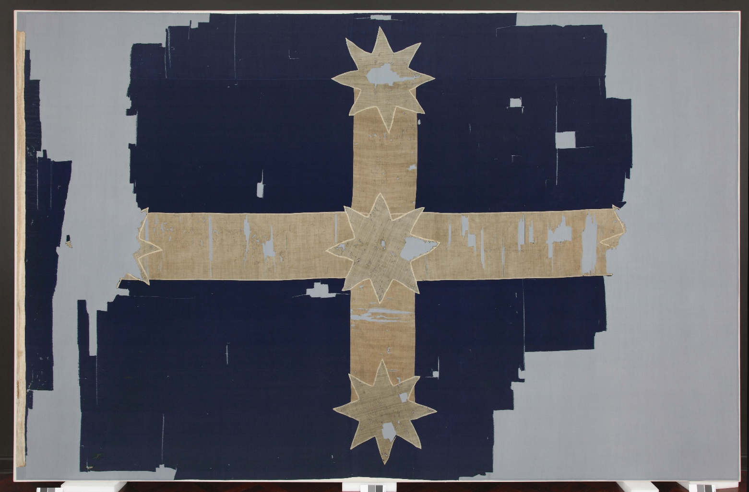
The flag of the Southern Cross (Eureka Flag), 1854, wool and cotton, 260 x 324 cm (irregular). Collection of the Art Gallery of Ballarat, Gift of the King family, 2001. Image courtesy of Art Gallery of Ballarat.

Decorated with white cotton stripes that form a partial cross with stars at its ends and centre, this fragmented sheet of navy woollen fabric was the Southern Cross flag raised at Bakery Hill, Ballarat, on 29 November 1854, at the height of the Victorian Goldrush. On that date, the flag played a central part in the assembly of thousands of angry gold miners who took action against the exorbitant mining licence fees imposed upon them by local law enforcement and began building a stockade at the Eureka diggings. It was at this meeting that the leader of the Eureka Uprising, Irish miner Peter Lalor (1827–1889), encouraged all attendees to face the flag and ‘swear by the Southern Cross to stand truly by each other, and fight to defend our rights and liberties.’
According to the eyewitness account of Raffaello Carboni (1817–1875), the flag’s design was modelled on the blue-and-white cross of the flag of Quebec, another territory experiencing rebellions at the time (Carboni 1855:50). The inclusion of the Southern Cross constellation, which was a new phenomenon for immigrants from the northern hemisphere, signified the struggle’s specific location. Due to its size, the flag’s production would have likely involved many hours of sewing by more than one set of hands, possibly by seamstresses or tentmakers (Wickham 2008:106).
The flag was raised inside a makeshift fortification at the Eureka Lead, which was the centre of the miners’ open rebellion against authorities. On 3 December 1854, after 5 days of encampment, British soldiers stormed the stockade, killing 22 and arresting 113. Trooper John King (1830–1881) took down the flag and stored it at the Government Camp as a trophy and evidence for the court (Withers 1890:1). Public outcry at the government’s violent response to the rebellion was overwhelming, and all who stood trial were eventually pardoned. The incident was a catalyst for political change and is often described as the birth of democracy in Australia.
Despite conflicting eyewitness accounts raised in the years following the event, Art Gallery of Ballarat founder, James Oddie (1824–1911), was convinced of the flag’s authenticity when he arranged for its long-term loan from descendants of Trooper King in 1895. In the 1940s, historians and textile experts gathered evidence to prove that this flag flew at the Eureka Stockade (Fox 1947:107-108). Descendants of Trooper King transferred ownership of the flag to the Art Gallery of Ballarat in 2001, and it underwent extensive conservation.
The incomplete condition of the flag is physical testament to its provenance and rough handling at the hands of the police and soldiers who captured it. The Geelong Advertiser described how ‘the diggers Standard was carried by in triumph to the Camp, waved about in the air, then pitched from one to another, thrown down and trampled on’ (Geelong Advertiser 1855:3). The flag was also subject to decades of mistreatment: small fragments of the flag were cut and offered as trophies or souvenirs to Art Gallery of Ballarat visitors who had a family association with the Uprising – a practice eliminated by the 1970s. The Gallery owns several of these fragments, which have been returned by later family members. Since 2013, the flag, in its current form, has been displayed in its own dedicated museum at the Eureka Centre, on loan from the Art Gallery of Ballarat Collection.
The flag of the Southern Cross held by the Art Gallery of Ballarat and displayed at the Eureka Centre is a famed item of great historical significance due to its role in rallying miners to participate in the Eureka Uprising in 1854. This event was a key moment in the development of democracy, political protest, and workers’ rights in Australia. The flag’s provenance, as established through careful research and technical investigation, adds to its significance. It also has strong interpretive capacity. The flag is a central visual touchstone in telling the story of the Gold Rush and the Eureka Stockade, as well as stories of its appropriation by varying political groups. It is receiving ongoing maintenance to help ensure its long-term preservation. For its material connection to one of Australia’s most important political events, the flag was deemed a National Trust icon of Victoria in 2006.
References
- The Age (31 July 1899) ‘The Eureka Stockade Flag’, The Age.
- Carboni R (1855) The Eureka Stockade: The Consequences of Some Pirates Wanting on Quarter-deck a Rebellion, J P Atkinson.
- Fox L (1947) ‘The Eureka Flag,’ Meanjin Papers, 6(2):107-108.
- Geelong Advertiser (28 February 1855) ‘State Trials’, Geelong Advertiser and Intelligencer.
- Wickham D (2008) ‘‘Blood, Sweat and Tears’: Women at Eureka’, Journal of Australian Colonial History, 10(1):106.
- Withers W B (19 April 1890) ‘Ballarat Chronicles and Pictures’, Ballarat Star.

Case study 29: Olympic Torch, in the collection of the Powerhouse
Contributed by: Anni Turnbull, Collection Curator
Organisation: Powerhouse
Dated: June 2026

Sydney 2000 Olympic Games torch used by Cathy Freeman, designed by Blue Sky Design and made by G A & L Harrington, c. 1998, metal and plastic, 79 x 10 x 4 cm. Powerhouse Collection, part of Sydney 2000 Games Collection, Gift of the New South Wales Government, 2001.

This Olympic torch was used by Cathy Freeman (born 1973) on 15 September 2000 to ignite the Olympic cauldron during the opening ceremony of the Sydney 2000 Olympic Games. The torch is one of the most significant items associated with the Games, marking the moment when the Olympics officially opened and when global attention turned to Sydney and Australia.
Freeman, a First Nations athlete, carried the torch in a moment widely interpreted as symbolising hope for unity between Indigenous and non-Indigenous Australians. Her selection as the person to light the cauldron was considered highly appropriate by many Australians: she excelled in athletics, spoke proudly of her Aboriginal heritage and advocated for justice for Aboriginal people. These qualities resonated strongly at a time when the nation was actively debating reconciliation with its Indigenous peoples.
As the Olympic Torch Relay approached the stadium, speculation intensified as to who would light the cauldron. Both the media and the public debated possible candidates, with many expecting one of several prominent Australian sportswomen. The final stage of the relay inside the stadium featured 6 celebrated female athletes, honouring the contribution of women to Australian sport and acknowledging 2000 as the Olympic Year of Women.
Emerging from the darkness in a white flame-proof bodysuit, Freeman ascended a staircase and stepped into a shallow reflective pool. Standing above the audience, she lowered the flame into the liquid surrounding her feet, igniting the Olympic cauldron. The cauldron then rose on a concealed mechanism, briefly pausing before reaching its final position high above the stadium. Ceremony organiser Ric Birch had first envisioned this dramatic moment in Monaco in 1993, immediately after Sydney won its bid to host the Games.
In November 1998, the Sydney Organising Committee for the Olympic Games invited 40 Australian companies to submit designs for the Sydney Olympic torch. Designers from disciplines including architecture, industrial design, graphic design and art were asked to create a torch that reflected the Olympic spirit while incorporating recognisable Australian symbols such as native flora and fauna, Australian inventions like the Sarich engine (an orbital internal combustion engine invented in 1972 by Ralph Sarich), and iconic locations including Sydney Harbour and the Sydney Opera House. The torch also needed to withstand Australia’s varied and often harsh environments – from desert heat to alpine conditions – while keeping the flame alight. Within months, 4 companies were shortlisted, and the final design for both the Olympic and Paralympic torches was awarded to the Sydney-based company Blue Sky Design. The torches were manufactured by G.A. & L. Harrington in anodised and textured aluminium, with contributions from Philips and the RMIT University Centre for Design.
The torch’s tiered rim echoes the sail-like roofline of the Sydney Opera House, while its curved body references the form of a boomerang. The blue aluminium surface symbolises the waters of Sydney Harbour. Weighing approximately 900 grams, the torch tapers towards the base and incorporates a pivoting sleeve that allows access to the internal fuel cylinder, burner and valve mechanism. The exterior consists of 2 shells: an anodised blue outer layer containing space for the fuel cylinder and a white powder-coated layer featuring the silver Sydney 2000 logo on each side.
The Sydney Olympic Torch links to the aesthetic and historical primary significance criteria, combining clever, technically innovative design with visual references to Sydney Harbour and the Sydney Opera House. Cathy Freeman’s role gave the torch and Olympic flame powerful social and cultural meaning, particularly in relation to First Nations recognition, reconciliation and Australian identity. This torch forms part of the Sydney 2000 Games Collection, which includes more than 1,000 objects donated to the Powerhouse by the New South Wales Government in 2001.

Case study 30: Braille teaching aid, Townsend House Collection, History Trust of South Australia
Contributed by: Corinne Ball, Senior Curator, Collections
Organisation: History Trust of South Australia
Dated: April 2026
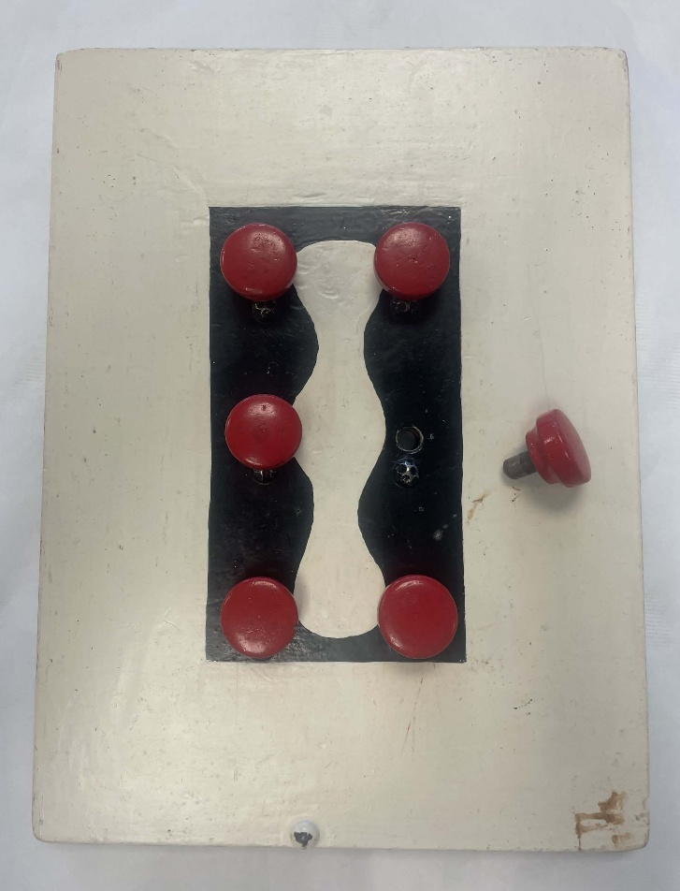
Braille teaching aid, 1940–1980, wood, metal and paint, 33 x 24.5 cm, Townsend House Collection, State History Collection (HT 2019.1167 a-g), History Trust of South Australia.
This Braille teaching aid was used in the mid-20th century to demonstrate the components of the Braille cell and tactile alphabet to young children. It is part of the History Trust of South Australia’s Townsend House collection, which comprises 2 dozen items that were used at Townsend House in Brighton, South Australia, during the 125 years that it operated as a school for deaf and blind children. The collection was donated by the private charitable organisation Can:Do Group (Townsend House Incorporated).
Initially known as the South Australian Institution for the Blind, Deaf and Dumb, the charity was founded in 1874 and managed by a committee headed by a former Mayor of Adelaide, William Townsend (1821–1882). The Institution opened with just 5 blind and 2 deaf students, but within a decade over 30 children were living and learning there. By its 50th anniversary the school had taught over 400 pupils, as well as providing Home Teacher visits to children who could not attend in person. In 1946, the Institution was renamed Townsend House Schools for Deaf and Blind Children. From the 1970s the deaf and blind schools were separated. Educational activity ended at Townsend House in 1999, although the South Australian Institution for Blind and Deaf Inc (which became the Can:Do Group in 2019) continued to use the offices and hold clinics and events there. The building was sold in 2016.
Invented by Frenchman Louis Braille in the 1820s, Braille was one of several tactile reading and writing systems for the blind developed in the 19th century. It became internationally popular due to its efficiency and relative ease of production compared with other methods. Braille education transformed the lives of people with vision impairment, giving them effective access to communication, literacy and opportunities.
Braille was introduced to South Australia in the 1870s and taught at the Brighton Institution from the early 1880s. Although a simple, handmade object, this wooden teaching aid effectively communicates the principle of the 6-dot Braille system and builds early tactile literacy. It has considerable historical significance as a rare and well-provenanced example of teaching tools used with blind children in the mid-20th century. It is also indicative of changing practices, with proprietary educational toys now in common usage. This aid is complete, with all 6 knobs present. Although it shows signs of wear, it is in relatively good condition, increasing its research and interpretive capacity.
The Braille teaching aid has high historical and social significance because it represents aspects of the history of disability and education in South Australia. Its retention as part of the historical displays at Townsend House after the school closed demonstrates the contemporary attachment of the Blind community to their shared experiences and educational history at the institution and to the history of Blind education more broadly. The Townsend House collection, which also includes items used by members of the Deaf community who attended the school, adds to knowledge of the history and development of charitable and educational organisations for deaf and blind children and provides evidence of the education of South Australian children with disabilities in the 20th century.
Early teaching aids such as this demonstration Braille cell rarely survive, and the lives and experiences of children and young people with disabilities are often under-represented in museum collections, enhancing the significance of this object.

Case study 31: Both Iron Lung, in the collection of the Queanbeyan Museum
Contributed by: Dr Roslyn Russell, significance assessor
Organisation: Queanbeyan Museum, New South Wales
Dated: June 2026
Queanbeyan Museum holds a Both Cabinet Respirator, or iron lung, used at Queanbeyan Hospital to treat poliomyelitis patients during Australia-wide epidemics of the disease in the 1950s.
Professor Joan McMeeken of the University of Melbourne has described the impact of the recurrent epidemics of poliomyelitis in the first half of the 20th century in Australia, before the development of the effective Salk and then Sabin vaccines in the mid-1950s and early 1960s:
For more than half a century, through to the 1950s, Australians were periodically terrified by recurrent epidemics of polio that could potentially leave its victims paralysed, sometimes permanently. Hospital wards filled up with paralysed victims bandaged into splints and families built special carts to move around their stricken children… At its worst, victims would be left reliant on artificial respiration for the rest of their lives. It wasn’t until the 1950s that an effective vaccine was developed that would eventually eradicate the disease in developed countries; it’s estimated that 20,000-40,000 Australians developed paralytic polio between 1930 and 1988. (McMeeken J (18 January 2018) ‘Remembering Australia’s polio scourge’, Pursuit, University of Melbourne).
The polio virus, transmitted through faecal matter, can affect the central nervous system, leading to paralysis and consequent breathing difficulties, necessitating the use of a respirator or ‘iron lung’. An iron lung is a large, elongated sealed cabinet that encloses the patient up to the neck. A mechanical pump produces negative pressure that replaces the action of the respiratory muscles when the patient breathes in. When the negative pressure is released, the patient breathes out.
The iron lung (Cabinet Respirator) in the Queanbeyan Museum collection was made in Australia around 1950 of metal, plywood, cloth and glass. It was used in the Queanbeyan District Hospital and had been presented by the Viscount Nuffield (born William Richard Morris, 1877–1963), English industrialist and philanthropist, who founded the Nuffield Foundation that produced the Both-Nuffield respirator.
The Both iron lung is of historical significance as an item related to a massive public health crisis in Australia in the first half of the 20th century; and as a demonstration of how the health system in Queanbeyan dealt with patients suffering the symptoms of this devastating disease. The iron lung is a representative example of its type, in good condition and has a firm provenance. It can be compared with other examples of intact iron lungs, most notably one on display in Schaeffer House in Grafton, New South Wales, the headquarters of the Clarence River Historical Society. The iron lung also has a high degree of interpretive capacity, enabling people to better understand historical medical practices.
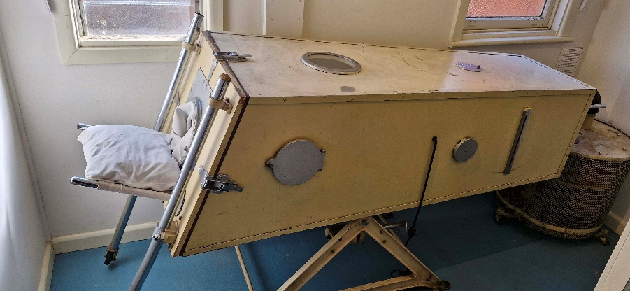
Both iron lung, made in Australia, c. 1950. Queanbeyan Museum collection.

Case study 32: Uluru climb chain, in the collection of the National Museum of Australia
Contributed by: Kate Morschel, Martha Sear, Rebecca Britt and Suzanne Gibson, Head and Senior Curators
Organisation: National Museum of Australia
Dated: March 2026
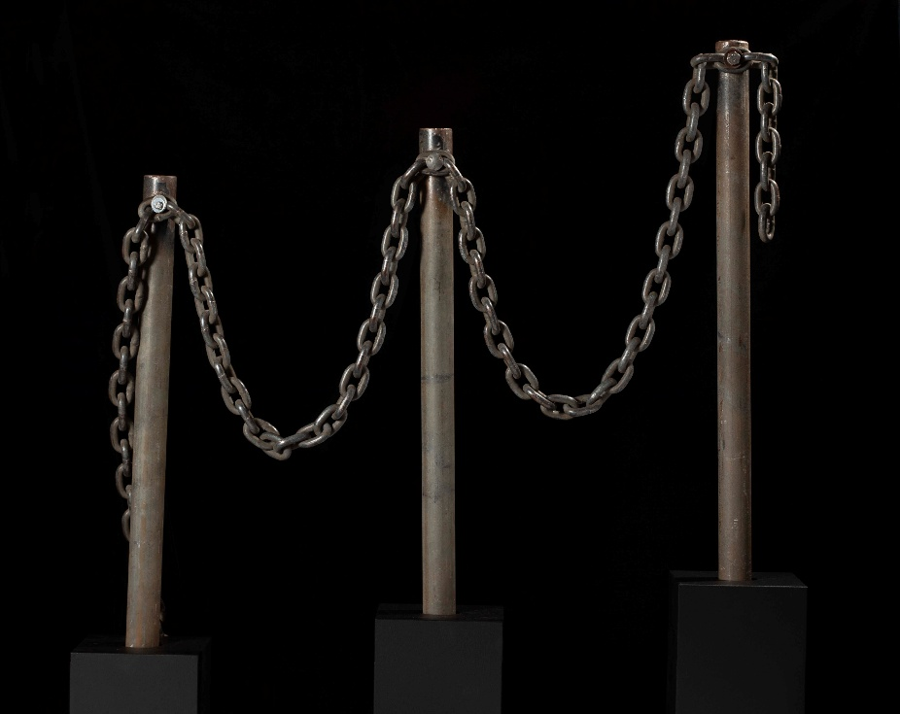
Section of the Uluṟu climb chain, in use 1966–2019. Donated by Parks Australia with approval of the Uluṟu-Kata Tjuṯa Board of Management. Photograph by Glen Goodwin, National Museum of Australia.

This section of chain and accompanying poles was used on the Uluru climb between 1966 and 2019 and embodies the long struggle for physical, cultural and narrative control of a place that is both the geographic and symbolic heart of Australia.
Uluru lies in Anangu Country, which stretches across the desert regions of present-day South Australia, the Northern Territory and Western Australia. For the Anangu people, Uluru is a deeply significant cultural and spiritual place understood and governed through Tjukurpa, the Law that binds Country, people, stories and obligations. Over deep time, Anangu cared for this Country according to Tjukurpa. However, in the colonial period it was removed from their control, renamed Ayers Rock, and over the 20th century, steadily absorbed into Australian identity as a symbol of the continent and its imagined ‘Red Heart.’
Uluru was represented in popular culture and tourism promotion, and for many non-Indigenous people, became connected to a sense of national identity. As tourism and safety concerns intensified, posts and chains were installed on Uluru in two stages in 1966 and 1976. The links on the section of chain held by the National Museum of Australia are worn smooth by the touch of millions of visitors, testimony of the immense popularity of climbing Uluru. Yet the climb conflicted deeply with Anangu Law as it followed the path taken by ancestral Mala men upon their arrival at Uluru. Anangu also carried a heavy burden from environmental damage and visitor injuries and deaths.
Throughout the late 20th century, Anangu petitioned state and federal governments for greater protection of the sites. In 1985, control of Uluru was returned to Anangu. Through joint management with Parks Australia, Anangu worked to shift visitor behaviour, installing signage and explaining why climbing violated Tjukurpa. Gradually, public understanding changed. By the 2010s, the proportion of visitors climbing dropped below 20 per cent, meeting the threshold for closure set by the Uluru–Kata Tjuṯa National Park Board of Management. On 26 October 2019, the climb was closed permanently. The removal of the chains and poles demonstrated the strength and sophistication of Anangu culture, the value of intercultural dialogue, and a national shift toward respecting First Nations authority over Country.
The acquisition of the Uluru climb chain by the National Museum of Australia was prompted by the development of the Museum’s permanent gallery, Great Southern Land, which opened in 2022. The acquisition was carried out through the Uluru–Kata Tjuṯa National Park Board of Management, the Central Land Council and Parks Australia, ensuring that the process was conducted in accordance with the appropriate legal and cultural authorities. Curators defined and researched the object’s physical attributes, provenance and historical context, and identified the Anangu knowledge holders and organisational partners with whom to build relationships.
Through this process, the National Museum of Australia has been able to situate the chain within Anangu knowledges and Tjukurpa, as well as within the broader contexts of tourism, land rights and joint management in the region. The chain has historical significance due to its role in national tourism history and connection to the political movements that led to the recognition of Indigenous land rights and custodianship in Australia. Foregrounding Anangu perspectives reveals its social and spiritual significance, with the chain representing the incompatibility of the climb with Anangu culture, and the authority and advocacy of Anangu in the management of their Country.
The significance of the Uluru climb chain is strengthened by its clear provenance and well documented transfer from the Board of Management. Displayed within the Great Southern Land gallery, the chain has great interpretive capacity. In addition to illuminating the history of Uluru, it embodies a transformation in Australian cultural values, documenting the transition from an era that celebrated the conquest of the landscape to one that increasingly recognises and honours the laws and custodianship of its First Peoples. It stands as a tangible record of the dynamic mix of historical, political and social forces that shape national iconography and identity, and a powerful tool for exploring contested landscapes, intercultural governance and the shifting community attitudes to sacred sites such as Uluru.

Case studies 33–37: Statements of significance on collections

Case study 33: The Red Rock Collection and Archive at the Western Australian Museum
Contributed by: Dr Melanie Piddocke, Director Culture and Communities, and Dr Ross Chadwick, Head of Anthropology and Archaeology
Organisation: Western Australian Museum
Dated: March 2026
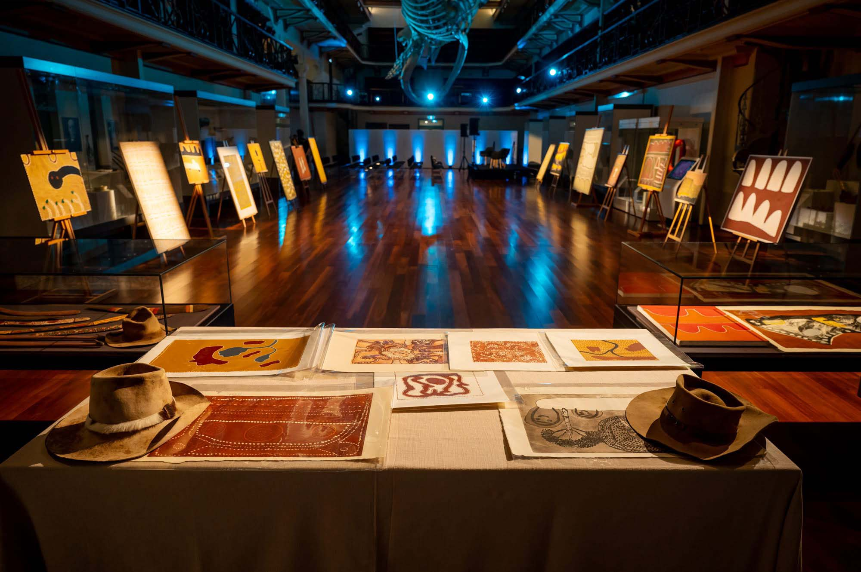
Selection of the Red Rock Collection on display in Hacket Hall, Western Australian Museum. Miles Noel Photography, 9 November 2023.

Background
The Red Rock Collection and Archive was acquired by the Western Australian Museum (WA Museum) in 2023 through a grant from the WA Museum’s Foundation and in consultation with its Aboriginal Advisory Committee. The Collection was assembled by Kevin and Jenny Kelly through the 1990s and 2000s in Kununurra, Western Australia. It includes over 130 individual items, including 31 canvas paintings, 12 painted wooden boards, 54 limited edition prints, 21 cultural objects, 5 dance boards, personal items – including 9 hats worn by a number of the artists – and an extensive archive including video recordings, still photographs and negatives.
The Kellys moved to the East Kimberley in 1992 when Kevin assumed the role of Exhibitions Coordinator at Waringarri Aboriginal Arts, where he later became the Art Centre Manager. In 1996, he established Red Rock Art Gallery in Kununurra, which provided a space for artists not represented by the Kimberley’s community arts centres. The Kellys built enduring relationships with many of the foundational artists of the East Kimberley art movement, allowing them to build a uniquely comprehensive collection capturing cultural renewal in the Kimberley from the late 1970s, as demonstrated by some of the period’s most influential artists.
The artists represented in the Collection are some of the most important and influential artists to have emerged from the East Kimberley in the 1970s and 1980s, including: Rover Thomas (1926–1998), Queenie McKenzie (circa 1915–1998), Alan Griffiths (1933–2018), Peter Skipper (1929–2007), Ginger Riley (circa 1936–2002), Jack Britten (1922–2002), Tiger Moore (born circa 1940) and Freddie Timms (1944–2017).

Statement of significance
The Red Rock Collection and Archive is of historical significance as it demonstrates the establishment and flourishing of East Kimberley art as a movement through the work of some of its most important artists. The breadth of the Collection also means the lives and identities of these artists outside of their art is well represented. This is evidenced by the collection of hats, which relate to the artists’ work and identity on cattle stations. The stockmen’s hats became a ubiquitous symbol of cattlemen, and many of the artists represented in the collection had worked on cattle stations, creating another layer of pride and identity. The archive enhances the historical significance of the Collection through its documentation of key events and the reestablishment of cultural practice leading to an affirmation of Aboriginal identity in the East Kimberley.
The East Kimberley art movement created a distinct visual identity which also served as a vehicle for historical memory and cultural assertion. It is significant for the way in which it blends ceremonial practice with a new painting tradition, depicting aerial views of Country, sites of significance and ancestral stories, while also confronting difficult histories of frontier violence, creating a form of historical testimony interwoven with spiritual expression. The movement is also significant for how it helped shift the reception of Aboriginal art internationally, with Rover Thomas and Trevor Nickolls becoming the first Aboriginal artists to represent Australia at the Venice Biennale in 1990.
As a demonstration of the work of foundational East Kimberley artists, this Collection has clear artistic significance, representing artists both at the peak of their practice and throughout their careers. It exemplifies the characteristics of East Kimberley art with an emphasis on natural earth pigments applied in large blocks of solid colour.
The Collection has research significance for its documentation, both through art and archival records, of cultural practice and stories, including the Aboriginal cosmology of the East Kimberley. It is of research significance to those studying the history, careers and practice of the key figures of this art movement. The archive provides rich evidence of ceremonies, important events, and the personal experiences and knowledge of the artists which, when combined with the works of art and cultural items, provides unusually comprehensive documentation of this key period in the growth of art and cultural expression in the East Kimberley.
The Red Rock Collection captures important stories through art, archival records and objects, as highlighted by 10 boards recording the Gurirr Gurirr ceremony. The Gurirr Gurirr ceremony was revealed to Rover Thomas in a series of dreams following Cyclone Tracy. Many of the movement’s foundational artists participated in the ceremony and it became the direct catalyst for the development of the movement. Much of its subject matter relates directly to ongoing belief in the Ngarranggarri (Dreaming), and therefore the collection as a whole is of cultural, social and spiritual significance. These stories would likely be of particular social and spiritual significance for Wangkajunga, Kukatja, Jaru, Gija, Miriwoong and Gadjerong language groups but there would be some significance for communities more broadly as an example of cultural revitalisation.
The provenance of the Collection is impeccable, with the works of art and objects sourced directly and ethically from the artists themselves, and this is supported by documentation in the archive. There are many aspects of the Collection which could be considered rare, particularly elements of the archive, including the only audiovisual record of the handover ceremony of the first land claim in the Kimberley to be determined by consent in 2001. As a collection, the artworks are representative of the East Kimberley art movement and each artist's unique style and approach. The works of art and archival material are in good condition, and the Collection can be seen as an unusually complete representation of art, culture, life and individual creative expression in the East Kimberley.
The richness and breadth of the Collection, and the depth of archival material that complements the artworks, give the Collection unusually strong interpretive capacity. This allows the Collection to be interpreted not simply as an aesthetically pleasing assemblage, but also as a pathway to understanding the culture, stories and individuals who produced it.
The WA Museum’s Aboriginal cultural collections have historically been focused on objects connected to traditional lifeways but more recently have included contemporary expressions of cultural identity. Works of art allow sharing and recording of stories that are often difficult to represent in a single object. The Red Rock Collection offers a means by which to reflect important experiences and representations of Country and documents the emergence of an important economic and cultural activity for Aboriginal people in the East Kimberley.
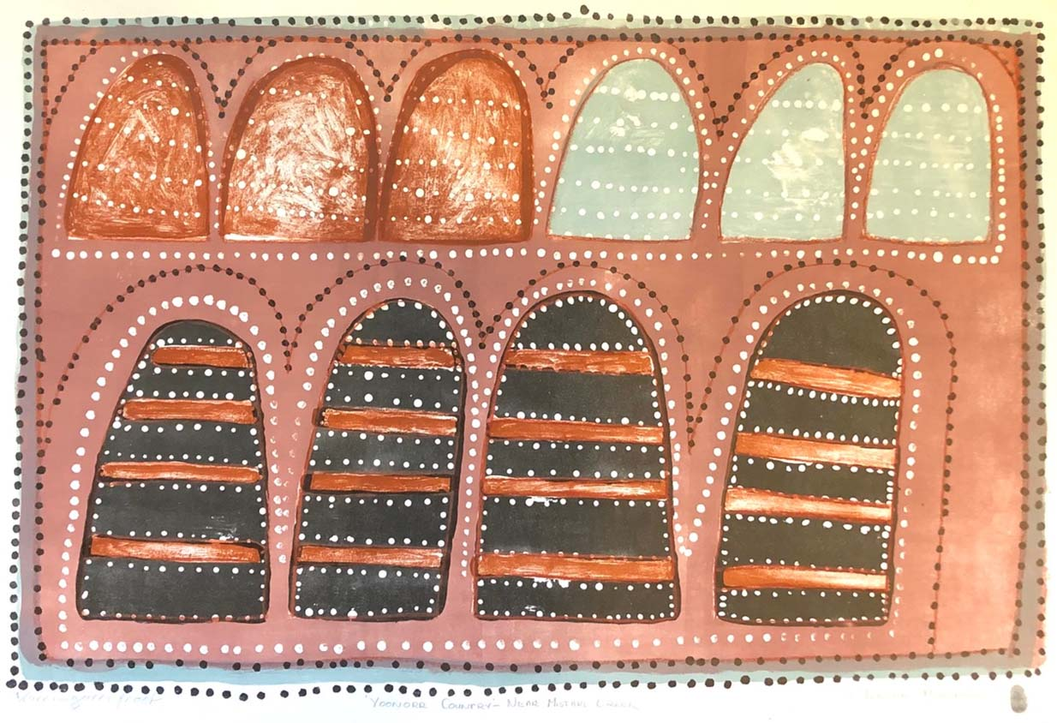
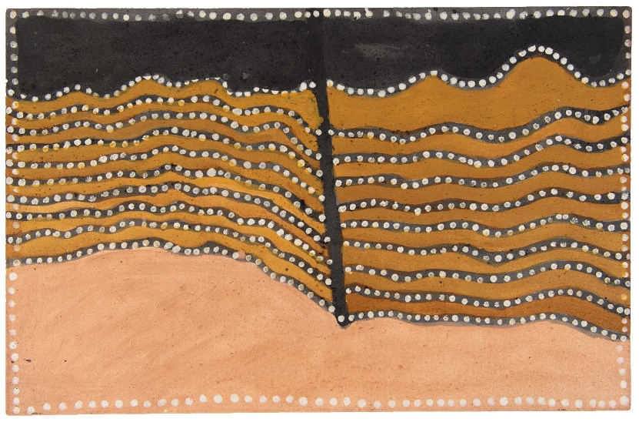
Above: Waringarri proof Yoonoor Country – Near Mistake Creek, Queenie McKenzie, 1995, offset lithograph, 76 x 110 cm. Red Rock Collection, Western Australian Museum.
Below: Ribbon Rock Country, Jack Britten, 2002, natural (Kimberley) ochres and binder on canvas, 45 x 70 cm. Red Rock Collection, Western Australian Museum.

Case study 34: The Stencil Collection at Miss Porter’s House in Newcastle, New South Wales
Contributed by: Marion Bannister, Miss Porter’s House Volunteer for collection documentation and conservation, and Pam Marley, Miss Porter’s House Volunteer for research and documenting the collection
Organisation: Miss Porter’s House (National Trust, NSW)
Dated: February 2026
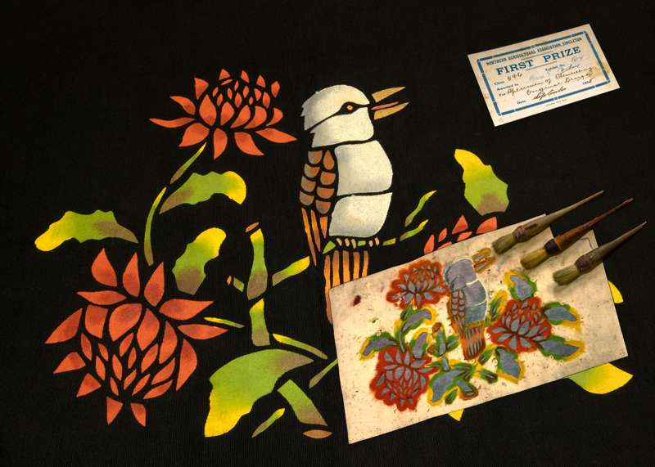
Kookaburra and waratahs, created by Miss Ella Porter, c. 1930s, black grosgrain fabric and stencilling inks, wood and cotton string brushes and cardboard (certificate). From the collection of Miss Porter’s House – National Trust of Australia (NSW). Courtesy: National Trust of Australia (NSW). Photograph: Edward Lovelock.

Miss Porter’s House (MPH) at 434 King St, Newcastle, was bequeathed to the National Trust in 1997. Holding over 1,980 items of documentary and significantly more movable heritage items spanning the period 1910 to 1997, MPH provides a living snapshot of women’s lives in 20th-century Newcastle. An important part of the collection is the MPH Stencil Collection. It includes 16 pieces of stencilled fabric (cushion covers, doilies and several unfinished items of fabric), 38 cardboard cut stencils, 6 wooden handled brushes used to apply paint and 24 agricultural show certificates relating to this material.
Following the death of Herbert Porter in 1919, his widow, Florence, and daughters, Ella and Hazel, lived in the house until their deaths. All 3 Porter women were skilled craftspeople, creating beautiful hand-made items for their Newcastle terrace house, for themselves and as gifts for their friends. Hundreds of these knitted, crocheted and sewn items are in the MPH collection.
Florence was a highly skilled crochet lace worker, and Ella was a talented basket maker. Both had winning entries in agricultural shows. However, Ella was a particularly talented stencil artist and highly skilled in applying colour gradients. Between 1935 and 1944, Ella won 24 prizes in agricultural shows, 18 for her original designs. Because the kookaburra and waratah fabric (pictured) was originally mounted on cardboard, it was probably an entry in one of the agricultural shows.
Ella’s stencil designs include only one with a distinctly Australian theme: a kookaburra and waratah design (pictured). The rest are predominantly floral arrangements such as water lilies, roses and what appears to be a favourite: poinsettias. There are 2 stencils of Dolly Varden figures and several Egyptian scenes of a camel and stylised palm trees and pyramids. The finished works are brightly coloured and aesthetically pleasing.
The cardboard stencils appear to be a mixture of Ella’s original and purchased designs. Creating and using stencils and paint to decorate clothing, pillows, tablecloths and other household items was popular in the early 20th century, particularly in the 1930s and 1940s when the Great Depression and Second World War meant material goods were less available or unaffordable. Magazines such as the Australian Women’s Weekly and many newspaper columns offered stencil designs, with suggestions for paint colours and techniques. Equipment and kits were available from local firms and the Anthony Hordern & Sons department store and its early 1920s mail order catalogues.
The overall MPH craft and clothing collection, including the Stencil Collection, illustrates fashions, skills and a range of women’s domestic crafts of the early to mid-20th century. It is therefore of historical significance as a rare representation of women’s lives in Australia during this period, with strong interpretive capacity. The Stencil Collection is a rare example of this type of craft from this period. In the significance assessment of the MPH collection conducted in 2021 with the support of the Community Heritage Grants program, independent assessor Roslyn Russell noted:
The [stencil] collection is a rarity and we [the assessors] see the stencil collection as a key component of the craft theme that is such a significant feature of the MPH collection. We couldn't find any other examples in other collections either. As far as the stencil cutouts themselves go, most people would have discarded them after use so they can be categorised as rare survivors. The whole ensemble of cardboard stencils, stencilled fabric and show certificates has a high degree of integrity.
The MPH Stencil Collection is part of the broader MPH documentary heritage collection, which has recognised national significance as it has been inscribed on the UNESCO Australian Memory of the World Register since 2023. The MPH inscription features an image of the kookaburra and waratah stencil, brushes and certificate from the Stencil Collection. The inscription notes that ‘… the collection in its entirety is rare because it captures the lives of the Porter family, to a degree that is seldom seen in documentary collections relating to women…[and] is historically significant because it sheds light on women’s lives at a period of social change.’(UNESCO Australian Memory of the World Register 2023).
The MPH Stencil Collection is also in very good condition. The cardboard stencils have undergone professional conservation as many were discoloured, weakened and some broken; fortunately, the missing pieces were located and rejoined. Conservation of several fabric pieces has markedly improved their appearance.
References
- Roslyn Russell Museum Services (2021) Miss Porter’s House, Newcastle: Significance Assessment of the Collection, Addenda, Canberra [Russell R and Douglas L].
- UNESCO Australian Memory of the World Register (2023) Miss Porter’s House Documentary Heritage Collection 1910-1997, [inscription #86], www.amw.org.au/register/listings/miss-porter’s-house-documentary-heritage-collection-1910-1997.

Case study 35: Nancy Bentley Collection at the Tasmanian Museum and Art Gallery
Contributed by: Dr Jody Steele, Head of Cultural Heritage
Organisation: Tasmanian Museum and Art Gallery
Dated: 22 January 2026
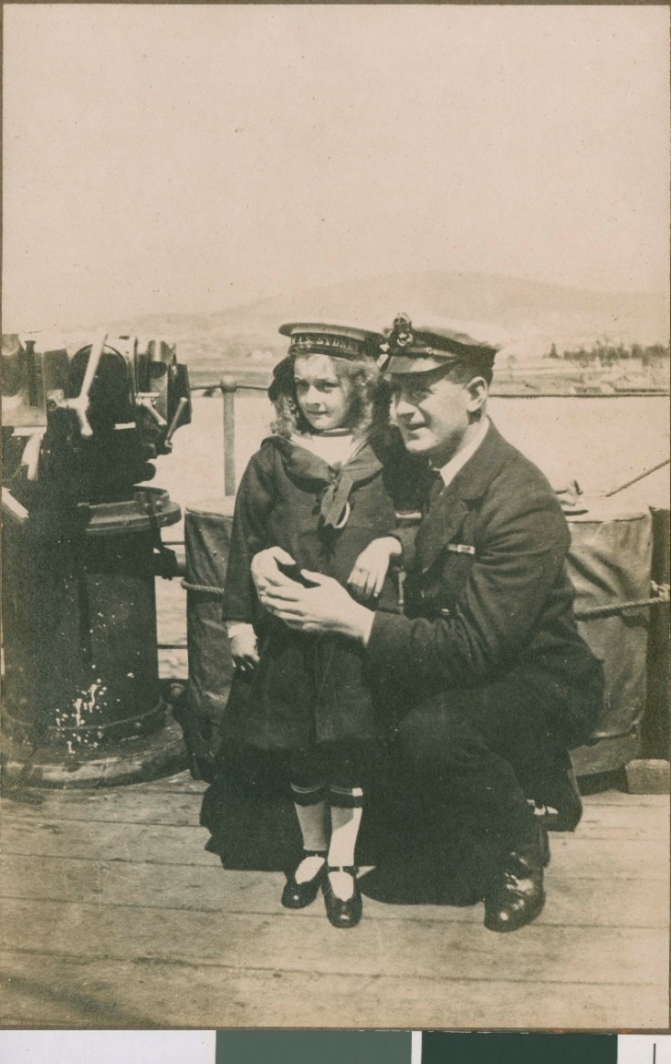
Nancy Bentley, aged 6 with naval officer on HMAS Sydney, photographic print. Tasmanian Museum and Art Gallery (Q2011.18).

Background
The Tasmanian Museum and Art Gallery holds a modest selection of 15 items known as the Nancy Bentley Collection: a sailor’s cap, 2 badges, 3 photographs, and 9 documents. Together they tell the unique story of the Royal Australian Navy’s ‘first lady.’
The Nancy Bentley Collection has historical significance due to its connection to a specific incident. At just 6 years of age, Tasmanian Nancy Bentley (1914–1999) became the first female enlisted in the Royal Australian Navy (RAN). In November 1920, after Nancy was bitten by a snake at Port Arthur, her father rowed her to the RAN warship HMAS Sydney (I) that was anchored nearby, seeking medical treatment in the absence of a local doctor. The ship’s officers enlisted her for 8 days while she underwent treatment, discharging her with her own sailor’s cap, service record and medical history sheet. The story of Nancy’s scrape with death and her treatment on the vessel was reported nationwide.
The Collection has social significance because Nancy’s story remains embedded in the narrative of HMAS Sydney (I) and the wider RAN. The collection demonstrates recognition of the early history of women in the RAN and community memory building. The contemporary practice of awarding the First Lady of the Fleet Trophy to the longest-serving commissioned vessel in the RAN preserves Nancy’s legacy as the Navy’s ‘first lady.’ First presented to HMAS Darwin in 2017, the trophy is traditionally handed to the youngest person on board, paying homage to Nancy’s youth. For more information, refer to: https://www.navy.gov.au/about-navy/history/customs-traditions/first-lady-fleet-trophy.
The items have a firm provenance. They were donated by Nancy Bentley’s family and relate to her medical treatment aboard HMAS Sydney, her brief enlistment and the later recognition of the young Tasmanian’s place in Australian naval history.
The collection is rare and in fair to good condition. Nancy was the first female enlisted in the RAN and Nancy’s service and medical records contain non-standard entries created to work around naval regulations restricting treatment on board to enlisted personnel only.

Statement of Significance
The Nancy Bentley Collection has historical and social significance because it represents a rare and well-documented moment in Australian naval history, capturing the extraordinary circumstances that led to 6-year-old Nancy Bentley becoming the first female enlisted in the Royal Australian Navy (RAN). The items illustrate the challenges of remote life in 1920s Tasmania and the compassion shown by the crew of HMAS Sydney when they brought Nancy aboard for lifesaving treatment. Her service record, medical documentation and the improvised naval paperwork created to legitimise her care provide an unusually detailed insight into naval practice of the era and preserve a part of RAN history. The Collection’s social relevance to the contemporary RAN is strengthened through the ongoing tradition of the First Lady of the Fleet Trophy, which symbolically acknowledges Nancy’s place in naval history and ensures her story continues to be recognised within the service
The collection’s strong provenance, rarity, condition and completeness reinforce its significance, while its interpretive capacity to illuminate both the human and institutional dimensions of the story makes it a powerful resource for exhibitions and education. Together, the items offer a fascinating lens through which to explore service, community and gender, as well as the evolving identity and values of the Royal Australian Navy across time.
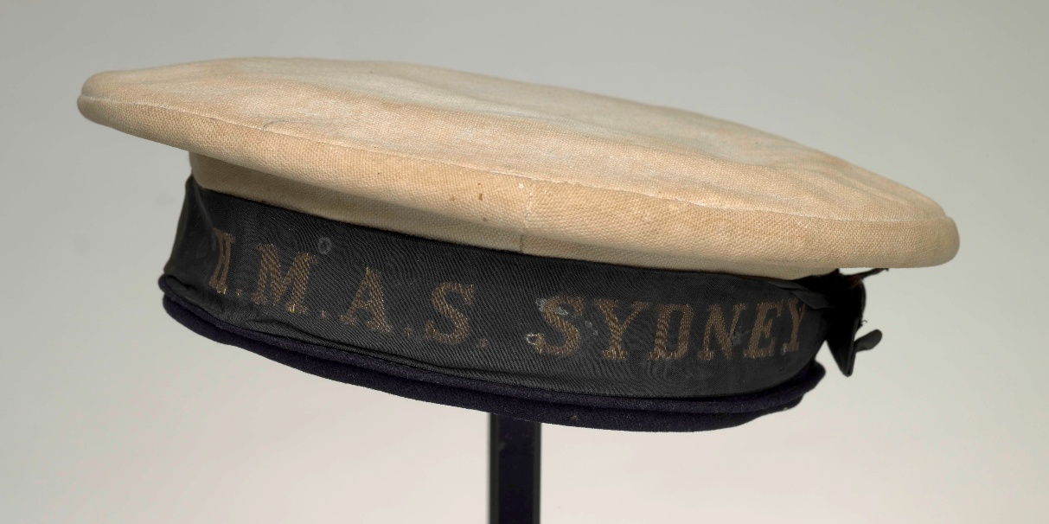
Sailor cap, navy blue and white sailor's hat, no brim, with the words ‘HMAS Sydney.’ Tasmanian Museum and Art Gallery (S2011.19).

Case study 36: Australian responses to COVID-19 oral history project, National Library of Australia
Contributed by: Rowan Henderson, Assistant Director, Curatorial & Collection Research
Organisation: National Library of Australia
Dated: January 2026

Margaret Wheeler greeting her granddaughter Alice Sarah-Lay through a window at the Trentham Aged Care Facility due to COVID-19 restrictions, photograph by Sandy Scheltema. Trentham, Victoria, 26 May 2020. Collection of the National Library of Australia (http://nla.gov.au/nla.obj-2931859303).

The global outbreak of COVID-19 resulted in a public health emergency on a scale not seen since the 1918-1920 influenza pandemic. The virus was first identified in December 2019, and the first Australian case was recorded in January 2020. Across the years that followed, COVID-19 significantly impacted social, environmental, economic, digital and political landscapes in Australia and around the globe. The National Library of Australia’s COVID-19 oral history project recorded 262 oral history interviews to document the impacts of the COVID-19 pandemic on Australian lives and society. The collection is of national historical and research significance as it documents the role of the COVID-19 pandemic in changing the course of national and international history from the perspective of both response leaders and the broader community.
The interviews reflect the geographic and demographic diversity of the Australian population, along with the varied range of experiences and views on the pandemic held by the community. The collection includes interviews with those in significant leadership positions who were responsible for major decisions during the pandemic such as the former prime minister, former and current premiers and chief ministers, and individuals who were tasked with providing expert advice, including chief medical officers and leading researchers. It also contains interviews with members of the wider community, reflecting their everyday experiences during this period, as well as their broader life stories, enhancing the historical, research, cultural and social significance of the collection.
The National Library’s careful selection of interviewees for the project means that the collection is representative of diverse Australian pandemic experiences. Interviewees included First Nations Australians, Australians from 28 different cultural backgrounds, Australians who lived within Australia and abroad during the pandemic, people from all Australian states and territories, people from urban, rural and remote locations in Australia, Australians aged between 18 and 80, people who identify as male, female, gender-fluid or non-binary, members of the LGBTIQA+communities, and people who live with a disability or are immunocompromised. Major themes explored in the project include time, health and wellbeing, homes and housing, managing everyday life, work and education, impact of public health restrictions, relationships, emotions and public spaces, within the context of the pandemic. Several interviewees were minors at the time and were therefore able to speak to the experiences of high school students during the pandemic. Diverse views were recorded on a range of issues related to medical and public health interventions and responses.
The significance of the collection is enhanced by the timing of the project. The interviews were recorded between 2024 and 2025, at a time when the height of the crisis was recent enough for memories to remain clear for interviewees, but after the substantive rollout of a vaccination program had seen a significant shift in the management of the pandemic. Meanwhile, the continued medical, social, economic and political impacts of the virus meant that Australian responses to COVID-19 were ongoing.
This collection of whole-of-life interviews is a significant addition to the National Library of Australia’s oral history collection, which now comprises more than 58,000 hours of digital audio recorded since the 1950s. It preserves vital information about both the ‘behind-the-scenes’ context of major decisions, as well as moments of everyday life and experiences during this historically important period in Australia and the world. The collection possesses research significance as a resource detailing Australia’s political, medical and social responses to COVID-19, including for researchers investigating responses to future public health crises such as pandemics. The well-provenanced Australian responses to COVID-19 oral history project is the largest and most complete project of its kind to date in Australia, with no comparable oral history collection reflecting the diversity of experiences captured.
Australian responses to COVID-19 oral history project, 2024–2025
Sound recordings
262 oral history interviews
ORAL TRC 7490 – https://catalogue.nla.gov.au/catalog/10018006
National Library of Australia

Case study 37: Papers of Jeremy Beckett, in the collection of the Australian Institute of Aboriginal and Torres Strait Islander Studies
Contributed by: Dr Sara Tomkins, Acting Executive Director, Collections Services Group, and Lisa Smith, Director, Collection Management
Organisation: Australian Institute of Aboriginal and Torres Strait Islander Studies
Dated: May 2026
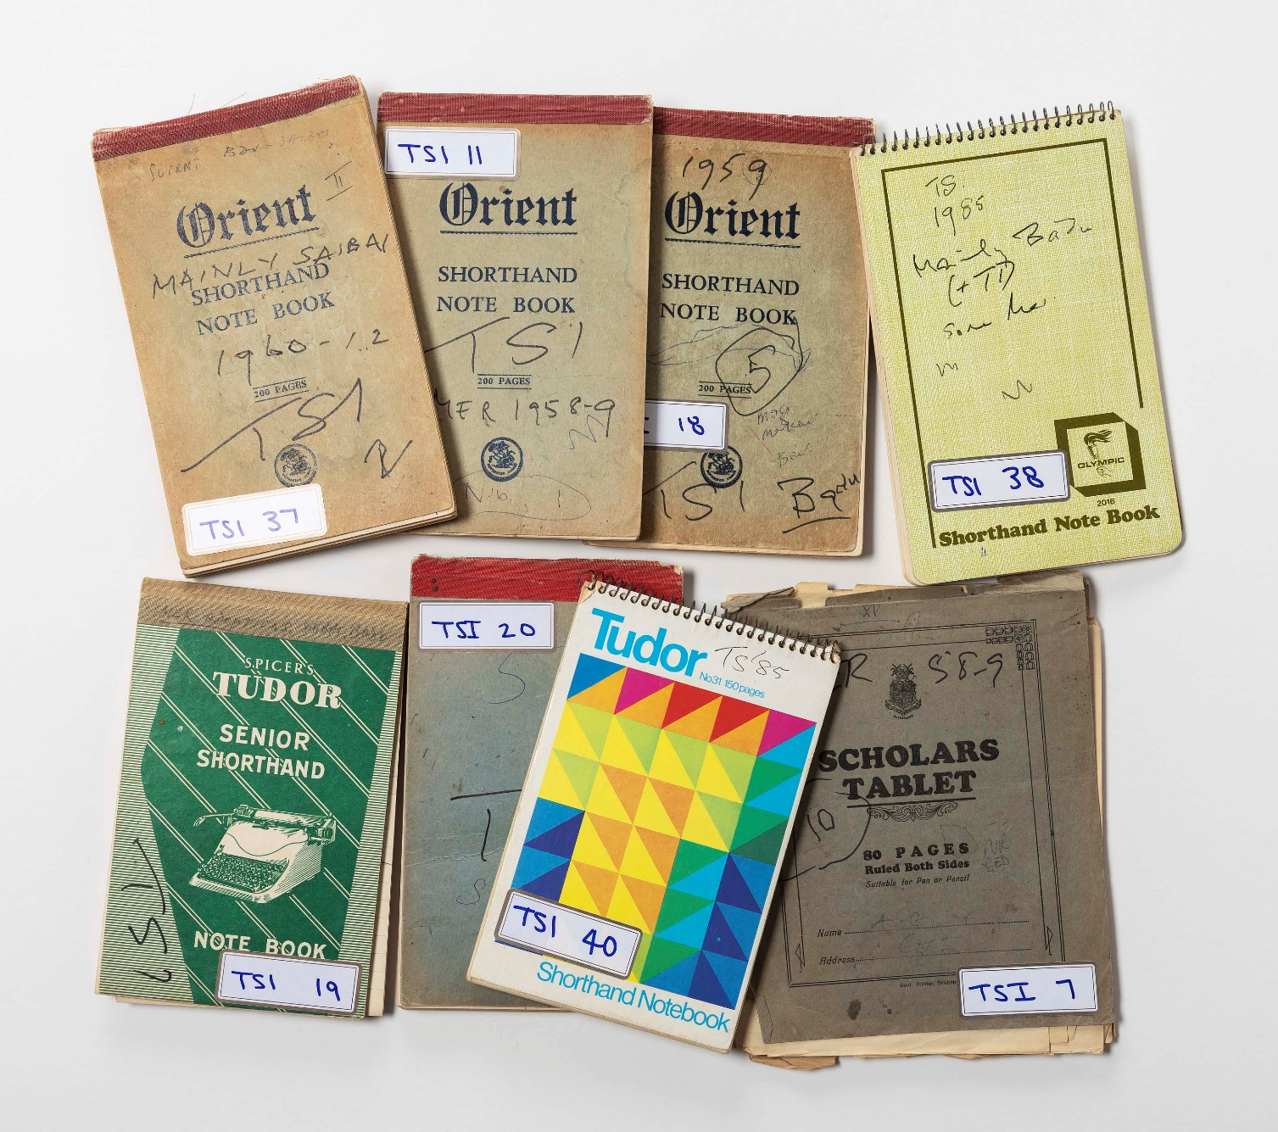
Diaries from the Papers of Jeremy Beckett collection (MS 5363) held at the Australian Institute of Aboriginal and Torres Strait Islander Studies (AIATSIS). Photograph courtesy of AIATSIS.

Emeritus Professor Jeremy Beckett’s (1931–2022) extensive collection of papers document over 50 years of his research with Aboriginal and Torres Strait Islander peoples. Donated to the Australian Institute of Aboriginal and Torres Strait Islander Studies (AIATSIS) in 2023, it comprises 76 diaries written by the anthropologist during his extended periods of fieldwork in western New South Wales and the Torres Strait between 1958 and 2008.
As a non-Indigenous anthropologist, Beckett spent periods living with the Wangaaypuwan, Barkindji and Ngempa peoples from New South Wales, and Meriam Mer and Kala Lagaw Ya language groups from the Torres Strait. In that time, he developed enduring relationships within these communities. The significance of these papers is centred on the rich cultural knowledge many Aboriginal and Torres Strait Islander people shared with Beckett in active efforts to document their cultural connections, identity and continuity. It is through this lens that the shared provenance between researcher and communities as well as the rarity of this collection can be understood.
The collection is of exceptional cultural, historical and research significance, representing one of the most sustained and influential bodies of anthropological field research in Australia. The diaries include observations and descriptions of cultural practices, language, kinship systems, music, and everyday social and political life as well as community understanding of and attitudes towards administrative authorities. These materials were developed in a context of profound social, political, economic and legal change for the communities involved. As a longitudinal archive, the collection also provides insight into the academic discipline of anthropology, the evolving role of non-Indigenous researchers in this space and the documentation of knowledge at the cultural interface.
The body of research captured in his diaries underpins Beckett’s major scholarly contributions, including his MA thesis A Study of Aborigines in the Pastoral West of New South Wales (1958; republished 2005), his PhD thesis Politics in the Torres Straits Islands (1963), and his influential book Torres Strait Islanders: Custom and Colonialism (1987).
The significance of Beckett’s work in the Torres Strait is evident in its contribution to the landmark 1992 Murray Island Land Case (known as ‘the Mabo decision’) and the 2009 Torres Strait Sea Rights case, in which he acted as an expert witness. In these contexts, the collection is situated at the intersection of cultural documentation and social justice. Several diaries document Beckett’s work in the Torres Strait including Mer (Murray Island), Badu (Mulgrave Island), Saibai, Erub (Darnley Island) and Waiben (Thursday Island). Key community knowledge holders shared culturally significant information with Beckett on a range of topics including marriage, adoption and inheritance practices, morality law, language, stories and local politics. These notebooks have demonstrable national significance through their contribution to Indigenous rights outcomes.
The collection holds strong social, cultural and personal significance for the Aboriginal and Torres Strait Islander communities whose knowledge it contains. It offers detailed records of cultural identity, genealogy, and place-based knowledge that have the potential to support cultural revitalisation, intergenerational knowledge transmission and community-led research.
The significance of the collection can only be fully realised through culturally appropriate stewardship. The culturally specific and potentially sensitive knowledge within the diaries requires administration that is informed by consultation with knowledge holders, respect for cultural authority, and access processes grounded in Indigenous Cultural and Intellectual Property. Through these practices, they become a resource for contemporary truth-telling.

Case studies 38–40: Significance-informed collecting and collection management projects

Case study 38: Project to recover digital artworks at the State Library of South Australia
Contributed by: Kimberley Dye, Acting Manager, Archival Collections
Organisation: State Library of South Australia
Dated: May 2026

PRG919_107_504_Newton5c, An example of Stan Ostoja-Kotkowski’s pioneering digital artworks, recovered from obsolete 3.5-inch floppy disks at the State Library of South Australia. Ostoja-Kotkowski, S. (1992) Newton5c. Digital artwork, PRG 919/107/503/NEWTON5C. Adelaide: State Library of South Australia. https://collections.slsa.sa.gov.au/resource/PRG+919/107/503/NEWTON5C.

This case study demonstrates how significance assessment must respond to born‑digital complexity, recognising that technical decisions are tied to cultural meaning and that preservation can generate new knowledge about artistic practice.
The State Library of South Australia (SLSA) holds an extensive archive relating to the life and practice of Joseph Stanisław (Stan) Ostoja‑Kotkowski (1922–1994), a pioneering Australian artist of historical, artistic and technical significance.
Ostoja-Kotkowski was renowned for his innovation in chromasonics, laser kinetics and sound-image productions (experimental practices that used sound, light, colour and laser technology to create visual and performative works). He sustained a diverse interdisciplinary practice spanning painting, photography, theatre design, sculpture, stained glass and computer-based media, which situated his early digital work as a continuation of his engagement with light, sound and computation. The importance of the Ostoja-Kotkowski archive was formally recognised in 2008 through its inscription on the UNESCO Australian Memory of the World Register, which aims to recognise documentary heritage of significance for Australia and the world and advocate for its preservation. The listing is available at: https://www.amw.org.au/register/listings/archives-joseph-stanislaus-ostoja-kotkowski.
A fragile component of this archive comprises approximately 900 3.5-inch floppy disks created between the late 1980s and early 1990s, containing digital artworks, software and related working files. An obsolete format, the disks are of historical significance as evidence of early Australian digital art practice and its technological context and of artistic significance as part of Ostoja‑Kotkowski’s oeuvre. The material also has strong research significance, offering insight into artistic processes and constitutes a rare, representative record of late 20th-century digital art practice in Australia.
By the time active preservation had commenced, the disks were at high risk due to magnetic media degradation and hardware and software obsolescence. Their rarity and vulnerability reinforced the need for a preservation approach that conserved content and context. The project sought to preserve and enable access to the artworks while retaining evidence of provenance and original operating condition.
Planning began in 2017–18, followed by disk imaging in 2020 using specialised legacy hardware and software. Rather than extracting individual files, the SLSA created complete disk images to preserve each disk. These disk images now function as the primary preservation objects, supporting data integrity, future access and reinterpretation as knowledge and tools evolve.
Preservation and access workflows proved technically and interpretively complex. Early manual extraction risked misrepresenting the works, including distortions caused by misinterpretation of RISC OS (the operating system used by the original hardware on which the artworks were created) rectangular pixels. In response, the SLSA developed automated workflows using open‑source tools and custom scripts to extract files, migrate formats and capture detailed technical metadata.
A critical interpretive challenge emerged when migrated images displayed dramatic colour shifts. Comparison with photographic slides of Ostoja‑Kotkowski’s computer monitor, held elsewhere in the archive, demonstrated that these differences reflected artist‑defined palettes and screen modes embedded within the files. This evidence revealed that screen modes and colour palettes were being incorrectly interpreted during migration and informed the development of revised scripts and workflows that more accurately reproduced the artist's intended visual presentation. The documentation associated with this strengthened the collection’s provenance and supported informed preservation decisions grounded in the artist’s working methods.
The project resulted in the recovery and preservation of digital artworks and associated files, each supported by descriptive and technical metadata. It also generated new knowledge about Ostoja‑Kotkowski’s evolving digital practice, revealing that some files functioned as software or reference material rather than as finished artworks. With the additional information gathered through this project, the collection has strong interpretive capacity, as the digital material can be presented alongside related analogue documentation to communicate both the artworks and the conditions of their creation.

Case study 39: The Sandra Greentree Nicolaides Collection of performance art works, in the collection of Flinders University Museum of Art
Contributed by: Fiona Salmon, Director
Organisation: Flinders University Museum of Art
Dated: May 2026
Research underpinning this Significance Assessment was undertaken by Sasha Grbich, whose contributions informed the contextual analysis and documentation of the Sandra Greentree Nicolaides Collection.

Summary Statement of Significance
Born in England in 1945, Sandra Greentree Nicolaides was a graduate of the South Australian School of Art and an active participant in Adelaide’s experimental art scene in the late 1970s and early 1980s. She made a notable contribution to the emergence of conceptual and performance-based artistic practice in Australia. Working at a time when artists were critically reassessing the intersections of art, politics, gender, ecology and everyday life, Nicolaides developed a body of work that expanded the possibilities of performance as a medium. Her practice is marked by conceptual clarity, formal experimentation and an acute engagement with the social conditions of the period.
Greentree Nicolaides’s performances captured in the collection adopt theatrical and ritualised structures derived from domestic and institutional settings. Through these staged environments – where dining tables tilt, meals become unmanageable and bodies are constrained or submerged – her work exposes tensions within contemporary political culture. These scenarios function as distilled visual metaphors for environmental degradation, class relations and systems of authority, illustrating how performance can operate as a site of critical reflection and political agency.
Although aligned with international developments in feminist and conceptual performance, Greentree Nicolaides’s work remains distinctly shaped by the cultural and political climate of Dunstan-era South Australia. Her involvement with the Experimental Art Foundation, the Women’s Art Movement (Adelaide), the South Australian School of Art and Artlink underscores a rigorous, research-driven approach.

Primary criteria
The Sandra Greentree Nicolaides Collection held by Flinders University Museum of Art (FUMA) comprises 18 works of performance art recorded in various film and video formats. The collection has historical, artistic and research significance as a record of conceptually driven performance practice emerging from Adelaide’s experimental art scene in the late 1970s and early 1980s. Created at a pivotal moment in Australian time-based and performance art history, the works mark a shift from object-based production toward an emphasis on process, embodiment and critical inquiry. They demonstrate innovative and rigorous use of performance as a primary medium, contributing to the development of contemporary art in Australia.

Comparative criteria
The collection is rare and cohesive. Acquired directly from the artist’s personal archive, it has strong provenance, ensuring authenticity and contextual integrity. Time-based media presents conservation and access challenges. However, FUMA is committed to ensuring the ongoing preservation of the collection. This is because the collection aligns closely with FUMA’s focus on early conceptual and performance-based practices and was shaped by leading theorist Donald Brook (1927–2018), former Emeritus Professor of Visual Arts at Flinders University and critic for The Sydney Morning Herald and Nation Review. The collection addresses the ongoing under-representation of women artists from this period, both within FUMA and nationally. It also highlights how significant artistic contributions may occur outside long or continuous careers – particularly for women, who often experience interrupted work lives. These qualities enhance the collection’s interpretive capacity and position it as a vital resource for future scholarship, exhibition and teaching.
As the only comprehensive institutional record of her performance practice, the rarity and provenance of the collection contribute to its historical, artistic and research significance. It holds exceptional interpretive capacity, enriching understanding of a pivotal moment in Australian art history while addressing the broader under-representation of women artists within national collections.

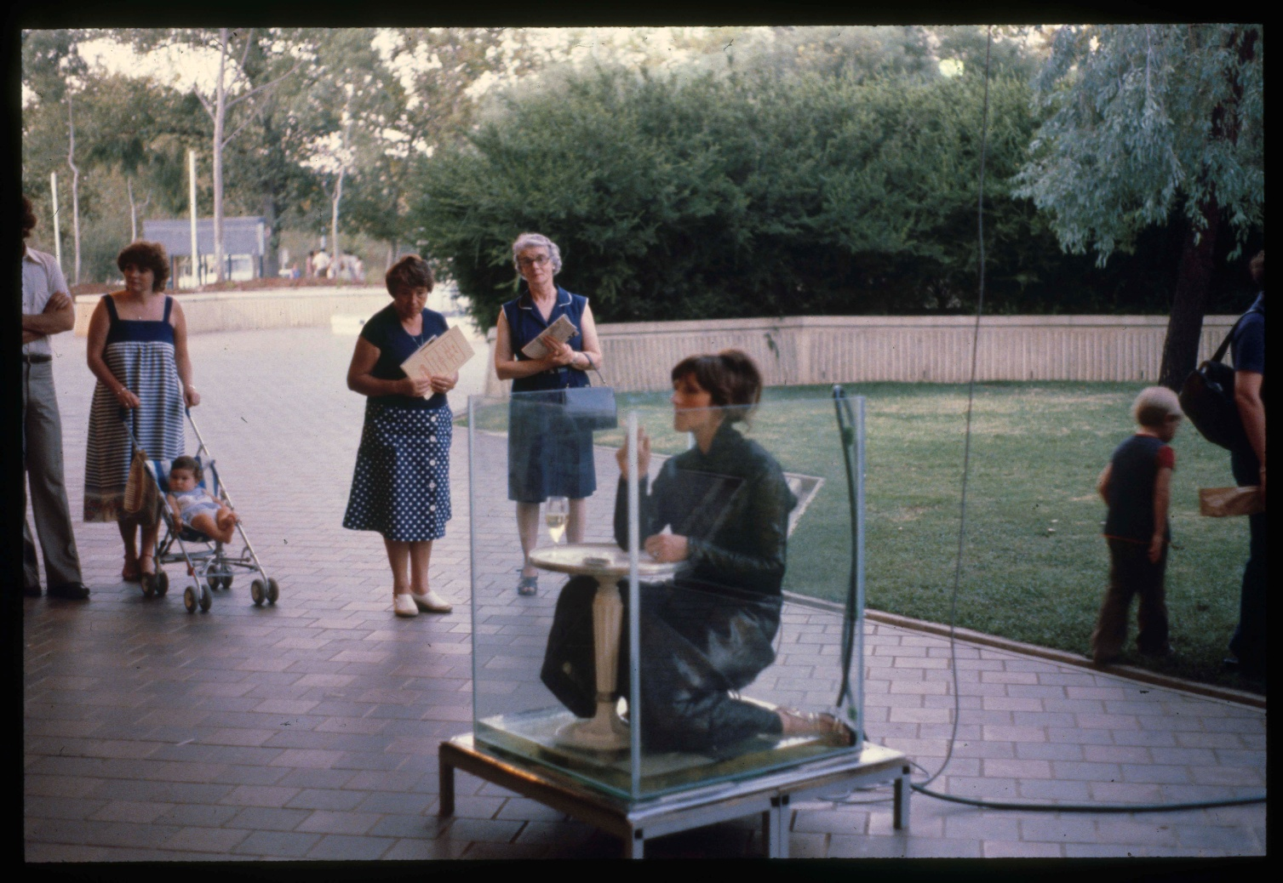
Up To Our Necks by Sandra Greentree Nicolaides, 1980. Colour photograph documenting performance, Adelaide Festival Centre, Experimental Art Foundation Performance Week, March 1980. Photographer unknown. State Library of South Australia, Women’s Art Movement Slide Registry (SRG 850/97/3283). Image courtesy of the State Library of South Australia. © the artist.

Case study 40: 177 Nations of Tasmania, in the collection of the State Library and Archives of Tasmania
Contributed by: Ross Latham, Director Collections and State Archivist
Organisation: State Library and Archives of Tasmania
Dated: August 2026
The collection of the State Library and Archives of Tasmania includes the records of enduring value created by government in Tasmania (government archives) and the documentary heritage of the Tasmanian community (community archives).
Recognising that the community archives are incomplete without the perspectives, voices, and stories of the broad range of people and communities they are intended to represent, the collecting focus for the community archives has been refined. It now aims to better reflect the diversity of the state by including the stories and achievements of Tasmanians from diverse backgrounds, and by safely and respectfully elevating marginalised voices. As part of this process, the State Library and Archives of Tasmania also shifted its collecting focus to include contemporary and born-digital content.
In 2025, an opportunity arose to significantly broaden the cultural and linguistic scope of the community archives in response to a contemporary multimedia exhibition by Mark Thomson and Andrew Wilson called 177 Nations of Tasmania. The exhibition project started in 2020 as a podcast exploring Tasmania’s diverse migrant communities and evolved into a living exhibition of photographic portraits and oral histories. Thomson and Wilson were inspired by 2016 Australian Census data, which revealed that people of 177 nationalities were living in Tasmania. The exhibition developed as people shared their stories and lived experience as neighbours, colleagues, parents and community members.
People representing these 177 nationalities were encouraged to participate via social and local mainstream media as well as community networks. When sharing their stories, they were welcome to bring an item of clothing from their homeland, as well as an object of personal significance, to their oral history interview and photography sessions. The resulting recordings and photographic imagery of the 90 people who have participated so far present personal histories, rich in culture and spirituality. Viewed together, this material provides a powerful insight into the diversity of Tasmania in the 21st century and the lives and backgrounds of the many people for whom Tasmania is now home.
The project brings together material of historical, cultural and social significance to Tasmanians, particularly those from migrant communities. Its presentation also has creative significance. The material has documented provenance, and the overall exhibition is representative of contemporary Australia and has extensive interpretive capacity. The project is also rare because it is the first of its scope and scale completed in Tasmania.
The State Library and Archives of Tasmania identified 177 Nations of Tasmania for acquisition via a negotiated purchase, due to the significance of the material and its alignment with the collection focus. After reaching agreement with the creators to acquire much of this content, the State Library and Archives of Tasmania identified and responded to the ethical and cultural issues associated with acquiring, managing and providing access to this culturally rich digital material.
As the creators had obtained and documented the consent of the participants for their stories and images to be kept and shared, this mainly involved determining how much of the oral history content created should be acquired to adequately capture the histories, social expression and learning from each person’s story, as well as how many of the images were needed to capture the essence of the original project and honour the contribution of each participant.
From a collection management perspective, it was critical to consider what digital formats the content was created in to determine whether migration to more generic digital formats was required. This process also involved assessing the digital file sizes that would be sufficient to minimise the environmental impact of keeping and maintaining this unique digital collection indefinitely.
It was also necessary to gain a deep understanding of the sensitivity of the content with the creators to guarantee the safety of each participant. This was achieved by only acquiring versions of the oral histories and written narratives that had been vetted by the interviewers to ensure they would not create unintended consequences or harm.
Consultation with peer institutions about their practices was required so that the purchase of the content from the creators recognised and valued their artistry and effort. This sharing of knowledge and experience by peers was also of value in achieving clear and documented agreement on provenance, copyright, use and publishing of the acquired content.
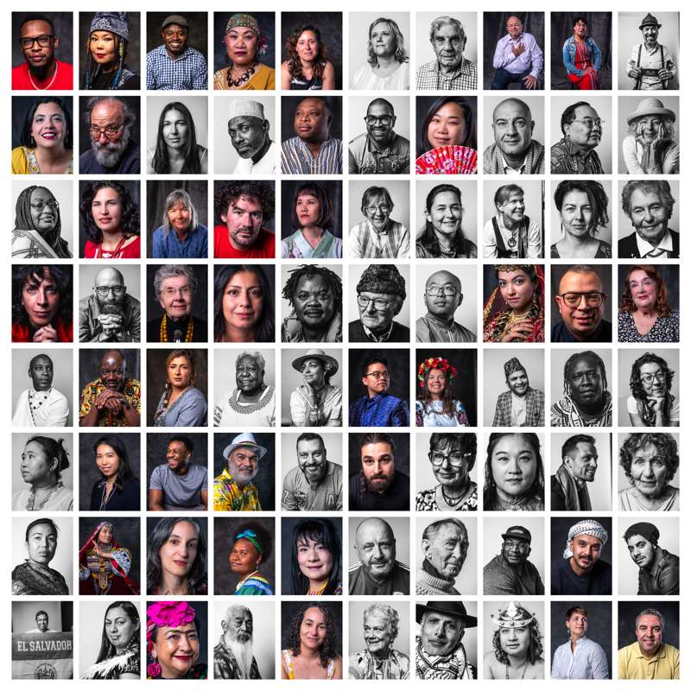
177 Nations of Tasmania, State Library and Archives of Tasmania. Photograph courtesy of Andrew Wilson and Mark Thomson.

Part 6: Resources
This section comprises a non-exhaustive list of reference material relevant to the significance assessment process and related collection management practices, and a glossary of key terms. It is intended to provide custodians of items and collections with a starting point for finding information on how to best assess, care for and manage cultural collections.

Relevant publications and websites

Australian Government departments
- Department of Climate Change, Energy, the Environment and Water: https://www.dcceew.gov.au/parks-heritage/heritage
- Department of Infrastructure, Transport, Regional Development, Communications, Sport and the Arts: https://www.infrastructure.gov.au/ and https://www.arts.gov.au/

Example significance assessment reports
- Australian Institute of Aboriginal and Torres Strait Islander Studies (AIATSIS) collection: https://aiatsis.gov.au/sites/default/files/2020-09/significance-international-report-2014.pdf
- Fred Embrey Sculpture Research Project (see Case study 18): https://collection.qagoma.qld.gov.au/sites/default/files/2024-11/11830_Fred_Embrey_Report_Collection_Online_v13.pdf
- Fremantle Prison collection: https://fremantleprison.com.au/media/3142/fremantle-prison-collection-significance-assessment-2018.pdf
- Garage Graphix Community Art Poster Archive, Blacktown Arts, Blacktown City Council: https://blacktownarts.com.au/wp-content/uploads/2024/01/BAC-GG-Significance-Report.pdf
- Geoffrey Kaye Museum of the Australian and New Zealand College of Anaesthetists: https://www.anzca.edu.au/getattachment/75288715-5a1f-4f4f-a069-14ada6603d1b/Museum-Significance-Assessment-(2023)
- Hunter New England Local Health Libraries Historical collection: https://www.hnehealthlibraries.com.au/media/Health_News/HNE%20Health%20Libraries%20Historic%20Collection%20Significance%20Assessment%202025.pdf
- Kew Historical Society collections: https://kewhistoricalsociety.org.au/khs/collection/
- La Trobe Art Institute: https://www.latrobe.edu.au/art-institute/art-institute-documents/LTU-Collections-Significance-Assessment_Summary-Document_October-2017.pdf
- Port Macquarie Historical Museum collection: https://portmuseum.org.au/files/819cb0b4b7e9d220dd15f547ffae8150.pdf
- Royal New South Wales Lancers Memorial Museum collection: https://www.lancers.org.au/documents/The_Collection.pdf

Relevant peak bodies and professional associations
- Australian Academy of the Humanities: https://humanities.org.au/
- Australian Archaeological Association: https://australianarchaeologicalassociation.com.au/
- Australian Geoscience Council Inc.: https://www.agc.org.au/
- Australian Historical Association: https://theaha.org.au/
- Australian Institute for the Conservation of Cultural Material: https://aiccm.org.au/
- Australian International Council on Monuments and Sites: https://australia.icomos.org/
- Australian Library and Information Association: https://www.alia.org.au/
- Australian Museums and Galleries Association: https://www.amaga.org.au/
- Australian Museums and Galleries Association Victoria: https://www.amagavic.org.au/
- Australian Society of Archivists (ASA): https://www.archivists.org.au/
- Blue Shield Australia: https://blueshieldaustralia.org.au/
- Council of Australasian Archives and Records Authorities: https://www.caara.org.au/
- Council of Australasian Museum Directors: https://camd.org.au/
- Council of Australasian University Librarians: https://caul.edu.au/
- Council of Heads of Australian Faunal Collections: https://www.ala.org.au/the-council-of-heads-of-australian-faunal-collections-chafc/
- Engineering Heritage Australia: https://www.engineersaustralia.org.au/engineering-communities/engineering-heritage-australia
- Fédération Internationale des Archives de Télévision / International Federation of Television Archives (FIAT/IFTA): https://fiatifta.org/
- Federation of Australian Historical Societies: https://www.history.org.au/
- First Nations Heritage Protection Alliance: https://culturalheritage.org.au/
- GLAM Peak: https://glampeak.org.au/
- Indigenous Archives Collective: https://indigenousarchives.net/
- International Association of Sound and Audiovisual Archives: https://www.iasa-web.org/
- International Council of Museums: https://icom.museum/en/
- Museums and Galleries of NSW: https://mgnsw.org.au/
- Museums and Galleries QLD: https://magsq.com.au/
- National and State Libraries Australasia: https://www.nsla.org.au/
- National Trust of Australia: https://www.nationaltrust.org.au/
- Operating Heritage Australia: https://operatingheritageaustralia.com.au/
- Professional Historians Australia: https://www.historians.org.au/
- Public Galleries Queensland: https://www.pgq.org.au/
- Public Galleries Association of Victoria: https://pgav.org.au/
- Public Libraries Australia: https://www.pla.org.au/
- University Art Museums Australia: https://www.uama.edu.au/

Cultural heritage databases and registers
- ACT Heritage Register: https://www.act.gov.au/environment/heritage/act-heritage-register
- Atlas of Living Australia: https://www.ala.org.au/
- AUSTLANG Language Codes https://aiatsis.gov.au/research/languages/austlang
- Australasian Underwater Cultural Heritage Database, Department of Climate Change, Energy, the Environment and Water: https://www.dcceew.gov.au/parks-heritage/heritage/underwater-heritage/auchd
- Cultural Data Online, Australian Government: https://www.arts.gov.au/cultural-data-online
- Australian Heritage Database, Australian Government, Department of Climate Change, Energy, the Environment and Water: https://www.dcceew.gov.au/parks-heritage/heritage/publications/australian-heritage-database
- Australian Memory of the World Committee, UNESCO Australian ‘Memory of the World program: https://www.amw.org.au/
- Australian Register of Historic Vessels, Australian National Maritime Museum: https://www.sea.museum/en/collections/arhv
- National Quilt Register: https://www.nationalquiltregister.org.au/
- National Mineral and Fossil Collection, Geoscience Australia: https://www.ga.gov.au/data-pubs/nmfc
- National Research Collections Australia, Commonwealth Scientific and Industrial Research Organisation (CSIRO): https://www.csiro.au/en/about/facilities-collections/Collections
- New South Wales heritage databases: https://www.environment.nsw.gov.au/topics/heritage/resources/search-heritage-databases
- Northern Territory Heritage Register: https://www.ntlis.nt.gov.au/heritageregister/
- Queensland Heritage Registers: https://qhr.detsi.qld.gov.au/ and https://www.culturalheritage.qld.gov.au/achris/public/home
- South Australia Heritage Register: https://www.environment.sa.gov.au/topics/heritage/sa-heritage-register
- Tasmania Heritage Register: https://heritage.tas.gov.au/heritage-listed-places and https://heritage.tas.gov.au/Documents/7-ConservingMoveableCulturalHeritage_FINAL%20June2020.pdf
- Victoria Heritage Register: https://heritagecouncil.vic.gov.au/protecting-our-heritage/heritage-protection-process/victorian-heritage-register
- Western Australia Heritage Register: https://www.wa.gov.au/government/document-collections/the-state-register-and-other-heritage-listings

Resources to guide significance assessment and collection management
- Aboriginal and Torres Strait Islander Histories and Cultures (2018), Australian Curriculum, Assessment and Reporting Authority (ACARA): https://www.australiancurriculum.edu.au/f-10-curriculum/cross-curriculum-priorities/aboriginal-and-torres-strait-islander-histories-and-cultures/
- AIATSIS Code of Ethics for Aboriginal and Torres Strait Islander Research (2020), Australian Institute of Aboriginal and Torres Strait Islander Studies:
https://aiatsis.gov.au/sites/default/files/2020-10/aiatsis-code-ethics.pdf
- AIATSIS Core cultural learning online training, Australian Institute of Aboriginal and Torres Strait Islander Studies: https://aiatsis.gov.au/about/what-we-do/core-cultural-learning
- AIATSIS Guidelines for Ethical Research in Australian Indigenous Studies (2012), Australian Institute of Aboriginal and Torres Strait Islander Studies: https://aiatsis.gov.au/sites/default/files/2020-09/gerais.pdf
- AIATSIS Return of Cultural Heritage, Australian Institute of Aboriginal and Torres Strait Islander Studies: https://aiatsis.gov.au/about/what-we-do/return-cultural-heritage
- Atlas of Living Australia’s guide to digitisation (2011), Atlas of Living Australia: https://www.ala.org.au/wp-content/uploads/2011/10/Digitisation-guide-110818.pdf
- Australian Best Practice Guide to Collecting Cultural Material (2015), Australian Government: https://www.arts.gov.au/publications/australian-best-practice-guide-collecting-cultural-material
- Collections Law & Ethics (2025), Shane Simpson and Ian McDonald, hard-copy resource.
- Commission for Looted Art in Europe: https://www.lootedart.com/
- Community Heritage Grants, National Library of Australia: https://www.library.gov.au/services/grants/community-heritage-grants
- Concise Introduction to Heritage Studies (2025), Laurajane Smith, hard-copy resource.
- Continuous Cultures, Ongoing Responsibilities: principles and guidelines for Australian museums working with Aboriginal and Torres Strait Islander cultural heritage (2005), Museums Australia, hard-copy resource.
- Decolonizing research: Indigenous storywork as methodology (2019), J.A. Archibald, J. B. J. Lee-Morgan, J. De Santolo, and L. Tuhiwai Smith, hard-copy resource.
- Dhawura Ngilan: A vision for Aboriginal and Torres Strait Islander heritage (2020), Heritage Chairs of Australia and New Zealand: https://www.dcceew.gov.au/parks-heritage/heritage/publications/dhawura-ngilan-vision-atsi-heritage
- First Nations Cultural Rights and Engagement Policy v3.0 (2025), National Museum of Australia:
https://www.nma.gov.au/about/corporate/policies/first-nations-cultural-rights-and-engagement
- First Nations Engagement: the principles of Free, Prior and Informed Consent, Australian Government, Department of Climate Change, Energy, the Environment and Water: https://www.dcceew.gov.au/sites/default/files/documents/free-prior-informed-consent-guidelines.pdf
- First Nations Restricted Collections & Repatriation Policy (2025), Australian Museum:
https://australian.museum/learn/cultures/restricted-collections-repatriation/
- First Peoples and Australian museums and galleries: A report on the engagement of Indigenous Australians in the museums and galleries sector (2018), Terri Janke and Company, Australian Museums and Galleries Association:
https://amaga.org.au/common/Uploaded%20files/Resources/First%20Peoples%20Museums%20and%20GAlleries.pdf
- First Peoples: A roadmap for enhancing Indigenous Engagement in Museums and Galleries (2018), Terri Janke and Company, Australian Museums and Galleries Association: https://amaga.org.au/common/Uploaded%20files/Resources/First%20Peoples%20_%20A%20roadmap.pdf
- Heritage: Key Findings, in Australia State of the Environment (2016), R. Mackay, Australian Government, hard-copy resource.
- Indigenous Art Code: https://indigenousartcode.org/storage/uploads/bb25a0cb-35c1-4d78-884c-f6f725127bcb/The-Indigenous-Art-Code.pdf
- Indigenous Cultural and Intellectual Property (2023), National Library of Australia:
https://www.library.gov.au/first-australians/indigenous-cultural-and-intellectual-property
- Indigenous Cultural and Intellectual Property Protocol (2023), NSW Department of Planning and Environment: https://www.water.dcceew.nsw.gov.au/sites/default/files/2025-09/Indigenous%20Cultural%20and%20Intellectual%20Property%20Protocol.pdf
- Indigenous Cultural Intellectual Property (ICIP) Information Sheet, Arts Law: https://www.artslaw.com.au/information-sheet/indigenous-cultural-intellectual-property-icip-aitb/
- Indigenous Referencing Guidance for Indigenous Knowledges (2023), Indigenous Archives Collective: https://www.caval.edu.au/referencing-toolkit/
- International Centre for the Study of the Preservation and Restoration of Cultural Property (ICCROM): https://www.iccrom.org/
- International Council of Museums (ICOM): https://icom.museum/en/resources/
- Interpol Stolen Works of Art Database: https://www.interpol.int/en/Crimes/Cultural-heritage-crime/Stolen-Works-of-Art-Database
- Lost Art Database: https://www.lostart.de/en/start
- Maiam nayri Wingara Indigenous Data Sovereignty Collective: https://www.maiamnayriwingara.org/
- Museum Collections Management: A Handbook (2011), Freda Matassa, hard-copy resource.
- Museum Registration Methods Sixth Edition (2020), John E. Simmons and Toni M. Kiser (eds), hard-copy resource.
- Museums & Galleries NSW resources (practical toolkit): https://mgnsw.org.au/sector/resources/
- National Cultural Policy, Revive – A place for every story, a story for every place (2023), Australian Government: https://www.arts.gov.au/what-we-do/revive-place-every-story-story-every-place
- National Standards for Australian Museums and Galleries Second Edition (2023): https://mgnsw.org.au/wp-content/uploads/2023/03/Nationals-Standards-for-Australian-Museums-and-Galleries-2.0.pdf
- Observatory Illicit Traffic, International Council of Museums (ICOM): https://www.obs-traffic.museum/
- Protocols for Libraries, Archives and Information Services (revised 2012), Aboriginal and Torres Strait Islander Library and Information Network:
https://atsilirn.aiatsis.gov.au/protocols.php
- Protocols for using First Nations cultural and intellectual property in the arts (2019), Australian Council for the Arts (now Creative Australia): https://creative.gov.au/first-nations-arts/protocols-for-using-first-nations-cultural-and-intellectual-property-in-the-arts
- Recordkeeping policies and standards, State Records NSW: https://www.nsw.gov.au/nsw-government/recordkeeping/policies-and-standards
- Red Lists Database, International Council of Museums (ICOM): https://icom.museum/en/resources/red-lists/
- Respectful use of Indigenous Knowledge, Australian Government, IP Australia: https://www.ipaustralia.gov.au/understanding-ip/indigenous-knowledge/how-to-engage-indigenous-knowledge
- Robert Cripps Institute for Cultural Conservation at the University of Melbourne: https://arts.unimelb.edu.au/crippsinstitute
- Significance 2.0: a guide to assessing the significance of collections (2009), Ros Russell and Kylie Winkworth, Collections Council of Australia: https://www.arts.gov.au/sites/default/files/documents/significance-2.0.pdf
- Standards & Guidelines, Australian Museums and Galleries Association: https://amaga.org.au/Web/Web/Resources/Policies--Standards-Guidelines.aspx
- The Museums + AI Network: https://themuseumsai.network/
- The Small Museums Cataloguing Manual Fifth Edition (2021), Australian Museums and Galleries Association Victoria: https://www.amagavic.org.au/resources/smcm
- Total Cost of Stewardship: Responsible Collection Building in Archives and Special Collections (2021), OCLC Research Library Partnership’s Collection Building and Operational Impacts Working Group, OCLC: https://www.oclc.org/research/publications/2021/oclcresearch-total-cost-of-stewardship.html
- True Tracks: Respecting Indigenous knowledge and culture (2021), Terri Janke, hard-copy resource.
- United Nations Educational, Scientific and Cultural Organization (UNESCO): https://www.unesco.org/en/culture
- Valuing Art, Respecting Culture, Protocols for working with the Australian Indigenous visual arts and craft section (2001), Doreen Mellor and Terri Janke, National Association for the Visual Arts Ltd, hard-copy resource.

Websites of collecting institutions referred to in the publication
- ACMI, Australian Centre for the Moving Image: https://www.acmi.net.au/
- ACT Historic Places: https://www.historicplaces.com.au/
- Adelaide Repertory Theatre Company: https://adelaiderep.com/
- Albany Historic Whaling Station (Discovery Bay Tourism Precinct): https://discoverybay.com.au/
- Art Gallery of Ballarat: https://www.artgalleryofballarat.com.au/
- Art Gallery of New South Wales: https://www.artgallery.nsw.gov.au/
- Australian Institute of Aboriginal and Torres Strait Islander Studies: https://aiatsis.gov.au/
- Australian Museum: https://australian.museum/
- Australian National Maritime Museum: https://www.sea.museum/en/home
- Australian War Memorial: https://www.awm.gov.au/
- Bathurst District Historical Society: https://www.bathursthistory.org.au/
- Bundanon: https://www.bundanon.com.au/
- Flinders University Museum of Art: https://www.flinders.edu.au/museum-of-art
- Geoscience Australia: https://www.ga.gov.au/
- Goulburn Historic Waterworks Museum: https://www.goulburnwaterworks.com.au/
- History Trust of South Australia: https://www.history.sa.gov.au/
- Koorie Heritage Trust: https://kht.org.au/
- Mackay Sub Branch Inc, Returned and Services League of Queensland, https://rslqld.org/get-involved/rsl-districts-and-sub-branches/districts/central-queensland-district/mackay-sub-branch-inc
- Maitland Regional Art Gallery: https://mrag.org.au/
- Melbourne Electronic Sound Studio: https://mess.foundation/
- Museum and Art Gallery of the Northern Territory: https://www.magnt.net.au/
- Museum of Australian Democracy at Old Parliament House: https://www.moadoph.gov.au/
- Museums Victoria: https://museumsvictoria.com.au/
- National Archives of Australia: https://www.naa.gov.au/
- National Film and Sound Archive of Australia: https://www.nfsa.gov.au/
- National Gallery of Australia: https://nga.gov.au/
- National Library of Australia: https://www.library.gov.au/
- National Museum of Australia: https://www.nma.gov.au/
- National Portrait Gallery of Australia: https://www.portrait.gov.au/
- National Trust of Australia: https://www.nationaltrust.org.au/nsw/
- Operating Heritage Australia: https://operatingheritageaustralia.com.au/
- Port Arthur Historic Site Management Authority: https://portarthur.org.au/
- Port of Echuca: https://portofechuca.com.au/
- Powerhouse Museum: https://powerhouse.com.au/
- Queanbeyan Museum: https://queanbeyanmuseum.org.au/
- Queensland Art Gallery | Gallery of Modern Art: https://www.qagoma.qld.gov.au/
- State Library and Archives of Tasmania: https://libraries.tas.gov.au/slat/
- State Library of South Australia: https://www.slsa.sa.gov.au/home
- State Library Victoria: https://www.slv.vic.gov.au/
- Tamworth Regional Museums: https://www.tamworth.nsw.gov.au/live/arts-and-culture/tamworth-regional-museums
- Tasmanian Museum and Art Gallery: https://www.tmag.tas.gov.au/
- Trafalgar Holden Museum: https://trafalgarholdenmuseum.com.au/
- University of Melbourne Potter Museum of Art: https://potter-museum.unimelb.edu.au/
- Western Australian Museum: https://visit.museum.wa.gov.au/

Glossary
Term | Meaning
Accession | To register an item or collection into a collecting organisation. This generally involves the preparation and formal endorsement of an acquisition proposal, entering the item or collection into a register or database using a numbering system, briefly describing the item or collection, and recording the details of its provenance, context and circumstances of acquisition.
Acquisition | Acquiring or gaining possession of an item or collection.
Aesthetic, artistic, creative or technical significance | One of the 4 primary criteria of the Significance framework. The value an item or collection has due to its visual impact, artistic quality, technical accomplishment, artisanship, design, or power to evoke an emotional response.
Appraisal | The process of selecting items and collections for inclusion in an archive. Appraisal for recordkeeping purposes encompasses determining what records to create and capture, how long records need to be kept, and the needs for records: legal, administrative, societal, cultural and historical.
Archive | A document in any format created or received and accumulated by a person or organisation in the course of the conduct of affairs and preserved because of its continuing value. Historically, the term has often referred more narrowly to non-current records deposited or selected for deposit in an archival institution. The word ‘archives’ is also commonly used to refer to (a) the organisation, agency or program responsible for the selection, care and use of records of continuing value, and (b) the building or place dedicated to their storage, preservation and use.
Artificial Intelligence (AI) | An engineered system that generates predictive outputs such as content, forecasts, recommendations or decisions for a given set of human-defined objectives or parameters without explicit programming. AI systems are designed to operate with varying levels of automation.
Born-digital | Material originally created, managed and stored in digital form that has never existed as a physical object. Distinct from a digital item converted from a physical or analogue source.
Burra Charter | The Charter developed and adopted by Australia ICOMOS (a branch of the United Nations-sponsored International Council on Monuments and Sites), which establishes nationally accepted principles for the conservation of places of cultural significance.
Cataloguing | Creating a record of an item or collection to systematically record and describe its key elements. Cataloguing will follow different principles depending on the collecting domain. Elements of a catalogue record generally detail information about the physical attributes of an item, its name, provenance, associations and functions.
Collecting domain | The collections sector is generally regarded as having 4 major domains – archives, galleries, libraries and museums.
Collection | A body of acquired items held by a collecting organisation, or the accumulated items held by a collector.
Collecting organisation | An organisation that manages a collection, including archives, galleries, libraries, museums, historical societies, cultural centres and keeping places.
Commissioning | The act of formally contracting or ordering a creator (such as an artist, photographer, researcher or artisan) to produce an item, work or study.
Conservation | The profession and practice of preventing damage, slowing deterioration, and prolonging the existence of cultural heritage for future generations.
Condition or completeness | One of the 5 comparative criteria of the Significance framework. The physical state of an object, including its stability, damage, degree of deterioration, intactness and the presence of original components.
Context | The historical, social and physical circumstances surrounding the creation, use and life of an object.
Cultural, social or spiritual significance | One of the 4 primary criteria of the Significance framework. The ongoing cultural, social, spiritual or religious values and meanings an item or collection has for an identified group of people.
Cultural protocols | The ethical principles, codes of behaviour and traditional customs that govern how people interact with a specific community’s cultural material, heritage and knowledge.
Deaccession | To deregister an item from a collection. This generally involves clearly stated reasons.
Desiderata | Latin for ‘things desired’ – a strategic ‘wish list’ of the items or types of items a collecting organisation will seek to acquire.
Distributed national collection | The items and collections of significance to the nation that are held in multiple different public and private collections.
Disposal | The final physical and legal act of removing an item from an institution's custody after completing the formal deaccessioning process. A highly regulated administrative procedure that can include transferring the item to another collection, returning it to traditional custodians, selling it at public auction or, as a last resort, physically destroying it.
Dissociation | The separation of items from the information needed to identify, locate or understand them.
Documentation | The written, photographic or digital records that provide details about an object's history and care.
Ephemera | Material produced originally for short-term use.
Fabric | Physical material of an item or collection.
Historical significance | One of the 4 primary criteria of the Significance framework. The values and meanings an item or collection has in relation to a known person, group, place, event, activity or period in history, and how it assists understanding of the past.
Immovable cultural heritage | Permanent physical structures, sites, and built environments of cultural, historical, scientific or artistic significance, including places, cultural landscapes, historic and archaeological sites, monuments and buildings.
Indigenous Cultural and Intellectual Property (ICIP) | Indigenous Cultural and Intellectual Property is a broad term referring to the rights Aboriginal and Torres Strait Islander people have to their heritage and culture. Includes knowledge, songlines, language, dance, symbols, art, medicines, foods, sacred sites and ecological knowledge.
In situ | Latin for ‘in place’. Refers to items or collections that remain in their original context of use or discovery.
Intangible cultural heritage | The practices, expressions, knowledge and skills that communities recognise as part of their cultural identity, including oral traditions, language, performing arts, social and cultural practices, knowledge and artisanship.
Interpretation | All the ways of presenting the significance of an item or collection, from simple object labels to exhibitions, education programs and web-based resources.
Interpretive capacity | One of the 5 comparative criteria of the Significance framework. The potential or capacity of an item or collection to effectively demonstrate, illustrate, teach, or communicate themes, stories, concepts and historical narratives to an audience.
Item | Refers to any type of cultural object.
Legal title | The formal ownership of property recognised by law, usually evidenced by documentation.
Movable cultural heritage | Any reasonably portable item or collection of significance.
Oeuvre | The entire body of work of an artist.
Operating heritage | Cultural heritage items and collections that are used regularly to demonstrate their original form and function.
Oral history | Documented recordings of the experiences, memories or knowledge of a person or group of people.
Preservation | All actions taken to minimise chemical and physical deterioration to prolong the existence of cultural material.
Provenance | One of the 5 comparative criteria of the Significance framework (sometimes considered a primary criterion). The full life history and documented chain of ownership of an item or collection, including origin, movements, previous owners, and context of use.
Rarity | One of the 5 comparative criteria of the Significance framework. Refers to the relative uncommonness of the item or collection.
Registration | A set of specialised museum or cultural institution systems to manage the documentation, legal compliance and logistical care of collections and exhibitions.
Repatriation | The act of returning ancestors and cultural items and collections to the place, community or peoples from which they originated or belong.
Representativeness | One of the 5 comparative criteria of the Significance framework. How well the item or collection exemplifies or demonstrates its type, era, or cultural or social context.
Restoration | Actions taken to modify the existing material and structure of an item to represent a known earlier state.
Restitution | The act of returning lost, stolen or unethically obtained property to its rightful owner, or providing them with compensation.
Scientific or research significance | One of the 4 primary criteria of the Significance framework. The current significance, or research potential, an item or collection has for a field of research, such as the sciences, social sciences, humanities, linguistics or the arts. The item’s capacity to advance knowledge through ongoing investigation.
Significance | The meaning and values of an item or collection, or what makes it important.
Significance assessment | The process of studying, understanding and documenting the meanings and values of an item or collection.
Significance assessment report | A document recording the research and findings of significance assessment in a structured format.
Species | The smallest unit of taxonomic classification, a species consists of individuals capable of interbreeding and producing fertile offspring.
Specimen | A sample of a natural item or organism, such as a whole or part of an animal or plant, a rock, mineral, or fossil, biological tissue or DNA.
Statement of significance | A reasoned summary of the meaning, values and importance of an item or collection.
Sustainability | A state or situation that can be sustained into the future, taking into account economic, environmental, social and cultural factors.
Voucher specimen | A specimen that serves as a basis of study and is retained as a reference. At a minimum, a voucher specimen is a specimen collected in the field under scientific controls that include data on the find spot, date of collection and name of collector.

Acknowledgements
This publication was produced by the Department of Infrastructure, Transport, Regional Development, Communications, Sport and the Arts (the department). It comprises updated content from Significance 2.0: a guide to assessing the significance of collections, published by the Collections Council of Australia in 2009, as well as newly commissioned guidance material and case studies supplied by a range of contributors.
The department acknowledges the many people involved in the development of Significance 2.0, notably the Significance 2.0 Project Team, including Sue Nattrass (Chair), Veronica Bullock (Project Manager and Editor), Dr Roslyn Russell and Kylie Winkworth (Authors), Ian Cook (Sector Advocate) and the individuals acknowledged for their contributions on page 70 of that publication (https://www.arts.gov.au/sites/default/files/documents/significance-2.0.pdf).
This edition of Significance was developed and edited by a working group consisting of qualified staff from the department's Office for the Arts, Dr Roslyn Russell and representatives from the National Library of Australia. New content was provided by Dr Roslyn Russell, Dr Kirsten Thorpe, Bronwyn Campbell, Dr Jessie Lymn, Bridget Guthrie, Rochelle Armstrong, Fiona Clarke, and the authors of the case studies listed in the publication. The department sincerely thanks all participants, including the many cultural organisations that contributed information and images.
The publication was refined based on the advice of numerous internal and external reviewers, including Dr Kirsten Thorpe and cultural heritage experts from National Collecting Institutions and representatives of Operating Heritage Australia.
This edition of Significance was designed and typeset by the department's Creative Services team.

This guide uses the terms First Nations, Aboriginal, Aboriginal and Torres Strait Islander, and Indigenous when referring to the first peoples of Australia. Wherever possible, specific nations, communities, or language groups are named, in recognition of the diversity of communities and nations across the country. Anyone assessing significance is encouraged to do the same in their own work, using current and community-preferred terms and naming specific communities or language groups rather than relying on general labels. The term First Nations is also used internationally to refer to the Indigenous peoples of other countries. Where a collection includes First Nations cultural material originating outside Australia, the same principles of respect, consultation, and free, prior, and informed consent set out in this guide should be applied, in partnership with the relevant communities and their representative bodies.

