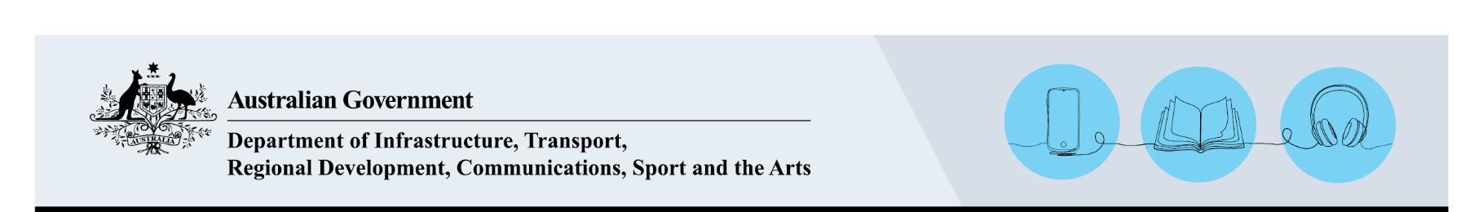

Update details for creators for the Lending Right Schemes
March 2026

Guidance for creators

Important information
This form is for creators, under the Public Lending Right (PLR) or Educational Lending Right (ELR) schemes, to update their contact details and/or their bank details.
You can update your details quickly and easily by logging onto Lending Rights Online, or you can complete the form below and submit it for processing.
If you have forgotten your password you can request a password reset. Note that you will need access to the email address that you have registered with. If you have any issues with this process you can contact the team for assistance.
Payment advice notifications are sent each year in May. Payments (if applicable) are made in June. To avoid delays in receiving payments, please keep your contact and banking information up-to-date. It is your responsibility to keep this information up-to-date. Payments that are returned to the department (i.e. that bounce due to incorrect banking information) may be subject to cancellation.
If you have any other questions regarding the PLR or ELR schemes, please see our FAQs.

Privacy and use of information
The Department of Infrastructure, Transport, Regional Development, Communications, Sport and the Arts (the department) is collecting your personal information in accordance with the Privacy Act 1988 as delegate of the Public Lending Right Committee under the Public Lending Right Act 1985.
The department will use your personal information to administer the Lending Right Scheme including to assess your eligibility for payment under the PLR and ELR schemes and to make payments to you if you are found to be eligible. Further information about the schemes and eligibility can be found on our Australian Lending Right Schemes (ELR/PLR) webpage.
The department may disclose your information to the Public Lending Right Committee for the purpose of making recommendations to the Minister for the Arts, or their delegate, concerning payments that may be made under PLR and/or ELR and for inclusion in the Public Lending Right Committee Annual Report. The annual report names the creators who received the highest payments and identifies payment ranges and the numbers of creators within each bracket.
The department will not otherwise use or disclose your personal information except as authorised by law.
You are not compelled by law to provide your personal information however if you do not then we may be unable to process your claim for Lending Rights payments.
The department will store your personal information securely and the department's privacy policy contains information regarding complaint handling processes and how to access and/or seek correction of personal information held by the department. For more information see the department's Privacy webpage.

How to lodge this form
In line with the Net Zero in Government Operations Strategy and commitment to sustainability, we encourage submitting this form by email to lendingrights@arts.gov.au.
You may also post your application to us at GPO Box 3241, Canberra ACT 2601.
For assistance please call 1800 672 842.

Update details for creators form

Creator’s details
Claimant number (if known):
Claimant name (title, first name, surname):
Postal address (street, state/territory, postcode):
Country:
Telephone:
Mobile:
Email one:
Email two:

Literary Agent (only complete if details have changed)
If you wish to use a Literary Agent, please complete the following questions:
Do you want all correspondence to be directed to your literary agent? | Yes  No
Do you want all payments to be directed to your literary agent? | Yes  No
If yes to either of the above questions, who is your Literary Agent? (Company name)

Creator’s Australian bank details (only complete if details have changed)
Branch number (BSB) – maximum 6 digits:
Account number – maximum 9 digits:
Account name:
Does the account name match your name? | Yes  No, please provide an explanation below
If no above, what is the connection between you and the bank account name?
If you only have an international bank account, please contact the Lending Rights team to discuss.

Creator’s statement
I declare that all information given in this form is correct.
I understand that making false and misleading statements in applications, and the provision of false or misleading information constitute offences under Sections 136.1, 137.1 and 137.2 of the Criminal Code Act 1995, and that these offences carry serious penalties.
Creator’s signature:
Date:

