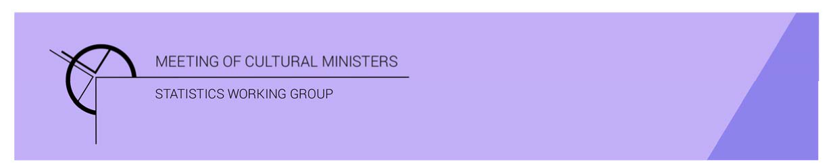

# Cultural Funding by Government—2019–20

## Western Australian Government

The estimate of expenditure funded by the Western Australian Government in 2019–20 for cultural activities was **$375.6m**, representing an increase of 27% or $78.8m from 2017–18[1].

Table 1. Western Australian Government cultural expenditure, 2016–17 to 2019–20

| 2016–17 | 2017–18 | 2019–20 |
| --- | --- | --- |
| $293.8m | $296.8m ↑1% | $375.6m ↑27% |

* Recurrent expenses accounted for 69% ($258.8m) of funded cultural expenditure.
* Capital expenditure was $116.8m, and the largest two categories were *Other museums and cultural heritage* ($98.2m) and *Libraries* ($8.7m).
* The estimate of per person cultural funding was $141.98.

Funds on *Heritage* activities rose 41% (or $75.4m) to $257.3m.

This increase was driven by expenditure on the categories of *Other museums and cultural heritage* (↑$37.3m) and *Libraries* (↑$37.2m). Increases were offset by a fall in *Arts museums* (↓$0.6m).

Almost two-thirds (63%) of *Heritage* funds were spent on *Other museums and cultural heritage* ($162.0m)with an additional 32% spent on *Libraries* ($82.2m).

Figure 1. Western Australian Government heritage expenditure

Funds for *Arts* activities also increased 3% (or $3.3m) to $118.3m.

The main contributors to this movement were *Community arts and cultural development* ↑$3.0m, *Music* ↑$2.9m and *Dance* ↑$2.8m. Conversely, funding for *Multi-arts festivals* decreased by $14.2m and *Cross-art form* ↓$4.2m.

Figure 2. Western Australian Government arts expenditure, by selected categories

The main categories of *Arts* activities funding were:

* *Performing arts venues*—$16.0m
* *Film and video production and distribution*—$12.2m
* *Arts education*—$10.6m
* *Multi-arts festivals*—$9.7m
* *Music*—$8.2m.

Recurrent expenditure increased 19% (or $40.5m) to $258.8m.

Table 2. Western Australian Government recurrent cultural expenditure, 2016–17 to 2019–20

| 2016–17 | 2017–18 | 2019–20 |
| --- | --- | --- |
| $229.3m | $218.3m ↓5% | $258.8m ↑19% |

* The largest recurrent expenditure was for *Libraries* ($73.5m) followed by *Other museums and cultural heritage* ($63.8m).

Figure 3. Western Australian Government recurrent cultural expenditure, by selected categories

1. *Cultural Funding by Government* survey not conducted in 2018–19, as it changed to a biennial collection.